Overview of Nursing Informatics in Retail Clinics
Overview of Informatics Solutions for Emergency Planning

Spivak and Ryan (2015) provide an overview and introduction to nursing informatics in retail clinics. The chapter authors identify retail clinics as a disruptive innovations. Notably, disruptive innovation often takes a market such as health care by surprise. In health care, retail clinics transformed the health care model from business-centric to patient centric. In the patient-centric model health care services could be delivered to a larger population of skilled but less expensive providers. | 

Townsend identified the following as needed to achieve the goal of affordable and accessible health care (as cited in Spivak & Ryan, 2015, p. 364)
- The utilization of skilled but less expensive healthcare personnel to provide appropriate levels of care
- A shift away from traditional healthcare venues like hospital and physician offices into lower cost and/or more accessible settings like community-based retail clinics
- Information technology to support individualized patient care, coordination of care across multiple care venues, and accessible to care via new technologies like telehealth and ehealth

Spivak and Ryan (2015, pp. 364-365) give details that retail clinics are the result of consumer demand for
- Convenient
- Easily accessible
- Affordable quality healthcare

Retail clinics are typically
- Open 7 days/week
- 12 hours/day
- 360 plus days/year

The hours of operations for convenient care clinics are much more comprehensive than the typical 8-5, Monday through Friday hours of ambulatory care. Markedly 50% of retail visits occur on the weekends or during weekday hours when primary care offices are closed. Typically, appointments are not required.

Spivak and Ryan (2015, p. 365) explain that retail clinic operators planned for the use of technology to overcome the lack of administrative and ancillary staff. In order to streamline workflows and data sharing, retail clinics rely on the use of practice management, the EHR, decision support, and patient facing technologies. The authors provide additional details regarding the use of technology in retail clinics. These technologies include patient self-management, practice management, and clinical care delivery workflows.

Patient self-management technology or technology found in retail clinics include
- Online or mobile accessed scheduling systems
- Appointment reminders
- Secure text or email messaging
- Kiosks
- Queue monitors
- Health information on monitors

Practice management in retail clinics
- Input devices to capture patient demographics
- Scanning devices to record insurance information
- Virtual insurance card
- Barcode readers
- The electronic sharing of insurance to verify in eligibility
- Payment technology
- Billing for services using Evaluation and Management Coding (E&M Coding)
- E&M Codes are based on American Medical Association’s Current Procedural Terminology (CPT) codes

Clinical Documentation Management
- EHR
- E-prescribing
- Codes including ICD-10 codes
- Sharing the discharge summary with the patient’s primary care physician
- Clinical decision support

Spivak and Ryan conclude the chapter stating, “information technology is the foundation upon which the retail clinic business has been built. This foundation enables retail clinics to rapidly respond to market demands of its consumers and care delivery partners” (2015, p. 370).

In the conclusion of the chapter authors note the need that retail clinics need to respond to market demands of consumers. To meet this response nurse administrators, nurse practitioners, and nurse informatics specialist need to know the number and location of clinics. This can be accomplished by an Internet search using the search terms of retail clinics. This can be made more specific by adding the city and county. Following the search, a mapping application can be used to visualize the locations of the clinics. This information can be used to drive health policy and the creation of new clinics.

Disasters can be classified as natural or manmade. Natural disaster events include hurricanes, flooding, typhoons, earthquakes, and pandemic disease events. Manmade events include terrorism, war, as well as political and social disturbances. These events require emergency planning and response. The WHO (2007) note that “major emergencies, disasters and other crises are no respecters of national borders and never occur at convenient times (p. 5). Natural disasters do not always occur in remote locations. For example, Hurricane Maria, struck Puerto Rico, September 20, 2017. A more local natural disaster was landfall of Hurricane Harvey and subsequent flooding in the Gulf Coast region. August 29, 2017 is a date that will be remembered by many especially in the Houston area. | 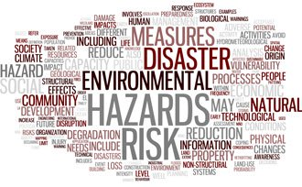

Weiner and Slepski (2015) introduce the reader to the federal system for emergency and planning and response. “Most disasters and emergencies are handled by local and state responders. The federal government provides supplemental assistance when the consequences of a disaster exceed local and state capabilities” (p. 472). The chapter authors note the “National Response Framework was enacted in January, 2008” (p. 473). The authors state that “the framework details federal, state, local, tribal, and private sector partners including the healthcare sector, prepare for and provide a unified domestic response, improving coordination and integration.” The Framework emphasizes preparedness activities that include planning, organizing, training, equipping, exercising, and applying lessons learned and assigns lead federal agencies to each of 15 Emergency Support Functions” (p. 473).

The chapter authors use the H1N1 as exemplar of Informatics and a potential pandemic disease. It should be noted that many countries had engaged detailed pandemic planning and archaic measures to delay but not stop the arrival of the disease.

In the US, the CDC monitors flu activity and trends and virus characteristics that a nationwide surveillance system. The CDC began reporting H1N1, April 29, 2009 and ceased the initial case counts July 24, 2009 as H1N1 was less severe and caused fewer deaths than expected. As a result, scientists used other methods to begin to understand the effects of H1N1. For example, more than 29,000 retail pharmacies, groceries, and merchandize stores participated in the National Retail Data monitoring system monitored in the monitoring of real-time purchase of antipyretics. In addition the CDC began using BioSense to track health departments, hospital ERs, Laboratory Response Network, labs, Health Information Exchanges (HIEs), and the Department of Defense and Veterans Affairs. It should be noted the Real-Time Outbreak Disease Surveillance (RODS) was designed in 1999 to collect and analyze disease surveillance data in real time (Weiner & Slepski, 2015). New methods of surveillance activities include
- Real time telephone triage data are now used to track flu in a specified region
- Physician group proprietary systems
Weiner and Slepski (2015) provide an overview of informatics needs and competencies. The authors describe a number of competency development efforts by various organization including CDC, International Nursing Coalition for Mass Casualty Education (later rebranded as the Nursing Emergency Preparedness Coalition (NEPC), WHO, Association of Colleges of Nursing, University of Hyogo, and International Council of Nursing. The National Nursing Emergency Preparedness Initiative (NNEPI) and NEPEC produced online modules. See the textbook for the websites.

At Cizik School of Nursing, Dr. Elda Rameriz has led the effort to develop a mass casualty simulation for UTHealth students along with participation by students from other schools and universities located in Houston and surrounding counties. Students from all six UTHealth schools have the opportunity to participate in the interprofessional simulation. The simulation is hosted at the Houston Fire Department’s Val Jahnke Training Facility. The yearly event is held in November. Watch for announcements regarding participation in the next mass casualty simulation.

As part of the incident management system (IMS), informaticians are now considered a member of the interdisciplinary team. IMS uses as hierarchical chain of command led by the incident manager or commander. The IMS improves communication through the use of a shared vocabulary and language. The IMS has been adapted from the firefighter model for use in hospitals, the Hospital Incident Command System (HICS). The Emergency Operations Center (EOC) is the physical location of the Incident Management Team meet. Various technologies have been suggested for use by Incident Management. Potential technologies include
- Smart white board
- Electronic dashboard
- Staffing and scheduling records
- Online disaster manuals
- Cell phones
- Radios
- Wireless devices
- Internet
- Radiation monitors
- CPS devices
- Electronic health record (EHRs)
- Pharmacy electronic records
Weiner and Slepski (2015) bring attention to provide exemplars of disasters and the value of EHRs. KatrinaHealth.org was a free and secure online service where Hurricane Katrina evacuees’ medications were listed. The importance of EHRs in preserving patient information was shown when St. John’s Medical Center of Joplin, Missouri, suffered an EF5 tornado. St. John’s was a leader in the use of technology. This hospital had implemented an electronic ordering system in the late 1960s. This hospital was well known to Dr. Brixey. She completed many clinical experiences at St. John’s during nursing school and worked as a staff nurse for about 3 years following graduation from Missouri Southern State College. Another EHR of interest is the Wireless Internet Information System for Medical Response in Disasters (WIISARD). This handheld wireless system. The WIISARD merges pre-hospital data with the receiving hospitals EHR using HIPPA complaint methods. This system has been met with several criticisms.

Another important area of emergency response is patient tracking. “Accurate and current information is critical for situational awareness – the ability to make timely and effective decisions during rapidly evolving events” (Weiner & Slepski, 2015, p. 482). The chapter authors explain Marres, Taal, Bemelman, Bouman, and Leenen developed the Victim Tracking and Tracing System (VTTS).

This chapter brings attention to informatics in emergency planning and response. The need for competencies was discussed. Furthermore, the chapter authors importantly noted that informaticians are members of the incident command system. Additionally, examples of the use health information technology were provided.

Of consideration during an emergency planning and response is downtime for health information and communications systems. It is imperative to have a plan to manage downtime. Smith and Macdonald (2006) recommend the following in preparation for a disaster
- Conduct a ‘needs assessment’
- Develop an electronic list of patient ID, medications, allergies and immunizations
- Consider converting to electronic records
- Prevent damage to your paper-based records
- Back up computer files
- Plan for the potential loss of information technology infrastructure
- Develop an HIS disaster plan
Manmade mass casualty events have become all too common in the US. For many, 9/11/2001 is one of the first mass casualty events. The mass casualty event entailed a series of attacks including the Twin Towers of the World Trade Center, the Pentagon and the crash of commercial aircraft in Pennsylvania. As a result, 2,996 people were killed and more than 6,000 were injured. Since 9/11 there have been many mass casualty events including the Boston Marathon Bombing. Three individuals were killed but several hundred were injured. Additional mass casualty events have involved the use of weapons. Most recently were the events in Las Vegas and Sutherland Springs, Texas. These events require pre-planning as well as the inclusion of health informatician professionals and informatics technology to support patient tracking and communication.

Learning Objective
- Understand the evolution of the retail industry and need for innovation
- Understand the mission and the foundational characteristics of affordable, high-quality, easily accessible health care
- Understand the key services offered and how clinics operate and adjust services to meet consumer needs
- Understand the use of technology and innovation to validate the quality of care delivered in retail clinics
- Describe the contributions that informatics can provide to emergency planning and response.
- Illustrate various ways that informatics tools can be designed and used to support decision making and knowledge base building in emergency planning and response efforts
- Utilize the 2009 H1N1 example as a case study in how informatics was used to plan and respond to this pandemic event
- Project areas of emergency management and response that would be benefit from informatics assistance.
Activities
Read and review
Spivak, F. M., & Ryan, S. F. (2015). Chapter 24 Nursing informatics in retail clinics. In V. Saba & K. McCormick (Eds.). The essentials of nursing informatics (6th ed., pp. 363-370). McGraw-Hill.
Weiner, E., & Slepski, L. A. (2015). Chapter 33 Informatics solutions for emergency planning and response. In V. Saba & K. McCormick (Eds.), The essentials of nursing informatics (6th ed., pp. 471-484). McGraw-Hill.
Fung, I. C-H., Tse, Z. T. H., & King-Wa Fuc, K-W. (2015). The use of social media in public health surveillance. Western Pacific Surveillance and Response Journal, 6(2), 3–6. doi:10.5365/wpsar.2015.6.1.019
Schmidt, C. W. (2012). Trending now: Using social media to predict and track disease outbreaks. Environmental Health Perspectives, 120(1), a30–a33. http://doi.org/10.1289/ehp.120-a30
As an individual
The chief nursing officer (CNO) and chief nursing information officer (CNIO) need to know the location of retail clinics in Houston and Harris County for surveillance of communicable diseases and to add retail clinics. The Health Informatics Department has compiled a list of retail clinics based on an Internet search. Duplicate clinics have been removed. As the Nurse Informatics you are assigned to create a pin map of locations and analyze the map. Are the clinics equally distributed across the city and county, what areas have a concentration of retail clinics (e.g. are more clinics east or west of I-69 or I-45, are more clinics north or south of I-10), what areas lack coverage by retail clinics and where should retail clinics be added (e.g. east or west of I-69 or I-45, or north or south of I-10). What three (3) communicable diseases would the nurse practitioners request the Informatics Nurse Specialist (INS) to monitor in the electronic health records (EHRs) and generate reports to detect trends. Provide the rationale as to why these five (5) communicable diseases were selected.

- Create a pin map using Batchgeo https://batchgeo.com/ based on the data provided in excel spreadsheet. The map must be included in the submission. Label as a figure.
- Analyze the map and answer the questions
  - Are the clinics equally distributed across the city and county clinics (e.g. are more clinics east or west of I-45, are more clinics north or south of I-10)?
  - What areas of Houston and Harris County have a concentration of retail clinics? (e.g. are more clinics east or west of I-69 or I-45, are more clinics north or south of I-10)?
  - What areas of the city and county lack coverage by retail clinics? (e.g. east or west of I-45 or north or south of I-10).
  - Where should retail clinics and nurse practitioners be added? (Word count 150-200 words) (e.g. east or west of I-69 or I-45 or north or south of I-10).
- What three (3) communicable diseases would the nurse practitioners request the Informatics Nurse Specialist (INS) to monitor in the electronic health records (EHRs) and generate reports to detect trends. Provide the rationale as to why these three (3) communicable diseases were selected. (Word count 150-200 words)
- References are required
  - In the text references are required
  - A reference list is required

Grading Rubric

Activity | Points Possible | Points Earned | Comments
Create a pin map using Batchgeo https://batchgeo.com/ based on the data provided in the excel spreadsheet. The map must be included in the submission. Label as a figure following APA style. Explain in the text why the map is included | 25
What areas of Houston and Harris county have a concentration of retail clinics? (e.g. east or west of I-69 or I-45 or north or south of I-10). | 5
What areas of the city and county lack coverage by retail clinics? (e.g. east or west of I-69 or I-45 or north or south of I-10). | 5
Where should retail clinics be added? (Word count 150-200 words). (e.g. east or west of I-69 or I-45 or north or south of I-10). | 25
What three (3) communicable diseases would the nurse practitioners request the Informatics Nurse Specialist (INS) to monitor in the electronic health records (EHRs) and generate reports to detect trends. Provide the rationale as to why these three (3) communicable diseases were selected. (Word count 150-200 words) | 25
References are required  In the text references are required and follows APA 7 | 1
A reference list is required  Reference list follows APA 7 | 1
APA 7 style, grammar, punctuation, spelling, and readability | 13
Total | 100

Suggested readings
Bader, S. (2013, December 11). The doctor’s office of the future: Coffee shop, Apple Store, and fitness center. Futurist Forum. Retrieved from https://www.fastcompany.com/3023255/the-doctors-office-of-the-future-coffeeshop-apple-store-and-fitness-center
Berry, L. L., & Mirabito, A. (2010). Innovative healthcare delivery. Business Horizons, 53, 157-169. Retrieved from https://papers.ssrn.com/sol3/papers.cfm?abstract_id=2064819
Christensen, C. M., Bohmer, R., & Kenagy, J. (2000, September-October). Will disruptive innovations cure health care? Harvard Business Review, 78(5), 102-112, 199. Retrieved from https://hbr.org/2000/09/will-disruptive-innovations-cure-health-care
Daniel, H., & Erickson S. (2015). Retail health clinics: A policy position paper from the American College of Physicians. Ann Intern Med, 163, 869–870. doi: 10.7326/M15-0571
Glabman, M. (2009, January). Disruptive innovations that will change your life in healthcare. Managed Care. Retrieved from https://www.managedcaremag.com/archives/2009/1/disruptive-innovations-will-change-your-life-health-care

Godman, H. (2016, January 15). Retail health clinics: The pros and cons. Harvard Health Blog. Retrieved from https://www.health.harvard.edu/blog/retail-health-clinics-the-pros-and-cons-201601158979
Hansen-Turton, T., Ridgway, C., Ryan, S. F., & Nash, D. (2009). Convenient care clinics: The future of accessible health care – The formation years 2006-2008. Population Health Management, 12(5), 231-240.
Ryan, S. F. (2009). Providing high tech patient care. The Nurse Practitioner, 34(10), 6-7.

SAASADDICT. (2015, October 28). How the cloud is turning retail health providers into power players. Retrieved from https://cloudtweaks.com/2015/10/how-the-cloud-is-turning-retail-health-providers-into-power-players/

Shute, D. (2017, September 29). What's next for retail healthcare? HealthLeaderMedia. Retrieved from http://www.healthleadersmedia.com/leadership/whats-next-retail-healthcare-0#
Townsend, J. C. (2013, April 23). Disruptive innovation: A prescription for better healthcare. Forbes. Retrieved from https://www.forbes.com/sites/ashoka/2013/04/23/disruptive-innovation-a-prescription-for-better-health-care/#671cab9330ec
Suggested Resources
RECOMMENDED WEBSITES for APA STYLE
American Psychological Association (APA). (2015). APA style. Retrieved from http://www.apastyle.org/index.aspx
Angeli, E., Wagner, J., Lawrick, E., Moore, K., Anderson, M., Soderlund, L., & Brizee, A. (2010, May 5). General format. Retrieved from http://owl.english.purdue.edu/owl/resource/560/01/
RECOMMENDED URL Shortener
Google. (2012). Google url shortener. Retrieved from https://goo.gl/

RECOMMENDED GRAMMAR CHECKER
http://www.gingersoftware.com/grammarcheck#.Veug1BFViko

Directions for Creating a Pin Map

- Copy and paste the Excel data set to https://batchgeo.com/
- Select Map Now button

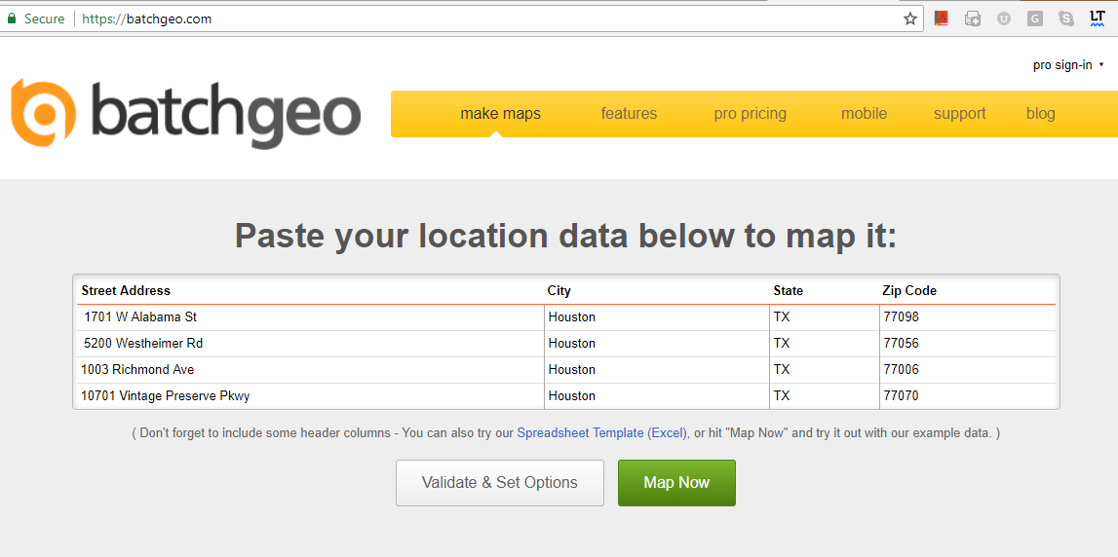

- Once the data are analyzed you receive the following screen
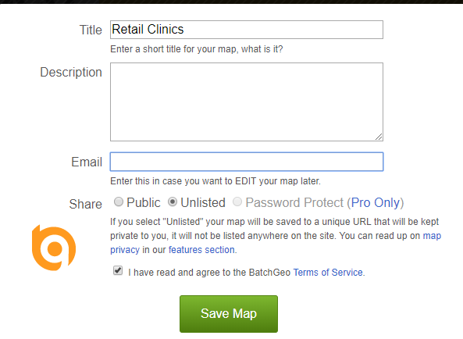
Give the map a title such as Retail clinic
Enter an email address
Select Save Map
The map will be sent to your email address

- Select the link to the map
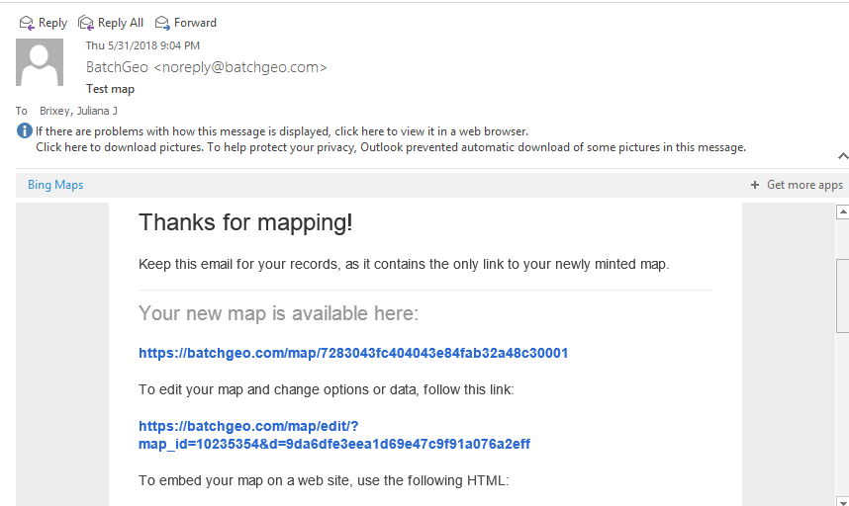

- Once you are at the map you can use the print screen function on your computer to select the map.
Step 1: Capture the image — Assuming the area you want to capture is displayed on your screen, press the “Print Screen” (often shortened to “PrtScn”) key, typically located in the upper-right corner of your keyboard, to capture a screenshot of your entire display. Alternatively, press “Alt + Print Screen” to capture a screenshot of the active window.

If you’re on a laptop, you may need to press “Fn” + “Print Screen” if your laptop has another feature assigned to that particular key.

Retrieved from https://www.digitaltrends.com/computing/how-to-take-a-screenshot-on-pc/

You can also use snipping tools. More information is available from https://support.microsoft.com/en-us/help/13776/windows-use-snipping-tool-to-capture-screenshots

- Paste the map into the Word document. Be sure to label as a figure following APA style.

