Remove (.) from the title

Remove tutorial/ Question# and add search for any query

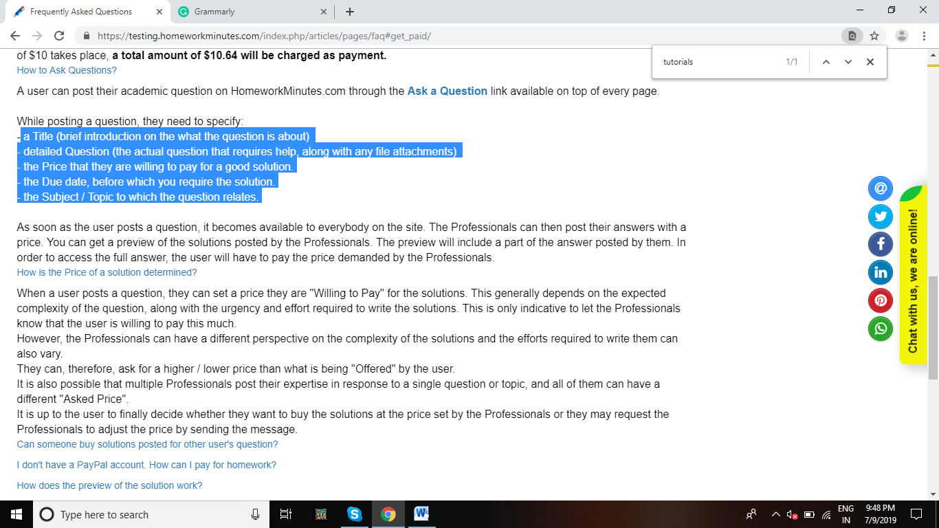
(Corrected lines)
-A Title (brief introduction on what the question is about)
- Detailed Question (the actual question that requires help, along with any file attachments).
- The Price that you are willing to pay for a good solution.
- The Due date, before which you require the solution.
- The Subject / Topic to which the question relates.

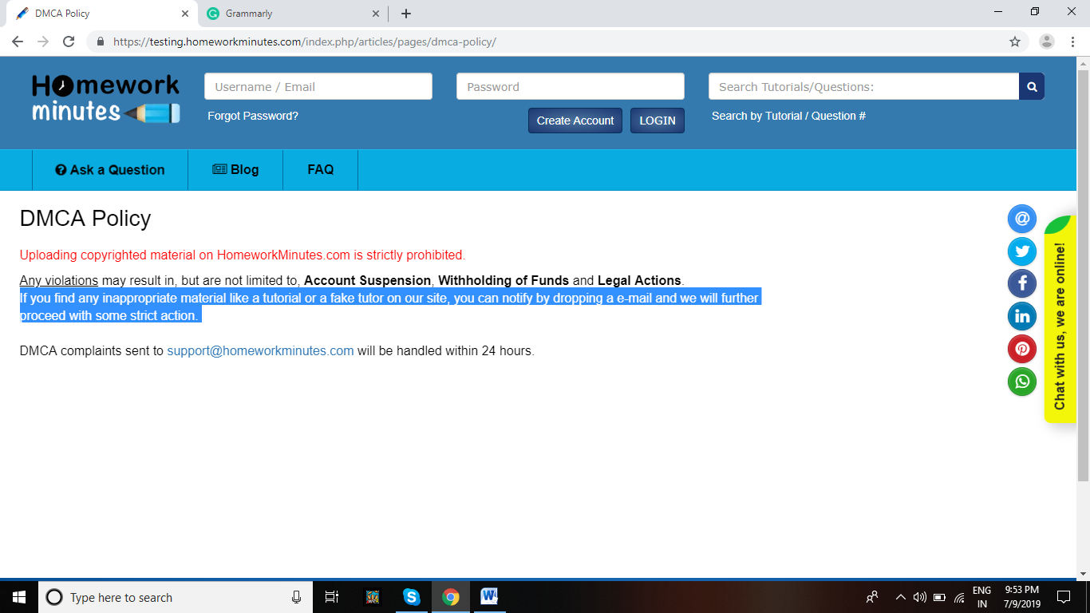
If you find any inappropriate material like a tutorial or a fake tutor on our site, you can notify us by dropping an e-mail and we’ll proceed with some strict action against the prosecutor.

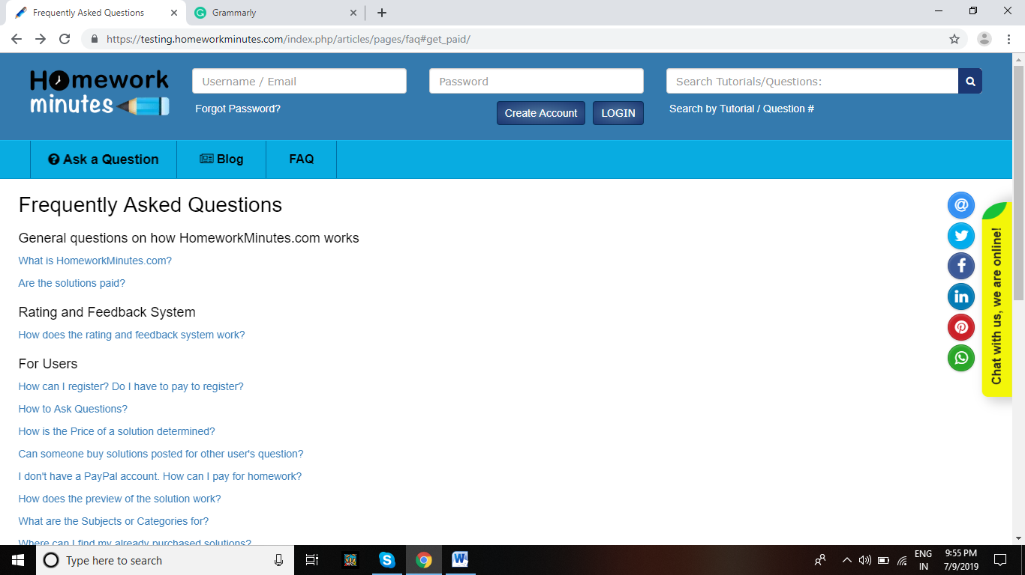
Removal tutorial/ Question# placed below the search bar. Add search for any query

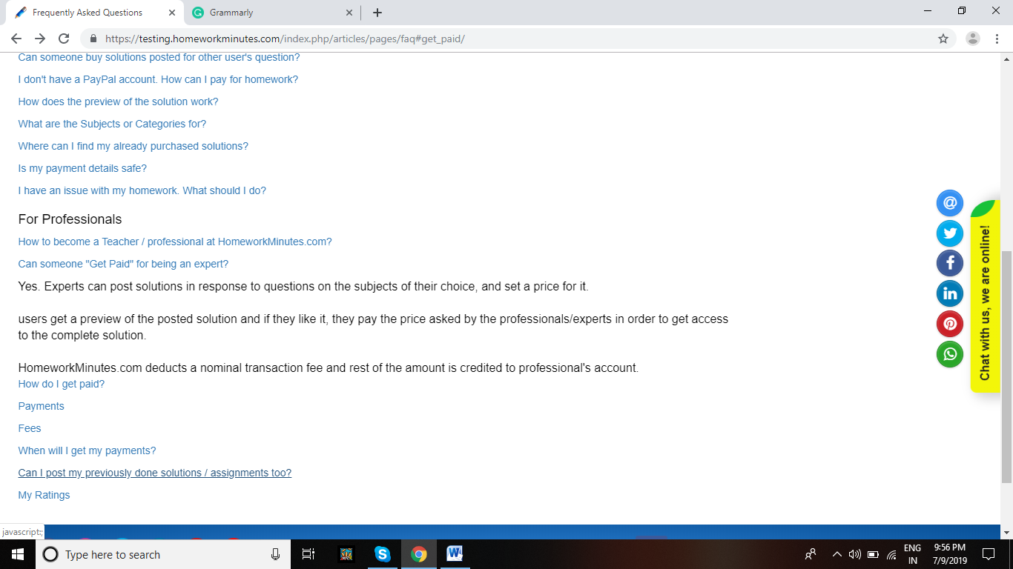
Can I do my previously done solutions too?

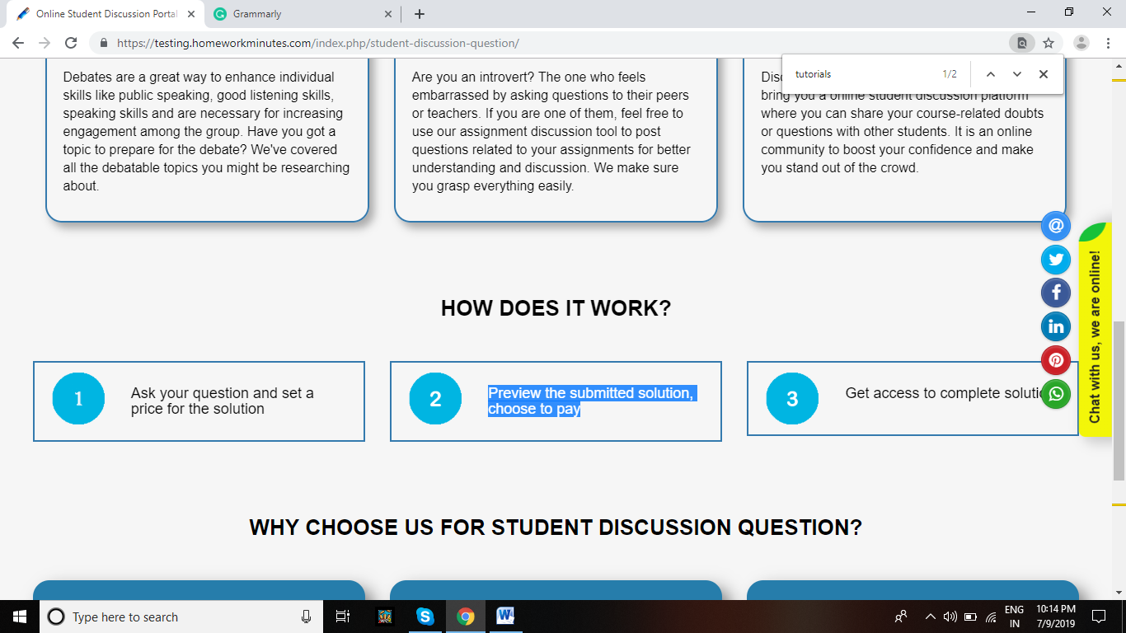
Correct this line on each page: Preview the submitted solution and choose to pay

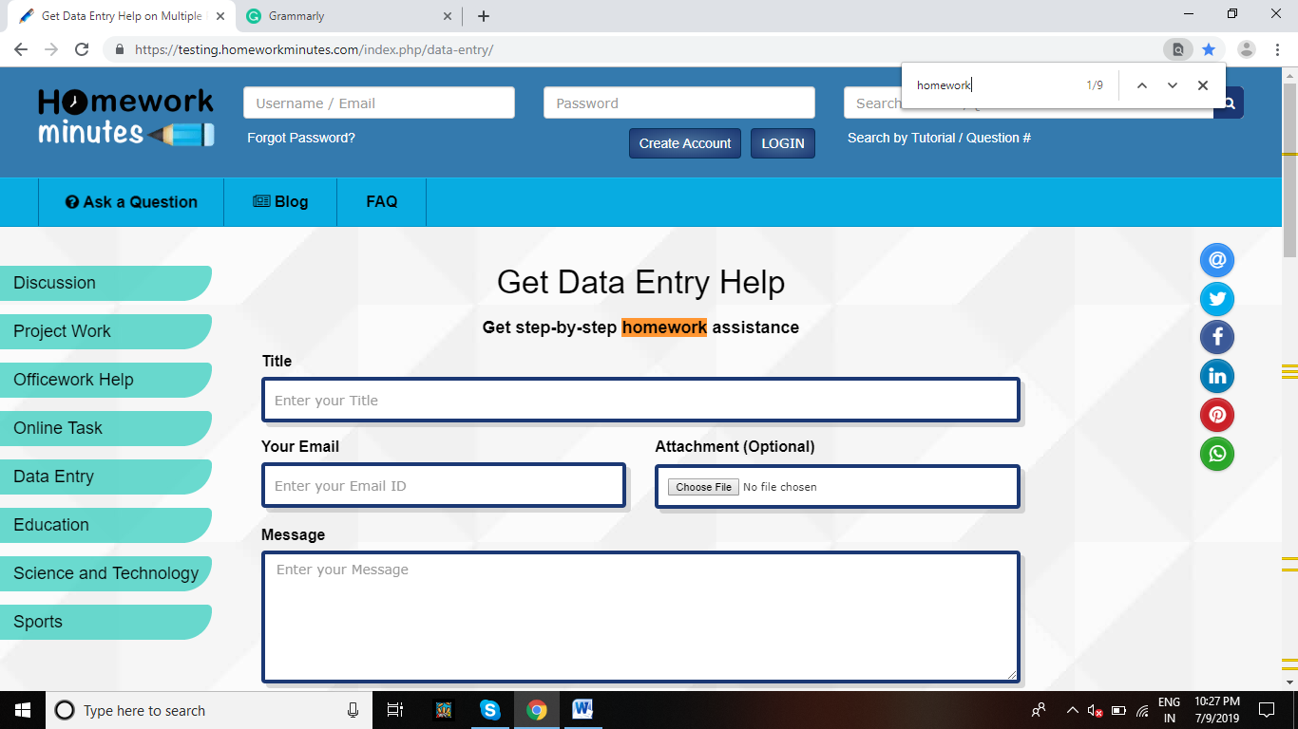
Get step-by-step data entry assistance

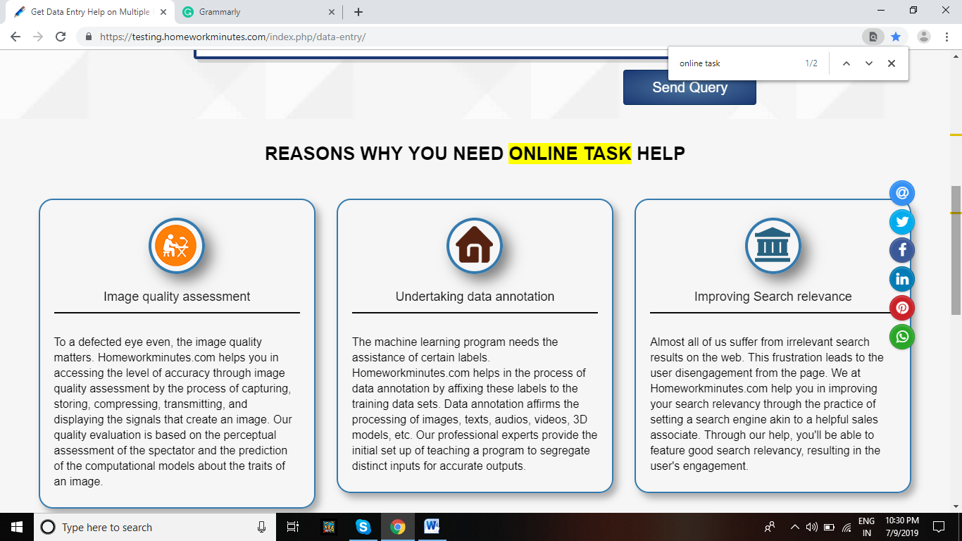
Reasons Why You Need Data Entry Help

