Individual Project
Name
Class
Date
Instructor

Part 1
- Determine the year-to-year percentage annual growth in total net sales.
Year-to-Year percentage of growth will be possible to calculate from increase in sales of present year and from sales of preceding year then divided by sales of preceding year (Gitman, 2009).
Formula for calculation of percentage growth is:
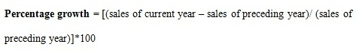
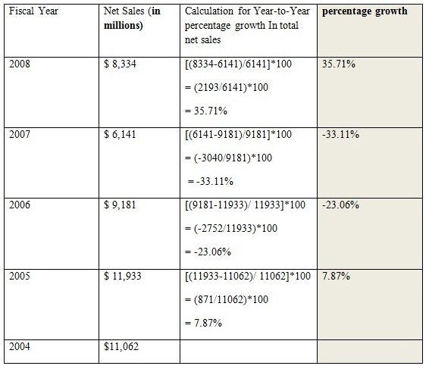
In 2005 and 2008, the company managed to enjoy positive growth. However, in 2006 and 2007, the company experienced significant negative growth. In general, net sales have
followed a declining trend.
2. Based only on your answers to question #1, do you think the company achieved its sales goal of +10% annual revenue growth in 2009? Determine the target revenue figure, and explain why you do or do not feel that the company hit its target.
As it can be observed from the sales performance of the organization from 2004 to 2008, it is highly possible for the organization to achieve a +10% in 2009. This is because the growth in 2008 is already very high at 35.71%. Thus, continuing this trend albeit at a smaller scale should be highly possible. However, the possibility of achieving the goal will also need to depend on other factors such as events which may greatly affect sales.
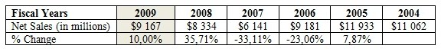 Based on the figures given, to hit +10% in 2009, the company will need to achieve $9167 million in net sales.
Part 2
- Use the Percentage Sales Method and a 25% increase in sales to forecast Micro Chip's Consolidated Statement of Operations for the period of September 26, 2008 through September 25, 2009. Assume a 15% tax rate and restructuring costs of 5% of the new sales figure.
Here we apply the Percentage Sales Method (PSM) and a 25% appreciation in sales to predict Micro Chip's Consolidated Statement of Operations for the period begining from 26th September, 2007 to 25th September, 2008. 25% appreciation in sales would alter the present year figures by multiplying with (1+25/100) = (1+0.25) = 1.25.
While using sales percentage with 25% appreciation in sales and applying consolidated statement for present year, here will be the predicted consolidated financial statement for year 2007-2008:

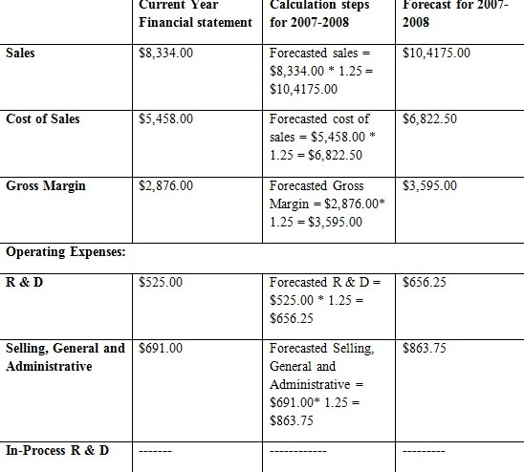
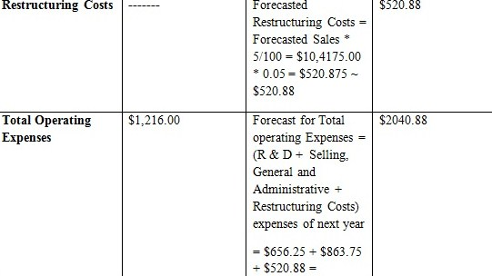
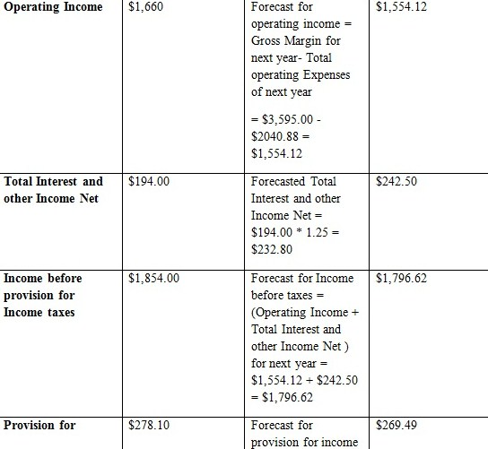

Using the percentage sales method as well as a 25% increase in sales, the forecasted statement of operations for the company for 2007-2008 will be as follows:

As it can be seen that the projected sales will be $10,4175.00 million, while the cost of sales will be $6,822.50 million. With a provision for tax at 15%, the net income of the company for 2008-2009 is estimated to be $1,527.13 million.
2. Discuss your results from question number #1. What assumptions have you made? Do any of your assumptions seem unreasonable?
The method of percntage sales can be unrealisitc. That is why; I would be expecting costs to be higher than forecasted by this method. Possibly, such growth rate will require the firm to expand, employ new workforce and all of which may show initial higher costs than the forcasted by the percentage method. Further, appreiciation in the sales also may reauire exploring the new markets (sale of new products and services or in different locations) that may hike the cost of sales temorarirly (since there is possiblity that firm can do mistakes as it does not possess exprience of manufacturing new products and services), or the selling costs (promotional campiagns need to be launched in markets where the product is still not popular). Hence, it is expected these costs, in the year 2009 and for the next few following years may represent higher sales percentage than the one forecasted by the percentage sales method.
References
Gitman, L. J. (2009). Principles of managerial finance (12th ed.). Boston, MA: Pearson Higher Education.
Jerry J. Weygandt, Paul D. Kimmel, Donald E. Kieso. (2009). Managerial Accounting:
Tools for Business Decision Making John Wiley & Sons, pp. 114-167
Lawrence J. (2008). Gitman Principles of Managerial Finance Addison-Wesley, pp. 205-220.

