UNIVERSITY OF LA VERNE

La Verne, California



Organizational Analysis: BJ’s Restaurants, Inc. (NASDAQ:BJRI)
A Paper Submitted in Partial Fulfillment
of the Requirements for
BUS 695 Strategic Management

Richard Orozco
Peter Buccola

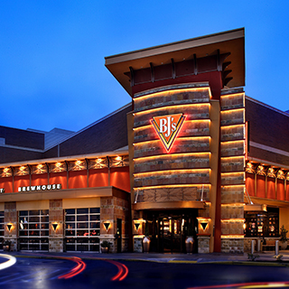

December, 2017

Table of Contents
Introduction ….3
Strategic History 4
Five Forces Analysis: Casual Restaurants 5
Industry Life Cycle 7
Internal Analysis 8
Value Chain Analysis or Functional Analysis 8
Financial Analysis 10
Core Capabilities, Distinctive Competencies, VRIO Analysis 12
Organization Structure and Culture Analysis 14
Internal Assets Analysis 15
SWOT Analysis 15
TOWS Analysis 16
Key Strategic Issues 26
One Year Operation Plans 26
Conclusion 29
Appendix 30
References ….32

Introduction

BJ’s Restaurant, Inc. was founded in 1978 and the first restaurant was opened in California in 1978. At first, the company showcased Chicago style deep Pizza that had a unique flair of California but improved to the small pizzeria and to a full-service restaurant. The company has been expanding for the past decades and it has changed from a small family-owned business to a full-service casual dining restaurant. There has been an increasing competition in the market and the company has implemented a variety of strategies for the maintenance of the market share. This organization analysis will survey the external “premium” casual dining restaurant industry, as well as BJ’s Restaurants, Inc.’s business strategy, including a value chain analysis, financial analysis, organization structure and cultural analysis, and the intellectual assets analysis.

Industry Overview
The restaurant industry in the Unites States is part of a larger food service industry, which infuses $2.7 trillion into the economy annually. According to Hoover’s, full-service restaurants with a “sit-down” experience with wait staff generate approximately $550 billion of total revenue-- approximately 20% of all restaurant revenues--and comprises over 245,000 establishments.. There is a tremendous level of fragmentation in the full-service restaurant industry: fine dining vs. casual; independent or local vs. chain; cuisine types; number of unit location stratification; franchised vs. company operated; and geographic tastes and cultures. Casual restaurants in the Unites States, in broad terms, are distinguished by family-friendly, seated patrons, with wait staff, who pay at the end of the meal (Hoover Industry Analysis, Casual Restaurants, 2017). The largest companies in this segment include Applebee’s ($23.6 billion sales), Darden Restaurants ($7.1 billion sales), Blookin’ Brands which includes Outback Steakhouse and Flemings Steakhouse ($4.2 billion sales), and Brinker International which does business as Chilli’s and Maggiano’s ($3.1 billion sales).

Strategic History
Since the mid-1990s, the casual restaurant industry has evolved out of two bifurcated options: only very small, local eateries and large, national chains such as Red Robin and Applebee’s. In a 1995 article published in Nation’s Restaurant News, the increased demand and competition at upscale casual restaurants fueled a trend to replace traditional Kitchen Managers with Executive Chefs to deliver “fresh menu ideas and a creative personality -- a chef who knows how to greet the guests and give validity to the food" (Vol. 29 Issue 36, p1. 2p. 1). This coincided with an expansion in new and existing eateries across regional and national geographies, as Americans preferred eating out to cooking at home. By 2000, overall full-service restaurant revenue increased 30% (National Restaurant Association Factbook, 2017) but the growth curve was still on its upward ascent. As of 2003, millennials were graduating high school and college and have becoming the largest consumers of casual restaurants (First Research Industry Analysis: Casual Restaurants, 2017). The affluence and spending behavior of this key demographic, compounded by advances in mobile and software technology cooked up several innovation in the casual restaurant space: curbside delivery offerings, online reservations, online reviews (such as Yelp.com and OpenTable.com). Restaurant revenues consequently nearly doubled from 2000 to 2010 to $440 billion--of which casual dining incurred the largest increases (National Restaurant Association).
Now, in the post-iPhone era, other trends are emerging which are revolutionizing how the food service industry competes for the same patrons across various industry segments. Promises of faster services, with higher quality ambiance and food items have driven significant growth in the quick casual segment, producing twice the growth than full service restaurants at 4.5% (Long Range Systems, White Paper: “The Evolution of Fast Casual,” 2017). Kiosk and booth ordering capabilities, augmenting wait staff and ordering clerks give customers more control over what they are ordering and reduce food prep and waiting times. Online ordering with more intuitive menu displays and real-time preparation monitoring, along with new food delivery channels such as Grubhub enable patrons to eat their favorite foods off-premises--putting more emphasis on convenience and food quality than ambiance and customer service, and competing with meal kit food subscription services (Hoovers Industry Trends, 2017). Some large casual chains have resorted to lowering their menu prices (also known as the average ticket price) and trying to round-out their menus with healthier alternatives (Hoovers, 2017). Despite the significant amount of innovation and focus on food quality, casual restaurants will still contend with lower same-store sales and a glass ceiling on average ticket prices, as higher end quick casual, niche restaurants, and meal kit subscriptions eat into market share. Ominously, as recently as October, 2017, Macaroni Grill filed for bankruptcy protection and burger chain Ruby Tuesday was sold to a private equity company after its parent was unable to boost sales following a recent upgrade to its menus (Associated Press. Romano’s Macaroni Grill files for bankruptcy protection, 10/18/2017).

Five Forces Analysis: Casual Restaurants
Bargaining Power of Suppliers: Low-Moderate. This is served by a myriad of food wholesalers and even local food growers in some markets. Food wholesalers have national, regional, and local networks, which make differentiation difficult, and is a notoriously commoditized industry. However, with the trend toward non-GMO, organic, certified humane, greater emphasis on food safety, and on where and how the food was grown, could create greater bargaining power by suppliers. The increased scrutiny of food sources and handling will limit the number of available suppliers in the future, especially to national and specialty casual restaurants.
Bargaining Power of Buyers: Moderate. Restaurants, because of the fresh food service aspect of the industry, are de facto highly customized, catered toward individuals (or groups for business meetings or parties, for example). Therefore, there is no phenomenon in this industry of buyer groups forming to drive prices downward, or improve menu quality. However, this segment is highly influenced by societal and economic factors which influence consumer behaviors, including economic recession, and demographic shifts--and therefore, the buyer has a high degree of input on the chains’ success. In addition, the switching costs are low at the individual level: they will vote with their wallets in a traditionally inelastic industry. This could force casual restaurants to further scrutinize their supply chain, nutrition facts, and ultimately foot traffic in the brick and mortar locations. Third party apps (i.e. Grub Hub or DiningIn.com) which intermediate the buying transactions could also play a new role in forcing commissions of the chains or sliding scale fee structures.
Potential New Entrants: Moderate. The greatest growth stems from smaller regional restaurant firms, also known in the industry as the “Second 100.” These are the second-tier of restaurant chains as stack-ranked by annual revenue, which have incurred organic growth of 4% in 2016 according to the Nation’s Restaurant News’ 2017 Second 100 report. On the other hand, barriers to entry are moderate as success requires word of mouth, time, and capital in order to expand.
Substitutes: High. Alternatives within the restaurant industry--namely, quick casual and niche dining, as well as a trend toward farm-to-table eateries are key alternatives. Other substitutes such as fast food and traditional grocery shopping whereby avoiding dining altogether will also be constant supply forces if dining prices are too high, wait times too long, or quality is poor, etc.
Rivalry among existing competitors: High. There are many, many competitors in a shrinking growth rate overall, with negative same store sales, in which patrons have low switching costs to move from one chain to another.
The resulting assessment of the competitiveness of the casual restaurant industry as illustrated by Porter’s Five Forces is an industry, which is highly competitive and difficult to achieve profitability driven primarily by the availability of substitutes and rivalry among the chains. Long-term profitability and long-term competitive advantage within competitors is very difficult.

Industry Life Cycle
By most measures, the casual restaurant industry has reached the maturity stage. Markets are now saturated with many competitors large and small, which makes it difficult for competitors to create new growth and instead directly compete (DME, Strategic Management, Chapter 5, page 169). Same store sales in the casual restaurant industry have shrunk year-over-year in the last 3 years as a result of recent trend toward both local, higher-quality restaurateurs and also quick casual restaurants. An industry expert recently commented:
“The sector has experienced eight consecutive months of declining sales—with only February showing positive sales growth—and traffic growth has trended down at an increasing rate since the beginning of 2015, according to TDn2K, which measures data based on weekly sales from nearly 26,000 restaurant units and 130-plus brands representing $65 billion in annual revenue. Year-to-date traffic growth has fallen by 3 percent, which Fernandez categorizes as a “troubling scenario” when compared to the drop of 0.8 percent for all of 2015.” (“Casual-Dining continues to cede market share” Nation’s Restaurant News7/24/2017, Vol. 51 Issue 10, p42-43. 2p.)
The future of the casual restaurant industry will be determined by competitors’ ability to leverage technology across its value chain, highly differentiate its menu and service offering, and all the while maintain price parity with substitute products.

Internal Analysis
A number of resources that the company has helped in the production of enough beer that is enjoyed by the customers and the company have even diversified to help in the supply of beer sold in stores. Additionally, BJ’s Restaurant, Inc. operates microbreweries that help in the production and crafting of the company’s beer (Seo and Jang, 2013). Along these lines, the promotion of more distributions will be a stepping-stone for the company to increase the market size. The competition that arises from the other companies has led to the improvement of strategies to cap the amount of competition that is increasing in the market.
Value Chain Analysis or Functional Analysis
As affirmed by Restrepo (2017), the supply chain department helps in procuring of the ingredients, products, as well as in the supply of the brews in the company. The aim of the company to be able to obtain ingredients of a high quality hence it has focused on relying on sources that are reliable and the market even with the competitive prices of commodities. According to Sheel (2016), the company continuously indulges on the research for different food ingredients as well as the consistency of the companies offering the services.
For the enhancement of the performance of the company as well as the efficiency of operation, the company takes measures to ascertain the purchases and the usages. As such, the each of the kitchen managers is obligated to provide a usage requirement for each day.
These include the necessary food ingredients, the supply needed, vendors who have approved and all the orders that are necessary for the day. This is a fundamental step that the company undertook to ensure that there is minimum wastage and the supply of the customer needs should be enough. The company has taken a toll and negotiated with suppliers who can provide long term and short term supplies for the consistency of the organization. This task has been undertaken depending on the amount of demand from the customers. The contracts are deemed to last for a time of between two and twelve months. However, there are products that are contacted annually for the stabilization of prices as well as the improvement of the availability of the products.
The company has even taken the step of entering into an agreement with the food distributors who are located all over the United States. As such, the non-exclusive contracts has been agreed upon with the cooperatives and hence are able to maintain the distribution of the products that are manufactured by the restaurant. Additionally, the agreements ensure that the company can be able to plan for a long time say a year without expecting much changes in the prices of commodities. One of the companies that BJ’s Restaurant, Inc. has contracted for the distribution of the products is the Jacmar Food Service Distributors. This has acted as the primary distributors for the company in the restaurant in California for the past decade. Additionally, BJ’s Restaurant, Inc. has been in contract with the fresh produce distributors for the distribution of the company produce to areas that are legally permitted.

Financial Analysis
The investors of BJ’s Restaurant, Inc. have been buying and selling shares for the company and some have even increased the share amount by up to 0.6 like for the case of Mason Street Advisors LLC. The price per revenue of the company is the ratio of the current price to the sales per share in the company for the trailing 12-month period. The value is recorded as 0.66 and hence indicates that the company revenue turnover is moderate.
The ration of the value of the trailing 12 months on the total revenue and the diluted shares that are outstanding for the 12 months is the revenue per share and the company has 44.46. This is a moderate amount and indicates that the company is able to operate within the means. However, this has seen an increase for the past three years since in 2014 and 2015 the values were 37.4 and 42.0 respectively.
The operating margin of the company is the measure of the percentage of the remaining revenue when all the costs of operation are deducted. The operating income is the difference between the total revenue and the operating expenses. The operating margin is then calculated by dividing the difference with the total income and multiplying by 100 yielding 4.99 percent. The return on sales is as well a crucial issue that is useful for looking into in the financial analysis of the company and includes the difference that is got by subtracting the taxes that are seen in the company. BJ’s Restaurant, Inc. has a net profit margin of 3.82. The current ratio for the industry is a ratio of the current assets and the current liabilities for the three years is 2.4. For BJ’s Restaurant, Inc. the current for 2014, 2015, and 2016 are 0.9%, 1.4%, and 1.8%. This indicates that the company is increasingly having more current asserts each year. The sales of the company have increased from 870,592 dollars in 2014 to 2,546,453 in 2016. The increasing sales have however led to the increase in the cost of operation.
Cash ratio  BJ’s Restaurant, Inc.:  Hotels, Restaurants & Leisure Industry
  2014 | 2015 | 2016
  0.12 | 0.15 | 0.18
  0.11 | 0.13 | 0.21
Short-term solvency or liquidity ratios  BJ’s Restaurant, Inc.:  Hotels, Restaurants & Leisure Industry
  2.5 | 3.4 | 5.3
  1.9 | 3.2 | 7.2
Long-term solvency or financial leverage, ratios  BJ’s Restaurant, Inc.:  Hotels, Restaurants & Leisure Industry
  10.3 | 11.4 | 15.7
  3.4 | 8.2 | 11.4
Asset utilization or turnover ratios  BJ’s Restaurant, Inc.:  Hotels, Restaurants & Leisure Industry
  39 % | 44% | 51%
  32% | 33% | 53%
Profitability ratios  BJ’s Restaurant, Inc.:  Hotels, Restaurants & Leisure Industry
  1.8 | 2.15 | 2.58
  1.33 | 2.12 | 2.21
Market value ratios  BJ’s Restaurant, Inc.:  Hotels, Restaurants & Leisure Industry
  4.30 | 6.75 | 6.15
  3.80 | 5.80 | 6.01

One of the interest rates risks that are faced by the company is they have a 150 million-credit facility that is not unsecured. The use of the credit is mainly based on the insurance programs for the company. As eluded by Lee et al. (2016), a company can be in a position to minimize the cases of increased credit by eliminating the credit facilities. As such, BJ’s Restaurant, Inc. has been focusing on the elimination of the increased impacts of recurrent losses.

Core Capabilities, Distinctive Competencies, VRIO Analysis
Albrecht, Holland, and Peters (2016) elude that the VRIO analysis is a fundamental way of evaluating the resources that are found in the company for enhancing the understanding of the competitive advantage of the company as well as the weaknesses. Along these lines, the analysis of the distinctive competencies and the core capabilities of BJ’s Restaurant, Inc. are critical for understanding the ability of the company to compete with the others in the market. These will include the resources available, the ability of the rivals to copy the activities of the company and the ways in which the resources are used in the organization. The table below indicates the VRIO analysis for the company.
VRIO Analysis
 | Is it valuable? | Is it rare? | Is the resource difficult to imitate? | What is the conclusion?
Infrastructure | Yes | No | Yes | Competitive equality and parity
HRM | Yes | Yes | Yes | Competitive advantages
Technology Development | Yes | Yes | No | Competitive advantages
Procurement of ingredients | Yes | No | no | Competitive disadvantage
Management available | Yes | Yes | Yes | Competitive advantages
The company product’s brand | Yes | Yes | Yes | Competitive advantages
Table 1
The company has state of the heart infrastructure that helps in the manufacturing of the food products and drinks for the different restaurants in the United States. The infrastructure is valuable and hence the company is able to invest in it. The company is able to attain competitive parity with the infrastructural facilities. The human resource management is another resource that the company uses in the attainment of a competitive advantage. The employees in the organization are subjected to extensive training for the improvement of the quality of products as well as the enhancement of their performance.
In addition, technology has been used for the organization in the fact that it helps in the improvement of communication between the clients and the organization as well as enhancement of the performance. The procurement of ingredients in BJ’s Restaurant, Inc. is unique and the competitors may not be in a position to copy the process. As such, the company makes use of short and long-term contractors in the procumbent of the materials needed each day. However, the company has focused on the long-term contracts to ensure that it is able to assure the customers of a stable price for a long time.
The brands of the products that are produced by the company have been trusted by the customers for the past decades and hence have a larger market share as compared to the competitors. This is as well difficult for the rivals to copy and BJ’s Restaurant, Inc. has been able to capitalize on the uniqueness to improve on the competitive advantage. Specifically, the management of the organization plays a crucial role in the enhancement of the amount of revenue. The company advocates for continuous communication among the customers and the employees to create a mutual understanding.

Organizational Structure and Culture Analysis
BJ’s Restaurant, Inc. has the obligation of giving back to the society that the restaurant operates and hence it acts as a good corporate business. The success of the organization is attributed to the support that has been derived from the community and the Team action of support communities has been developed for the past many years to use in the community support. This is a cultural obligation that the company believes in.
The competitive strategy has been deemed by the organization as the main tool that is used in the management of the amount of expansion. Employees have therefore been trained to have the idea that the expansion of the company is to be achieved by the enhancement of the competitive advantage. This will help in the increase of the market size and hence increasing the number of sales of the company.
Burke (2017) opines that the culture of an organizing has a crucial impact on the ways that the employees will operate. Along these lines, BJ’s Restaurant, Inc. depends on the sustainability on the image and therefore the increasing cases of credibility and integrity are always at the core of success in the organization. In this regard, it can be concluded that the employees have been able to develop a culture of reputable services and the rate of performance of the employees should be commendable. The management in the organization has opted to reward the positive actions of the employees that increase the credibility and performance of the organization.

Intellectual Assets Analysis
The assets of a company are of crucial importance in that it helps in ensuring that the company is able to maintain an increasing development (Kianto, Ritala, and Vanhala, 2014). The intellectual capital has acted as the main factor that is used in the analysis of the profitability of an organization. BJ’s Restaurant, Inc. operates and managers dining restaurants that take part in the selling of Pizzas, Beers, and other food components such as salads.
There are a variety of properties that are owned by the company including the fact that the company owns stores and manufacturing centers that help in the manufacturing of beer. The operation of the assets in the company is done under the BJ’s Restaurant and Brewhouse, BJ’s Restaurant and Brewery, and BJ’s Grill as the brand names. The number of long terms assets has been increasing for the past manage years due to the increase e in a number of trusts bestowed to the company.
SWOT Analysis
BJ’s Restaurant, Inc. is competitive but as well faces a variety of challenges that can be seen from the SWOT analysis. One of the strengths of the organization is that it is able to have a skilled workforce. Along these lines, the company is able to offer effective services to the clients in terms of quality and the rate of performance. Additionally, the management of the organization has been in the restaurant industry for a long time and hence have the experience in the operation of the industry.
The weakness that is seen and the organization include the fact that the business that is dealt with by BJ’s Restaurant, Inc. is small and may not be expanded beyond a specific limit. In addition, the company has not focused on any specific brand that is sold in the market. The other weakness that is faced by the company is the fact that the company has a high loan rate.
In regard to the opportunities, the company has the opportunity of having a venture capital, improving the rate of growth as well as introducing new products in the market. This will help in the improvement of the amount of revenue for the company by increasing the product sale. Additionally, the growing economy plays a role in allowing the company to expand the available business to reach a bigger market. However, BJ’s Restaurant, Inc. faces threats in the operation including the fact that there are many government regulations that are necessary including the fact that the company should conform to the health standards as well as the distribution standards. This slows the operation of the company. The company as well has a challenge as a result of a low cash flow and high rates of interest. The high costs of operation have also been a challenge for the operation of the organization. The competition that the company faces as well acts as a threat to a number of sales and therefore the amount of revenue to be achieved in the organization.

TWOS Analysis
The threats that are faced by the company include the low amount of cash flow that may end up affecting the revenue. The opportunities include the availability of venture capital, the availability of global markets that the company can venture into, the possibility of having new acquisitions. On the other hand, there are weaknesses identified including the taxes that are increasing annually as well as the challenges in the regulations that are put by the government. Finally, the strengths include the availability of barriers to entry into the market by new companies and the experience of the staff in the restaurant business.

Key Strategic Issues

Strategic Issue # 1: Diversification of Locale and Target Market
BJ’s target market is groups who patronize malls, shopping centers, and movie theaters. In fact, from BJ’s 2016 annual report, this was a risk factor called out in to investors:
Our restaurants are primarily located near high consumer activity areas such as regional malls, lifestyle centers, “big box” shopping centers and entertainment centers. We depend in large part on a high volume of visitors to these centers to attract customers to our restaurants. (BJ's Restaurants 2016)

- Given the growth in online retailing and reduced foot traffic at regional indoor malls, as well as competition within the movie theater business driven by Netflix and streaming alternatives, this is contributing negatively to same-store-sales at the BJs restaurants.
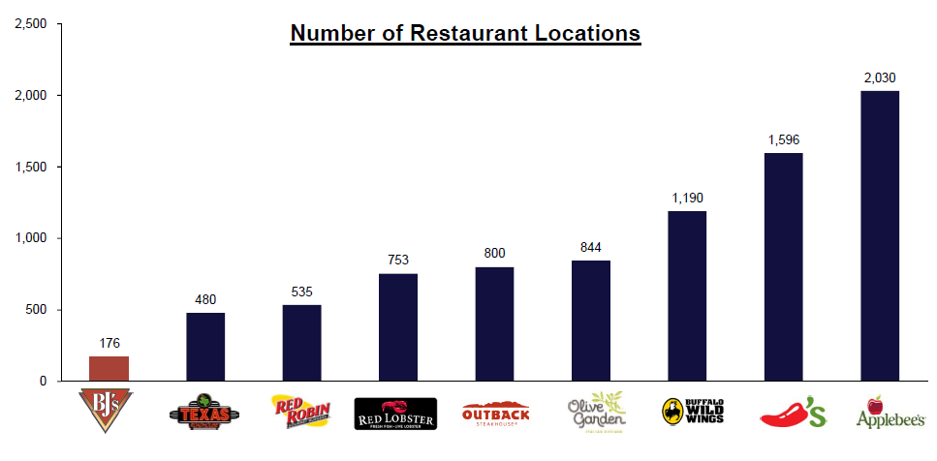
Action Plan
- Strategic Alternative:
- Evolutionary Change:
- Revolutionary Change:

Options and Recommendation #1: Accelerate and diversify new location growth
Given BJ’s price point, food and beverage menus, and customer experience, alternative location strategy include leasing sites near large university campuses which are often year-round despite the school year and attract large groups; athletic venues such as baseball parks or football stadiums; or convention centers near hotels and entertainment districts. These three alternatives would avail BJ’s to a wider demographic of income and appetite for pizza and beer, while catering to groups of 3+ who typically share a pizza. Given BJ’s relatively small size relative to its competitors, at under 200 location and 20% of the median number of stores compared to its competitors, there is significant head room to expand and try alternative restaurant models.

Strategic Issue #2: Get Un-stuck from the Middle
As a business competing in a mature, saturated market, BJ’s Restaurants lacks aggressiveness in an overall competitive advantage. Its management focuses on food quality, low price point, and friendly atmosphere, but has seemingly gotten away from its “brewhouse heritage” (only two restaurants even brew beer). Moreover, pizza and beer together only account for 32-38% of its sales depending on the location (BJ's Restaurants, Inc. 2016).
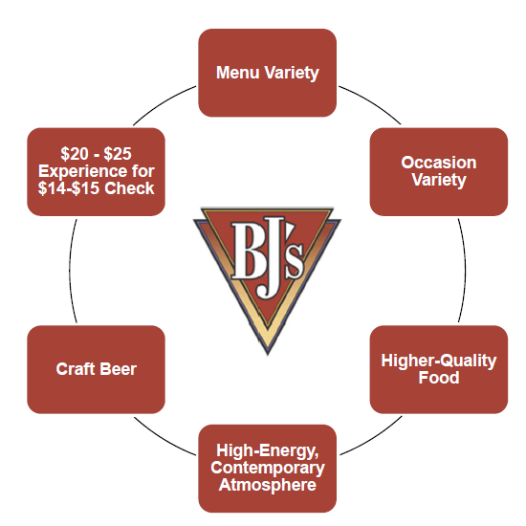
(BJ's Restaurants, Inc. 2016)
Conversely, BJ’s Restaurants have adopted strong discounting via coupons and promotions, while maintaining very high food and beer quality standards, expanding its menu to include organic and vegan options, and friendly atmosphere. As a result, BJ’s average guest check of $14 is less than the median average of $14.60 compared to twelve direct competitors (BJ's Restaurants, Inc. 2016), despite leading the industry in guests per square foot of space.
In short, BJ’s lacks strategic differentiation and therefore has difficulty distinguishing its brand from other pizza, brewery, or any other upscale casual restaurants. Which is it: value dining or a high quality experience? While BJ’s product maintains a mass market appeal, greater value differentiation and/or focus is necessary to get out of the mediocre “middle.”
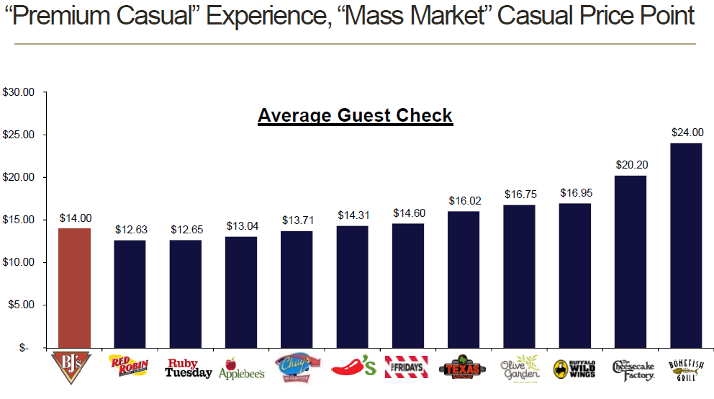
(BJ's Restaurants, Inc. 2016)
BJ’s benefits from very high foot traffic, but unremarkable guest check levels. As a result, they have an enviable opportunity to increase its value to the customers and differentiate itself from competitors to reverse the -2% decrease in year-over-year comparable restaurant sales.

Action Plan
- Strategic Alternative:
- Evolutionary Change:
- Revolutionary Change:

Options and Recommendation #2
- BJ’s could leverage its roots in beer and focus on the brewery appeal of its product. This would entail investing in people, supply chain, and facilities to improve the quality of its craft beer, and its output capabilities. Alternatively, BJ’s could also consider vertical integration by acquisition of a regional craft brewery or a engage in a licensing agreement with a craft beer which would complement the BJs missions statement, values, and experience.
- Skinny-down the menu: BJ’s should focus on their trademark food products of deep dish pizza, beer, and its famed “pizookies”. This is what they are known for and what they are very good at replicating every location, every visit. The current menus is nearly 16 pages with hundreds of items. We suggest BJs not attempt to cater to too wide of a mass market, which it does by introducing organic or vegan “healthy” options in 2016 (BJ's Restaurants 2016). These frankly do not pair well with beer! Moreover, current trends in nearly all sub-segments of the restaurant industry are trimming the menu to focus on the food. Restaurant chains in 2014, including Tony Roma’s, IHop, Ruby Tuesday, and Olive Garden all reduced the number of food items. Moreover, according to data from Datassential as published in the Washington Post, new restaurant openings in 2013-2014 had nearly 40 fewer items on average on their menus, than established ones the prior year. This has a positive impact on the consumer as it allows the restaurant chains to focus on quality, and gives the perception to the evolving U.S. consumer palate of specialization (Ferdman 2014).

Strategic Issue #3: Improve Employee Engagement and Performance
According to Sobieski during our interview, while his staff retention is better than industry average, he monitors staff performance entirely on a subjective basis: attitude, customer feedback, positive engagement with coworkers, etc. Moreover, wait staff are not trained on making “soft,” additional food recommendations, nor measured on customer interactions; and, the restaurant does not have initiatives for wait staff to drive higher margin items. We believe improved tracking of financial metrics, items sold, food quality scores, wait times, and other relevant data points would avail BJ’s to better improve quality, average guest ticket amounts, and net income.

Action Plan
- Strategic Alternative:
- Evolutionary Change:
- Revolutionary Change:
Recommendation #3: Use data and analytics to incentivize staff and promote products
BJ’s Restaurants should institute a system to measure staff performance that would provide a feedback loop to staff and management in real-time of critical factors that drive revenue, repeat customers, and employee satisfaction. Vendors such as Microsoft and IBM could assist with deploying the data and analytics retrieval and reporting features. Then, management can implement product or promotion strategies depending on the learnings and results. Employees can also be motivated to score the highest marks, for instance on the most pizookies sold or most customer compliments received. The insights would drive a culture of transparency and if used correctly, would positively enhance staff engagement, employee monetary incentives, and recognition.
Strategic Issue #4: Adapt to consumer trends in demand for delivery
Current industry trends for takeout and delivery methods of consumption are on the rise according to industry trade periodical, Nation’s Restaurant News (Maze 2017). Moreover, BJ’s takeout orders only account for up to 4% of their gross revenues, according to Sobieski. With 96% or more of its patrons dining in, this speaks volumes for the company: that its patrons want to stay at the establishment and enjoy the ambiance, food, beverage, and company. Nevertheless, it also points to a greater opportunity to capitalize on the growing trend for online and takeout demand. In 2017, BJ’s entered in to agreements with Uber and Grubhub to provide local delivery to customers ordering on their Smartphones, iPads, and computers (Grubhub, Inc. 2017). BJ’s Restaurants leverage its brand reputation in specialty deep dish pizza, dessert, and other appetizer items, and seek alternative takeout and delivery methods to increase same-store Year-over-Year sales, and average guest check revenues.
Action Plan
- Strategic Alternative:
- Evolutionary Change:
- Revolutionary Change:

Options and Recommendation #4: Develop new store model
In order to compete with the quick serve pizza competitors, BJs should develop a new “Quick Brew” store concept that is located in high density urban geographies, which focus on driving a higher percentage of delivery and takeout orders. This new layout would entail using a smaller footprint, but provide more bar-style and group seating. Equipment for these locations would enable higher and faster output of its signature deep dish pizzas as well as other popular pairing. Data and analytics could be used to derive learnings from the research and development phase. This would in turn, help refine the Quick Brew location format, and also benefit the existing BJ’s Brewhouses to ascertain times, staffing, promotion, and pricing necessary to compete in the growing off-premises consumption market.

ONE YEAR OPERATION PLANS

Example – Please fill in information for each KSI (Update highlighted areas)
KSI #1 Brand Expansion | Year one:Q1 | Year one:Q2 | Year one:Q3 | Year one:Q4
Action Step | - Research locations in states not currently operating in to potentially open  - Locate potential franchisees that would meet qualifications  - Locate local suppliers that would meet demands | - Sign up Franchisees  - Begin building restaurants  - Sign up suppliers that work well with the business  - Determine what dough facilities will be supplying dough to restaurants  - Begin marketing campaign to consumers | - Open restaurants  - Manage supply routes  - Monitor operations and collect data on consumers  - Continue Marketing campaign  - Monitor suppliers | - Check on operations and make improvements to new restaurants  - Look at new potential locations to continue expansion for the franchisee  - Continue Marketing  - Monitor suppliers
Accountable Party | Franchise approval team  Supplier approval team | Franchise approval team  Supplier approval team  Fresh dough management team  Building Project team  Marketing team | Operations management  IT  Marketing | Operations management  Marketing
Projected Cost | Low | High | Moderate | Moderate

Example – Please fill in information for each KSI (Update highlighted areas)
KSI #2 Food handling and safety | Year one:Q1 | Year one:Q2 | Year one:Q3 | Year one:Q4
Action Step | - Conduct analysis on food and determine timeline for spoilage  - Conduct analysis of food delivery trucks to determine how well they are operating | - Identify the food that could cause the most problems when it comes to spoilage  - Identify the delivery trucks that need maintenance and need to be replaced.  - Begin to develop plans to reduce these issues | - Implement plans (timelines) to remove spoiled items before they reach the consumer  - Perform maintenance on trucks that need it and purchase new trucks to eliminate trucks that are beyond maintenance  - Monitor actions to determine if there is an improvement in operations  - Monitor delivery trucks for maintenance | - Make corrections to plans for food as needed to improve operations.  - Maintenance trucks as needed and purchase new ones as needed.  - Continue to monitor operations to make sure no spoiled food reaches consumers
Accountable Party | Food Research team  Truck Maintenance team  IT | Food Research team  Truck Maintenance team  Operations management  IT | Food research team  Truck maintenance team  Operations management  IT | Food research team  Truck maintenance team  Operations management  IT
Projected Cost | Moderate | Low | High | Moderate

Example – Please fill in information for each KSI (Update highlighted areas)
KSI #3 Relationship with Suppliers | Year one:Q1 | Year one:Q2 | Year one:Q3 | Year one:Q4
Action Step | - Monitor prospective suppliers operations to purchase  - Conduct financial analysis on prospective suppliers to purchase  - Conduct analysis on operations of farms and ranches to better understand the industry  - Identify potential avenues of attaining money to perform the acquisition | - Attain Money to acquire supplier  - Continue to monitor potential suppliers to determine who to acquire  - Continue to conduct analysis on industry | - Identify the supplier(s) to be acquired  - Purchase the supplier(s)  - Begin operations and maintain current management team of supplier to run operations  - Develop a plan of which restaurant locations will be supplied from these newly acquired supplier(s) | - Begin to utilize acquired supplier(s) only for restaurant identified in Q3  - Monitor operations to determine how well operations are running at suppliers and how well restaurants are being supplied  - Identify new local supplier(s) for acquisition for other restaurant locations
Accountable Party | Operations Management  Financial Department  IT | Operations Management  Financial Department  IT | Operations Management  Financial Department  IT | Operations Management  Financial Department  IT
Projected Cost | Moderate | High | High | Moderate

Example – Please fill in information for each KSI (Update highlighted areas)
KSI #4 High Prices for Premium Products | Year one:Q1 | Year one:Q2 | Year one:Q3 | Year one:Q4
Action Step | - Continue strong marketing campaign explaining what Panera Bread is about, what commitments they have made towards food, and what avenues Panera will pursue to continue to improve its food quality and freshness | - Perform research to further back Panera Bread’s initiatives to better quality and healthier food.  - Continue Marketing Campaign | - Continue Marketing Campaign and include the research to back why it is beneficial to eat Panera Breads food. | - Monitor if the Marketing Campaign has helped bring more customers to the stores and improved sales.  - Continue Marketing campaign
Accountable Party | Marketing Department | Marketing Department  Research Department  IT | Marketing Department | Marketing Department  Research Department  IT
Projected Cost | Moderate | High | Moderate | High

Summary and Conclusion

APPENDIX

BJ’s Restaurants Employee Interview
Our research of BJs was augmented by an interview conducted with BJs employee, Patrick Sobieski on October 26th, 2016. Patrick has worked at BJs for fifteen years, starting his career at the Brea, CA location as a Host. He rotated through several positions as Takeout Host, Server, and Trainer. Then, he moved to three additional stores throughout California, including West Covina, Corona, Rancho Cucamonga, and La Mesa, assuming greater location leadership responsibility. Today, he is General Manager of the Akron, Ohio restaurant which opened as a new location in 2016. His store is approximately 7,000 square feet and can hold 230 patrons. This location was built from the ground-up as part of BJ’s organic growth strategy, using a 15% smaller footprint to increase margins by increasing average unit volume (AUV) for each restaurant.
During the interview, Patrick validated several current strengths and weaknesses. First, his location is located across from a movie theater complex and caters to movie-goers. This is consistent with BJ’s location strategy to locate near malls and movie theaters. According to Patrick, BJs avoids over-saturating a geographic area such that they are no closer than approximately 20 minutes driving time from each other. Second, 90% of the beer sold is BJs beer on tap, not other craft brews. This beer is centrally brewed in one of three breweries in TX and CA—not on-site as formed at the original restaurant in Brea, CA. Third, the BJs Loyalty Program is new and evolving; this is an area on which he focuses in order to enhance the guest experience, give the waiter or waitress information on allergies, preferences, etc. and to drive promotional coupons. Fourth: there is no structured staff performance matrix or staff incentives; while Patrick’s first priority is hospitality and guest experience, there is no formalized or measured employee performance system in place. Fifth, the menus constantly change for seasonal and promotional reasons. This is both an advantage to trying to increase return guests, but also a hindrance for expenses, training staff, and the burgeoning menu size. Sixth, the coupons work. Patrick has a noticeable increase in sales when the corporate office targets customers with appetizer discounts and “B.O.G.O.” offers.
Utilizing the SWOT and TOWS analysis, and incorporating the Sobieski interview and firm research, we have developed four key strategic issues which we believe BJ’s Restaurants could undertake as a strategic priority in order to improve its long-term competitive advantage.

References
Albrecht, C., Holland, D., & Peters, M. (2016). Strategic revenue analysis. Strategic Direction, 32(7), 32-34.
BJ's Restaurants. 2016. "Annual Report."

BJ's Restaurants, Inc. 2016. "BJ's Restaurants." Oppenheimer & Co 16th Annual Consumer Conference Presentation. June. Accessed November 2, 2017. http://investors.bjsrestaurants.com/phoenix.zhtml?c=99411&p=irol-presentations.
Burke, W. W. (2017). Organization change: Theory and practice. Sage Publications.
Dess, G., McNamara, G., Eisner, A. (2016). Strategic Management: Text & Cases (8th Edition)
Ferdman, Roberto. 2014. "Americans are tired of long restaurant menus." Washington Post, September 18.
Grubhub, Inc. 2017. "Grubhub Partners with BJ's Restaurant & Brewhouse® to Provide Online Ordering, Delivery and Corporate Catering for 100 Restaurant Locations Nationwide." October 16.
Kianto, A., Ritala, P., & Vanhala, M. (2014). The interaction of intellectual capital assets and knowledge management practices in organizational value creation. Journal of Intellectual Capital, 15(3), 362-375.
Lee, W. S., Lee, W. S., Kim, I., Kim, I., Moon, J., & Moon, J. (2016). Determinants of restaurant internationalization: an upper echelons theory perspective. International Journal of Contemporary Hospitality Management, 28(12), 2864-2887.
Maze, Jonathan. 2017. "As delivery grows, casual dining tries takeout-only restaurants." Nation's Restaurant News, November 4.
Restrepo, B. J. (2017). Calorie labeling in chain restaurants and body weight: evidence from New York. Health economics, 26(10), 1191-1209.
Sheel, A. (2016). 2016-A Year in Review for Restaurant Firms.
Seo, S., & Jang, S. S. (2013). The roles of brand equity and branding strategy: a study of restaurant food crises. International Journal of Hospitality Management, 34, 192-201.

