Cost
The significance in aviation maintenance cost is a high priority in the aviation industry. The goal of aviation maintenance is to service an aircraft and do it at minimum cost. Organizations need to have budget plan and know certain costs that money is being spent on. Depending on the aircraft, maintenance costs will vary. Some of those factors could be the age on the aircraft or how often it is used. There needs to be a good understanding of any possible problems that can occur, as aircraft upkeep is continuing. In the early stages of an aircraft, maintenance is foreseeable. However, an older aircraft maintenance costs are expected to rise since the structure is maturing. There is much more though to an aircraft than just fixing an aircraft. It also involves the equipment, facility, supplies, and overhead. Maintenance costs will vary on the age of the aircraft, the supplies and equipment needed, and labor. IATA’s MCTF FY2014 presented that 48 airlines reported for direct maintenance cost of $15 billion and 41 airlines reported maintenance overhead of $2.5 billion. (IATA’s Maintenance Cost Task Force, 2015, p. 21). Direct maintenance cost involves the labor and material costs that directly goes into performing the maintenance. Factors that influence direct maintenance costs are design and environmental factors and 70 to 85 percent of those costs are determined in the design factor. “The design of an aircraft depends on many factors such as customer and manufacturer demand, safety protocols, physical and economic constraints etc. Minimizing the cost to support an aircraft and maximizing the availability of that aircraft are best done by designing the product to be reliable and maintainable.” (PeriyarSelvam, Tamilselvan, & Shanmugaraja, 2013). Another cost is indirect maintenance cost. Overhead is a component of indirect maintenance cost work and while it does not work directly with maintenance but it contributes to the overall cost of it. The use of maintenance, repair, and overhaul organizations (MRO) is important to an aircraft operator as it breaks down labor and material parts.
There are methods and goals to cut down direct maintenance costs which was introduced by Boeing. In 2005, Boeing searched approaches to better understand maintenance costs, the factors that drive high costs, and how their costs compare to those of other operators (Buyers, n.d.). Even in the 21st century, there were no methods in tracking and reporting maintenance costs. Within an organization, there needs to be a balance between maintenance requirements and availability to optimize the cost of maintenance. With the use of Technical Operations Performance Improvement and Cost Solutions (TOPICS), this led to the first meeting with Boeing, airlines, suppliers and maintenance, repair, and overhaul facilities (MRO) to discuss the financial impact on aircraft maintenance and look for opportunities to improve cost. They discussed what goals and improvements could be achieved. For example, airlines can gain a better understanding of fleet maintenance economics (Buyers, n.d.). They also examined the use of benchmarking maintenance costs and where to make cost reductions.

Figure 1
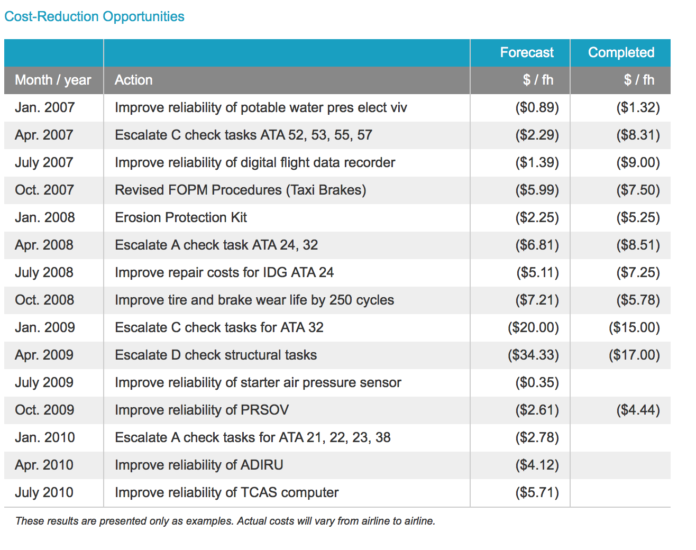
Retrieved from http://www.boeing.com/commercial/aeromagazine/articles/qtr_01_10/2/
Boeing created questionnaires for airlines, suppliers, and MRO organizations to help understand and reduce maintenance costs. They will analyze all the costs in maintenance and what drives those costs up. It is inputted into the TOPICS maintenance cost modeling tool and each report is provided showing how their maintenance costs are compared to the industry in various categories (Buyers, n.d.). Below is a graph of how TOPICS is used to lower maintenance costs for scheduled maintenance checks. “In 2007, the airline discovered that its costs were more than 100 percent higher than the TOPICS industry average for those maintenance events.” (Buyers, n.d.). This resulted in over a $4 million annual savings for this airline. The use of benchmarking will help set performance improvements, identify opportunities in specific areas, and monitor the company’s performance.
Figure 2
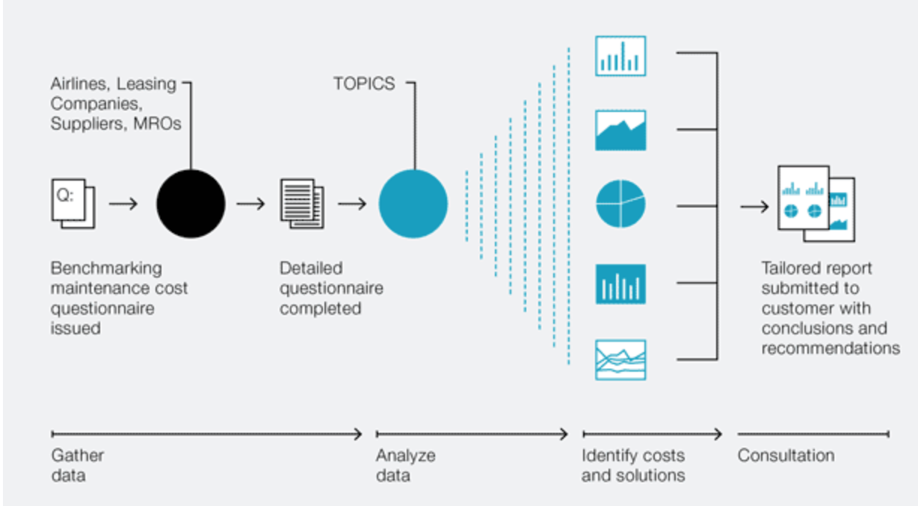
Retrieved from http://www.boeing.com/commercial/aeromagazine/articles/qtr_01_10/2/
With Boeing taking on TOPICS and offering benchmarking to provide the best procedures and solutions, there are challenges with the aging aircraft. “By December 20, 2010, airlines that operate airplanes under Title 14 of the Code of Federal Regulations (CFR) 121 or 129 must revise their U.S. Federal Aviation Administration (FAA)-approved structural maintenance program to comply with the FAA’s Aging Airplane Safety Rule (AASR)” (Pillo & Hoggard, n.d.). The importance to of understanding the costs associated with aging aircraft and how to maintain those costs efficiently. Older aircrafts tend to be noisier and less fuel efficient, which in turn is more expensive to operate. Once the aircraft manufacture warranty expires, additional costs to maintain that aircraft adds up. However, by understanding the costs, implementing a maintenance program, and understanding if the aircraft is airworthiness will affect the longevity of its performance. Some issues regarding aging aircraft involves metallic corrosion and structural fatigue. Metallic corrosion is the deterioration of chemical attack and can take place internally and on the surface. If left unchecked, it can cause structural issues. “Water or water vapor containing salt combines with oxygen in the atmosphere to produce the main source of corrosion in aircraft” (Chapter 6: Aircraft Cleaning and Corrosion Control, 2008). This can change the strength of the metal, which leads to cracks and eventually the part fails.
After December 20, 2010, airline operators must address the new repairs to fatigue serious structure and receive a damage tolerance evaluation. “The AASR requires operators to have a damage-tolerance-based structural maintenance program for each applicable transport category airplane operated in 14 CFR 121 and U.S.-registered airplanes operated in 14 CFR 129” (Pillo & Hoggard, n.d.). With Boeing’s help, they have developed approved FAA methods to help airline operators meet the requirements of this plan. First, operators need to demonstrate their understanding in this plan. They are required to identify repairs and alterations that will require damage tolerance inspections, obtain the inspection data and perform the needed inspections, and perform surveys of airplanes to determine whether existing repairs will require damage tolerance inspections (Pillo & Hoggard, n.d.). Boeing participated in the Airworthiness Assurance Working Group (AAWG) to help spread awareness of compliance issues through implementing a maintenance program. The development of the Advisory Circular 120-93 by AAWG was published and Boeing held a Structure Task Group (STG) that would create the documents for operators to use in their plan. Below is the plan that is approved by the FAA maintenance inspector.

Figure 3

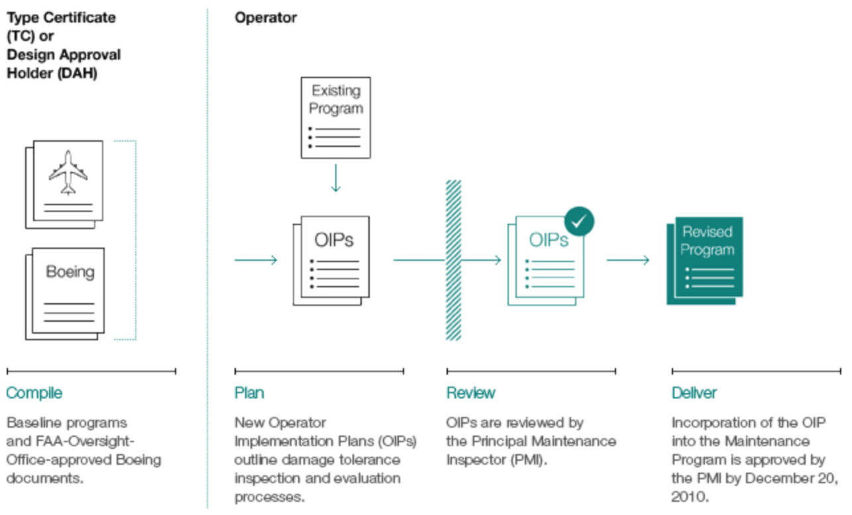
Retrieved from http://www.boeing.com/commercial/aeromagazine/articles/qtr_02_10/3/

References
Buyers, T. (n.d.). AERO - Optimizing Airplane Maintenance Economics. Retrieved from http://www.boeing.com/commercial/aeromagazine/articles/qtr_01_10/2/
“Chapter 6: Aircraft Cleaning and Corrosion Control.” Aviation Maintenance Technician Handbook - General, www.faa.gov/regulations_policies/handbooks_manuals/aircraft/amt_handbook/media/F A-8083-30_Ch06.pdf.
IATA’s Maintenance Cost Task Force. (2015, December). AIRLINE MAINTENANCE COST EXECUTIVE COMMENTARY [PDF]. Iata.
PeriyarSelvam, U., Tamilselvan, T., Thilakan, S., & Shanmugaraja, M. (2013). Analysis on Costs for Aircraft Maintenance. Advances in Aerospace Science and Applications., 3, 177-182. Retrieved from https://www.ripublication.com/aasa/aasav3n3spl_08.pdf.
Pillo, R. M., & Hoggard, A. (n.d.). AERO - Complying with the Aging Airplane Safety Rule. Retrieved from http://www.boeing.com/commercial/aeromagazine/articles/qtr_02_10/3/
Saltoglu, R., Humaira, N., & Inalhan, G. (2016). Scheduled Maintenance and Downtime Cost in Aircraft Maintenance Management. World Academy of Science, Engineering, and Technology International Journal of Aerospace and Mechanical Engineering, 13(3), 602 607. doi:10.1109/icmae.2016.7549592

