Running Head: BEST BUY STRATEGIC ANALYSIS



Organizational Analysis of Best Buy

March, 2015
Table of Contents
Current Situation 3
Strategic Posture 4
Strategic History 4
Organizational Mission and Vision 7
Current Business Level Strategy 7
Environmental Analysis 9
Strategic History of the Industry 9
Five Force Model 11
Industry Segment Analysis 26
Conclusion 37
Internal Analysis 40
Value Chain Analysis 40
Financial Analysis 54
Core Capabilities and VRIO Analysis 81
Organizational Structure and Culture Analysis 87
SWOT Analysis 92
TOWS Analysis 104
Strategic Direction 110
Key Strategic Issue #1 – Enter Luxury Electronics Market 110
Recommendations and Justifications. 113
Key Strategic Issue #2 – Increase Private label Brands 113
Recommendations and Justifications. 116
Key Strategic Issue #3 – Improve Inventory Management 116
Recommendations and Justifications. 120
Action Plan 120
Action Plan for Key Strategic Issue #1: Alternative 1- Status Quo: Luxury Electronics Market 120
Action Plan for Key Strategic Issue #2: Alternative 3 - Revolutionary Change: Expansion 122
Action Plan for Key Strategic Issue #3 – Alternative 3 Revolutionary Change 123
Appendix 126
Table A 126
Table B 126
Interview Transcript 127
References 130

Current Situation
Today, Best Buy is regarded as a “multi-national, multi-channel retailer of technology products and technology services” (Best Buy 10k, 2014). Best Buy operates in the U.S, Canada, and Mexico with more than 1,400 locations employing 140,000 employees (Best Buy 10k, 2014). In the U.S it is reported that more than 70 percent of Americans live within a 15-minute radius of a Best Buy location (Bestbuy.com). The U.S accounts for 85 percent of its total sales (Hoovers, 2015). Domestic segments consist of locations in the U.S which operates under: “Best Buy, Best Buy Mobile, Geek Squad, Magnolia Audio and Pacific Sales” (Best Buy 10k, 2014). Depending on the surrounding market, Best Buy determines which brand to operate their store-within-a store strategy (Best Buy 10k, 2014).
Best Buy offers their services through three primary channels, which include brick and mortar locations, online retailing, and call center locations (Hoovers, 2015). In addition to electronics, Best Buy offers in-home installation, car audio installation, technical support both in-home and onsite, mobile services and Internet services (Hoovers, 2015). Consumers often view the technology and services offered by Best Buy as essential or discretionary purchases (Best Buy 10k, 2014). Its business is seasonal, as most of their profits are generated in the fiscal fourth quarter, which is during the U.S, Canada, and Mexico holiday season.
As of 2014, Best Buy completed its first fiscal year implementing the new business strategy Renew Blue (Best Buy 10k, 2014). The transformation has been geared at overcoming previous fiscal year challenges. Best Buy has been suffering from declining sales and profit margins. CEO Hubert Joly determined that Best Buy would change their strategic direction to “five pillars” which include:
“1) Reinvigorate and rejuvenate the consumer experience 2) Attract grow engage and Inspire transformational leaders and employees 3) Work with vendor partners to innovate and drive value 4) Increase our Return on Invested Capital 5) Continue our leadership role in positively impacting our world” (Best Buy 10k, 2014).
With the five pillars in mind, the 2014 implementation of Renew Blue will focus on “igniting the possible”. Best Buy will direct focus on its core strategy of becoming the authority and designation for the latest and greatest technology (Best Buy 10k, 2014).

Strategic Posture

Strategic History
Since its humble beginnings in St. Paul Minnesota as the Sound of Music, Best Buy has transformed into a consumer driven consumer electronics outlet both domestically and internationally (Hoover’s, 2014). The start of its transformation into a major electronics retailer began in 1989, where it revolutionized the “grab-and-go” store format (Best Buy 10k, 2014). This “grab-and-go” experience was implemented through a non-commissioned warehouse-style environment (Best Buy 10k, 2014). Consumers were able to shop in a faced paced environment without sales driven employees to impede their choices. This revolutionary store format assisted in the unprecedented growth of Best Buy in 1993; as it became the second largest consumer electronics retailer in the nation (Best Buy 10k, 2014). Throughout its history Best Buy has positioned itself through key strategic events.
One move that Best Buy used to develop its growth was through its partnerships with its vendors. The first partnership that took place was with Microsoft in 1999 (Best Buy 10k, 2014). Microsoft and Best Buy agreed to cross-promote their products (Best Buy 10k, 2014). This allowed for an increase in sales for both companies by efficiently meeting the needs of consumers. In 2013, Best Buy grew their partnership with Microsoft by launching a store-within-a-store strategy. Microsoft centers were opened in 500 U.S. Best Buy locations and 100 in Canada (Gillian, 2013). This partnership was also created with Apple and Samsung. Samsung opened 1400 centers in Best Buy U.S (Gillian, 2013). The store-within-a-store strategy created mini stores within Best Buy that employed Apple, Samsung, and Microsoft representatives (Gillian, 2013). These employees were aimed to meet the needs of each vendor. The strategy is to bring consumer into Best Buy while booting the sales of the vendors (Gillian, 2013). In turn this would assist in revenue growth for Best Buy while creating a strategic alliance.
In order to reach new heights, Best Buy evolved with the fast-paced online retailing business in 2000 (Best Buy 10k, 2014). They launched Bestbuy.com as a wholly owned Internet subsidiary to Best Buy Inc, in order to stay competitive with e-commerce business. Bestbuy.com was leveraging features of its parent company in order to create a differentiated service (PR Newswire, 2000). It developed the system that was, “reliable, timely, and cost effective product deliveries for its consumers (Business Wire, 2000). The launch of Bestbuy.com created a convenience for consumers through delivery and in-store pickup of all products that are provided in-store. Additionally, BestBuy.com offered live consumer care in order to meet the needs of consumers that were having issues (Business Wire, 2000). During inception, Bestbuy.com was aimed at positioning itself to seize the market leadership (PR Newswire, 2000). However, online retailing has been an obstacle that they are trying to overcome.
In 2002, Best Buy acquired the residential consumer business, Geek Squad (Business Wire, 2002). The 24-hour task force was aimed to bring in computer services into Best Buy locations and to consumer’s homes (Business Wire, 2002). Geek Squad services of in-home installation, in-store services, and car audio installations have become the core strategy of Best Buy (Crosby, 2010). Best Buy differentiated itself from competitors by joining forces with Geek Squad; offering technological support that competitors did not. To date, there are more than 20,000 Geek Squad agents that have represented a unique competitive advantage (Lee, 2013). Geek Squad has now been referred to as the public face of Best Buy building its brand recognition and consumer loyalty (Lee, 2013).
In 2013, Best Buy changed its strategic direction from expanding into new markets to narrowing its existing markets in order to gain higher efficiency. After its rapid expansion from 2003 to 2011, Best Buy decided to leave the European Market by selling their stake in a partnership with Carphone Warehouse Group (Hsu, 2013). The European exit was done in order to simplify operations, strengthen its balance sheet and improve returns (Hsu, 2013). According to CEO Hubert Joly, this change in strategic direction was the start of Best Buy’s turnaround strategy. In order to stay competitive Best Buy was, “slashing its workforce, shrinking store sizes and matching online prices” (Hsu, 2013).
Best Buy launched a new business strategy in 2012 and fully implemented the business strategy called Renew Blue 2014 (Best Buy 10k, 2014). Renew Blue strategy was brought to light by CEO Hubert Joly in 2012, “he was coming in at a critical moment, stabilizing the company while making considerable progress on a comprehensive plan to return Best Buy to sustained, profitable growth” (Hsu, 2012). The Renew Blue strategy was aimed to implement strategic initiatives to assist in helping Best Buy thrive (Best Buy 10k, 2014). It is a multi-year strategy, which focuses on operational performance, growth strategies, and creating differentiation for consumers and vendors (Best Buy 10k, 2014). Hubert Joly stated that the Renew Blue strategy enhanced how it served consumers and built key foundational capabilities for its future (Best Buy 10k, 2014).

Organizational Mission and Vision
Best Buy has a mission that is directed toward its consumers and vendors. It strives to “enrich and empower people’s lives through technology” while “partnering with vendors to market their products and solutions in a highly effective fashion, providing the best online and in-store showrooms” (Best Buy 10k, 2014). Best Buy aims to serve consumers by “helping consumers discover, choose, purchase, pay for, finance, activate, use, enjoy and eventually recycle technology products and solutions” (Best Buy 10k, 2014).
Best Buy has a vision for its “expert service, unbeatable price” (Best Buy.com). It aims to serve its consumers by creating a difference in their lives (Best Buy 10k, 2014). Hubert Joly, expresses the Best Buy journey “to become the leading multi-channel retailer in the country: one that makes promoters out of its consumers; attracts, develops, and rewards outstanding leaders and associates; partners effectively with key vendors; and provides attractive returns on its inventors “ (Best Buy 10k, 2014). The vision of the Renew Blue strategy is aimed to “focus on stabilizing and improving comparable store sales and increasing profitability” (Best Buy 10k, 2014).

Current Business Level Strategy
The three generic strategies presented by Michael Porter assist organizations in achieving a competitive advantage (Dess et al., 2014). The three generic strategies presented by Porter include: differentiation, overall cost leadership and focus strategy (Dess et al., 2015). It has been suggested that when an organization adopts more than one of these generic strategies there is a tendency for it to outperform rivals who do not adopt any generic strategies (Dess et al., 2104).
It has been determined that Best Buy’s has focused their strategic direction of generic strategies to differentiation. In order to stay competitive in the saturated industry of U.S Consumer Electronics, Best Buy must set itself apart while attempting to achieve above average returns. Pricing and affordability have a bigger impact on consumers purchasing decisions (Lin, 2014). Therefore, Best Buy integrated cost leadership with their differentiation strategy
In regards to differentiation, Best Buy has focused its efforts on creating a unique experience that is valued by consumers. Best Buy has been dedicated to delivering high quality consumer experience that is different from many of their competitors who focus on low cost operating structures (Best Buy 10k, 2014). With consumer experience as a fundamental driver, Best Buy’s differentiation strategy is considered to be unique. It focuses on the knowledge of their human capital, integrated online and store channels, variety of products, service and support offerings, distinct store formats, brand recognition (Best Buy 10k, 2014).
Due to the differentiation advantages offered by Best Buy, they have been able to offer price premiums for their Geek squad services which have compensated for the costs incurred by their differentiation (Lin, 2014). Best Buy has leveraged their distinct competitive advantage through their Geek Squad services. This service is not offered by competitors and has provided Best Buy with the key opportunity to deliver superior experience for consumers. The brand loyalties consumers have experienced with Geek Squad services have provided a protection against rivalries within the industry.
Best Buy’s differentiation strategy has created a uniqueness that is valuable. There differentiation has not diluted the brand identification within the industry. Additionally Best Buy has created parity with overall cost leadership. Price is also the primary importance to its consumer segments and price transparency and comparability is increasing (Best Buy 10k, 2014). Therefore, Best Buy has increased price competitiveness by offering “low price guarantee” (Best Buy 10k, 2014). In order for effective implementation of the low price guarantee, Best Buy has to maintain efficient operations and leverage its economies of scale (Best Buy 10k, 2014).

Environmental Analysis

Strategic History of the Industry
In order to provide a broader perspective on the U.S Consumer Electronics Industry, a strategic history must be taken into consideration. In the U.S Consumer electronics industry, the American first movers were in the 1920’s, which consisted of General Electronics, RCA, Philco and Zenith (Chandler, 2001). The retailing of electronics usually took place in family-run businesses between the 1920’s to late 1940’s (Smyyth, 2011). Since its conception, the demand for consumer electronics has been driven by innovation and value (Chandler, 2001). This sparked a growth in industry consolidation between 1990-2000. Major chains in the industry were getting larger (Smyyth, 2011). Currently, consumer adoption of the latest and greatest technologies is occurring faster than at any other time in history (Encyclopedia.jrank.org).
The largest transformation of technology was the MP3 handheld music devices. The ability to download music files from the Internet to a handheld device altered music distribution in a very short amount of time (Encyclopedia.jrank.org). Digital satellites systems and digital video is another innovation that was widely adopted in a short amount of time. (Encyclopedia.jrank.org). It has been suggested that “early adopters” of technology have caused consumer electronics to grow and innovate in the final 20 years of the twentieth century (Encyclopedia.jrank.org). One of the most important trends in the U.S. Consumer Electronics & Appliances Retail Industry is the convergence of telecommunications and computing. Internet service on computers, mobile phones with email, and televisions with Internet are examples of the power of telecommunications with computing (Encyclopedia.jrank.org). Moving from wired technologies to wireless technologies is another example of the ever-changing technology.
The competitive landscape in the industry is dependent on replacement and upgrade products that are driven by demand (Hoovers, 2015). In order for individual organizations to remain competitive in U.S consumer electronics, it is imperative that the organizations are able to generate traffic and repeat business (Hoovers, 2015). Circuit City and Comp USA are only a few of the retailers that succumbed to the pressures of demand and changes of the industry landscape (Chang and Zimmerman, 2009). Circuit City was the nation’s second largest consumer electronics chains; its 2009 bankruptcy filing was one of the largest in the industry history. With the demise of the second largest consumer electronics retailer, many industry competitors still faced fierce competition from the online retailers.
It has been suggested that the fastest growing frontier in U.S consumer electronics is Internet retailing (Smyyth, 2011). Online retailing has consumed the industry at a rapid rate. The practice of consumers browsing products in a brick-and-mortar location only to buy them online is cutting into sales (Hoovers, 2015). This show-rooming effect has affected the industry on a large scale. In order to combat this type of competition, retailers have adopted online price matching and developed unique products and SKUs (Hoovers, 2015).
Another avenue in which the industry has struggled with is the significant decline in retail prices. For example, between 2009 and 2013, the average price for a television declined by 50 percent (Hoovers, 2015). Compensating for the decline in price is dependent upon growth in volume, which proves to be difficult. In order to address these price declines, the industry must focus on business trends. These trends include a growth in wireless and mobile segments, the expanding use of electronic media and the transition to digital technology is an opportunity (Hoovers, 2015). Although Internet retailing is said to take over the brick and mortar locations; “The gravitation of communications-related software and hardware away from analog and toward digital will continue to drive the consumer electronics industry” (Encyclopedia.jrank.org).

Five Force Model
The use of Porters Five Forces Model is necessary when a retailer is determining its potential profitability and competitiveness in its Industry. This next area will discuss the competitive landscape in the Industry, using Porter’s Five-Forces Model. We will explore: threat of new entrants, bargaining power of buyers, bargaining power of suppliers, threat of substitute products and services, and intensity of rivalry among competitors in the Industry.
Threat of New Entrants - Low
Threat of New Entrants LOW | High | Low
Economies of Scale | X
Product differentiation | X
Capital Requirements | X
Switching costs | X
Access to distribution Channels |  | X
Incumbents proprietary knowledge | NA
Incumbents access to raw materials | NA
Incumbents access to government subsides | NA

Economies of scale. In the U.S. Consumer Electronics & Appliances Retail Industry, highly competitive retailers saturate the U.S. market. There are reported to be 50,000 stores, with 70 percent of sales coming from the 50 largest retailers (Hoovers, 2015). Additionally, the Industry averages 100 billion dollars in sales (Hoovers, 2015). The statistical data shows that any new entrant will have to generate enough capital to enter the market at a large scale in order to have a cost advantage (Hoovers, 2015). A new entrant would be at a cost disadvantage if it entered the market at low scale. It would not be able to gain the supplies necessary at a reasonable price in order to compete with the stiff competition.
Product differentiation. Major retailers in this Industry have strong brand recognition with consumers. Consumers are aware of the veterans in this Industry and have developed consumer loyalty to these retailers. When consumers have been provided with exceptional product and services, they are more inclined to continue to shop at that retailer. The differentiation of these products and services provided by retailers in this market create a high barrier to entry. A new entrant would have to invest a tremendous amount of marketing and advertising in order to create brand recognition. Additionally, new entrants would have to cut costs of products in order to become attractive to consumers that are loyal to other retailers.
Capital requirements. In order to enter this Industry, the capital requirement would be extremely high. A new entrant would have to consider start up costs, real-estate costs, inventory costs, and marketing costs. The new entrant would have to provide a substantial amount of capital in order to open a store. Some locations in the Industry range in size from 30,000 square feet to 1,500 square feet (Hoovers, 2015). Not only would the new entrant have to open locations of this scale, it would also need to have a separate distribution center to house the large products. This would be the only way the new entrant would be able to keep up with demands of products.
However, some retailers have forgone the cost of physical locations by selling its inventory online. This would be a way to cut cost for new entrants, yet many consumers still prefer to buy major purchases in person. The suppliers to this Industry would also be unlikely to sell its products to a new entrant, in the fear that it would not generate profit. Additionally, building an inventory would also be costly. Major product segments include televisions, laptops, tablets and major household appliances (Hoovers, 2015).
Switching costs. In this particular Industry, switching costs are low when a buyer switches from one retailer to another. This is largely due to the fact that consumers see the major retailers in this Industry as equal. However, in the case of a new entrant, it would have to encourage consumers to switch to buying products from the major retailers to them. As started previously, consumers in this Industry have loyalty to the major retailers. They know what they are getting from the retailer in terms of products and services. In order to attract loyal consumers, the new entrant would have to slash prices and provide exceptional service in order to entice the consumer to switch.
Access to distribution channels. The access to distribution channels for new entrants would be extremely low. Large suppliers already have agreements with current retailers in this Industry. The lack of capital investments and economies of scale play a role in the inability to replicate efficient supply chains in the Industry. Majority of suppliers also depend on sales of large brick and mortar locations to generate large profits. Suppliers such as: Apple, LG, Sony, and HP are some of the suppliers that work with the retailers in this Industry (Hoovers, 2015) Therefore, it is unlikely that a new entrant would get access to these products without providing incentives for the supplier. Incentives or risky agreements could impede profits for the new entrant. The shortened life cycle and high cost of out-dated inventory would also prove to be difficult for new entrants (First research, 2015).
Conclusion
All things considered, it is evident that the threat of new entrants is low. New entrants would be competing with large retailers and would have a problem attracting and retaining consumers. Additionally, the major competitors capture 70 percent of Industry sales, further proving that the new entrant would have to come in at a large scale in order to compete. Even so, major retailers may retaliate in order to push the new entrant out. Existing retailers can accomplish this by cutting prices, increasing advertising, or creating loyalty programs for their consumer base. With competitors in the Industry such as Wal-Mart, existing retailers are finding it difficult to compete on price alone. Another issue that the consumer electronics Industry is facing is the showroom effect. Consumers are going to local brick and mortar locations in order to see products before they buy online. This is a benefit to online retailers such as Amazon, but it would still affect new entrants who are attempting to open physical locations. This showroom phenomenon is said to be affecting the growth of the Industry (Hoovers, 2015). Therefore, a new entrant would not have the tools or capital necessary to compete.
Bargaining Power of Buyers - Moderate
Power of Buyers is Moderate | High | Low
Concentration of buyers relative to suppliers | X
Switching costs |  | X
Product differentiation |  | X
Threat of backwards integration |  | X
Extent of buyers profits | X
Supplier's input to quality of the buyer's final products | X

Concentration of buyers relative to suppliers. In the consumer electronics Industry there is not one consumer alone that has the ability to drive down the prices of a product or service. There are business consumers in the Industry that do buy in bulk which are able to negotiate prices. However, these consumers are not price sensitive (Hoovers, 2015). It is important to mention that word of mouth is as important to marketing as any other tactic (Tischler, 2004). Therefore, an unhappy consumer or consumers have the power to voice their opinions through social media avenues. These reviews have the potential to hurt sales and influence changes in the retailer and Industry. The consumers in the Industry as a whole do generate all of the sales in the Industry. That being said, in some cases one single consumer does have the ability to influence many other consumers.
Switching costs. As stated previously, there are reported to be 50 top retailers in this Industry (Hoovers, 2015). With these top 50 retailers capturing 70 percent of the market, it is evident that sales by these retailers are not difficult to attain. The switching cost of these consumers is extremely low. All major retailers have incorporated price matching into its policies (Hoovers, 2015). Its price matching policies make it easy for consumers to buy products from whichever retailer they choose. With these price-matching policies in place, the consumer does not feel locked into buying from one retailer. The consumer has the power to switch retailers at any point in time.
Product differentiation of suppliers. Since electronics and appliances are similar across all retailers in this Industry, product differentiation is extremely low. All products are similar and do not vary in quality. When one retailer no longer has a product, the consumer can easily choose from another retailer without the fear of losing a quality product. Consumers are always going to be able to find alternative retailers to purchase product from; making the product differentiation of the retailers very low.
Threat of backwards integration by buyers. The threat of backwards integration by consumers is low. A consumer would not be able to cause retailers to lose influence in the Industry, as they are not partially integrated in this Industry. Consumers’ ability to manufacture and supply their own electronics is unlikely.
Extent of buyer’s profits. The extent of a consumer’s income is relatively important to this Industry. The products that are being sold in the Industry are luxury products that are not a necessity. During the recession, retail growth was significantly down from 6 percent to 10 percent, from 2006 to 2009 respectively (Hoovers, 2015). In order to survive in this Industry during the recession, costs to the consumers had to be decreased. Nowadays, the U.S personal income rose 4.2 percent in 2014, allowing more households to purchase luxury electronics (Hoovers, 2015). Technology has revolutionized this Industry with more individuals needing to have the latest and greatest electronics, regardless of cost. U.S retail sales for the Industry also rose 2.9 percent, showing the demand for consumer electronics. Majority of the buyers in this Industry are early adopters to technology. These early adopters are said to spend more money on electronics and own more devices (Hoovers, 2015). Therefore, the extent of buyer’s profits is high.
Importance of an Industry’s input to quality of buyer’s final product. The quality of the product that is being sold is an important factor to the consumer. Consumers are investing in electronics and appliances due to the high cost. The products that consumers are purchasing for a high cost are expected to be quality. Consumers expect these products to be functional and last once they are purchased. Therefore, the input quality to the consumer’s final product is high. The extent of the quality of these products provided by consumers can be a determining factor of where they purchase the product, since majority of products in the Industry are homogeneous. However, the consumers in this Industry do want better quality products at a low price.
Conclusion
To address the issues of low product differentiation, retailers have tried to differentiate themselves by the service it is providing its consumers. Whether is it in store services, installation services, or expert advice, retailers are trying to increase switching costs and product differentiation to stay competitive. The buying power of consumers in this Industry is moderate. Consumers are more educated on electronics than ever before. There are also applications on phones that allow consumers to find product reviews and compare prices to nearby retailers. If consumers are not satisfied with the products or service they are getting from one retailer they have the ability to take their sale elsewhere at a zero switching cost. Since products in the Industry are considered to be luxury items, the Industry depends on consumer’s income in order to stay profitable. If the household income drops, so will sales. This in turn, causes prices in the Industry to fluctuate due to consumers.
Bargaining Power of Suppliers -Moderate
Bargaining power of Suppliers - Moderate | High | Low
Concentration relative to buyer Industry |  | X
Availability of substitute products |  | X
Importance of consumer to the supplier | X
Differentiation of the supplier's product and services |  | X
Switching costs of the buyer are | X
Threat of forward integration |  | X

Concentration relative to buyer Industry. This Industry is saturated with retailers and suppliers are concentrated in this Industry. The major suppliers in this Industry do not have much say in the influencing the prices, quality and terms (Dess et. al, 2014). Suppliers such as: LG, HP, Apple, Samsung, and Whirlpool rely on the Industry to sell items in mass quantities. Therefore the concentration of suppliers relative to buyers is low. However, if we are taking into consideration the top 50 retailers in this Industry, the ratio of suppliers to buyers in this Industry is high.
Availability of substitute products. In consumer electronics and appliances there are not many substitute products that are at the same level. Within itself, suppliers can compete with other suppliers for price and shelf space. However, in terms of supplier substitutes this is relatively moderate to low.
Importance of consumer to the supplier. The importance of the consumer to the supplier is high in this Industry. Suppliers rely on the sales of its inventory to these large retailers in order to gain profit. Majority of the suppliers do not sell its products to many other industries. If it is able to sell to other industries, the scope of its sales do not compare to the 100 billion dollar annual revenue of the consumer electronics and appliances Industry (Hoovers, 2015).
Differentiation of the supplier’s products and services. There is high market penetration for the products that are sold by the suppliers in this Industry (Hoovers, 2015). There is no differentiation between suppliers in this Industry. An example would be televisions; the only differentiator in televisions of the same specifications would be brand name or supplier name. Therefore, there is low differentiation between suppliers brand and other brands.
Switching cost of the buyer (retailer). The switching cost of the buyer is somewhat high in this Industry. Consumers prefer certain suppliers to other suppliers. Therefore, if the Industry were to cut off agreements with one of the major suppliers there is the potential to lose consumers. However large retailers in this Industry, such as Wal-Mart, decrease the switching costs. The one way in which switching costs are considered to be low is the lack of differentiation between the supplier’s products. As stated previously, majority of the supplier’s products are relatively similar, thus leading to lower switching costs.
Threat of forward integration. The threat of forward integration is moderate in this Industry. Suppliers such as Apple and Sony have opened its own retail locations housing only its products and third party suppliers. The thought behind this forward integration is to provide fulfillment of its loyal consumers. However, these stand-alone stores have proved to be difficult. Apple reported an 8 million dollar loss in its first quarter in 2002 (Saucerman, 2002). Sony also found it difficult to succeed in forward integration. Sony recently released a statement that it was “closing 21 of its 30 U.S stores” (Seitz, 2014). The threat of suppliers having power over the distribution of its products is not treating to this Industry due to the unlikelihood of success, but some suppliers are still taking the risk.
Conclusion
In sum, the purchasing power of the Industry allows larger retailers to negotiate the volume and prices with the suppliers (Hoovers, 2015). This further limits the supplier’s ability to negotiate terms of purchase. The more the retailer is able to bargain down prices the better discount the Industry can offer its consumers (Hoovers, 2015). The suppliers in the Industry have struggled with the declines in retail prices. Historically, suppliers have relied on the Industry’s increased volume to compensate for the prices it was giving to the Industry’s retailers (Hoovers, 2015). The switching cost and forward integration make the supplier threat moderate.
Threat of Substitute Products - Low
Threat of substitute products- LOW | High | Low
Differentiation of substitute products |  | X
Rate of improvement in price-performance |  | X

Differentiation of substitute products. In electronics and appliances there is not a variety of substitute products. Historically, the substitute products for technology would be books, magazines, and outdoor leisure activities. These substitute products serve the same purpose of fulfilling the needs of consumers. Nowadays, technology is being integrated into the everyday lives of consumers. Items such as magazines and books are now in the form of eBooks, further increasing the need for electronics. Outdoor activities have also been integrated with technology. There has been an increase in the use of wristwatches and fitness trackers for consumers (Hoovers, 2015). This wave of new technologies has eliminated the possibility of substitute products. Furthermore, there is no substitution for technology such as computers and tablets. Other industries influencing the prices and product sales that serve the same consumer need is very low.
Rate of improvement in price-performance relationship of substitute product. The pre-performance relationship of substitute products would be in the form of services. This Industry faces competition from warehouse chains that are able to lower its prices substantially. Internet retailers are also able to beat out the prices of retailers in this Industry by offering the same service of the product at a lower price.
Conclusion
The threat of substitute products is relative low in the consumer electronics and appliances Industry. There are no substitute products for electronics as a whole. The threat of substitute services is somewhat moderate. This is largely due to the fact that brick and mortar locations in this Industry face fierce competition from superstores, E-commerce, mass merchandisers, and warehouse clubs (Hoovers, 2015). The ability for consumers to shop from the comfort of their own home or at superstore as a one-stop-shop, threaten the profitability of this Industry.
Intensity of Competitive Rivalry - High
Intensity of Competitive Rivalry - HIGH | High | Low
Number of competitors | X
Industry growth rate |  | X
Fixed costs | X
Storage costs | X
Product differentiation |  | X
Switching costs |  | X
Exit barriers | X
Strategic stakes | X

Number of competitors. The number of competitors in this Industry is relatively high, with about 50,000 stores that generate around 100 billion dollars in sales. The top 50 competitors account for 70 percent of the U.S. sales in this Industry (Hoovers, 2015). There are major chains in this Industry, which offer a superstore format to consumers (Hoovers, 2015). There are also competitors in this Industry that own kiosks which carry a limited selection of products; these are in addition to the large locations that it operates.
Industry growth rate. There is a demand for new electronics in the Industry; this includes wireless and mobile segments (Hoovers, 2015). According to the Census Bureau, annual retail sales growth increased by 2 percent. Majority of cash flow for this Industry is generated during the holiday season. During the holiday season, the major retailers can generate 50 to 100 percent of its earnings. Therefore, competition during these winter months is fierce.
The falling prices of electronics have made them more accessible to the average consumer (Hoovers, 2015). Additionally, consumers are continuing to demand newer and better products. When a supplier comes out with a new product that has new features, consumers are eager to purchase. These consumers are looking for the latest and greatest technology at a competitive price. With the transitions to digital technology and the expanding use of electronic media, it can be said that the Industry growth rate is medium according to (Hoovers, 2015).
Fixed costs. In this Industry, the retailers that are major superstores have leases that last up to 20 years. The smaller mall based locations usually have leases that run five to10 years (Hoovers, 2015). Leases that average three to five years are given to the strip mall locations. In these leases there is usually the base rent, maintenance, and advertising that are included (Hoovers, 2015). If there are high fixed costs in the Industry it must fill its capacity, especially during the holiday season (Hoovers, 2015)
Storage costs. With technology advancing at a rapid rate, the Industry has to keep a close eye on its supply-chain management. With technology advancing, older products in inventory can end up costing the retailer money. This is due to the fact that the retailer may have to sell the older products below cost in order to get it out of its inventory. In order to avoid write-off, retailers in this Industry must evaluate the trends in order to “predict which Industry standards will dominate” (Hoovers, 2015).
Inventories in this Industry also increase during the holiday season/ third quarter. The Industry has to be ready for the high demand products during the holiday season so it does not go out of stock. The use and purchase of distribution centers in this Industry is a necessity and often an added expense.
Product differentiation. Within this Industry product differentiation is extremely low. All competitors in this Industry are selling the same products by the same manufactures. These competitors are selling products that are in high demand that can be purchased from any Retailer. Therefore, competitors in this Industry must attract consumers based on the service it provides rather than the products it sells
Switching costs. The switching costs between competitors in this Industry are low. The consumer can jump from retailer to another without any cost to them. He or she is able to shop for the best price and best service among competitors in this Industry.
Exit barriers. The exit barriers are high for competitors in this Industry. In this particular Industry, major retailers that went out of business such as Circuit City, faced profit loss for many years before it pulled out of the Industry. There are social pressures for many of the chain retailers due to the high volume of human capital. If one of the retailers had to pull out of the market numerous jobs would be lost. Inventory would have to be sold at below cost prices in order to be cleared out of distribution centers or retail locations. The exit barrier of fixed costs would play a role; many of the chains in the Industry have leases that are for 10-20 years. In the case of social, fixed costs, and economic pressures the exit barriers are very high on this Industry.
Strategic stake. The strategic stakes in the Industry is high. The competitors in the Industry rely on individual success tremendously. Some of the competitors are only a part of this Industry
Conclusion
In an Industry that has low switching costs and low differentiation, the competition between retailers in this Industry is extremely high. Each competitor has its own tactics in order to capture market share. When a retailer attempts to gain a competitive advantage such as price matching, other retailers must react to it. Competitive tactics such as price matching, rebates, loyalty programs, or warranties are way in which retailers in the Industry respond to the competitiveness. This dependence could cause major issues and losses for the Industry
Since switching costs and product differentiation are extremely low in this Industry, retailers are attempting to better position themselves in areas like services. In the Industry, exceptional service can generate consumer loyalty for some of the retailers (Hoovers, 2015). Additionally, some of the retailers’ have incorporated online sales of refurbished items in order to set themselves apart. It is important to mention, that competitors in this Industry also face competition from warehouse clubs and Internet retailers. Internet retailing or ecommerce have changed the way business is being done in the consumer electronics and appliance Industry. Brick and mortar locations are treated by ecommerce; it must make strategic moves in order to stay in the Industry.

Industry Segment Analysis
The Consumer Electronics & Appliances Industry is susceptible to several influencing events and trends in the General Environment. We will be analyzing following five segments of the industry general environment in detail: Demographic, Socio-cultural, Political/Legal, Technological and Economic.
Demographic Segment
Ethnic composition changes . This trend will result in more diversity in the future. The projections for 2060 include an increase by 14 percent in Hispanic, by 2 percent in African American and 3.1 percent in Asian American ethnicities (US Census Bureau, 2012). At the same time, a significant drop in the traditional majority of Caucasian ethnicity will occur. These ethnic composition movements would further drive social changes, affecting the Socio-cultural Segment.
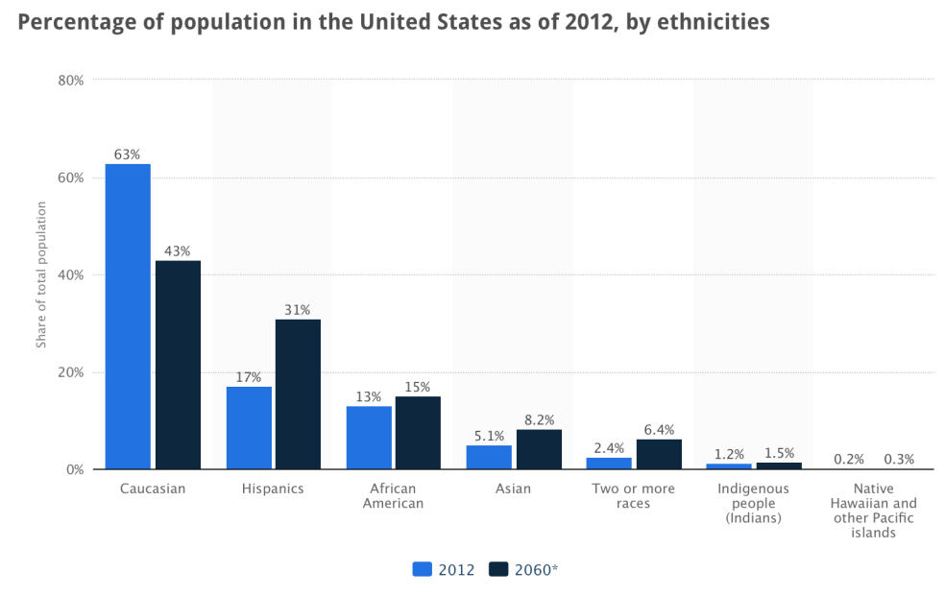
Source: US Census Bureau, 2012
Industry marketing, promotion, product offering and consumer reaching strategies will certainly need to be adapted to cater to a more diverse consumer base. These could include increased multi-lingual advertising as well as changes in brand offerings and promotional techniques. Discounts and mail-in rebates were listed as the most effective promotion technique by Hispanic Americans, in a survey to understand buying patterns of Hispanics (Rizkallah & Truong, 2010). In the same article, in store buying were listed as preferences towards online purchases. Considering the increase in online electronic purchasing and resulting competition to brick and mortar stores, the demographic trend and specific preferences of the increased population segment could be a great opportunity to explore for the specific consumer market. Additionally, offerings in technical services such as home installation and repair could further extend the in-store and/or online experience of the consumer.
Age structure .The age distribution in the United States will gradually change in the next 45 years to becoming an older population. There will be an increase in the proportion of 65 years and over category by 7 percent, but an equal decline in the other two categories (US Census Bureau, 2012).
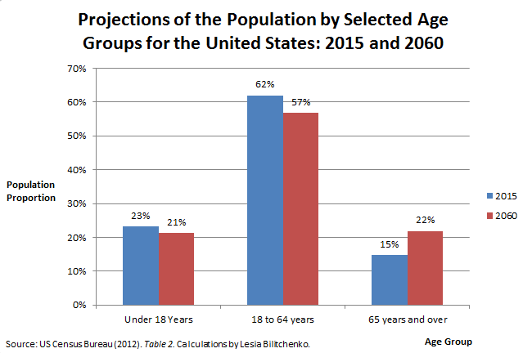
Source: US Census Bureau, 2012
Traditionally the older population has been quite conservative in their buying behavior for electronic goods and appliances due to low level of technical aptitude. However, with the rapid technolization of society along with the fact that today’s 30 and 40 year olds will be the older population in the future, we can be sure that the aging population will continue to be technologically forward thinking. At the same time, today’s common concerns such as health, safety, convenience and retirement wealth preservation will continue to exist in the older sector. Increased reliance on technology coupled with these traditional concerns will mean new opportunities in appliance offerings, services and changes in marketing strategies. Complementary products and services in consumer electronics would present growth opportunities for the Industry.
Income Disparities. Income disparities have affected the affluence of the middle class in the United States. The trend has been disparging between the top five percential and bottom 95. While the income for the top five has stadily increased over the last 40 years, it has gradually declined for the rest of the population (US Census Bureau, 2013).
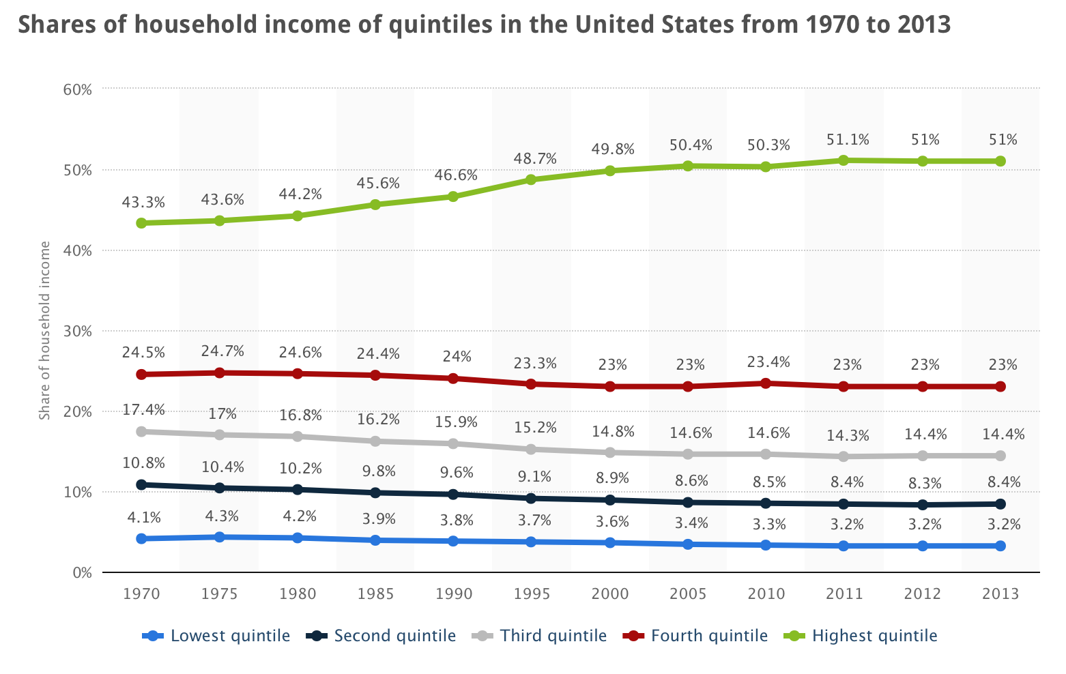
Source: US Census Bureau, 2013
Although this trend has leveled off between 2010 and 2013, the long lasting effects of income inquality have majorily affected the product offerings in luxury and economocial levels. Income inequality could both mean a threat and an opportunity for the Industry. Retailers with higher prices might find it challenging to cater to a declining middle class compared to low price electronic retailers. At the same time, any means to differentiate the product offerings through price comarisons of brands and stores could allow some retailers to get ahead of its competion in attracing price conscius consumers. On the other part of the spectrum, offerings in luxury consumer electronics could address the needs of the high end market and avoid price cutting competiton. These retailers could provide product differentation based on value, quality and enhanced technology capabilities.
Socio - Cultural Segment
Decline in Female Labor Force Participation. Female labor participation had been on the rise in the past 30 years and peaked in 1999. However, the last two recessions and social changes have brought about a change in the workforce. Although, the number of women in the civilian labor force is expected to increase between 2012 and 2022 by 5.4 percent, the labor force participation rate of women will continue to decline, where she will represent only 46.8 percent of labor force by 2022 (Bureau of Labor Statistics, 2013). With more leisure at home, female consumers will make up a good proportion of buyers in Consumer Electronics such as home appliances and entertainment electronics.
Implications to the Consumer Electronics Industry are twofold: 1) Marketing strategies and product offerings for appliances and entertainment electronics will need to more inclusive towards women and 2) personalized consumer service will be key differentiator to attract more female consumers. According to a survey from Good Housekeeping, consumer service is the deciding factor for female consumer electronics purchases (Wasden, 2006). The same survey also indicated that women are more demanding consumers when making electronics purchase decisions.
Increase in Technology adoption. American consumers have been notorious in their early adoption of latest consumer electronics such as smart phones, wearable devices and tablets. This trend is demonstrated in the steady increase of smart phone users from 2010 to 2018 by 157.4 million (eMarketer, 2015). Social influences are the main contributors to these trends. This was demonstrated in a study for the iPhone, where “relative advantage, triability and social influence are the key constructs in adoption intention” (Ismail, 2012).
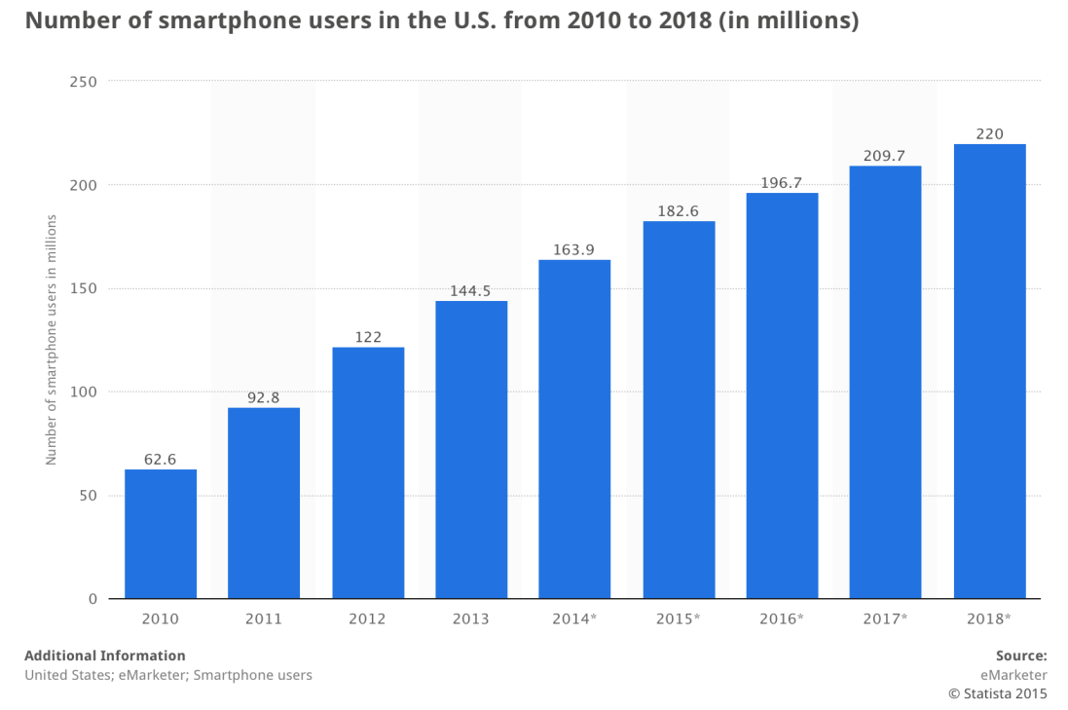
In this context, early consumer adoption of latest technology can present high profitable potential for suppliers and retailers in the Consumer Electronics Industry. These consumers will tend to spend more money on technology and will continue to come back for latest models regularly. Technically inclined consumers will also tend to own a higher variety of different types of electronics. The key challenge will be to attract these early adopters to the specific retailer and establish brand loyalty for recurring purchases.
Greater concern for fitness and environment. Fitness and lifestyle concerns have been key trends in the realignment of consumers to healthier food and lifestyle choices. Weight loss programs, organic food and Zumba classes are constantly circulating in the media. While busy working schedules and the raising of families have taken the time out of the day, consumers still seek quick alternatives to manage their health effectively. Technology has been a key enabler in this aspect. The number of users of fitness health wearable devices will increase by 540 percent from 2013 to 2018 (Juniper Research, 2015). This provides significant opportunities for retailers to meet the new demand of health enabling technologies. Retailers with early and wide selection of such devices will clearly be ahead of the curve to its competitors in monetizing on this trend.
Political and Legal Segment
Increases in Minimum Wages. As of Jan 1st 2015, 30 states will have minimum wages above the federal minimum wage of $7.25 (NCSL, 2014). This will impact retailers, as it will have to adjust base salaries of its employees to comply with the new law. For retailers whose operating model is based on cost control to attract consumers with low prices, this change will provide a significant setback. Consumer Electronics retail is already highly competitive on prices, especially with new opportunities in online retail. Therefore, higher operating expenses from the wage increases can be a significant threat for retailers.
Taxation. U.S. corporations are currently not taxed on its foreign profits. However, there are proposals by the U.S. president to cut corporate tax breaks and allow the taxation of foreign profits. Past foreign profits will be taxed at 14 percent, while new profits will receive 19 percent (Fox News, 2015). At the same time, the tax rate for U.S. earned profits will be lowered from 35 to 28 percent (Fox News, 2015). For the Consumer Electronics Industry this would affect retailers with overseas operations, as it would diminish its profits. At the same time, it would create new opportunities for onshore retailers due to the decrease in the tax break.
Affordable Health Care Act. The Affordable Health Care Act stipulates that effective January 1st 2015 businesses meeting the requirement of at least 50 full time employees need to provide subsidized, affordable health care coverage or face penalties (IRS, 2015). This requirement might mean additional expenses in the form of higher healthcare and regulatory compliance costs. Retailers in the U.S. Consumer Electronics & Appliances Retail Industry already have low profit margins and this will add additional risk to profits. Although, certain loopholes such as the definition of full time employment have already prompted several retailers of electronics such as Wal-Mart and Target to reclassify its employees and avoid the coverage, the long-term impact of the new law still remains to be seen.
Technological Segment
Wireless and Mobile Growth. Advances in network speed and bandwidth as well sophistication of wireless devices such as smart phones and tablets have created new opportunities for consumers and business to communicate remotely. Data, voice and video capture and transmittal have improved efficiency and convenience. The increase of mobile APPs for online payments, coupons and price comparisons has yielded mobile technology indispensable for consumers. On the other hand, Business-to-Business transactions can be performed more cost effectively. In person communication such as meetings can occur remotely, which can save travel time and costs.
Pertaining to Consumer Electronics, retailers in this industry can leverage these advances for its own operational efficiency while on the other hand provide a wide variety of products to consumers. Additionally, advances in data accumulation from social media and consumer smart phone usage such as GPS tracking, installed apps, personal preferences can improve targeted marketing and promotional efforts. Finally, retailers can enhance the in-store experience of consumers by employing mobile technology in the form of payment options, inventory lookup, receipts, and points of sale.
Digital Technology Transition. Digital technology has changed consumer electronics products in every aspect. Today it is no longer just about the laptop or TV. Advances in picture, sound quality and variety of technology channels such as TVs, cameras, tables, game consoles and audio devices have contributed to short product life cycles and high level of product proliferation (Hoover, 2015). These technology developments have had signification implications on sales.
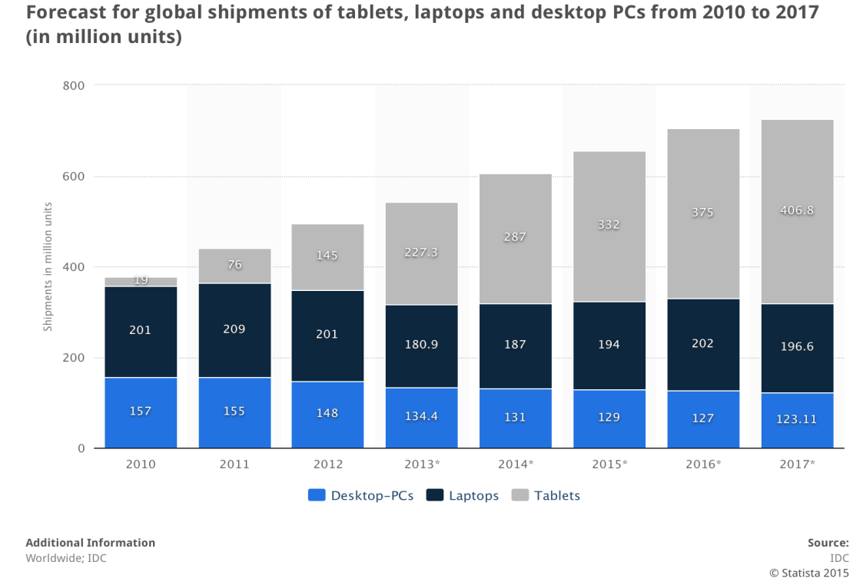
Source: IDC, 2015
The distribution of shipments of tablets, laptops and desktop PCs is projected to change in the next years with a higher proportion of tablets being bought by consumers. The overall number of technologies shipped will increase globally from 542.6 million to 726.5, while tablets sale proportion will rise from 42 percent to 56 percent from 2013 to 2017 (IDC, 2015). Consumer electronics retailers will need to shift product offerings accordingly to this trend to meet the new consumer demand.
Economic Segment
Unemployment rates. Employment has decreased at U.S. consumer electronics and appliances stores by more than 10 percent from 2003 to 2013 (Hoover, 2015). This could be attributed to increased competition from other chains and online retail stores. However, overall unemployment in all sectors of the economy has decreased since 2012 and will continue to do so for projections until 2024 with 5.5 percent of unemployed (US Congressional Budget Office, 2013).
At the same time, automations and efficiencies in inventory tracking, supply chain management and cashiers have resulted in higher productivity gains for the Consumer and Electronics Industry. The low level of unemployment overall is a good sign for the retail industry to attract skilled and experienced employees.
Historically Low Interest Rates. Interest rates have been at a historical low with near zero values. The 2014 rate is 0.09 percent for Federal Funds (Federal Reserve, 2013). This has been soothing for the economy and created a positive climate for all industries. Consumers have more disposable income to spend and thus can afford purchases in Electronics. At the same time, loans can be offered to those who cannot afford to pay cash and the rates are low. Retailers in the Industry also face low expenses for new loans due to near zero interest rates. Expansion opportunities are thus cheap compared to other times.
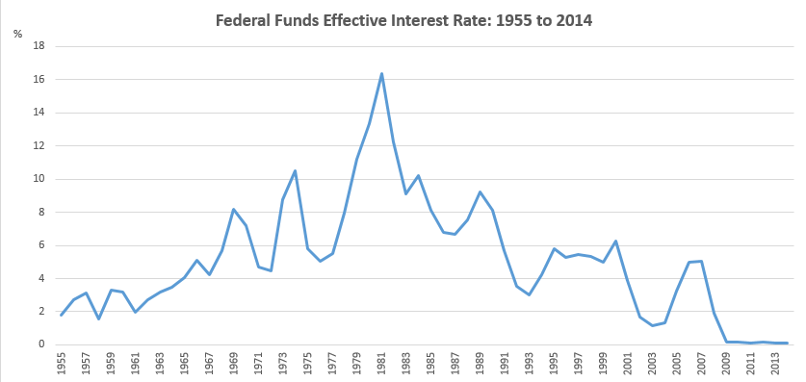
Source: Federal Reserve System (2013), Historical Data
Consumer Price Index. The rising trend in the Consumer Price Index for the 2014 to 2019 period indicates inflationary trend suggesting the cost of living will continue to increase. The Consumer Price Index is projected to grow by about an average of 1 percent (IMF, 2015). The predicted change appears small and steady, which is a good indicator for the overall economy.
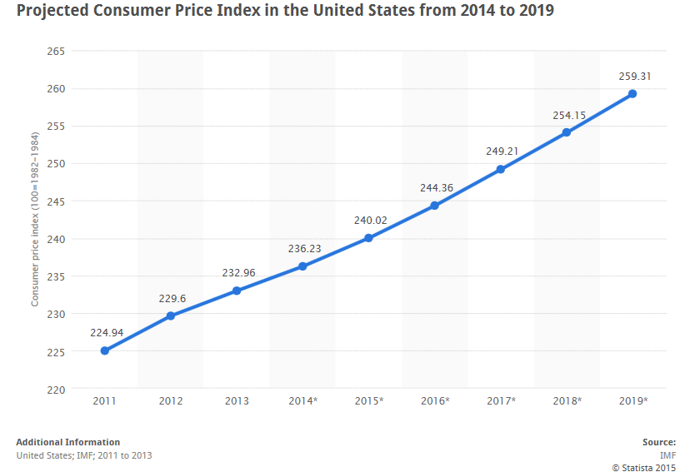
Source: IMF, 2015

Conclusion
Opportunities
Existing Products with Service Bundles. For differentiation purposes, retailers can extend its product offerings by bundling them with services. This strategy will allow brick and mortar stores to position themselves differently from online retailers. Services could be home installations, in-store repairs, warranties, in-store pickups and returns for online purchased items. Certain consumer demographics (Hispanics, women, older consumers) prefer the in person experience along with services to address concerns of quality and convenience. These population groups are projected to increase in representation in the future.
Luxury Electronics Niche Market. A growing economy has allowed certain population groups to become wealthier faster and at a higher rate than others. The resulting income disparity has created a high-end market for luxury electronic goods. This niche market is looking for brand names and enhanced technical capabilities. Retailers selling these brands can position its marketing on product value, reputation and differentiation rather than price competition.
New Technology Products. Technology keeps growing at a fast pace and product life cycles have become shorter. This has opened up opportunities for a variety of new products addressing all areas of everyday life. Growth in mobile technology space and cultural trends for health, fitness and convenience has created new demands for technology products to meet. This variety coupled with socio-cultural changes in society towards technolization and early adopting can create new venues of exploration for retailers.
Online Restrictions. Despite increasing online presence and threat to brick store electronics retailers, recent developments in the form of taxation on online retail have leveled the playing field. The impact to online operating expenses has new opportunities for brick and mortar stores to compete on prices as well.
Favorable Economy. Low interest rates, low unemployment and predictable CPI indicate a favorable climate for growth and investments. This can reduce retailer risk in implementing some of the strategies for addressing Industry opportunities and threats.
Threats
Show-Rooming. One of the major threats to this Industry is the rapid growth in technological advancements. This includes the growing technology of electronics, as well as, the wide use of the Internet. The Internet poses one of the biggest threats. Majority of consumers in this Industry are now browsing products online. Once they find a product they are interested online, they find it at a brick-and-mortar location. By seeing and feeling the actual products, consumers feel more comfortable purchasing it online for a discounted price. The opposite can also happen; a consumer can shop at a brick-and-mortar location and use their Smartphone to compare prices to online retailers or local competitors. If the consumer can get the same product for a cheaper price elsewhere they will most definitely choose to do so. As mentioned previously, this show-rooming affect is having a detrimental impact to brick-and-mortar locations (Hoovers, 2015). There have been numerous attempts to address this issue. Some retailers began price-matching online retailers, but have still fallen short on providing the convenience that online shopping provides.
Inventory Systems. The rapid growth of technological advancements in electronics poses a threat to inventory systems in the Industry. The Industry must keep track of the trends in order to avoid selling out of the high demand products. This has proved to be difficult for some of the retailers. Product life cycles are shorter than before and have impacted inventory control. A poor supply-chain in the Industry could be very costly to a retailer.
Market Saturation. Market saturation is another threat that this Industry faces. Many households have the key products in the Industry such as: televisions, appliances, DVD players, computers etc. According to the Association of Home Appliance Manufactures, almost all households in the U.S. own major appliances. Therefore, the Industry must rely on replacement products for profit. Additionally, since consumers are replacing out-dated products that they paid a high price for they are less inclined to spend the same amount of money once again. The declining middle class has consumers demanding cheaper products of the same quality. This is causing the Industry to reevaluate the supplier costs.

Internal Analysis

Value Chain Analysis
In this section we will be analyzing Best Buy’s value creating primary and support activities in the value chain. Synergies across functions can lead to higher profitability and efficiency within the organization. We will analyze if and how Best Buy achieves these synergies and thus determine its functional strengths and weaknesses.
Primary Activities
Inbound Logistics. Majority of merchandise is shipped to Best Buy’s distribution centers and warehouses by manufactures. Sometimes, delivery has to be expedited to meet release dates and it is shipped directly to Best Buy’s stores (Best Buy 10k, 2014). Best Buy has adopted a collaborative framework with its vendors, carriers and 3PLs to reduce lead times, minimize freight damage and improve delivery performance (Inbound Logistics, 2007). Best Buy has also partnered with the 3PL provider, National Parts, to improve its repair and return operations of returned merchandise. Additionally, the company is seeking to improve efficiencies by consolidating freight to reduce shipping costs (Greve).
Reverse logistics is often overlooked in the retail Industry. However, the secondary market is gaining traction. Per Best Buy CMO Barry Judge, “secondary market electronics sales represent an estimated $15 billion market in the United States” (Greve). Obtaining efficiencies in reverse logistics can provide significant competitive advantages and potential for increased profit. Despite the 3PL partnerships, Best Buy’s management still sees its reverse logistics operations as inefficient. About $400 million is lost each year by Best Buy (Murray, 2013). Returned products had been ending up in dark rooms and forgotten. Best Buy has not been maximizing returns on returned products through lack of visibility and established reverse channels (Reverse Logistics Magazine, 2015). Refurbishment, recycling and trade in services have generally existed. But an integrated end-to-end solution has been missing. Best Buy recently acquired Dealtree to remediate this and improve reverse logistics management (Reverse Logistics Magazine, 2015). But the journey has only started for Best Buy.
Operations. Best Buy operates retail, call-centers, and eCommerce stores as well as provides technology services in both the domestic and international segment. In this organizational analysis paper, we will only focus on the domestic sector. The domestic store brands include Best Buy, Best Buy Mobile, Five Star, Future Shop, Geek Squad, Magnolia Audio Video and Pacific Sales (Best Buy 2014). In total, these account to 1495 store locations as of 2014 with 73 percent of stores being dedicated to the Best Buy brand (Hoover, 2015). Majority of these stores are leased (Best Buy 2014). Store operations are not fully optimized yet and the company is planning to renegotiate leasing contracts to further reduce expenses in the coming years.
Computing & mobile phones, consumer electronics, entertainment, appliances and services, and other types make up the Best Buy Brands products with Computing & mobile phones and Consumer electronics making up 78 percent of total sales in 2014 (Hoover, 2015). Best Buy is also planning to extend its services expertise through the Geek Squad to other platforms such as eBay and selected Target stores (Hoover, 2015). This is a significant advantage for Best Buy if it can expand its service offerings successfully in the future, in order to differentiate itself from competitors and strengthen brand loyalty.
Each store brand has standardized operations pertaining to transaction processing, customer relations, store administration, product sales and services and merchandise display. With those standard procedures, each store has a degree of flexibility to address local market characteristics (Best Buy 2014). Best Buy operates on a “store-within-a-store format” (Hoover, 2015). Best Buy opened 1400 Samsung and 600 Windows stores-within-a-store (Best Buy, 2015). The company has also started since 2013 to change its store strategy by decreasing overall square footage yet increasing number of stores (Hoover, 2015). This combined store optimization effort will allow Best Buy to use its store operations strength effectively in its competition with online retailers by treating stores as assets. After all, many consumers still prefer to pick up the item in person from the store, after browsing and purchasing it online (Fitzgerald, 2013).
Outbound Logistics. A powerful network of distribution warehouses and stores are strategically located (Best Buy 2014). Additionally Best Buy implemented “ship-from-store” capabilities to more than 1400 locations to improve distribution and service for online customers (Best Buy 2014). Over the next 24 months, Best Buy is planning to continue investing in its outbound logistics infrastructure and systems to help improve inventory availability, delivery speed and quality of home delivery and installation capabilities (Best Buy 2014).
To capitalize on the omni-channel trend, Best Buy has even begun testing the concept of its store being a distribution center since 2013 to improve online sales. The company added inventories from 200 stores to its website for the 2013 holidays (Fitzgerald 2013). After combining the online division distribution centers with their stores, Best Buy has improved the availability of its merchandise and efficiency of supply chain operations.
Marketing and Advertising. Pre 2012, Best Buy has relied on traditional advertising such as television, print media and promotional events for marketing (Kumar, 2015). Mass advertising such as email blasts and Super Bowl ads have been the main focus. Although these types of advertising are still majorly employed, the company has started to slowly change this strategy and move towards increased digital and personalized advertising (Kumar, 2015). Targeted digital outlets include social media, web sites and mobile devices (Kumar, 2015).
In order to better compete with online competitors such as Amazon, Best Buy is also seeking to tailor its advertising messages based on consumer segments. This involves looking at browsing history, past purchase activities and provisioning of product recommendations similar to those of Amazon (Kumar, 2015). Although online sales are still only 6 percent of its revenues (Fitzgerald, 2013), Best Buy has started moving in the right direction. The changed strategy in marketing comes at a right time as it is a key enabling function for Best Buy to transform its presence from a mere brick and mortal store to an omni-channel one. Nevertheless, according to some analysts this approach is not aggressive enough as is indicated by the lower than expected sales reported in Q3 of 2014 (AdvertisingAge, 2015).
Support Activities
Procurement. Best Buy purchases inventory from various suppliers. Generally, it does not maintain long-term contracts for continuous supply of inventory. This can allow them to retain flexibility in the face of fast changing technology. The 20 largest suppliers account for 70 percent of inventory purchases, while the top main 5 suppliers account for 45 percent and consist of Samsung, Apple, Sony, Hewlett-Packard and LG Electronics in 2014 (Best Buy 10k, 2014). Overall, Best Buy has several alternative sources of suppliers and can minimize its procurement dependence as a result.
However, until recently Best Buy has not been managing its vendors effectively such as measuring providers against conformance to quality and encouraging competitive tension between providers. Supplier management procurement processes and technology are used on a case by case with different vendors and are not fully centralized (Best Buy 10k, 2014). Vendor management is starting to slowly change as Best Buy is putting incentives to its suppliers and seeking to improve vendor rationalization to increase purchasing power over suppliers (Greve). Best Buy has partnered with several of its suppliers in a collaborative win-win relationship to improve the sale of their merchandise in Best Buy stores. Best Buy achieved this by letting suppliers design and pay for the “sleeker mini-stores design” as well as expense of training and hiring employees (FitzGerald, 2014). Improved store display and training of employees at no additional cost benefits Best Buy, while increases in sales of brands does benefit suppliers. Nevertheless, there are still several aspects in vendor management that need to be addressed. These include holding suppliers accountable for quality control and standardizing procurement processes and technology for complete supplier portfolio.
Best Buy employs several inventory management processes to correctly match levels with consumer demand. These includes monitoring of historical and projected consumer demand, monitoring and adjustment of current inventory receipt levels, vendor agreements for cost markdowns, sales incentives and return privileges (Best Buy 10k, 2014). However, Best Buy’s systems are not automated and do not update inventory levels in real time across the board (such as phone, store and website) unlike Wal-Mart’s. Wal-Mart updates its inventory levels more frequent than every 15 minutes (O’Donnell, 2014). However, at Best Buy a team is assigned to count inventory through a combination of manual and scanning efforts every day (Ms H). If the count of a specific item falls beyond three, then other stores are checked for availability through phone calls. Additionally, team members have to physically walk and move the inventory.
The retail demand is seasonal and Best Buy usually increases its inventory purchasing in Q4 compared to the rest of the year in anticipation of increased expected sales during the holiday season (Best Buy 10k, 2014). Nevertheless Best Buy still has to adjust inventory costs based on markdowns resulting from uncertainty in consumer demand, inventory aging, inventory damages or losses and technological obsolescence (Best Buy 10k, 2014). Although Best Buy does not foresee a major change in its estimation degradation, this can greatly affect Best Buy’s profits as stated in the K10 report, where a 10 percent increase in markdown reserve would have affected net earnings by $7 million in fiscal 2014 (Best Buy 10k, 2014).
Best Buy also designs and develops its own private label brand of exclusive merchandise, which the company contracts out for manufacture (Best Buy 10k, 2014). This provides an additional outlet for product differentiation and price competitiveness, as Best Buy is not reliant on its traditional suppliers for generic products and can directly minimize the cost of its merchandise. Additionally, providing exclusive products allows Best Buy to be the single point of source and avoid competition with online retailers.
Technology. Best Buy heavily relies on management of its information systems in support of its primary and support activities such as demand forecasting, purchasing, supply chain management, website offerings, financial management and safeguarding of critical and sensitive information (Best Buy 10k, 2014). Thus any failure or interruption will have an adverse impact on effectiveness, efficiency, continued operations and compliance.
Best Buy has outsourced majority of its IT operations to Accenture beginning of 2004 (Best Buy 10k, 2014) to reduce costs and improve response. However, the growing significance of eCommerce, mobile technology and emergence of new IT channels has prompted it to reconsider this stance. The company has rehired several hundreds of IT professionals since 2011 and is working on increasing its internal IT talent. Best Buy has since improved its online site navigation and targeted product offerings with more than 200 changes in its online stores (Fitzgerald, 2013). Specifically, some of these changes include the addition of “Pick up in Store” option, product recommendations, reductions in number of clicks for making purchases and improved customer segmentation such as inclusion of geographical customer location, purchase preferences and browsing history (Fitzgerald, 2013).
Having a strong online presence and innovative technology supporting eCommerce effectively would be a key competitive advantage for Best Buy. According to Scott Heise, vice president of application maintenance and development, “IT is becoming a focal point for Best Buy to compete in the market place” and “is a critical differentiator” (Thibodeau, 2011). Thus, the company is seeking to regain control over its IT roadmap and align with its business strategies by in-sourcing some areas of its IT, while leaving daily, generic operations such as “coding” with its current partner Accenture.
Human Resource Management. Human Resource operations are managed by the third party provider Accenture (Best Buy 10k, 2014). Best Buy relies on this partner to reduce costs associated with this function. Human Resource operations are also centralized in Best Buy’s headquarters (Best Buy 10k, 2014).
In 2013, Best Buy has ended its work from home program for non-store employees to battle rising costs and falling sales. The goal has been also to increase communication and collaboration (Best Buy ends work from home program, 2013). Additionally, Best Buy is ending other flexible work policies of its “Results Only Work environment program” ROWE (Business Insider, 2013). The change includes setting strict 40 hours a week requirements for corporate staff. However, there has been no evidence that remote workers had worse productivity and outcomes (Business Insider, 2013). On the contrary, the program during its existence helped reduce Best Buy turnover by 3.2 percent and boost productivity by 35 percent according to an extensive case study on Best Buy (Smith, 2011). Additionally, in the same case study over 100 top organizations, surveys of 557 employees and 70 executives led to the determination that talent management through workforce environment customization produces a high performing and motivated workforce (Smith, 2011).
General Sales and Administration. General Sales and Administration activities are centralized in the Best Buy headquarters. The specific functions within these activities include corporate payroll and benefit administration, occupancy, maintenance and training (Best Buy 10k, 2014). The percentage of spending on General Sales and Administration out of operating income has been increasing from 18.4 to 19.8 percent, 2010 to 2014 respectively, with a peak of 20.5 percent in 2013 (Best Buy 10k, 2014). This indicates certain inefficiencies on Best Buy’s management of general operations. Management has signaled that they are planning to reduce expenses and improve efficiencies by reducing further redundant headcounts to combat this upward trend (Mark, 2014). However, headcount reductions might not be enough in combating this trend.
In terms of executive leadership, Best Buy has acquired significant strengths by changing its executive leadership in several areas in 2012 such as new Chief Executive Officer and Chief Marketing Officer Positions (Kumar, 2015). Hubert Joly and his new leadership team have been accredited with making a turnaround for the better. Profitability has improved through rising sales, lower expenses and rising stock price (Best Buy 10k, 2014). Executive leadership was key in developing and successfully implementing important new strategies to enable this turnaround in such a short period of time. The selling of low performing overseas stores, moving to digital marketing, organizational restructuring and staff trimming as well as store space reductions and store layout renovations are some of the important strategies that allowed Best Buy to battle back. Additionally, leadership’s new vision for omni-channel retail has set an important precedent for future competitive sustainability.
Summary of Value Chain Analysis
Inbound Logistics - Strengths
- Best Buy has a well functioning collaborative framework with vendors, carriers and 3PL to automate supply chain processes, increase communication and reduce lead times.
- Additionally Best Buy effectively and efficiently uses stores as warehouses through direct to store shipment.
Inbound Logistics - Weaknesses
- Reverse logistics is not fully efficient with losses of $400 million each year.
- Shipping costs are still high since freight is not optimally combined in each shipment.

Operations - Strengths
- Best Buy has multiple highly recognized and diversified brands.
- Best Buy has flexible omni-channel capabilities through combination of online buying and in store pickup.
- Best Buy uses physical stores to its advantage through the store-within-a-store display initiative for improved customer experience.
- Best Buy offers additional product capabilities and differentiation through its technology services provided by the Geek Squad brand.
- Geek Squad carries high brand loyalty and its services outreach is extensive including other outside channels such as eBay and Target.
Operations - Weaknesses
- Lease operations and store space not fully optimized
Outbound Logistics - Strengths
- Strategically located distribution network of warehouses and stores reduce distribution speed.
- Quality and speed of home delivery is attained by ship from store capabilities to more than 1400 locations.
- Best Buy has increased merchandise availability through combination of online division distribution centers with stores, that are being used as warehouses
Marketing and Advertising - Strengths
- Best Buy effectively employs multi channel marketing consisting of traditional and digital advertising.
- Best Buy has strong outreach of is advertising by targeting specific customer segments and tailoring advertising messages.
- Best Buy has implemented an effective recommendation system to rival its competitors such as Amazon.
Marketing and Advertising - Weaknesses
- Best Buy has still a small online sales presence.
- eCommerce implementation needs more aggressive strategy.
Procurement - Strengths
- Alternative sources of suppliers allow for reduced procurement dependence
- Best Buy owns a private label brand and has reduced reliance on traditional suppliers and products allowing it to achieve price competitiveness and product differentiation
- Best Buy has expanded one aspect of vendor rationalization effectively. It created incentives for vendors to improve performance through the creation of collaborative win-win relationships. Vendors have invested in own out of pocket costs into Best Buy staff training and storefront display.
Procurement - Weaknesses
- Other challenges in vendor management still persist through lack of complete vendor rationalization.
- Best Buy has inconsistent measures to hold suppliers accountable for quality control and a lack of standardization in supplier processes and technology.
- Consumer demand predictions are not highly effective as the company still frequently marks down inventory to account for inventory aging, damages and technological obsolescence.
Technology - Strengths
- Best Buy effectively employs a combination of managed service and internal IT. This has reduced costs while allow them to retain strategic IT capabilities and skills at the same time
- Rehiring of key technology roles improved Best Buy’s online presence and technology innovations.
- eCommerce rivals that of competitors through recent improvements in site navigation, product recommendation, and store pick up functionality on site.
Technology - Weaknesses
- Technology is not fully enabling inventory management and procurement practices.
- Best Buy needs to enhance technology to better leverage data and provide meaningful and actionable insight for consumer demand predictions.
- Technology is not standardized for efficient procurement practices thus resulting in some procurement functional weaknesses.
Human Resource Management - Strengths
- Best Buy has achieved significant cost reductions through outsourcing of HR operations management.
Human Resource Management - Weaknesses
- Productivity and turnover rates can be impacted through discontinuation of ROWE initiative that was very successful in improving collaboration, motivation and productivity.
General Sales and Administration - Strengths
- Best Buy has strong and effective executive leadership with strategic vision and skills to implement its strategies. Leadership turned the company around in a fast manner.
General Sales and Administration - Weaknesses
- Best Buy costs have increased from inefficient operations.
- Redundant headcount reductions can help but not sufficient to combat this trend.

Financial Analysis
In this section, we will perform a detailed financial analysis of Best Buy. We will provide insight into how this retailer is leveraging itself against Industry norms over a period of time and its current position against direct top competitors. The chosen trend period encompasses a four year range from 2011 to 2014, since Best Buy’s 2013 financial performance was out of the norm due to its restructuring efforts in 2012. The U.S. Consumer Electronics and Appliances Retail Industry is fairly extensive with top 50 retailers (Hoovers 2015). Thus for competitive landscape comparison, we have chosen to consider Best Buy’s direct top three strategic group competitors in our financial analysis. These are Amazon, Apple and Wal-Mart. We will address liquidity, debt and asset management, profitability and market value ratios to gain better insight into Best Buy’s financial position as well as its strengths and weaknesses.
Managerial Decisions Overview
In 2012, Best Buy began a process of restructuring to stay competitive and improve operational efficiency. It closed 50 out of 1100 large stores and laid-off 400 workers to trim $800 million in costs (Wall Street Journal 2012). Additionally, Best Buy has left Europe by selling its 50 percent stake in the partnership with London Telecommunications Retailer Carphone Warehouse group (Hsu, 2013). The intent has been to improve its returns and profitability according to CEO Hubert Joly (Hsu, 2013). However, Best Buy’s financial performance declined in 2013 as a result of costs associated with restructuring (Usatoday, 2013). Starting in 2012, Best Buy began to implement several strategic changes to improve its eCommerce business, service offerings and checkouts (Wall Street Journal, 2012). No doubt, these efforts are necessary to enhance the consumer shopping experience and reduce the effects of “show-rooming”.

Liquidity
In the U.S Electronics and Appliances Retail Industry, liquidity is a significant measure under consideration. Companies must meet its short term debt obligations, while having enough cash flow for daily operations expenses and unforeseen activities. Following is a detailed look at Best Buy’s historical liquidity trend measures, the overall Industry trend and comparison of Best Buy to its direct competitors in 2014.
Quick Ratio. In the Consumer Electronics and Appliances Retail Industry from 2011 to 2014, quick ratios remained relatively stable (Figure 1). However, in this case stability in these numbers is not necessarily a good indicator. The Industry had .85 of liquid assets to cover each 1.00 of current liabilities. This is an indicator that the Industry overall does not have the ability to pay off short term obligations in the event of a quick liquidation, which is considered to be expected due to the industries heavy inventory. Compared to the Industry, Best Buy is in the same low cash position and even worse. Its ability to pay immediate debt obligations worsened significantly from 2011 to 2013, where it could only cover half the debt. In 2014, Best Buy has shown improvements in its immediate liquidity to being able to cover almost 70 percent of debt. This can be attributed to Best Buy exiting Europe in 2013. However, this is still not close to the Industry and even to 100 percent short term debt coverage.
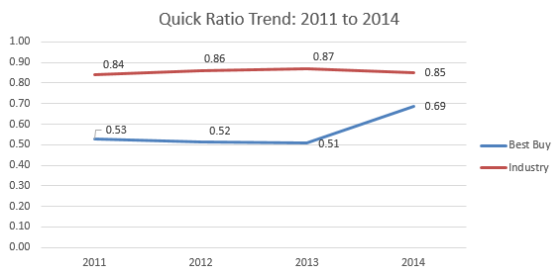
Figure 1: Best Buy and Industry Quick Ratio Trend
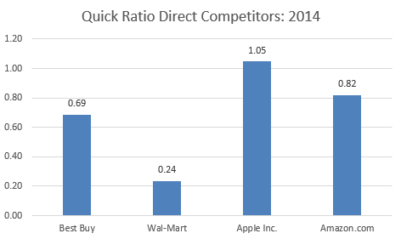
Figure 2: Best Buy and Direct Competitors Quick Ratio 2014

Best Buy’s competitors, with the exception of Apple, have also poor standing in terms of its liquidity (Figure 2). Amazon and Wal-Mart would not have the ability to pay immediate debt obligations. However, Best Buy is even worse than Apple and Amazon. Its quick ratio indicates that it will be at a significant loss in the event of a quick liquidation. Just as its competitors, Best Buy has serious cash liquidity problems in the short-term. It does not have the sources of immediate cash available and will have to sell items in its inventory below its book value. Low cash reserves also limit regular daily transactions and decision making.
Current Ratio. From 2011 to 2014, the Industry’s current ratio was above 1. It has remained relativity stable, only varying slightly but never below 1.5 (Figure 3). Thus, for every 1 dollar that the Industry has in current liabilities, it has 1.60 in current assets. In comparison, Best Buy has a current ratio above one, but its long term liquidity is still worse than the Industry norm.

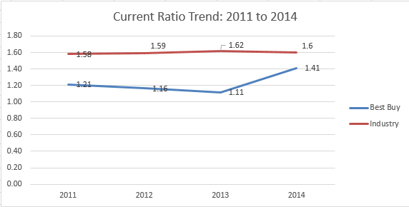
Figure 3: Best Buy and Industry Current Ratio Trend
However, compared to its direct three competitors Best Buy is in good standing. Its direct competitors would be able to cover its current liabilities with its current assets but not to the extent that Best Buy is able to (Figure 4). Apple and Amazon do have a ratio above one; however .08 and .12 are not significant enough. In 2014, for every 1 dollar of current liabilities, Best Buy has 1.41 dollars in current assets. This indicates that if Best Buy was required to pay its current obligations, it would have the ability to do so, but only through selling of inventory.
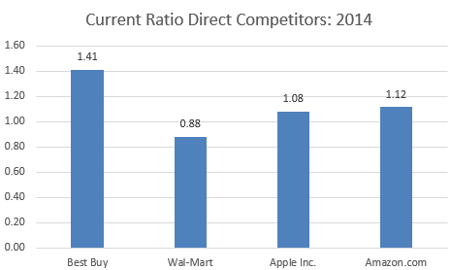
Figure 4: Best Buy and Direct Competitors Current Ratio 2014

Current Liabilities to Net Worth.
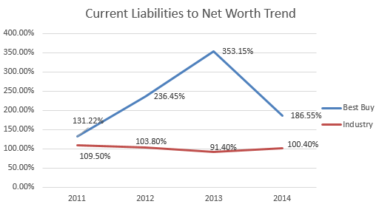
Figure 5: Best Buy and Industry Current Liabilities to Net Worth Trend
As of 2014, the Industry average was 100.40% and Best Buy was at a 186.55%. Both are far above the 60% benchmark, proving that there is an extreme amount of pressure on the future cash flows of the Industry and of Best Buy. Best Buy’s low immediate liquidity also contributing to this problem. The retailer is unable to handle immediate debt obligations fully through cash and cash like assets and thus has to rely on its equity for funding. The peak of debt in 2013 showed a turning point for the retailer. Best Buy did significantly decrease its percentage from 353.15% in 2013. In 2013, corporate management decided to exit Europe; in doing so it was able to strengthen its balance sheet and improve its returns (Hsu, 2013). In turn, its net worth was significantly smaller than its liabilities. Its lowest percentage was in 2011 at 131.22%. It appears as if Best Buy has had an ongoing issue with keeping its ratio below 60%, which represents less security for its creditors. Best Buy has never been able to rely on equity alone to finance its debt.
With the above statements in mind, it is evident that both the Industry and Best Buy are far above the recommended percentage. It is also evident that Apple is the only direct competitor that does not rely too heavily on its equity to finance debt (Figure 6). Apple’s higher than 1 quick liquidity ratio from previous section conclude that it has enough cash for short term obligations and does not need to use equity. Thus appropriate levels of cash reserves and improvements in liquidity would rectify Best Buy’s disproportionate reliance on equity. To signal proper management to stockholders, equity should rather be used for long term growth strategies and not for immediate operational expenses.
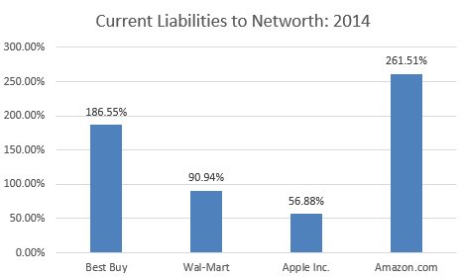
Figure 6: Best Buy and Direct Competitors Current Liabilities to Net Worth 2014

Current Liabilities to Inventory. In the Industry, the current liabilities to inventory are x1.57. Best Buy currently has x1.38 in current liabilities to inventory (Hoovers, 2015). Compared to the Industry, Best Buy is within the range, it is not relying on available inventory more than the Industry norm (Figure 7). In comparison to the Industry norms, Best Buy, Wal-Mart and Amazon are also within range, except Apple, which heavily relies on available inventory. Best Buy seems to be doing better than its direct rivals and not to be relying heavily on inventory to finance short term debt (Figure 8). This can be attributed to Best Buy’s disproportionate use of net worth on financing liabilities as discussed in previous section.
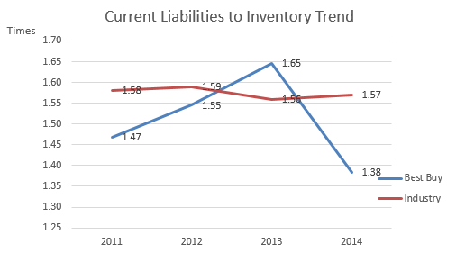
Figure 7: Best Buy and Industry Current Liabilities to Inventory Trend
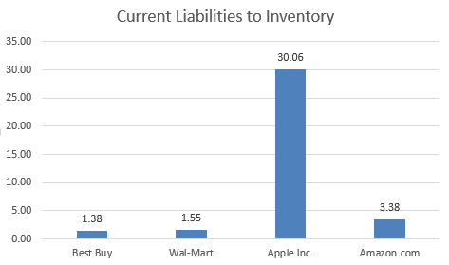
Figure 8: Best Buy and Direct Competitors Current Liabilities to Inventory 2014
Fixed Assets to Net Worth. The Industry average for 2014 was x0.34. This indicates that the norm in the Industry is to have access to immediate cash and not over-invest in fixed assets. In contrast, Best Buy has a ratio of x0.65, which means it over invests into fixed assets and as a result has less cash available for daily operations. During the Best Buy’s Renew Blue initiative; it closed 100 large brick and mortar locations, only to invest into smaller kiosk locations (Best Buy 10k, 2014). Although Best Buy closed locations, the investment into the smaller locations attributed to the overinvestment of fixed assets. Both 2012 and 2013 showed high fixed asset investment (Figure 9). However, the trend since then has declined in 2014. The closure of stores in 2013 has allowed Best Buy to bring down fixed assets in 2014. But the retailer is still not close to overall Industry benchmark.
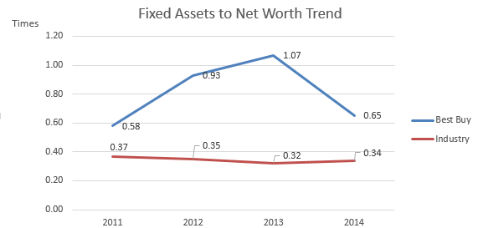
Figure 9: Best Buy and Industry Fixed Assets to Net Worth Trend

In contrast, Best Buy’s competitors face the same problem. Both Wal-Mart and Amazon have a significant amount of cash invested in fixed assets. Apple appears to be the only competitor in the Industry to have a desirable ratio. It has controlled investments and its ratio is significantly lower than the Industry’s and Best Buy’s.
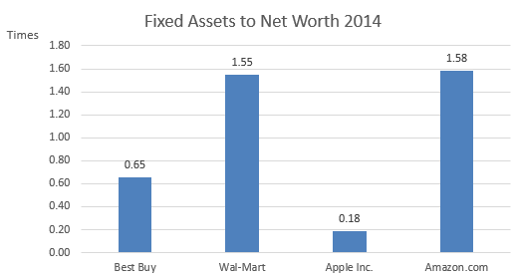
Figure 10: Best Buy and Direct Competitors Fixed Assets to Net Worth 2014

Working Capital to Sales. Best Buy’s working capital to sales ratio has been significantly below Industry norm indicating that it needs less working capital to generate sales. This could mean Best Buy is more efficient than the Industry as it needed 2.70 to 3.6 percent working capital per dollar of sales while Industry needed 8.5 to 9.2 percent (Figure 11). However, when considering the big picture this is not the case for Best Buy. It is using other ways of financing operations. Other financial indicators from previous sections suggest that Best Buy is relying heavily on equity. Further, Best Buy is poor in liquidity compared to the Industry and has over invested in long term assets. In that case, having lower Working Capital to Sales is not a good indicator for Best Buy.
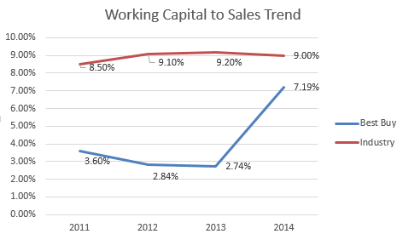
Figure 11: Best Buy and Industry Working Capital to Sales Trend
Amazon and Apple have also a lower working capital to sales ratio than the Industry and Best Buy (Figure 12). However, Apple has better liquidity position; it does not rely heavily on equity to finance liabilities and is not heavily tied into long term assets. Thus, its low working capital to sales suggests efficiency in generating a dollar of sales through its working capital.
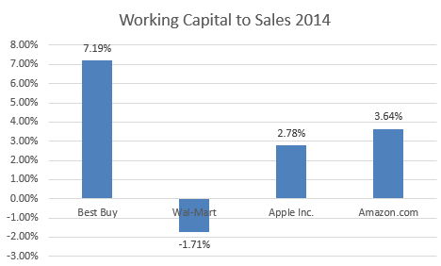
Figure 12: Best Buy and Direct Competitors Working Capital to Sales 2014
Debt Management
Total Debt-to-Net Worth. Compared to the Industry, Best Buy has not been aggressive in financing with debt and was below Industry norm for the four year period (Figure 13). Best Buy did have financial trouble and it has started decreasing its debt to equity ratio after 2013. Best Buy’s strategic group consisting of Wal-Mart, Apple, and Amazon also has lower than Industry debt to equity ratios (Figure 14). However, Amazon and Wal-Mart are still higher than Best Buy in its debt to equity distribution.
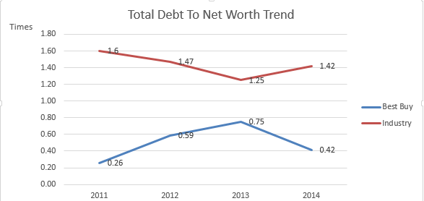
Figure 13: Best Buy and Industry Total Debt To Net Worth Trend
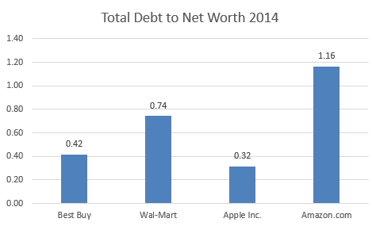
Figure 14: Best Buy and Direct Competitors Total Debt to Net Worth 2014
While this makes Best Buy attractive to lenders and creditors, there are suboptimal implications on the overall cost of capital. Cost of debt is cheaper than equity. Per recent calculation by Professor Damodaran from NYU on cost of capital, the general retail sector has 8.10 percent for cost on equity versus 3.10 percent on cost of debt (Damodaran, 2015). Interest expenses can be deducted from taxable income, while dividends cannot and thus the effective tax rate and expense is lower. Also, interest rates have been historically low; the 2014 rate is 0.09 percent for Federal Funds (Federal Reserve, 2013). This suggests that Best Buy is not optimally financing its operations due to its low debt to equity distribution. It might consider refinancing its existing loans with lower interest rates and possibly shifting to a higher debt to equity distribution closer to Amazon’s and Wal-Mart’s.
Interest Coverage. The Industry norm of the interest coverage ratio is x4.92 and has been increasing over the past 4 years. This is very positive considering that within the Industry there is enough revenue to cover interest expense. In regards to Best Buy, its interest coverage was far above the Industry norm in 2014 with a ratio of x11.40. This indicates that Best Buy had more than enough revenue to cover interest expenses. It has made a huge turnaround from 2013, which was at x-1.25. It is evident that during 2013 Best Buy was having issues with generating enough cash flow. However, by 2014 it was able to increase cash flow to cover interest expenses.

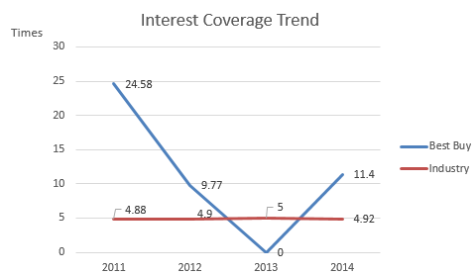
Figure 15: Best Buy and Industry Interest Coverage Trend
In comparison to direct competitors, Best Buy and Wal-Mart are in the same range of interest coverage with Wal-Mart being slightly better. Wal-Mart had a higher debt to equity ratio than Best Buy, but is still better at covering its interest expenses. Amazon on the other hand would have a hard time covering its interest expense. Thus, Best Buy’s positive ability to cover interest through earnings indicates that it can shift to a slightly higher debt to equity distribution as noted in previous section.
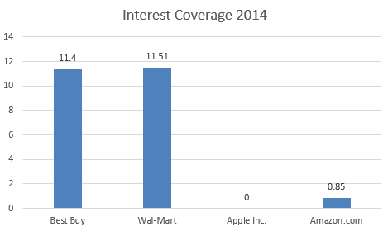
Figure 16: Best Buy and Direct Competitors Interest Coverage 2014
Asset Management
Successful asset management can increase efficiency, reduce operational expenses and improve revenue generation potential. Having the right amount of assets is key in the U.S. Consumer Electronics and Appliance Retail Industry. Following is a detailed look on Best Buy Inc. historical trend, overall Industry trend and its position compared to direct competitors.
Days Accounts Receivable
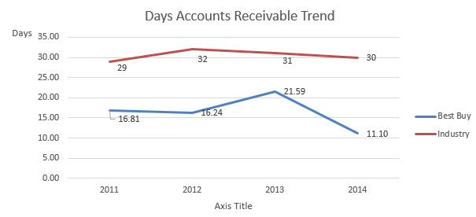
Figure 17: Best Buy and Industry Days Accounts Receivable Trend
The overall Industry trend has been fairly stable for collecting credit sales with an average of 30 days. Best Buy’s credit collection ability declined in 2013, but rebounded back in 2014 to only 11 days on average. Best Buy is doing much better than overall Industry and even its direct competitors in converting receivables to cash. Amongst these, Wal-Mart is collecting the fastest followed by Best Buy and Amazon (Figure 18). Thus Best Buy’s liquidity problems are not based on credit sales collection but on other factors.
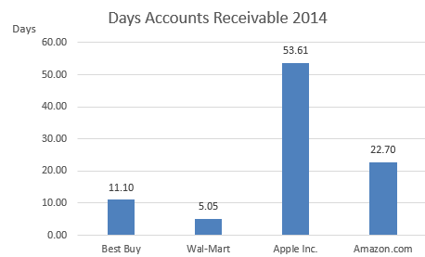
Figure 18: Best Buy and Direct Competitors Days Accounts Receivable 2014

Inventory Turnover. Certain Electronics and appliances inventory can become outdated quickly due to the short product lifecycles and creation of new models. Thus a retailer can incur profit losses if the inventory is not getting sold quickly and becomes outdated and/or damaged as a result.
Best Buy’s inventory turnover is lower than the Industry average throughout the last four years. Also within the retailer’s own performance, the overall trend is suggesting a decline in the inventory turnover efficiency for Best Buy. The ability to sell inventory quickly in 2013 was the worst in the four years. In 2014, the rate rebounded suggesting an improvement, but the turnover ability has not reached the 2011 levels.
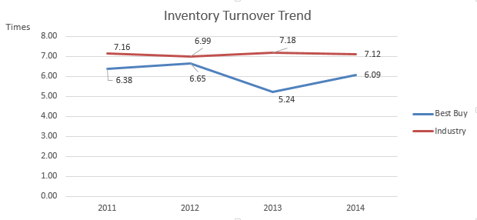
Figure 19: Best Buy and Industry Inventory Turnover Trend
Compared to its three direct competitors, Best Buy is also the worst in selling inventory quickly. Apple is astoundingly efficient in converting inventory to sales with 53 times a year or every 7 days. Best Buy on the other hand is doing it 6 times a year or every 60 days. This has direct implications to sales and profits. To compete on the level of Apple, Amazon and Wal-Mart, Best Buy needs to improve its ability to know what consumers want, stock the desired inventory and improve marketing outreach for faster sales.
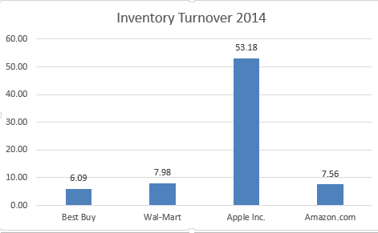
Figure 20: Best Buy and Direct Competitors Inventory Turnover 2014
Total Asset Turnover. Best Buy’s asset turnover trend has been unstable with certain spikes in 2012 and 2014 confirming the effects of the restructuring efforts and reduction of total assets since 2011. However, the higher than Industry asset turnover in 2014 indicates a positive trend towards recovery.
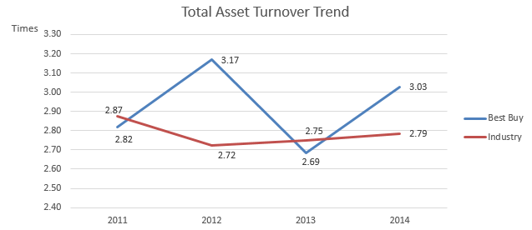
Figure 21: Best Buy and Industry Total Asset Turnover Trend

Compared to its direct competitors, Best Buy’s Asset Turnover ability is also positive. Best Buy has the highest asset turnover ratio (Figure 22). Nevertheless, Best Buy should strive to increase its sales and dispose of some unused fixed assets to go hand in hand with its “smaller store presence” strategy and improved eCommerce. This will also allow the retailer to have improved working capital funds and remove dependency on equity for financing daily operations.
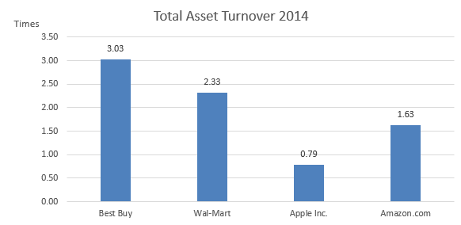
Figure 22: Best Buy and Direct Competitors Total Asset Turnover 2014
Profitability
Profitability is the end result of a number of combined policies in liquidity, asset and debt management on earnings generation. A retailer’s ability to translate sales into profits is vital in sustaining its future operations and growth.
Gross Profit Margin. Best Buy’s margin has been steeply declining since 2011 (Figure 23). Problems in attracting consumers for higher sales, along with high inventory costs resulting from suboptimal inventory management are some of the reasons. Compared to its direct competitors, Best Buy is clearly below the standard of profit margin (Figure 24). Amazon and Apple lead the way with high gross profit margins.
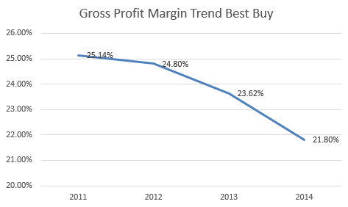
Figure 23: Best Buy Gross Profit Margin Trend
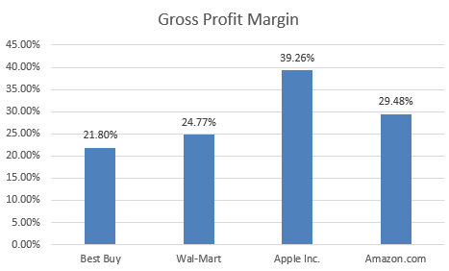
Figure 24: Best Buy and Direct Competitors Gross Profit Margin 2014

Best Buy’s relatively high cost of goods sold in relation to sales confirmi the previously noted problems in inefficient asset management. Increasing inventory turnover times per year should reduce the cost of goods sold and improve the gross profit margin. At the same time, the declining sales from $50.3 million to $42.4 million, 2011 to 2014 respectively, lower Best Buy’s profitability (Financials Morning Star 2015). Best Buy seems to having difficulties in attracting consumers to buy its merchandise.
Pre-Tax Return on Sales. Best Buy’s return on sales has declined in the last four years, with 2013 being the worst in its performance and generating losses. Best Buy has rebounded in 2014 with higher returns on sales than the Industry, but it is nowhere close to its 2011 rate (Figure 25). This indicates a decline in its operational effectiveness to generate sales.
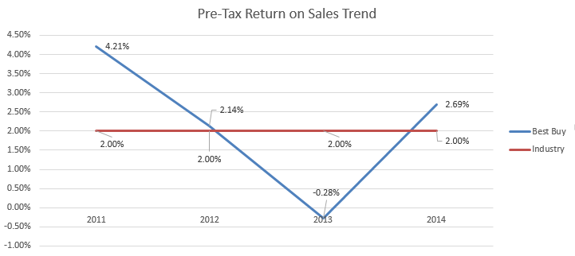
Figure 25: Best Buy and Industry Pre-Tax Return on Sales Trend

Compared to its competitors, Best Buy has very dismal returns on sales. Apple and Wal-Mart lead in its profitability and revenue generation potential (Figure 26). Best Buy is not doing a good job at controlling its Selling and General Administrative costs, even though it decreased from $10 million to $8.4 million, in 2011 to 2014 respectively (Hoover 2015). Both Wal-Mart and Apple have managed to have lower SG&A costs out of gross profits and thus generate higher Return on Sales (Figure 27).
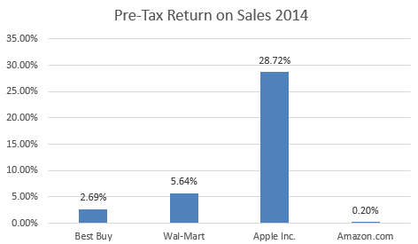
Figure 26: Best Buy and Direct Competitors Pre-Tax Return on Sales 2014
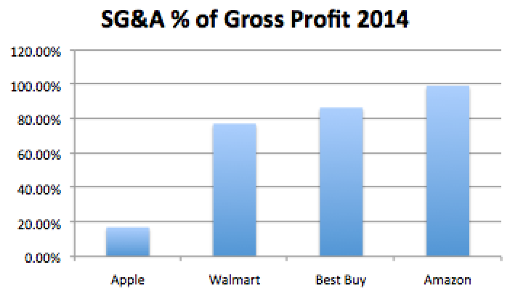
Figure 27: Best Buy and Direct Competitors Selling, General and Administrative % of Gross Profit

Pre-Tax Return on Assets. Best Buy’s return on assets rate has declined for the retailer in the last four years. Problems with available cash as indicated in the various analysis ratios of the liquidity section along with suboptimal asset management practices have contributed to the declining profitability. Best Buy is rebounding though in 2014 suggesting the restructuring in 2013 allowed it to improve efficiency in operations. Best Buy’s struggles with profitability compared to its competitors. This is further confirmed with its much lower returns on assets than Wal-Mart and Apple (Figure 29).
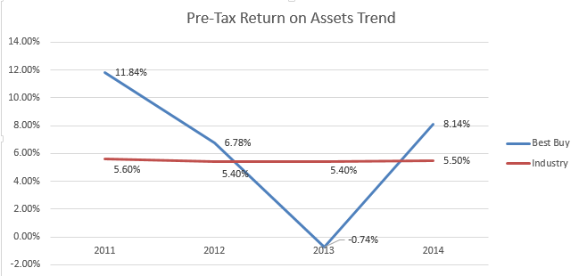
Figure 28: Best Buy and Industry Pre-Tax Return on Assets Trend
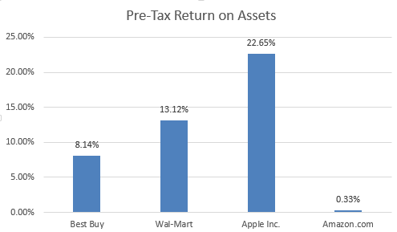
Figure 29: Best Buy and Direct Competitors Selling, General and Administrative % of Gross Profit

Pre-Tax Return on Net Worth. The Industry’s return on net worth has been in the 12 to 13 percent range in the last four years, while Best Buy has generated much higher returns on stockholder investment (Figure 30). In terms of trend analysis, Best Buys profitability has deteriorated as other measures also compare. Its pretax return on Net Worth dropped from 32.02 percent to 28.06 percent. Also Best Buy is lagging behind Wal-Mart and Apple in return on equity. One profitability measure after another confirms Best Buy’s problems in attracting consumers and increasing sales compared to its rivals.
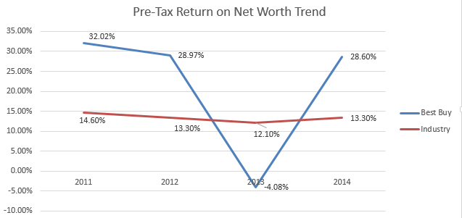
Figure 30: Best Buy and Industry Pre-Tax Return on Net Worth Trend

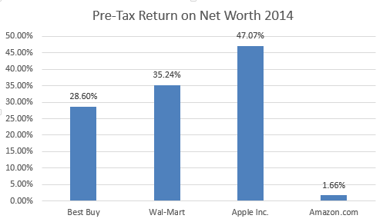
Figure 31: Best Buy and Direct Competitors Selling, General and Administrative % of Gross Profit

Market Value
Market value ratios indicate how investors perceive the retailer in terms of profitability and riskiness. Favorable market perception of the retailer and its potential to generate future income for investors gives the retailer additional revenue streams through selling of stocks.
Earnings Per Share (EPS). Analyzing this in the trend context for Best Buy, we see a general decline from 2011 in EPS suggesting a loss in profitability over this period of time. EPS has increased in 2014 and it remains to be seen if this trend will continue. Best Buy has also much lower earnings per share compared to Wal-Mart and Apple. This is worrisome, since Best Buy has relied on equity financing of its liabilities.

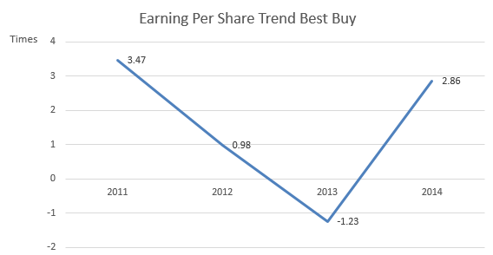
Figure 32: Best Buy and Industry Pre-Tax Return on Net Worth Trend
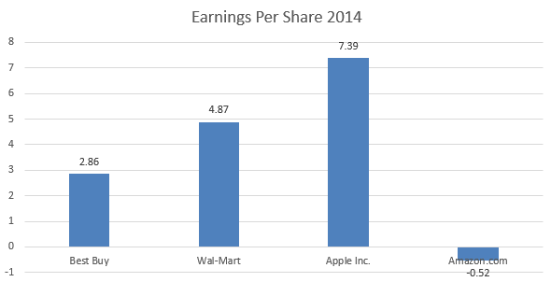
Figure 33: Best Buy and Direct Competitors Earnings Per Share 2014

Price Earnings. Best Buy relies heavily on equity. Historically, Best Buy’s PE ratio declined from 2012 to 2013 confirming the market’s risk perception caught on with its profitability issues (Figure 34). However, investors have since seen Best Buy more favorability with an increase to 13.73 times. Compared to its rivals, Best Buy is below Wal-Mart and Apple, suggesting the market sees those companies have better growth opportunities in the future.
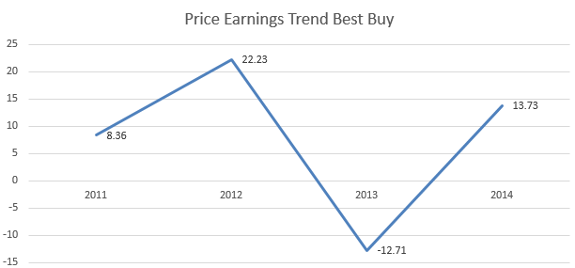
Figure 34: Best Buy Price Earnings Trend
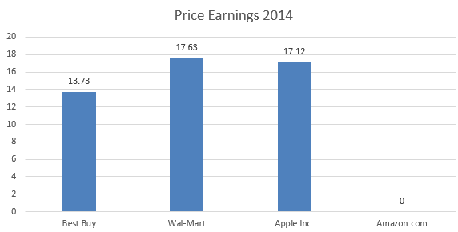
Figure 35: Best Buy and Direct Competitors Earnings Per Share 2014
Market Book. The Market Book ratio can tell investors how much the retailer’s book value is worth compared to the market value. Thus, it can tell if a stock is overvalued or undervalued. Best Buy’s market evaluation has improved since 2011. But it is still much lower than its competitors’ market value.
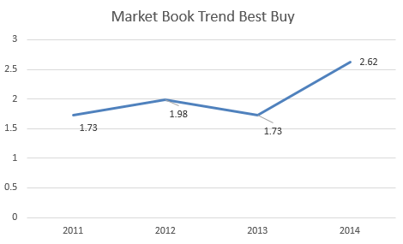
Figure 36: Best Buy Market Book Trend
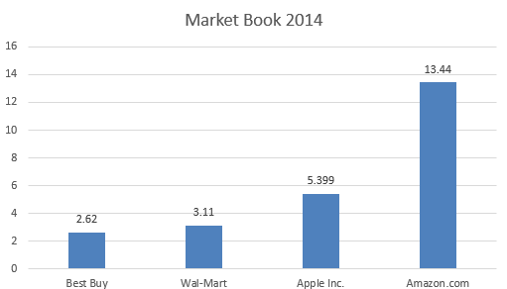
Figure 37: Best Buy and Direct Competitors Market Book Trend 2014
Summary
Best Buy has several strengths in its financial position. The retailer has good debt management and it covers its interest expenses well. Restructuring and reduction of assets in past two years have reduced Best Buy’s debt. Best Buy also manages efficiently its sales collections and has high overall asset turnover. However, these strengths do not translate into overall profitability compared to its direct rivals. Best Buy has cash liquidity problems and relies heavily on its equity to finance short term obligations. Despite, asset reduction initiatives, it still has cash tied up in fixed assets. Suboptimal inventory management practices are reflected in its low inventory turnover rate. This directly translates to low profitability measures based on sales such as, gross profit margins and returns on sales. Best Buy’s high general, selling and administrative costs also reduce its profitability compared to rivals such as Amazon, Apple and Wal-Mart. The market perception reflects the retailer’s financial stance. Investors value Best Buy’s growth potential less than Amazon, Wal-Mart and Apple’s.
Bottom line, Best Buy must do everything in its power to increase sales to improve its profitability. At the same time, optimizations in operations such as inventory management and reductions in general expenses will further improve returns and gross profit margins. Finally, Best Buy should consider changing its capital structure by moving to a slightly higher debt to equity distribution and thus lower the average capital costs. As suggested in the debt management section, debt costs less than equity and shareholders would see the value from this optimized management approach.

Core Capabilities and VRIO Analysis
In this section we will be analyzing Best Buy’s core capabilities based on a resource based view (RBV). We will investigate Best Buy’s core capabilities in terms of value creation, rarity, imitation difficulty and organizational capability to capture this value by using the VRIO analysis method.
Supply Chain: Integrated and Flexible Omni Channels
Best Buy has tightly integrated and flexible supply chain operations through its strategically located distribution centers, warehouses and stores. This allows the company to deliver products fast and cost efficiently. Best Buy has further started to integrate ecommerce capabilities into its traditional store operations to provide customers additional channels for flexible buying and picking up of products. Improvements in merchandise availability through the centralization of online and store distribution management has also meant higher customer satisfaction, brand loyalty and lower inventory management costs. At the same time, Best Buy has been successful in capturing the value from this capability by increasing domestic online sales by 20 percent in 2014 (Best Buy 10k, 2014).
This core competency is highly valuable to Best Buy, as it allows the company to exploit the opportunities and threats associated with ecommerce. Unlike its former rivals RadioShack and Circuit City, which went out of business due to failing to adapt and use online retail to their advantage, Best Buy chose to adapt its existing supply chain to the new omni-channel model. For customers this translates into high value as they experience convenience, flexibility, speed and lower product costs resulting from the omni-channel approach.
At the same time, this capability is quite rare and difficult to imitate, as it takes considerable amount of time and capital to establish distribution routes and vendor partnerships for effective supply chain management on the same level as Best Buy. Best Buy posses both in store and online distribution capabilities. Few companies have the same, advanced capabilities. Amazon is strong in online retail but lacks the scale of storefront and in person pickup capabilities. Additionally, Best Buy has been able to improve its online shipping speed to being faster than Amazon during the holiday shopping season (Moskowitz, 2014). Only Apple and Wal-Mart could possibly match the same flexible and integrated supply chains. Thus, for Best Buy having a flexible and integrated multi-channel supply chain translates into Sustainable Competitive Advantage.
Merchandise: Quality and Variety of Product Assortment
Best Buy and its various brands carry a wide variety of consumer merchandise such as computing and mobile phones, consumer electronics, entertainment and appliances (Hoover, 2015). Additionally, Best Buy has a variety of different merchandise brands including its own private label products that can only be bought at Best Buy stores. This availability of variety translates directly into value for the customer through improved experience and convenience. Best Buy also maintains rigorous standards with its vendors for consistent merchandise quality, which helps it build and maintain customer loyalty and generate sales (Best Buy 10k, 2014).
Majority of merchandise, except the high-end merchandise such as Magnolia products and own private labels, is also carried in other electronics retailers. Electronics merchandise is fairly standardized and suppliers interact with many different retailers. So overall, this resource is not necessarily rare or difficult to imitate for other competitors. However, Best Buy has to continue excelling at this in order to remain competitive in the market.
Services: Quality and Variety of Technical and Support Services
Best Buy provides a variety of technical and support services through its Geek Squad Brand. These technology services include technical support, repair, troubleshooting and installation (Best Buy 10k, 2014). These services are available for Best Buy purchases and online purchases from other retailers such as eBay and Target (Best Buy 10k, 2014). It is one of Best Buy’s biggest competitive advantages (Best Buy 10k, 2014). These services not only establish customer loyalty and brand recognition, but also provide an uncontested source of revenue, which makes it both rare and difficult to imitate. Additionally, the services provide a great synergy between the purchased merchandise and complementary offerings of services for consumers who need it. This translates into customer value and operational realization.
Reputation: Brand Loyalty
Best Buy has strong customer loyalty, as is evidenced in the recent measure of the Net Promoter Score, which measures customer service satisfaction and loyalty. For Best Buy it has increased by 400 basis points compared to previous years in customer loyalty, while the rest of the industry has declined by 200 basis points (Moksowitz, 2014). Best Buy has re-launched its loyalty program, which has resulted in higher customer participation across channels (Best Buy 10k, 2014). High price electronics purchases require high consumer trust and customers generally have expectations of support after the sale for repairs, accessories and installations. The Best Buy Brand offers these. Additionally, Best Buy has implemented the price-match guarantee including for online retailers such as Amazon to remain price competitive and build further brand loyalty. Considering Best Buy’s breadth of private labels and services, brand reputation is rare and difficult to establish, thus giving the company a sustainable competitive advantage.
Physical: Distinct Store Formats
Best Buy has managed to use its stores as assets in the fight with online retailers. Starting in 2012, the company has transformed its store layouts with the help of vendors to create the unique “store-within-a-store” design. This concept is more common among department stores and Asian retailers, but less among electronic stores (Lee, 2013). Vendors lease space within the store, invest own capital to improve the layout within Best Buy’s stores and create lavish displays specific to their brand to entice customers to try out the technology. Thus, Best Buy has benefited from not having to dedicate resources and capital to these efforts, while focusing on optimizing space in other cases. At the same time, Best Buy has started stocking high growth products to boost sales per square foot (Lee, 2013). As various studies have shown, store within store formats can lead to improvements in customer experience and higher in store traffic (Lee, 2013). The strategy seems to be paying off, as Best Buy’s same store sales rose by 2.8 percent, the second straight quarter since Q3 of 2014 (Reuters, 2015). Therefore, the ultimate competitive advantage comes when customers get the experience and service, which cannot be easily found anywhere else (Lee, 2013).
To some extent, other retail competitors can imitate this concept. The ease and speed of competitors catching up would depend on how well they can convince suppliers in investing in their storefronts. Being on a conservative side, this competitive advantage is only temporary for Best Buy, unless they can secure exclusive deals and heavily use exceptional customer and technological service in conjunction with the store within a store concept.
Brand Marketing Strategies: Effective Multi Channel Use of Advertising
Best Buy has recognized the potential of digital advertising, social media and targeted marketing approaches. The company successfully has incorporated these into traditional mass marketing such as television and promotional events. As a result, Best Buy has been able to increase online traffic and conversion rates (Market Realist, 2015). These ultimately have translated into gained value through the online sales growth of 20 percent since 2013, which account now 13 percent of total sales (Market Realist, 2015).
However, multi-channel marketing is not extremely complex to implement and many retailers have started using this approach. While it is not a sustainable competitive advantage, Best Buy needs to continue excelling at it, in order not to fall behind online and physical store competitors. Multi-Channel marking is one of the key enablers of successful omni-channel retail. As discussed, Best Buy’s integrated and flexible supply chains are already significant sources of sustainable competitive advantage.
Innovation of Products and Technology
Best Buy has begun expanding the selection of its private label electronics to gain competitive advantage over online and physical store retailers. The company designs, develops and markets the private label brands, which include the five house brands: Insignia and Dynex televisions, Rocketfish video cables, Init electronic cases and accessories, as well as GeekSquad flash drives (Best Buy 10k, 2014). The manufacturing function is contracted out though (Best Buy 10k, 2014). Through private labels, the company can control the price and product features. Private labels have become increasingly popular among retailers as a way of differentiation, but are less prevalent in the electronics retail sector. While any electronics retailer can generally create its own private label, the success of Best Buy lies in its private label brand recognition, quality, cost effectiveness and complementary offerings such as technological services. Thus, for Best Buy this is a sustainable competitive advantage. For example, Wal-Mart did try to sell its private line of inexpensive electronics called iLO, but ended up dropping it to focus on name brands (Retail Wire, 2009).
Outstanding Customer Service
Best Buy’s business strategy is based in superior customer service with central focus on the customer experience. The company has started expanding its program on several levels including Price matches and Loyalty Programs. Loyalty Programs provide customer incentives to continue shopping at Best Buy. Some of the loyalty features include extended no hassle returns up to 60 days instead of 15 days for non-loyalty members; shopping points such as for every $250 spent, customers get $5 back; free shipping on holiday purchases and some free interactive mobile games (Ms. H). To further enhance customer’s experience, Best Buy is offering in-store low or no interest promotional financing for qualified purchases (Ms. H). Customers who cannot afford these immediately can still make a purchase and pay it off later.
Additionally, Best Buy ensures its employees are well trained in their specialized area to offer exceptional knowledge and skill to their customers. Each department has E-Learning and in class courses for specific technology areas (Ms. H). Best Buy proactively trains its customers to prepare for releases of new product technologies pertaining to usage, features and other similar products. All employees are regularly certified in their respective areas (Ms. H). Additionally, Best Buy has partnered with vendors to provide vendor training at vendors’ expense for specific brands (Ms. H). Employees take great care when talking to customer, are always available, friendly, helpful and highly knowledgeable (Ms. H). Similar Electronics Stores do not have the same extent of personable and unique customer service. Thus, Customer Service is a valuable, sustainable competitive advantage for Best Buy.
Core Capabilities and VRIO Summary
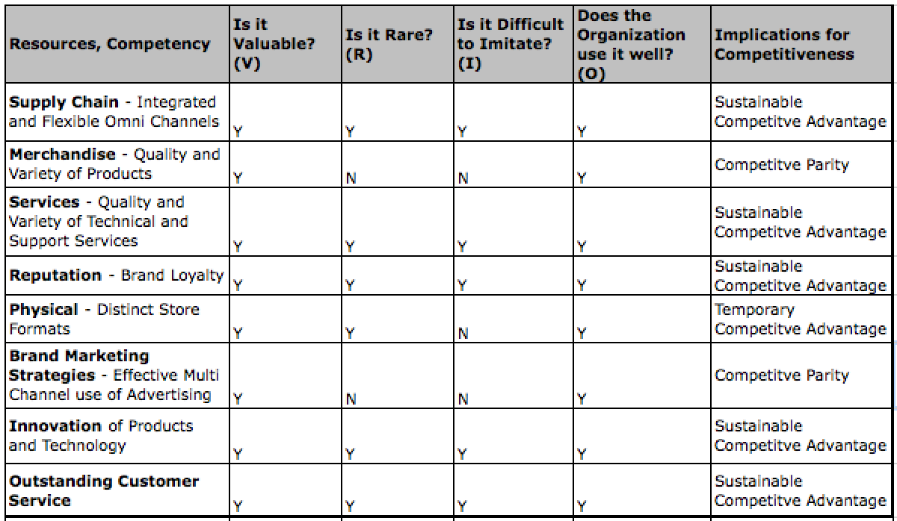

Organizational Structure and Culture Analysis
After a review of the Best Buy’s formalized patterns of interactions it has been determined that its approach to an organizational structure is a divisional structure. Best Buy has corporate members that oversee operations that are organized around domestic territories and markets. Each of these divisional managers oversees different products and services offered by Best Buy. Each territory and market manager in each geographical area has the same common goal of achieving sales and attracting consumers (Interview, Ms. L).
The divisional structure with a central corporate office allows Best Buy’s corporate managers to view the strategic issues of the entire corporation. However from the interview there is a communication gap between corporate and field level managers (Interview B, Ms. H). From her experience it appears as if each territory in the U.S competes with one another in store sales rather than working together for one common goal (Interview A, Ms. L). This competition is one of the disadvantages of divisional structure (DELM, 2014). Since field level managers are evaluated in terms of sales and revenues, there is a tendency to focus on the short-term goals and individual operations (DLEM, 2014).
The chart below gives an example of the different divisional mangers and the central corporate office that oversees each division. It is important to mention that there are currently 6 Territories and 42 markets in the U.S. Each Territory Manager roughly oversees 7 markets. Each Market Sales Manager has one District Manager. The District Manager oversees an average of 12 stores.
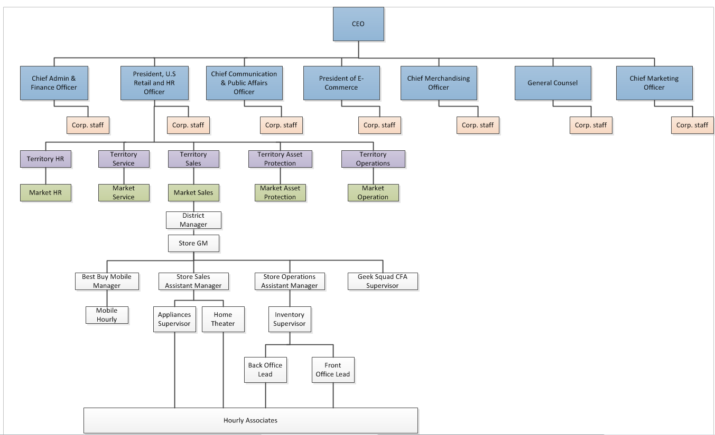
Culture Analysis
In Best Buy’s Annual report, CEO Hubert Joly stated that strengthening management and improving employee engagement is critical to its success. He goes on to state that, the talent and engagement of employees has the ability to redefine its key business processes in order to achieve a multi-channel consumer experience. In order to gain a better understanding of the Best Buy’s organizational goals and culture, an interview with two store level employees was conducted. An hourly associate and an employee in leadership were interviewed. For confidentiality reasons the employee in leadership will be referred to as Ms. L and the hourly associate will be referred to as Ms. H. This interview addressed whether or not Best Buy’s business strategies have been communicated and implemented. Questions regarding: culture, employee engagement, organizational structure, and rewards and incentives were asked.
Employee engagement
Since employee engagement is critical to success, the way in which it is measured and valued by Best Buy at a store level is essential. At a store level Best Buy has implemented a successful employee engagement strategy (Ms. L, Interview A). Best Buy has implemented a Evoice survey. This Evoice survey is a questionnaire that asks questions pertaining to work motivation, satisfaction, fairness, and confidence with Best Buy as an employer (Ms. L, Interview A). Ms. L and Ms. A feel as if their concerns are heard at a management level. If an area is poorly scored, management must create an action plan to address the concern (Ms. L, Interview A). In creating an Evoice survey, Best Buy has created an outlet for employees and a learning tool for management. An inclusive work environment that encourages employee engagement is essential in a successful organizational culture. As an hourly associate, Ms. H also feels as if the inclusive work environment and Evoice survey have contributed to her satisfaction with management.
Rewards and Incentives
Reward and incentive programs are often used as a powerful tool to influence culture, performance and motivation (DLEM, 2014). At a store level Best Buy has rewards and incentives such as: tuition reimbursement, benefits, paid-time off, 401k, and bonus structures (Ms. L, Interview A). There is also a Path to Excellence program, which rewards employees who are going above and beyond organizational goals. According to Ms. L, these rewards and incentives are drivers for individual performance.
Ms. H, also agreed with the rewards and incentive program however, she felt as if full-time employees reaped more of the benefits than the part-time employees. Since incentives such as benefits and tuition reimbursement are only offered to full-time employees she felt a sense of separation. She also stated that majority of full-time employees reap the benefits of path to excellence since the work full-time hours. Therefore they have ore opportunity to improve sales. Ms. H mentioned that this has created a gap between the full-time and part-time employees.
Communication
In regards to communication Ms. L mentioned that managers and employees have monthly one-on-ones to communicate individual performance and goals. These one-on-ones are a way to effectively communicate with hourly associates about where improvements need to be made. It also encourages an open-door policy where employees can voice their concerns directly to management. This has allowed management to provide avenues for employees to get promoted (Ms.L, Interview A).
As for hourly associates, Ms. H voiced her concerns with communication between upper management and hourly associates. As of now, there is no relationship built with district, market, or territory managers with hourly associates. These upper management teams only stay in connection with store managers and have built strong relationships with them (Ms. L, Interview A). Ms. H stated that she has never had a conversation regarding performance or organizational objectives with territory, district, and market managers. Therefore, she considers there to be a huge gap in communication.
Culture
Best Buy has the necessary tools to implement and effective and inclusive corporate culture. The Evoice surveys and the monthly one-on-ones keep communications between managers and employees open and honest. Employees know the organizational objectives and are encouraged to meet these objectives with the use of Path to Excellence. The path to Excellences allows employees to strive for outstanding performance.
Employee engagement has been successfully implemented. At a store level, management is staying in line with the objective of the Renew Blue strategy. The areas of opportunity for organizational culture are rewards and incentives and communication. It would be beneficial to offer rewards and incentives to part-time employees. However, since SG&A costs are high, this change may be something that is not of urgency; yet it should be addressed at a later time. (SG&A costs will be addressed in the financial analysis). Furthermore, it would be beneficial for Best Buy’s Market managers and the district managers to break down the barriers of communication with hourly associates. This has the potential to improve morale and organizational culture.

SWOT Analysis
In this section, we will summarize Best Buy’s strengths and weaknesses obtained from the Internal Analysis and the opportunities and threats presented in the U.S. Consumer Electronics & Appliances Retail Industry.
Strengths
Debt Management . As indicated in the financial analysis section, Best Buy’s significant cost reduction initiatives have allowed the company to reduce its indebtedness and interest expenses substantially. The company has much lower debt to equity distribution compared than the Industry and even lower than some of its direct competitors such as Wal-Mart and Amazon. This translates for Best Buy into strong financial leverage and stable credit ratings. Best Buy’s strength in debt management is an important prerequisite for funding its Price Match strategy.
Efficient and Effective Credit Sales Collections. Best Buy’s efficient and effective credit sales collection means the company can quickly translate credit sales into cash, which positively influences its liquidity and working capital for funding daily operations. Having enough cash liquidity is an issue for Best Buy, which we will discuss in the next section. Effective credit sales collection strategies can help remediate this problem along with other policies to increase sales overall. Additionally, credit sales account for a significant proportion of electronic retailer’s revenues due to the nature of high value pricing of many electronics products. Best Buy also plans to increase stocking of high-valued products, which will necessitate credit sales. Therefore, Best Buy should be in a strong position to leverage this move effectively.
Flexible Omni-Channel. Best Buy has transformed its retail operations into incorporating eCommerce successfully into its existing distribution channels. Channel flexibility and variety of distribution outlets mean the company can deliver merchandise quickly and cost efficiently. Thus, using stores as distribution centers and shipping from store directly has translated into higher merchandise availability, speed and quality of delivery to the consumer. This has allowed Best Buy to outperform even online competitors such as Amazon in delivery speed. On the other hand, Best Buy is able to provide a comprehensive shopping experience to its consumers through its online and in-store capabilities. Future shopping will not be just confined to one manner of shopping. Best Buy has the channel strengths to make it happen.
Highly recognized and diversified brands of products and services. Best Buy has created a brand recognition and loyalty throughout the Industry. Its merchandising, services, reputation, and innovation of products and technology have shaped Best Buy in what it is today. As mentioned in the VRIO analysis, Best Buy carries a variety of different brands including its own private labels. Through this backwards integration Best Buy has been able to cut costs, increase profit margins through value chain and create a unique position in consumer’s minds. The quality of service provided to consumers by Geek Squad has proved to be one of Best Buy’s competitive advantages (Best Buy 10k, 2014). The services offered have created brand recognition and customer loyalty that has been difficult to imitate. The innovation of products has allowed Best Buy to control the prices and features. They have been able to secure their domestic and international trademark and service mark for their distinct brands and services (Best Buy 10k, 2014). Geek Squad, Magnolia Home Theater, Pacific Sales, and Best Buy Mobile have contributed Best Buy’s brand loyalty. This past year’s increase in Net Promoter Score represents the loyalty and satisfaction Best Buy has gained. The implementation of online price matching and reward zone has continued to grow across all channels and increased its competitiveness.
Outstanding Customer Service. Being one of its business strategies, superior customer service has been effective for Best Buy due to the utilization of its multichannel platform. The impact of its customer service has created a demand for its products and services through generating increased margins (Best Buy 10k, 2014). Best Buy has emphasized importance on recognition and reputation for its brand. Therefore dependence on customer service is the key to success. In order to identify and execute appropriate business strategies emphasis has been placed on employee training. Best Buy has recognized that training and developing employees will increase its intellectual and human capital. Additionally, the integration of product offerings such as: reward zone, in-store credit cards, price guarantee, and in-store/in-home support, has assisted in the commitment of delivering expert customer service.

Creative and Efficient use of store space. Best Buy has uniquely and creatively turned its store space into an advantage. The “store within store” design has shown to attract more consumers and increase in store sales for Best Buy. Improving customer store experience is vital in building a well-liked brand and supporting the company’s customer centric strategy. The art of selling goes beyond price competitiveness. Best Buy’s strategy to entice consumers and increase store traffic has shown to improve its in-store sales. At the same time, Best Buy has reduced its overall store space and improved its usage. These store space optimization efforts carry significant implications to inventory management and cost overall cost structure reductions from inefficiencies.
Strong and collaborative vendor relationships. As a retailer of generally similar electronic products, Best Buy needs to have strong vendor relationships to stay ahead of other electronics retailers. At the least, the company must maintain merchandise variety and quality. At the most, the company has to translate the relationships into outstanding customer experience and service. Best Buy has been able to achieve these aspects by establishing strong vendor partnerships through collaboration and mutual interest in outcomes. The company’s approach through a win-win relationship means Best Buy can leverage this strength in several ways to its advantage. Vendors’ investments into Best Buy’s store design and employee training has benefited the company both financially and quality wise. On the other hand, vendors benefit from their investment through increased sales of their brands at Best Buy.
Effective Online presence and marketing outreach. Best Buy has a strong eCommerce and digital marketing presence. Best Buy has improved its online site in usability and functionality such as reductions in clicks for making purchases, pick up in store options and improved product recommendations. At the same time, Best Buy uses successfully various sources of digital advertising to improve marketing outreach and effectiveness to specific consumers. These strengths have also allowed the company to supports its flexible omni-channel, retail capabilities. In turn this has translated into increased online traffic and sales. While a strong online and marketing capability is not a unique factor in the Industry, considering the strengths of online retailers such as Amazon, Best Buy needs to continue using these strengths and improving them, in order to be able to compete effectively.
Strong and Effective Leadership. One of Best Buy’s five pillars of the Renew Blue business transformation was to continue leadership’s role in positively impacting its brand. The 2012 restructure of executive leadership had a positive impact on the turnaround of Best Buy’s profitability and stock prices. As mentioned in support activities, the sale of overseas operations and the organizational restructure assisted in reducing costs significantly. CEO Hubert Joly’s, implementation of the price-matching program, Samsung mini shops and simplification of operations displayed his ability to create an effective turnaround strategy through Renew Blue. Furthermore, the newly appointed executive leadership assisted in strengthening its balance sheet and improving returns (Hsu, 2013).
Weaknesses
Cash liquidity. Best Buy has cash liquidity problems and relies heavily on equity financing for short-term obligations, as indicated in the financial analysis section. Both the Industry and its direct competitors are better positioned in their liquidity. Cash liquidity allows Best Buy to sustain its operations, finance capital investments and strategic initiatives. Likewise, shortage of cash liquidity restricts Best Buy in these functions and makes them ill prepared for unforeseen market situations. Some of this problem can be attributed to Best Buy having cash tied up in long term fixes assets. Another cause for liquidity problems is that Best Buy needs to generate more sales. In the first point, Best Buy was able to reduce its fixed asset investments and improve liquidity in the past three years. In the second point, Best Buy is rebounding in sales. However, the company is still not at Industry and direct competitors levels in terms of cash liquidity.
Suboptimal and outdated inventory management systems. Best Buy has lower than Industry and direct competitors inventory turnover. Its technology and processes are not supporting quick turnover. As a result, the company struggles with predicting correct consumer demand and stock the desired inventory. Additionally, Best Buy has to mark down inventory due to aging, damage and technological obsolescence. Managing inventory efficiently and predicting consumer demand accurately would avoid low turnover rates and in turn increase sales.
Technology supporting real time inventory updates coming from all channels (such as stores, mobiles and site) could increase visibility and address the inventory management problem at Best Buy. In some respects, Best Buy made some improvements. It was able to improve its merchandise availability by combining online, retail store operations and inventory monitoring. As a result, inventory turnover increased in 2014. However, Best Buy still needs to address other root causes of low inventory turnover as well. No doubt, inventory optimization should be Best Buy’s highest priority.
Inefficient Reverse logistics. While Best Buy has great inbound and outbound integrated supply chains, its reverse logistics operations are not fully optimized. The company is losing about $400 million each year (Murray, 2013). Returned merchandise is not visible across the company. Best Buy is also not obtaining maximum returns on returned products, since the company has ignored the full lifecycle of the product in its supply chain, store operations and consumer interactions. The supply chain process has focused more on forward logistics and does not lend itself to advantageous collaborations in areas of part returns, part selling and refurbishment. Best Buy did acquire recently Dealtree, an online provider of such services, to reverse the trend in its inefficient reverse logistics.
High General Sales and Administration costs. The inefficiencies on Best Buy’s General Sales and Administration are displayed in the continued increase in operating income through SG&A spending. As mentioned in the value-chain, Best Buy has attempted to address expense concerns in corporate payroll, benefit administration, occupancy and maintenance and training. The reduction of store sizes and store-level staff has not been as effective as what was initially expected. It did not offset the spending on incentive compensation, executive retention and transition costs (Best Buy 10k, 2014). Additionally, SG&A spending is expected to increase sure the incremental SG&A investments in Renew Blue (Best Buy 10k, 2014).
Opportunities
Omni-channel retail. Online retail has significantly grown in the past years and is expected to continue growing. At the same time, consumer preferences have remained for certain in store sales and services as well as product pickup options in the consumer electronics space. This means that future retailing will consist of a combination of channels. Additionally, online restrictions in the form of taxation have leveled the playing field for brick and mortar stores in terms of cost structure. Brick and mortar store can expand their online capabilities to complement their in-store functionality, while online retailers might consider increasing their in person presence.
At the forefront of omni-channel retail are customer centric approaches. They are vital in order to deliver an encompassing customer experience. 360-degree views of customers are thus essential to understand their purchasing history, consumer behavior, preferences and demographics. According to the Motorola Retail Vision Survey in 2012, 74 percent of retailers see the critical importance of developing data-driven customer intelligence and insight to remain competitive (Simmons, 2015). Beyond data and analytics, tightly integrated and seamless cross channels are also important prerequisites for successful omni-channel retail.
Growing Economy. As indentified in the economic segment of the organizational analysis, Best Buy can take advantage of low interest rates, low unemployment, and predictable CPI for growth and investment opportunities. Historically low interest rates have provided a positive climate of industries. More consumers would be inclined to take advantage of Best Buy’s financing in the case that they do not have the cash on-hand to make an investment in electronics purchase. Best Buy would also be able to take advantage of low interest rates if they decided to refinance any existing loans. In addition to historically low interest rates, consumers have acquired more of a disposable income. This may be in response to the decrease in unemployment rates. The expected growth of CPI represents a growing economy. This will provide Best Buy with the opportunity to take advantage of price increases and predictability. Taking advantage of these opportunities has the ability reduce organizational risk.
Technology Innovation. Technology has continued to grow at a rapid rate. Although product life cycles are shortened, innovation has continued to increase. Growth in mobile technology has continued to increase and innovate. Best Buy has taken advantage of this opportunity through wireless networking and mobile segments. The Best Buy Mobile stand-alone stores were created in order to meet the demand of consumers (Hoovers, 2015). Best Buy should continue to focus efforts on mobile growth and wireless expansion. They will be able to enhance the in-store operations with the continued use and innovation of reward zone certificates and inventory look-up from mobile phones. Expanding wireless networks could decrease operational costs by decreasing travel time and expenses associated with WebEx conference calling and training. Best Buy should continue to build a strategy around the opportunity of technology innovation. Creating a business strategy that constantly evaluates trends and predictability of Industry standards (Hoovers, 2015); will prove to be beneficial opportunity
Luxury Electronics. Rising income disparities have provided opportunities for electronics retailers to target higher earning consumers through luxury technology products. This niche market is looking for enhanced capabilities, fashionable statements and brand reputation. Retailers have the opportunity to move away from commodity electronics and differentiate themselves based on product value and perception rather than price competition. Rapid technology innovation can support this opportunity sustainably.
Product Service Bundle. Brick and Mortar locations have a unique advantage over online-retailing; the ability to create a customer experience through product bundling allows for improved product offerings. When a consumer invests in electronics, they want the whole experience that comes along with the purchase (Hoovers, 2015). This opportunity allows Best Buy to increase their attachment rate of services. The service revenue opportunities include: service warranties, technical support, in-home installation, and delivery. End-under education is another avenue of product service bundles. By offering in-store training programs for beginners, Best Buy has the opportunity to provide an added value to their customer service. As stated in the Industry analysis, in-store trainings go hand-in-hand with the increase in household penetration of complex consumer electronics. Beginners will likely want basic training and expert consumers will want to learn how to fully leverage new features (Hoovers, 2015).
Secondary Electronics Market. On the opposite side of the spectrum from luxury electronics, several opportunities present themselves in the secondary electronics market. These can include trade in programs, refurbishment and online auctions and resale. These used electronic products are highly demanded in the secondary domestic and international markets. Rapid technology innovations have enabled the secondary electronics market to thrive, where many still functioning technology products are traded in for newer models. For electronics retailers it means, they need to process returns successfully and sell returned, traded in products at maximized profits to online buyers. Repair and refurbishment services, parts management and reconfigurations are essential for profitability in this market.
Threats
Strong Competition from Online and Physical Stores. In the highly saturated U.S. Consumer Electronics & Appliances Retail Industry, Best Buy faces fierce competition from mass merchandisers, warehouse clubs, Internet retailers and department stores (Hoovers, 2015). The threat of strong competition from online retailers and physical stores was identified in the Five Forces analysis. The increase in user-friendly electronics has provided these alternatives channels to sell these products. Online retailing has continued to threaten for brick-and-mortar locations. Many consumers appreciate the opportunity of shopping from the comfort of their home. This is especially evident during the U.S. holiday season. Although Best Buy has attempted to respond to the treat of online-retailers by offering online price matching and in-store pickup; it still faces the threat of some online retailers’ exemption from charging sales tax. The continued threat of decreased prices has added to the pressure on Best buy to decrease its cost structure. Furthermore, the ability to drive down prices from vendors by warehouse clubs has also posed a threat to Best Buy’s price index.
Savvy and Influential Consumers. Consumers are better informed in product pricing and feature comparison than they used to be in the past. Apps and website providing side-by-side comparisons have enabled buyer’s bargaining power. Additionally varieties of sources that sell fairly standard electronics brands are significant to give consumers enough choices. Consumers have information and alternatives. This means that affordability criteria are on the forefront of consumers’ demands. On the other hand, increased use and reliance on social networking has encouraged the spread of word of mouth and reviews by dissatisfied consumers on their product and retail experience. If retailers do not follow a customer centric approach, this can significantly threaten their profitability and future survival.
Low Cost Structure of eCommerce. The nature of eCommerce retailing inherently carries implications on low cost structure operations. Online retailers do not have to contend with securing store space and costs associated with in store operations such as managing sales employees, employee training, store administration and merchandise display. Ecommerce has reduced transaction costs as a result. For traditional brick and mortar stores, lower online retailer transaction costs force them to lower their cost structure as well with more efficient operations. Without adjusting their business models and operations, brick and mortar stores will not be able to compete on the same level in price and go out of business eventually. Thus eCommerce is a significant threat to contend with.
Market Saturation of Technology Products. Market saturation of consumer electronics has continued to pose a threat to Best Buy’s revenue growth. Key household and consumer electronics are already present in a majority of U.S homes. Therefore the need for high-end electronics only increases when a product needs to be replaced. Since proudest do need to be replaced, continued development of technology innovation would prove to be beneficial to address this threat. As products reach maturity or markets become saturated, demand levels decrease. Additionally, as product convergence becomes more prevalent, the need for separate products decreases. Market saturation could materially affect Best Buy’s revenues and profitability.
Show-rooming. As online retailing has increased so has the “show-rooming” effect. The show-rooming effect has threatened the revenue growth of Best Buy. The desire for consumers to physically touch a product before purchasing has contributed to the show-room effect. Consumers desire for an in-store experience while demanding a lower price has increased the show-rooming effect. Best Buy has recognized this threat and according to their annual report has attempted to respond to it. In attempt to partner with vendors Best Buy has made it a mission to market vendor products by effectively providing online and in-store showrooms (Best Buy 10k, 2014).

TOWS Analysis
In this section, we will relate Best Buy’s strengths and weaknesses to the presented threats and opportunities of the industry. We will analyze how Best Buy can leverage its strengths to meet the opportunities in the context of its weaknesses and industry threats.

TOWS | Strengths | Weaknesses
 | - Debt Management  - Efficient and Effective Credit Sales Collections  - Flexible Omni-Channel  - Highly recognized and diversified brands of products and services  - Outstanding Customer Service  - Creative and Efficient use of store space  - Strong and collaborative vendor relationships  - Effective Online presence and marketing outreach  - Strong and Effective Leadership | 1. Cash Liquidity  2. Suboptimal and outdated inventory management systems  3. Inefficient Reverse Logistics  4. High General Sales and Administration Costs
Opportunities | S-O | W-O
- Omni-channel retail  - Growing economy  - Technology Innovations  - Luxury Electronics  - Product Service Bundle  - Secondary Electronics Market | - Flexible Omni channel, effective online presence and use of retail space can take advantage of Omni channel retail expansion  - Strong financial leverage and credit rating can support capital investments into luxury electronics and product service bundle expansion by taking advantage of growing economy and favorable investment outlook  - Efficient Credit Sales collections can leverage credit sales successfully in luxury electronics  - Strong and collaborative vendor relationships will enable improving operations in the secondary electronics markets | - Cash liquidity can provide issues in expansion to luxury niche market and products service bundle  - Inefficient existing reverse logistics can hinder successful move into secondary electronics market  - Suboptimal and outdated inventory management can impact affordability in flexible Omni channel expansion
Threats | S-T | W-T
- Strong Competition from Online and Physical Stores  - Savvy and Influential Consumers  - Low Cost Structure of E-commerce  - Market Saturation of Technology Products  - Show-rooming | - Creative use of store space in combination with price match and customer service can combat show-rooming effect  - Strong vendor partnerships and flexible channels can help improve low cost structure threats  - Highly recognized and diversified brands can differentiate from competition beyond price matching  - Outstanding customer service to address savvy consumers with impartial expert tech advice | - High administrative costs can threaten competitiveness and make it harder to move to lower cost structure  - Outdated inventory managements systems also impact ability to have lower cost structure

Strengths and Opportunity Strategy
Best Buy is well positioned to continue taking advantage of the omni-channel retail trend based on its supply chain and digital marketing strengths. The future of retailing depends on retailers’ ability to deliver both online and in store, exceptional service and customer experiences. Customer centric approaches are required and this is what sets Best Buy apart. The company has focused on the customer by ensuring product availability and delivery speeds are met and outpace competitors both in online and in store purchases. Best Buy’s flexible multi channels and creative use of retail space play well into this strategy. The company has a strong platform to continue making improvements affecting omni-channel retail capabilities. The various tactics can include adoption of electronic mobile payments and targeted mobile advertising based on insights gained from customer analytics.
On the other hand, Best Buy can take advantage of the luxury electronics opportunities to stock higher valued products. It would provide another avenue of differentiation beyond low priced commodity electronics. Higher valued electronics require consumers to make conscious decisions based on brand perception, affordability, extended service offerings and after purchase product lifecycle support. These aspects are not easily obtained from pure online purchases. If the company decided to go this route, its stable credit rating and financial leverage would support it. At the same time, the favorable, growing economy provides good opportunities to expand into luxury electronics. Low interest rates, low unemployment and a stable stock market reduce the risk for such a move. Additionally, Best Buy’s in store credit offering and its exceptional ability in collecting credit sales set an important platform for expanding into higher valued products. Consumers often will use credit sales in purchasing such products and the company will benefit positively from its effective credit sales collection.
Another opportunity lies in the secondary electronics market. Best Buy has already been in this market for some time. But the company has not implemented operations cost effectively and not addressed all opportunities. Once the company decides to optimize its reverse logistics operations and expand functionality in the secondary market, Best Buy’s strong and collaborative vendor relationships will prove to be important assets in
Weakness and Opportunities Strategy
At the same time, Best Buy needs to control its cash liquidity issues to guarantee future success in any of its endeavors. If the company fails to do so, expansion into the luxury electronics market can be risky and prone to failure. The company needs to improve its inventory management ability, which will increase sales and solve its liquidity problems, and sell several unprofitable long-term assets to free up cash for capital investments. Only then will it be advisable to consider changing product offerings.
Another aspect to for consideration is inefficient reverse logistics operations. Again, before Best Buy can consider aiming at other opportunities in the secondary electronics market, the company needs to optimize its reverse supply chain by setting up appropriate processes, relationships and supporting technology. Although Best Buy has embarked on this journey as of last year, this is still a relative weakness to watch out when implementing secondary market expansion strategies.
Finally, outdated inventory management systems and processes can impact Best Buy’s overall affordability. As previously mentioned, Best Buy needs to improve predicting consumer demand and inventory monitoring to increase inventory turnover rates to that of the industry and beyond. Failing to address this weakness will have adverse impacts to Best Buy’s current direction and any of its chosen new growth strategies.
Strength and Threats Strategy
As mentioned in the SWOT Analysis, the only beneficiary of the show-rooming effect is the online retailer. The advantages online retailers have over Best Buy include: lower prices, free shipping and no sales tax. In order to respond to this threat, Best Buy will have to combine a creative use of store space, price-matching, and customer service. Utilizing store space to increase attachment rate of products will contribute to larger sales. The price-matching policy can be used in conjunction with reward zone certificates to provide consumers with an added discount. Best Buy’s highly recognized and diversified brands also aid in battling online competition, retail competitors and show-rooming. Best Buy should extend their exclusive services and brands in a product service bundle. In doing so, Best Buy would be taking advantage of the strength of their exclusive brand and the opportunity of product service bundle attachments.
Exceptional customer service is an added value of shopping at a brick-and-mortar location versus online retailers. With the added value of customer service Best Buy employees have the opportunity to build relationships with consumers. The training, provided by Best Buy employees, assists in the development of customer service skills and intellectual capital. Employee’s intellectual capital can also combat the tech savvy consumers. These consumers assume they have all the technological experience needed to make purchasing decision. The added value of human interaction and relationship building can combat purchases from online retailers.
The inability to attain a low cost structure has proved to be a disadvantage for Best Buy. Best Buy would have to decrease costs associated with in store operations, merchandise display and store space. It would be in the best interest of Best Buy to explore other avenues to lower its cost structure, in order not to sacrifice operations. Best Buy’s strong vendor partnerships and flexible channels can assist with lowering the cost structure. Loyal vendors will be more inclined to offer lower prices if the benefit is mutually beneficial.
Weakness and Threats Strategy
In order to not sacrifice operations or vendor relations Best Buy must lower their SG&A spending. High administrative costs can threaten competitiveness and make it harder to move into a lower cost structure. If Best Buy wants to get ahead of their online competition, lowering the cost structure is necessary. As mentioned above, building loyal vendor relationships is essential; however the only way to see a benefit is to decrease SG&A. High SG&A will continue to make them susceptible to the threat of the low cost structure of online retailers.
Best Buy’s outdated inventory systems are another contributing factor to the susceptibility of threats. As mentioned in the SWOT analysis, the inability to predict correct consumer demand and stock the desired inventory contributes markdowns of inventory. Marking down inventory creates a loss for Best Buy and decreases inventory turnover. Outdated inventory will prevent the lower cost structure initiative. In order to combat threats Best Buy’s main focus should be inventory optimization, SG&A decrease and vendor agreements.

Strategic Direction

Key Strategic Issue #1 – Enter Luxury Electronics Market
Strategic Alternatives
As previously mentioned in the SWOT analysis, the rise income disparities and the growing economy have provided potential opportunities for Industry retailers. The Luxury Electronics Market is considered to be a niche market. Currently, with the rapid growth in technology innovation Best Buy can enter this market and gain a competitive advantage through differentiation.
Alternative 1 – Status Quo. Best Buy currently offers commodity electronics with few luxury electronics. Luxury electronics are considered to be a niche market that Best Buy has yet to fully adopt. Best Buy offers Magnolia Audio and Video in select stores, which include higher-end televisions, home-audio equipment and accessories. These are considered to be special order items that are not located in any Best Buy brick-and-mortar locations. This may be largely due to the inability of Best Buy to predict consumer trends for niche items in the Industry due to current inventory management systems.
Since Best Buy offers select luxury brands it is not completely neglecting the niche luxury electronics market. Best Buy has also made the strategic decision to only offer the Magnolia Audio and Video brand in certain Best Buy locations. In doing so, Best Buy has mitigated the risk associated with being unable to turnover Magnolia inventory in all of its locations. Furthermore, Best Buy special order products do cut costs on stocking inventory of high end products. By continuing to offer luxury items in select stores and requiring special order for luxury products, Best Buy is better able to handle its luxury inventory.

Alternative 2 – Evolutionary Change. In order to become a leader in its Industry, Best Buy must go beyond commodity products. These are already highly and widely available in online outlets and do not require much servicing. On the other hand, high valued electronics are complex in nature with many features and potential for servicing needs. Best Buy must create synergy between its service and product bundles. Luxury electronics answer this need with their high growth potential.
The new hot trend in luxury electronics is in smart home appliances. The growth trend for projected revenue in smart homes market is expected to grow from $9.95 billion to $22.4 billion, 2015 to 2020 respectively (MarketsandMarkets, 2015). The positive economic trend also bodes well for the smart home, as consumers are going back to investing into their homes and improving automation with technology.
Best Buy will need to stock various smart home appliance products as well as convert its in-store display to convey the smart home experience. Smart homes will require all types of smart appliances such as refrigerators, televisions, thermostats, washers, entertainment appliances and other electronics, all connected over Wi-Fi and communicating to each other. Best Buy can leverage successfully its store-within-a-store format to demonstrate the smart home experience to consumers. Additionally, Best Buy can provide in-home installations and servicing.
The retailer will need to upgrade its store displays in selected most profitable locations on the West Coast to pilot and test the strategy. Once success is established, the retailer can pursue a more aggressive approach in rest of the country and other types of smart electronics. Certainly, other retailers can and will follow suit in this market. Best Buy might find itself competing against unlikely new types of retailers such as Home Depot. However, Best Buy strengths with suppliers and its exceptional offering of technology services will prove essential in overcoming these potential challenges. Expanding into this sub-market goes well with Best Buy’s existing platform and product offerings; provided the implementation goes well and Best Buy can establish a sound financial footing first.
Alternative 3 – Revolutionary Change. Alternatively, Best Buy can expand at the same time in all of its U.S. stores with its smart home electronics product offerings and store displays. Since other competitors can follow suit, Best Buy must act fast with its domestic across the board implementation. Additionally, Best Buy can move into other luxury product offerings such as high tech wearable and fitness technology. Wearable technology electronics are also predicted to grow significantly from $1.48 to $5.8 billion in the global sector, 2014 to 2018 respectively (Transparency Market Research, 2015).
Wearable technology contains devices such as smart watches, wristbands, fitness monitors, blood sugar and heart rate monitors and similar types of smart technology. Growing consumer trends towards fitness and health lifestyle along with growing demands for connectivity and digitalization, make wearable technology products great new opportunities for Best Buy. Best Buy can expand its eCommerce offering for wearable technology to capitalize on the global market trend. Other retailers, such as Apple, are already offering luxury wearable technology. The Apple Watch is a key driver in the wearable market, as it combines fashion, convenience and technology.
As many new types of wearable technology are coming out in 2015, the key is in identifying the right products and vendors. Best Buy needs to find those that are projected to appeal to mainstream consumers in order to generate sustainable growth in sales. Best Buy will also need to quickly educate its staff to meet consumers’ knowledge needs for the technology.
Recommendations and Justifications. At this time we recommend that Best Buy stay on the conservative side of risk when deciding to enter the Luxury Electronics Market. Currently, Best Buy should focus on strategic issues that require immediate attention. This is not to say that this market niche is something that should be avoided all together. Entering the Luxury Electronics market will prove to be beneficial. It will add value to Best Buy and will increase its differentiation from competitors.
However, due to time constraints it is strongly recommended that Best Buy choose alternative number one. Best Buy currently has issues with inventory turnover and inventory management systems; therefore adding to inventory of products that require sufficient consumer predictability will only add to the problem. Once Best Buy improves inventory management, we believe the niche market of Luxury Electronics should be entered.

Key Strategic Issue #2 – Increase Private label Brands
Strategic Alternatives
As stated in the Five Forces, the U.S. Consumer Electronics and Appliances Retail industry is heavily saturated. Switching costs and product differentiation are considered to be low. In order to remain competitive, Best Buy must address the issue of differentiation and switching costs. It is recommended that Best Buy focus its attention on its private label brands and services. Focusing on services and unique product offerings will increase both differentiation and switching costs.
Alternative 1 – Status Quo. Currently Best Buy has successfully integrated its private label branding and services to gain a competitive advantage. As mentioned in the generic strategies, Best Buy has implemented differentiation in order to create a value for its consumers. The private label brands such as Geek Squad, Magnolia Audio Video, Insignia and Dynex have proved to be revenue drivers (Best Buy 10k, 2014). Furthermore, Best Buy should continue to support the growth and development of its Geek Squad Agents in order to continue to increase intellectual capital. Continuing to drive sales of private label services and brands will fulfill Best Buy’s promise to shareholders; by delivering a superior experience to its consumers through the complementary products and services.
Alternative 2 – Evolutionary Change. An opportunity for growth would be a line extension of Best Buy’s Insignia brand. Currently, products branding with the Insignia label include: home theater accessories, digital camera accessories, computer accessories, DVD players and televisions. The profit margin on these products is high due the elimination of supplier costs. If Best Buy were to extend products with the Insignia logo, it is recommended that Best Buy focus on a line extension of activity trackers which are wireless-enabled wearable devices that measure data. This new wave of internet-enabled devices has given the U.S. Consumer Electronics and Appliances Retail industry new revenue opportunities (Hoovers, 2015). Samsung, Nike, Sony, and Garmin are a few of the major suppliers in the fitness enthusiast segment. These retailers viewed this fitness trend as an opportunity for line extensions. As of 2014, sales for fitness trackers reached 500 million in sales, which was twice the amount as in 2013(Scharper, 2015). We believe this trend is going to continue to grow and Best Buy should explore the same opportunity.
Alternative 3 – Revolutionary Change. In order to take Geek Squad services to the next level, Best Buy should explore expansion opportunities. Recently Best Buy focused its efforts on creating a store-within-a-store strategy. The mini-stores were created to showcase Best Buy’s top selling brands (FitzGerald and Calia, 2014). Vendors invested millions of dollars into Best Buy stores in order to make the brands standout (FitzGerald and Calia, 2014). Although Best Buy benefited from showcasing vendor brands, it lost sight of its competitive landscape.
Geek Squad services is where Best Buy should redirect its attention. Currently, there are two types of Geek Squad Agents in-home service Agents and in-store service Agents. Best Buy was successful with its smaller formatted stores which were 3,000-square foot stores with a "boutique-like setting," (Crosby, 2008). Therefore, we suggest Best Buy open stand-alone Geek Squad stores. These stand-alone stores will be located in malls across the U.S, just as the Best Buy Mobile stores were. The Geek Squad services will focus on phone repair, computer repair, technical support and virus removal. By expanding Geek Squad services, Best Buy will compensate for the decline in warranty services it experienced in 2013 and 2014 (Best Buy 10k, 2014).
Additionally, Best Buy would benefit from expanding Geek Squad services to mobile phone retailers such as Verizon and AT&T. Geek Squad will be used as a third party retailer and would be brought into those locations using the same store-within-a-store strategy used for Microsoft and Samsung. Geek Squad will only offer support on mobile telephone repairs and technical support. This will take advantage of the growing wireless and mobile segments. Currently, more than two-third of U.S households own smart phones (CEA as citied by Hoovers, 2015). By offering technical support for new mobile users, Best Buy will be incorporating end-user education which is an industry opportunity (Hoovers, 2015).
Recommendations and Justifications. In order to address key strategic issue 2, alternative 3 is recommended. As stated in Hoovers, technical services and the mobile phone segment are growing trends in the U.S Consumer Electronics and Appliances Retail Industry (2015). Best Buy could take advantage of these opportunities by investing capital in its strongest and most profitable brand. Geek Squad services is a trusted and well recognized brand. By leveraging Geek Squad services in a stand-alone store format, Best Buy will be offering a one-stop shop of repairs and services. There is a growth opportunity for consumer satisfaction as well. Consumers will now have a choice between going into a brick-and-mortar location or a kiosk. Consumers will be satisfied with shorter lines and more options. Additionally, locating Geek Squad services in the mall format will attract a larger and more diverse segment.
Offering Geek Squad service at mobile phone retailers is also a beneficial. With technological advances in the mobile phone segment growing at a rapid rate, end-user education is going to increase (Hoovers, 2015). Offering training classes on new phones will add value to the Geek Squad brand and develop consumer loyalty. Best Buy will also benefit from the increased profit margin of services. Unlike physical products, Best Buy does not have to incur supplier costs on services. By focusing on Geek Squad, Best Buy will be redirecting attention on highly profitable Geek Squad brand to outside markets.

Key Strategic Issue #3 – Improve Inventory Management
Best Buy has cash liquidity and profitability issues resulting from low inventory turnover. Addressing internal inventory management practices can help improve productivity, speed and product delivery.
Alternative 1 – Status Quo. Best Buy can leave its current inventory management practices as is. The company tracks somewhat successfully historical levels and consumer demand and has improved inventory availability though in-store and eCommerce systems centralization. Best Buy’s management does not foresee major impairment adjustments based on its 2014 10-K report in the future (Best Buy 10k, 2014). To improve inventory turnover rates and cash liquidity, Best Buy can choose to focus primarily on driving sales through promotional efforts.
Alternative 2 – Evolutionary Change. However, to make a big impact on profitability and move with competition, Best Buy can consider more aggressive approaches to improve its inventory management. One of the reasons for low inventory turnover, impairment costs and eventual low sales is Best Buy’s suboptimal consumer demand prediction. Consumer demand is a vital part of inventory management practices. The Industry is cyclical and faces ups and downs from environmental factors such as economical and political turmoil, as well as continuous introduction of new technology, thus making this a complex task. Therefore, a sophisticated and comprehensive technology solution is needed to improve consumer demand predictions to near accuracy.
Best Buy’s traditional Enterprise Data warehouse and Business Intelligence solution needs to be extended to incorporate other sources of data and build predictive models on top. Real-time demand forecast through use of Big Data, predictive and prescriptive analytics could meet this challenge. Streaming data from trucks, distribution centers, warehouses, in store point of sale systems in real-time can be analyzed and the system can provide forecasts and recommended actions for best outcomes (IBM, Big Data in Action). Additionally, other pertinent sources of data such as twitter feeds, social media, press releases of upcoming technology and even weather forecasts can be incorporated to understand consumer sentiments and technology trends at any point in time. This gives the power for Best Buy to become proactive rather than retroactive in its decision-making.
Tesco, a super market supply chain, is a valuable case proving the success of Big Data Analytics in inventory management. While the company sells different types of products, it still is in the retail industry and has to contend with inventory management issues. Since 2006, Tesco was able to save about $24.5 million annually as a result of predicting consumer demand better (Master, 2013). The company also uses this to understand effectiveness of each sale and promotion.
Investing into Big Data analytics solutions for improved consumer demand predictions will level Best Buy on the same plane as such innovative technology giants like Amazon and Apple. The function of retail is no longer a single disjoint function outside of technology. The Industry must incorporate technology or likely face extinction from agile and innovative eCommerce retailers. Thus, investing into this solution now ensures Best Buy does not fall behind.
Several large firms such as IBM, Teradata, Cloudera and Hortonworks specialize in providing of the shelf and customized solutions. Depending on Best Buy’s internal existing IT software and it needs, Best Buy must carefully consider several options for successful implementation, cost effectiveness and sustainable future maintenance needs.
Alternative 3 - Revolutionary Change. Beyond improving its consumer demand predictions, described in previous section, Best Buy must at the same time overhaul its outdated and manual inventory management system with a real-time, automated solution in all warehouses and stores across the country. This will set a platform for Best Buy to improve productivity and efficiency for both in-store and eCommerce warehousing and distribution operations. Best Buy will also keep its promise in its 2014 shareholder report to increase inventory availability, inventory turnover rates and improve consumer delivery speed (Best Buy 10k, 2014).
The goal is to use robotic and artificial intelligence type of technology along with shuttle based systems in stores, distribution centers and warehouses. This will reduce manual labor, improve accuracy of inventory levels, processing speed and precision handling of inventory. Best Buy can consider partnering with a 3PL consultant to find the right technology and service maintenance solution for the company. A type of technology solution to look for would be similar to Kiva robotics inventory management systems. Unfortunately, Amazon had acquired this company in 2012 and stopped distributing these systems to rival retailers (Tam, 2014). However, robotic and drone technology solutions are growing fast and Best Buy should not have problems in finding the right solution.
Automating inventory management will ensure that all inventories are accurately accounted for at any point in time for any location. The centralization will also ensure that all channels such as physical stores, websites and apps have the latest information. Also, Best Buy will be able to improve inventory-ordering predictions by accounting correctly for historical inventory levels, changes and outcomes. Additionally, expenses associated with manual labor can be reduced. Best Buy can consider reducing head count and/or using these employees in a different way, where human experience and interaction cannot be substituted through automation.
Recommendations and Justifications. We recommend an aggressive approach to solving Best Buy’s inventory management issues by going with recommendation number 3. This involves investing into a Big Data Analytics solution to enhance consumer demand predictions and an automatic, smart inventory management system in all its domestic distribution warehouses and stores. We recommend both technology solutions, since going one without the other will not deliver the best potential benefit.
Best Buy has already started expanding its technology solutions since 2012 in eCommerce and other areas. This will complement well their existing technology. Automation, availability of real time information and accurate consumer demand predictions are at the heart of buying the right inventory, delivering it fast and cost efficiently. Productivity improvements are other favorable outcomes from this approach, as success stories such as Tesco and Amazon show.
Best Buy’s weakness in cash liquidity and inventory turnover rates is significant enough to warrant a decisive and focused approach. Old ways of doing retail business no longer work in today’s agile and highly, digitalized environment. Amazon already uses automated, real time inventory management systems such as Kiva and Big Data Analytics to its advantage. Other retailers will likely follow suit in this area as well.

Action Plan
Tactics and Responsibility/Cost for 1st Year

Action Plan for Key Strategic Issue #1: Alternative 1- Status Quo: Luxury Electronics Market
Currently, there is a growing interest in the Luxury Electronics Market, “Smart-technology” of home products is expected to hit 71 billion by 2018 (Juniper Research, as cited in Wahba, 2014). With this expected growth opportunity, Best Buy should continue to establish its current luxury brand offerings to create consumer loyalty for future endeavors. Below is the recommended action plan for strategic issue one and alternative one. This action plan will be categorized in quarters with specific tactics to be addressed including: priority, responsible party and approximate cost.
Action Plan – Existing Luxury Electronics Market
No. | Tactics | Priority | Implementation | Cost | Quarter
1 | Review current inventory and sales trends of luxury electronics (Magnolia Video Audio, Pacific Sales). | High | Chief Merchandising Officer | Low | 1st
2 | In order to capture the growing trend, marketing research must be done to see where there is opportunity for sales and trends | Med | Chief Marketing Officer | High | 1st
3 | Create proposal based on results in No.2 for sales opportunities in geographic areas | Med | Chief Marketing Officer | Med | 1st
4 | Create a small online marketing campaign – to promote current luxury offerings (Being cautious of expenses) | Low | Chief Marketing/ President of Ecommerce/ CEO | Med | 2nd
5 | Validate marketing campaign effectiveness based on sales | Med | Chief Marketing/ President of Ecommerce/ CEO | Low | 3rd
* Low ($1-$2M), Medium ($3M to $8M), High (Above $8M)

Overview
As mentioned previously, Best Buy needs to focus its efforts on building a strong inventory management before it completely enters the Luxury Electronics Market. This action plan will allow Best Buy to strengthen its ability to predict market trends and demands. Pushing marketing strategies will enable Best Buy to capitalize on the existing market with existing luxury products. Best Buy will be creating a foundation to grow from and will eventually be able to capture market share in this niche market.
It is important to mention that little action will be taken for alternative one due to exiting and more demanding strategic issues that need to be resolved.

Action Plan for Key Strategic Issue #2: Alternative 3 - Revolutionary Change: Expansion
In order to successfully implement and increase private label brands and services, it is imperative for Best Buy to follow the strategic steps listed below. This action plan will be categorized in quarters with specific tactics to be addressed including: priority, responsible party and approximate cost.
Action Plan - Geek Squad stand-alone locations
No. | Tactics | Priority | Implementation | Cost | Quarter
1 | Look at the financials in order to determine how many test stand-alone stores to open | High | Chief Administrative & Finance Officer | Low | 1st
2 | Meet with Verizon CEO in order to extend the partnership and discuss profitability expectations and contracts. | High | CEO | Low | 1st
3 | Conduct marketing research to determine the most profitable stand-alone BBY Mobile Locations (Direct focus on urban locations in on the West coast) | High | Chief Marketing Officer | High | 1st & 2nd
4 | Work closely with Ecommerce and Marketing to determine strategies for online promotion before stores are open | High | Chief Marketing/President of Ecommerce | Low | 3rd
5 | Once partnerships are confirmed work with Verizon and AT&T Marketing to create a smooth marketing transition to partnerships. | Medium | Chief Marketing Officers and CEO | Low | 3rd
6 | Communication down the pipeline to Territory and Market Managers regarding expansion must be communicated successfully | Low | Chief Communications and Public Affairs Officer | Low | 4th
7 | Create a promotional strategy for Best Buy store level employees for the 4th quarter meeting. Expressing growth and opportunities for Best Buy expansion (Tag TV)* Best Buy’s TV for employees | High | Chief Communications and Public Affairs/ Chief of Marketing | Med | 4th
* Low ($1-$2M), Medium ($3M to $8M), High (Above $8M)

Overview
Although this is a high priority strategic issue, it is advisable for Best Buy to use the first year to focus on finance, marketing and partnership agreements. CEO Hubert Joly, Chief Administrative Officer and Chief Finance Officer Sharon McCollam, Chief Communications and Public affairs officer Matt Furman, President of e-Commerce Mary Kelley, and Chief Marketing Officer Greg Revelle must work closely in order to implement a successful transition to stand-alone locations. Geek Squad is one of Best Buy’s strongest brands. Failure to implement this strategy successfully has the potential to damage the brand. Once sufficient research has been conducted we can expect nine test stores to rollout in Q2 of 2016; this includes store-within-a store format. It is advisable to stay on the conservative side of expansion in the second year. This is largely due to the costs already incurred by the Renew Blue Strategy. By implementing these two strategies Best Buy will be expanding its multi-channel retail strategy. This expansion in the private label brand will maximize returns and is expected to offset some costs associated with this expansion.
Action Plan for Key Strategic Issue #3 – Alternative 3 Revolutionary Change- Automate Inventory Management Systems and Implement Big Data Predictive Analytics Solution
Best Buy needs to invest into an automated, centralized inventory management system in all its domestic warehouses, distribution centers and stores, as well as extend its current enterprise data warehouse with a Big Data Analytics solution to improve consumer demand predictions. This will lay the foundation for other strategic initiatives by improving Best Buy’s liquidity and profitability standing through efficiencies obtained in inventory management. This action plan will be categorized in quarters with specific tactics to be addressed including: priority, responsible party and approximate cost.
Action Plan – Inventory Management System and Big Data Analytic Solution
No. | Tactics | Priority | Implementation | Cost (*1) | Quarter
1 | Create Strategic Team consisting from IT, Marketing, Operations, Procurement and Sales stakeholders to lead the program, as well as the project team to implement it. | High | CEO | Low | 1st
2 | Evaluate current technology, data and processes. | High | IT team | Low | 1st
3 | Identify consultants and submit RFP to various consultants and vendors. | High | Project Team | Low | 1st
4 | Review and select vendor and consultant to implement the project. | High | Stakeholders and Project Team | Low | 1st
5 | Vendor and project team to develop proof of concept. | High | Project Team | Med | 2nd
6 | Evaluate proof of concept and make any necessary adjustments. | High | Stakeholders and Project | Med | 2nd
7 | Roll out the automated inventory management system in selected locations. | Med | Project Team | Med | 3rd
8 | Roll out the Big Data Analytics DW to selected users. | Med | Project Team | Med | 3rd
9 | Roll out both systems to rest of locations. | Med | Project Team | High | 4th
10 | Perform evaluation to understand return on investment from productivity gains. | Low | Project Team | Low | 4th
* Low ($1-$2M), Medium ($3M to $8M), High (Above $8M)
Overview
Best Buy will need to start and complete its planning, analysis and vendor selection activities by Q1 of its 2015 financial year. The initial focus should be to identify the specific drawbacks of current processes and technology; as well as understand various industry solutions. Best Buy needs to find a system that fits well with its existing technology to avoid additional conversion costs and delays in implementation. For example, enterprise technology dominated by IBM would lend itself better to IBM Big Data Analytics solutions. Best Buy will need to partner with an experienced consulting firm and 3PL provider to help it transition successfully. Q2 will largely see the start of a proof of concept of the technology and process solutions with evaluation performed by the stakeholders and project team. This will result in adjustments to the solution and start of the development. Q3 will the roll out of the Big Data Analytics technology to selected users as well as the inventory management system to selected locations. A phased approach is necessary to mitigate risks resulting from defects and unforeseen circumstances. By end of Q4 of Best Buy’s financial year (March 2016), the remaining stores and employees will be provided with the working solution for implementation.

Appendix

Table A
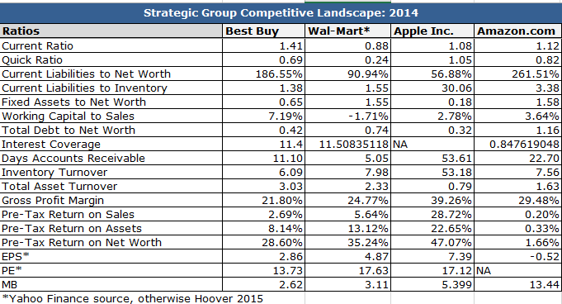

Table B
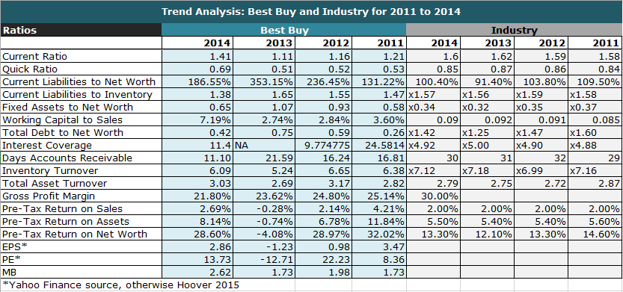

Interview Transcript
Employee engagement
Is employee engagement a key focus area at your store? If so how is this implemented?
Employee engagement is definitely a key focus area at my store. It is implemented in many ways. One way is that we create an open door policy where employees can speak their mind. As an organization, they have created a bonus program where employees bonus off of the same thing. This creates urgency of employees to reach a common goal. Leaders provide active one on one coaching so that employees are always aware of their goals. Evoice survey is also effective and we use results to come up with strategies(Ms. L)
As an hourly associate I feel that employee engagement is used. I like the one-on-ones with management. Evoice has been really hopeful in voicing my opinions. I feel as if management keeps me engaged.

Do you feel as if Best Buy as a company values employees? If so, do you think it is implemented at a store level?
I definitely feel like Best Buy values its employees and it is most implemented at a store level (Ms. L)
Yes definitely. I feel valued (Ms. H)
What does Best Buy do to encourage employee engagement?
To encourage employee engagement, Best Buy has not only created a bonus program, but it has also created a rewards program called Path to Excellence, where employees can earn points for other aspects of great performance and use those points to redeem prizes (Ms. L).
Yes, through the EVoice surveys we are given employee engagement integration (Ms M).
Do you think employee engagement can be improved? If so, how? If not what do you like about the employee engagement?
I think that employee engagement is currently at its best. I like that leaders make the employees feel comfortable about expressing themselves (Ms. L)
Yeah I think so. (Ms. H).
How do you measure employee engagement?
Best Buy measures employee engagement through a employee survey called E-Voice (Ms. L)
Rewards and incentives
Do you think the reward and incentives are beneficial?
Yes, they are definitely beneficial (Ms.L)
Yes, but a lot of the rewards and incentives are only given to full-time employees and sometimes this is not fair. Tuition reimbursement, benefits are for full-time only. Also for path to excellence full-time employees work more so they are able to get rewards faster because they interact and make sales more (Ms. H).
Do employees take advantage of rewards and incentives?
Employees do take advantage of rewards and incentives (Ms.L)
Yes, but not part-time employees (Ms. H)
Which is the most influential reward or incentive?
The most influential reward or incentive is our bonus structure and the ability for us to provide avenues for employees to get promoted (Ms.L)
Most influential would be tuition reimbursement (Ms. H)
Since rewards and incentives are often individual based, do you think this effects teamwork?
Since our main reward/incentive is not individual based, it creates at atmosphere where all employees have to work together as a team to achieve a bonus (Ms.L)
I am not sure, sometimes we compete (Ms. H).
Communication and culture
Procedures and policies are often given from corporate; do you see that there is a gap in implementation of these at a store level?
No, there is not a gap in implementation. There are some instances where we might make an exception, but that is on a case-by-case basis (Ms. L).
Do hourly employees have a close relationship with Market or territory managers? Does Management have a close relationship with Market or territory managers? (Close meaning good communication)
Our market managers have given employees the opportunity to communicate with them by all means. Management does have a close relationship with Market and Territory Managers, and there is consistent communication on a daily basis (Ms.L)
As an hourly associate I do not even know who my market and territory managers are. They do not talk to us, I get my information from management. I think there is a huge gap. I would be more motivated if those top managers encouraged me. (Ms.H).
How would you describe the organizations culture at a store level? Can this be improved?
We make technology easy and affordable for customers to have and use (Ms. L)
In the organizations business structure you have Corporate- territory-market- GM-Store managers-hourly associates. As a person in leadership do you think this is effective? If so how? If not why?
This is effective, as all forms of communication are cascaded from the top down. The company has done a great job of ensuring that each and every employee is informed through conference calls and visits. (Ms.L)
Customer service
How is customer service different from competitors? (Unique, competitive advantage)
Best Buy implements the customer promise, which is:
-The latest and devices and services- all in one place
-Competitive Prices (Every day low prices)
-Knowledgeable, impartial advice
-Shop when and where you want
-To support you for the life of your product (Ms. L)
How is inventory managed by your hourly associates?
It is manually counted every day and updated in our RSS system but this is not the most reliable. We often guess that it is off by 3.
What are the drivers of customer service?
-Employee engagement, urgency, and incentives drive customer service (Ms.L)
Does customer service need improvement?
-Customers’ needs are constantly changing; therefore, our customer service is consistently improving and evolving in order to be able to meet the needs of our customers (Ms.L).

References
AdvertisingAge (2015). Best Buy Sticks with Turnaround Plan Despite Sales Decline. Retrieved Feb 28 2015 from http://adage.com/article/cmo-strategy/buy-sticks-turnaround-plan-sales-decline/294711/

Avenir R. (n.d). How to Interpret Assets-to-Net-Worth Ratios. Demand Media. Retrieved Feb 9th, 2015 from http://smallbusiness.chron.com/interpret-assetstonetworth-ratios-57281.html
Baron, A., Armstrong, M. (2007) Human Capital Management: Achieving Added Value through People. London and Philadelphia: Krogan Page Limited.
BestBuy.com announces plans for launch of comprehensive Internet service for consumer electronics. (2000, Jan 06). PR Newswire Retrieved from http://0-search.proquest.com.leopac.ulv.edu/docview/449447307?accountid=25355
Best Buy Co. Inc. (2014). Form 10k. United States Securities and Exchange Commission. Retrieved Feb 21 2015 from https://www.sec.gov/Archives/edgar/data/764478/000076447814000011/bby-2014x10k.htm#sA7189035266A7359DE1F0D01B81161C8
Best buy ends work from home program. (2013, Mar 06). RTTNews Retrieved from http://0-search.proquest.com.leopac.ulv.edu/docview/1314816112?accountid=25355
Bureau of Labor Statistics (2013). Labor force projections 20 2022 : the labor force participation rate continues to fall. Monthly Labor Review. Retrieved Feb 01, 2015 from, http://www.bls.gov/opub/mlr/2013/article/labor-force-projections-to-2022-the-labor-force-participation-rate-continues-to-fall.htm
Business Insider (2013). The Creators of Best Buy’s Flexible Work Program are Furious That It’s Getting Dropped. Retrieved from http://www.businessinsider.com/best-buy-dropping-flexible-work-2013-3
Chang, A., & Zimmerman, M.(2009). Circuit City to close remaining 567 stores in the U.S. La Times. Retrieved March 2, 2015 http://articles.latimes.com/2009/jan/17/business/fi-circuitcity17
Crosby, J. (2008, Oct 16). Best buy hitting malls to push mobile phones. McClatchy - Tribune Business News Retrieved from http://0-search.proquest.com.leopac.ulv.edu/docview/455374011?accountid=25355
Crosby, J. (2010, Apr 01). How geek squad became geek army; after selling the repair firm he started in college to best buy, robert stephens helps guide its growth. Los Angeles Times Retrieved from http://0-search.proquest.com.leopac.ulv.edu/docview/422382040?accountid=25355

Damodaran A. (2015) Cost of Capital by Sector (US). Stern School of Business New York University. Retrieved on Feb 15th, 2015 from http://pages.stern.nyu.edu/~adamodar/New_Home_Page/datafile/wacc.htm
Editors, B. (2000, Jul 19). BestBuy.com's fulfillment & consumer care strategies lead to happy online shoppers; internet business combines the best of online shopping with existing stores. Business Wire Retrieved from http://0-search.proquest.com.leopac.ulv.edu/docview/445936464?accountid=25355
Encyclopedia.jrank.org. Consumer Electronics. Retrieved from http://encyclopedia.jrank.org/articles/pages/6483/Consumer-Electronics.html
eMarketer. (April 2014). Number of smartphone users in the U.S. from 2010 to 2018 (in millions). In Statista - The Statistics Portal. Retrieved February 03, 2015, from http://0-www.statista.com.leopac.ulv.edu/statistics/201182/forecast-of-smartphone-users-in-the-us/
IDC. (September 2013). Forecast for global shipments of tablets, laptops and desktop PCs from 2010 to 2017 (in million units). In Statista - The Statistics Portal. Retrieved February 03, 2015, from http://0-www.statista.com.leopac.ulv.edu/statistics/272595/global-shipments-forecast-for-tablets-laptops-and-desktop-pcs/
Juniper Research. (September 2013). Number of app-enabled mHealth and mobile-fitness (wearable) hardware device users in 2013 and 2018 (in millions). In Statista - The Statistics Portal. Retrieved February 03, 2015, from http://0-www.statista.com.leopac.ulv.edu/statistics/282489/app-enabled-mhealth-hardware-device-users/
Federal Reserve System (2013). Selected Interest Rates Daily, Historical Data. Board of Governors for the Federal Reserve System. Retrieved Feb 2, 2015 from http://www.federalreserve.gov/releases/h15/data.htm
Financials Morning Star (2015). Best Buy Income Statement. Retrieved Feb 7, 2015 from http://financials.morningstar.com/income-statement/is.html?t=BBY&region=usa&culture=en-US
Fox News (2015). In new budget, Obama proposing 14 percent tax on overseas profits to fund infrastructure projects. Retrieved on Feb 1, 2015 from http://www.foxnews.com/politics/2015/02/01/in-new-budget-obama-to-proposed-14-percent-tax-on-overseas-corporate-profits-to/
FitzGerald, D., & Calia, M. (2014, Nov 20). Best buy sales bounce back ahead of holidays; electronics retailer reports better-than-seen results. Wall Street Journal (Online) Retrieved from http://0-search.proquest.com.leopac.ulv.edu/docview/1626154253?accountid=25355
Fitzgerald, M. (2013). Best Buy Battles Back Online. Technology Review. Retrieved Feb 21 2015 from http://www.technologyreview.com/news/520821/best-buy-battles-back-online/
FitzGerald, D., & Calia, M. (2014, Nov 21). Corporate news: Best buy joins big-box rebounders. Wall Street Journal Retrieved from http://0-search.proquest.com.leopac.ulv.edu/docview/1626646182?accountid=25355
Gillian, R. (2013, Jun 13). Microsoft taking over big sections of best buy. Investor's Business Daily Retrieved from http://0-search.proquest.com.leopac.ulv.edu/docview/1367149616?accountid=25355
Greve, C., Davis, J. Recovering Lost Profits by Reverse Logistics. UPS. Retrieved Feb 21 2015 from http://www.ups.com/media/en/Reverse_Logistics_wp.pdf
Hoovers, Inc. (2015). Consumer Electronics & Appliances Stores. fact sheet. Retrieved Feb 7, 2015, from Hoover's Retailer Records database, http://0-subscriber.hoovers.com.leopac.ulv.edu/H/industry360/financials.html?industryId=1526
Hoovers, Inc. (2015). Best Buy. fact sheet. Retrieved Feb 7, 2015, from Hoover's Retailer Records database, http://0-www.mergentkbr.com.leopac.ulv.edu/index.php/reports/retailerFinancials/23058159
Hsu, T. (2012, Aug 21). Best buy selects hubert joly as CEO. Los Angeles Times Retrieved from http://0-search.proquest.com.leopac.ulv.edu/docview/1034420373?accountid=25355
Hsu, T. (2013, May 01). Best buy to make exit from Europe. Los Angeles Times Retrieved from http://0-search.proquest.com.leopac.ulv.edu/docview/1347033673?accountid=25355
IBM – Big Data in Action. Improve business outcomes using big daa for consumer products. Retrieved from http://www-01.ibm.com/software/data/bigdata/industry-consumer.html
IMF. (April 2014). Projected Consumer Price Index in the United States from 2014 to 2019. In Statista - The Statistics Portal. Retrieved February 03, 2015, from http://0-www.statista.com.leopac.ulv.edu/statistics/244993/projected-consumer-price-index-in-the-united-states/
Inbound Logistics (2007). 5 Burning Questions. Retrieved Feb 21 2015 from http://www.inboundlogistics.com/cms/article/5-burning-questions/
Inbound Logistics (2008). 3PL Elements: Outsourcing = A Formula for Change. Retrieved Feb 25 2015 from http://www.inboundlogistics.com/cms/article/3pl-elements-outsourcing-=-a-formula-for-change/
Inbound Lobistics (2010). Green Reverse Logistics Brings Many Happy Returns. Retrieved Feb 25 2015 from http://www.inboundlogistics.com/cms/article/green-reverse-logistics-brings-many-happy-returns/

Investopedia (n.d).Debt/Equity Ratio. Retrieved on Feb 9th, 2015. http://www.investopedia.com/terms/d/debtequityratio.asp

Investopedia. (n.d). Interest Coverage Ratio. Retrieved on Feb 9th, 2015. http://www.investopedia.com/terms/i/interestcoverageratio.asp
IRS (2015). Affordable Care Act Tax Provision for Employers. Inland Revenue Service. Retrieved Feb 1, 2015 from http://www.irs.gov/Affordable-Care-Act/Employers
Ismail, A. R. (2012). Understanding the factors that affect the adoption of innovative high-technology brands: The case of apple iPhone in malaysia. Journal of Global Marketing, 25(4), 226. Retrieved from http://0-search.proquest.com.leopac.ulv.edu/docview/1267150526?accountid=25355
Kumar, K. (2015, Jan 30). Best buy shifts emphasis from super bowl ads to digital marketing. McClatchy - Tribune Business News Retrieved from http://0-search.proquest.com.leopac.ulv.edu/docview/1648994371?accountid=25355
Lee, T. (2013, Jul 30). New geek squad chief may signal best buy push into business services. McClatchy - Tribune Business News Retrieved from http://0-search.proquest.com.leopac.ulv.edu/docview/1413372438?accountid=25355
Lee, T. (2013). Best Buy bets big on store-within-store concepts. Star Tribunal. Retrieved form http://www.startribune.com/business/215301161.html
Mark, L. (2014). Is Best Buy Still the Best Choice for Both Consumers and Investors. Fool Investing. Retrieved from http://www.fool.com/investing/general/2014/04/15/is-best-buy-co-inc-still-the-best-choice-for-both.aspx
Market Realist (2015). Best Buy: The largest consumer electronics retailer. Retrieved from http://marketrealist.com/2015/01/focus-online-sales-best-buy-goes-head-head-amazon/
MarketsAndMarkets (2015). Projected Revenue: Americas Smart Homes market from 2013 to 2020 (in billion U.S. dollars). Retrieved from http://0-www.statista.com.leopac.ulv.edu/statistics/296082/the-americas-smart-home-market-revenue/
Master, N. (2013). Tesco Improves Supply Chain with Big Data, Automated Data Collection. Rfgen. Retrieved from http://www.rfgen.com/blog/bid/285148/Tesco-Improves-Supply-Chain-with-Big-Data-Automated-Data-Collection
Moskowitz, D. (2014). Bet Buy Ships Faster Than Amazon. Fool Investing. Retrieved from http://www.fool.com/investing/general/2014/02/17/best-buy-ships-faster-than-amazon-really.aspx
Murray, M. (2013). Best Buy Adopt Supply Chain Efficiencies. About Money. Retrieved Feb 25 2015 from http://logistics.about.com/b/2013/05/23/best-buy-adopt-supply-chain-efficiencies.htm
NCSL (2014). State Minimum Wages Summary. National Conference of State Legislatures. Retrieved Feb 1, 2015 from http://www.ncsl.org/research/labor-and-employment/state-minimum-wage-chart.aspx
O’Donnel, J. (2014). Many stores don’t know what’s in stock. CNBC. Retrieved from http://www.cnbc.com/id/102296050

Rensselaer. (n.d) Introduction to management: Understanding Financial Reports and Financial Ratios. Lally School of Management and Technology.
Retail Wire (2009). Best Buy expands Private Label Electronics. Retrieved from http://www.retailwire.com/discussion/13716/best-buy-expands-private-label-electronics
Reuters (2015). Best Buy announces first buyback since 2012. Retrieved from http://www.cnbc.com/id/102470333#.
Reverse Logistics Magazine (2015). Best Buy Turning Returns Processing into Profit Center. Retrieved from http://www.reverselogisticstrends.com/rlmagazine/edition15p28.php
Saucerman, L. (2002). Apple opens first Manhattan store. DSN Retailing Today, 41(14), 5-5,26. Retrieved from http://0-search.proquest.com.leopac.ulv.edu/docview/228508798?accountid=25355
Seitz, P. (2014, Feb 28). Sony store closures likely good news for best buy. Investor's Business Daily Retrieved from http://0-search.proquest.com.leopac.ulv.edu/docview/1503159549?accountid=25355
Smith, D., & Cantrell, S. M. (2011). The new rules of engagement: Treating your workforce as a workforce of one. Strategic HR Review, 10(3), 5-11. Retrieved from http://0-search.proquest.com.leopac.ulv.edu/docview/868706703?accountid=25355
Simmons, T. (2015). The Keys to Unlocking Omni-Channel Retail Advantage. Forbes. Retrieved from http://www.forbes.com/sites/teradata/2015/01/02/the-keys-to-unlocking-the-retail-omni-channel-advantage/
Tam, D. (2014). Meet Amazon’s busiest employee – the Kiva robot. Cnet. Retrieved from http://www.cnet.com/news/meet-amazons-busiest-employee-the-kiva-robot/ Scharper, J. (2015, Jan 26). Obsession with FitBit, other fitness trackers prompts users to take steps. McClatchy - Tribune Business News Retrieved from http://0-search.proquest.com.leopac.ulv.edu/docview/1648109604?accountid=25355
Tischler, L. (2004, 05). WhaT's ThE buzz? Fast Company, , 76-77. Retrieved from http://0-search.proquest.com.leopac.ulv.edu/docview/228811927?accountid=25355
Thibodeau, P. (2011). Best Buy rebuilding IT capability outsourced, starts hiring. Computer World. Retrieved Feb 21 2015 http://www.computerworld.com/article/2498657/retail-it/best-buy-rebuilding-it-capability-it-outsourced--starts-hiring.html
Transparency Market Research (2015). Forecasted value of the global wearable devices market from 2012 to 2018 (in billion U.S. dollars). Retrieved from http://0-www.statista.com.leopac.ulv.edu/statistics/302482/wearable-device-market-value/
Usatoday (2013). http://www.usatoday.com/story/money/business/2013/05/21/best-buy-reports-1q-loss/2345373/
US Census Bureau. (December 2012). Percentage of population in the United States as of 2012, by ethnicities. In Statista - The Statistics Portal. Retrieved February 03, 2015, from http://0-www.statista.com.leopac.ulv.edu/statistics/270272/percentage-of-us-population-by-ethnicities/
US Census Bureau (2012). Table 2. Projections of the Population by Selected Age Groups and Sex for the United States: 2015 to 2060 (NP2012-T2). Retrieved Jan 31, 2015, from: http://www.census.gov/population/projections/data/national/2012/summarytables.html
US Census Bureau. (September 2014). Shares of household income of quintiles in the United States from 1970 to 2013. In Statista - The Statistics Portal. Retrieved February 03, 2015, from http://0-www.statista.com.leopac.ulv.edu/statistics/203247/shares-of-household-income-of-quintiles-in-the-us/
US Congressional Budget Office. (February 2014). Forecast of the unemployment rate in the United States for fiscal years 2012 to 2024. In Statista - The Statistics Portal. Retrieved February 03, 2015, from http://0-www.statista.com.leopac.ulv.edu/statistics/217029/forecast-to-the-unemployment-rate-in-the-united-states/
Rizkallah E., Truong A. (2010). Consumptive Behavior, Promotional Preferences, And Shopping Patterns of Hispanic Americans: An Empirical Perspective. Journal of Business & Economic Research. Retrieved Jan 31, 2015 from: www.cluteinstitute.com/ojs/index.php/JBER/article/download/710/695
Wasden, E. (2006). Consumer service is deciding factor for female consumer electronics purchases, according to study by good housekeeping institute; most women seek consumer service, clear understanding of product when considering technology purchases. Business Wire. Retrieved Feb 01 2015 from http://0-search.proquest.com.leopac.ulv.edu/docview/445301457?accountid=25355
Wall Street Journal (2012). http://www.wsj.com/articles/SB10001424052702303404704577311322427071212
Yahoo Finance (2015). Best Buy and Competitors. Retrieved Feb 7, 2015 from http://finance.yahoo.com/q/co?s=BBY+Competitors
Yahoo Finance (2015). Wal-Mart Income Statement. Retrieved Feb 7, 2015 from http://finance.yahoo.com/q/is?s=WMT+Income+Statement&annual

Zentes, J., Morschett, D., Schramm-Klein H. Strategic Retail Management: Text and International Cases. Springer Science & Business Media, Feb 2, 2012. Retrieved from https://books.google.com/books?id=dOK64-6VFrIC&pg=PA19&lpg=PA19&dq=insignia+brand+backwards+integration&source=bl&ots=KUxnBm6BSo&sig=0JnfYsNvHVikxIJ5EoZd20IO8gs&hl=en&sa=X&ei=6VH7VOncG8m9ggS81oLADg&ved=0CDMQ6AEwBA#v=onepage&q=insignia%20brand%20backwards%20integration&f=false

