Important Note to UMUC Students:
Xero is a New Zealand based company. This student manual has been edited to change the spelling of English words from British English to American English. For example, throughout the document, the British word “organisation” was changed to “organization.” If you detect misspelled words, please email Sharon.Levin@UMUC.edu so the document can be correctly for subsequent semesters.
In addition, Xero, the software, will use the British spelling of English words. Don’t let this throw you. If you can’t figure out the American version of the British word, Google it or ask your professor for help.

Xero

Accounting

Software
Student Manual
Using the Demo Company
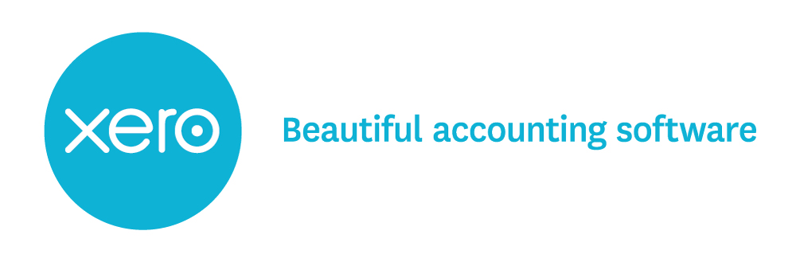
Contents
Welcome to the Student Manual 6
Let’s Get Started! 6
The Cloud 6
Create Your Xero Account 6
The Demo Company 10
Trial Organization name Error! Bookmark not defined.
Xero is live software. Dates in your exercises and assessments are important! 11
Manage Your Xero Access 12
Xero Security 12
Navigate Your Way Around 13
Menus 13
Icons 14
Tabs 15
Using excel .csv files 16
Xero Hints and Tips 18
Add New Accounts or Inventory items 18
Reports 18
Favorites 18
Xero’s Dashboard and Accounts drop-down menu 19
Select Accounts – Use Names or Numbers 19
Chart of Accounts 20
Set Up Your Chart of Accounts 20
Introductory Exercise Your Name Kayaks 22
Objective 22
The Business Scenario 22
Personalise your business name 22
Customize the Chart of Accounts 22
Conversion Date 27
Conversion Balances 28
Remove Current balances 28
Enter Trial Balance Amounts 28
Opening individual Accounts Receivable and Accounts Payable balances 31
Inventory Set Up 33
Transaction Time! 37
Process Credit Transactions for Inventory Items 37
Process Cash Transactions 43
Process Invoice/Bill Payments 48
Cash Receipts and Payments via Bank Reconciliation 50
Bank Reconciliation Procedure 50
Import Bank Statement File 51
Bank Statement Terms 52
Match Transactions 53
Create Transactions for Direct Bank Entries 54
Process Direct Credits for Part Payment of Sales Invoices 55
Work with Multiple Matches 56
Process Infrequent Transactions 58
Inventory Returns 58
Sundry Charges from Suppliers 63
Sundry Charges to Credit Customers 65
Drawings of Goods 67
Inventory Shortages 70
Purchase of Plant or Equipment on Credit 71
Correct Errors 73
Dispose of Plant or Equipment 77
Deal with a Sale Other than a Trade-in of Plant or Equipment (Fixed Assets) 82
View Your Reports 83
Journal Report 83
Profit and Loss 84
Balance Sheet 84
Wrap it Up 85
Correcting Receive Money or Spend Money Transactions 86
Invoices/Bills and Credit Notes 87
Manual Journal Transactions 89
Additional Resources 90
Help Centre 90
Xero TV 90
Xero U 91
Learn More About Using Xero 91
Appendix A - Introduction Exercise - Kayaks 92
Appendix B Your Name Home Care 104

Keys
 | Important |  | Helpful Hint | 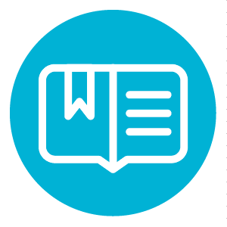 | Reference |  | Complete

Welcome to the Student Manual
You will use this manual to learn about Xero’s features and benefits. Throughout this manual you will learn what you can do and how to do it. The examples to illustrate concepts in this manual are based on the introductory exercise-Kayaks Ltd included in full as Appendix A to this manual. Enjoy!
The assessment activity will allow you to demonstrate your learning when you have completed the additional exercises.

Let’s Get Started!
Xero brings you online accounting that puts client financials at your fingertips. It’s easy for your clients, connected to banks and built in the cloud providing real-time access to what you need, when you need it. Let’s jump in and see how Xero can work for you.

The Cloud
Xero isn't software you need to install. Instead, it runs on the browser you normally use to access web pages on the internet. This means you have access to Xero anytime and anywhere you can get to the internet. Pretty convenient right? Xero works best on the Chrome or Safari web browsers.

Create Your Xero Account
All you need is a valid email address and Internet access. It is best to use your school email address if you have one. Follow these simple steps to log in and get started in Xero!
Go to www.xero.com/teaching and follow the online instructions to set up Xero’s free education trial.
This will give you access to Xero’s Demo Company, which you can use for all your exercises and your assessment activity.
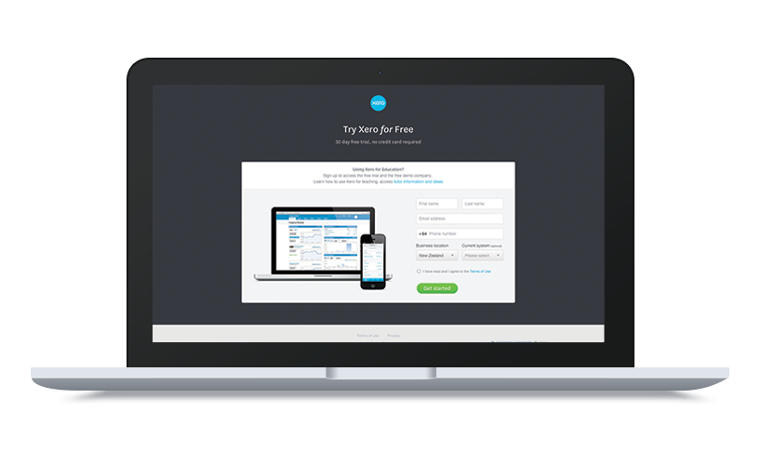 | STEP 1  Go to www.xero.com/teaching  Sign up using your own name and personal or  school email address.
 | STEP 2  Follow the prompt to your email Inbox, click  on the signup confirmation and activate  your Xero trial account.
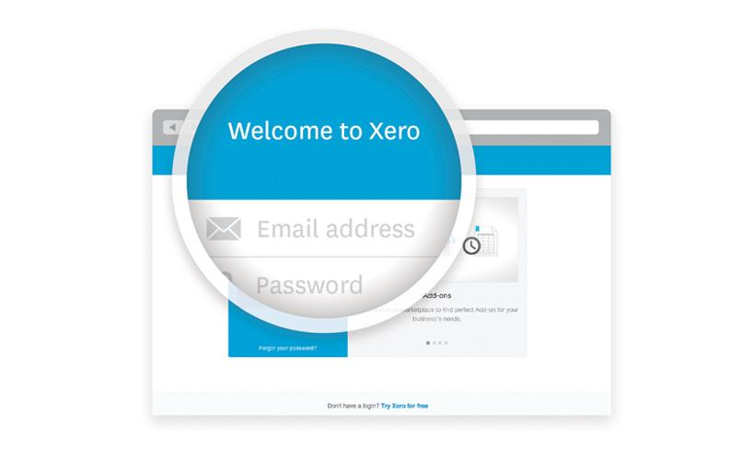 | STEP 3  Sign into Xero using the email address and password you have created.  We recommend that you add another layer of security to your Xero account by enabling Two-Step Authentication  https://help.xero.com/nz/MyXero_Two-Step_About
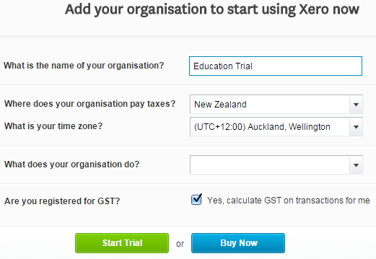 | STEP 4  Add Education Trial [& your own name] as your Organization Name and select Start Trial. You are now entered in the trial Organization called ‘Education Trial [your own name]’.  Click OK on the “You’re all ready to go” pop-up screen.
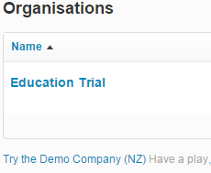  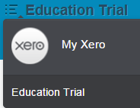 | STEP 5  From the Education Trial you can now access the Demo Company.  Select My Xero from the list menu beside your Education Trial business name  STEP 6  Under Organizations click on  “Try the Demo Company (NZ)”, to access the Demo Company.

STEP 7
Before starting an exercise in the Demo Company select the “Reset” button at the bottom of the screen. This ensures you have 28 days access to your demo company data.

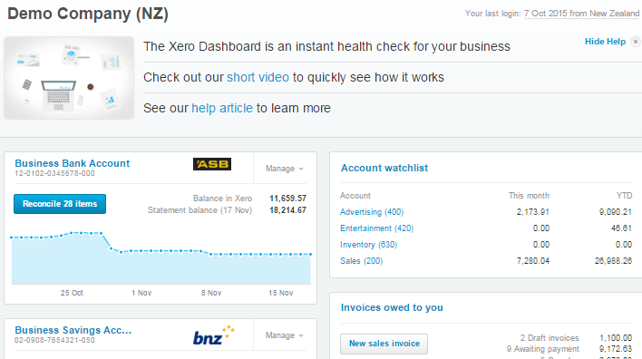 | STEP 8  You’re all ready to go!  You are now in the Demo Company so have a look around and take Xero for a test drive!

If you need more help with the signup process check out our video at
Getting Started Teaching Video (http://vimeo.com/107005153)

The Demo Company
You are going to use Xero’s Demo Company to learn how to process a variety of transactions using Xero accounting software.
All of the illustrations in this manual are from the Xero introductory exercise called
[Your Name] Kayaks. The complete exercise is attached to this manual as Appendix A.

Reset the Demo Company
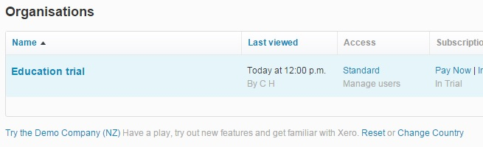
To make sure you have 28 days to complete your exercises you need to RESET the demo company before you start working in it.
To reset the demo company:
- Go to the MY Xero navigation menu.
- Click ‘Reset’ at the bottom of the screen.
You will return to the Demo Company dashboard where you can start your exercise.
The Demo Company’s data is automatically reset every 28 days.
Keep this in mind so you don't accidentally lose your work.

Change the Demo Company Name
Because everyone in the class has the same Demo Company in front of them, the first thing you need to do is change the name of the company. This way when you print out your journal files you will know which print out is yours.

It is very important to be able to distinguish your work for assessment purposes, so make sure you do this at the start of each exercise.

For each exercise and the assessment the company name will include your name.
In the example ‘Your Name Kayaks’ means if your name is Amy Lo your business will be called AMY LO KAYAKS.
To change the Demo Company name:
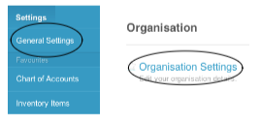
- Go to General Settings in the Settings drop down menu.
- Select Organization Settings.
- In the Basic Information change the Demo Company (NZ) name both as the Display name and the Legal / Trading name to ‘Your Name Kayaks’ as shown in this example for Amy Lo Kayaks.
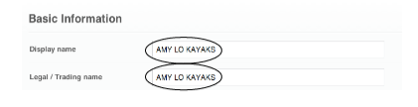
While you don’t need to add any more information or make any other changes to this screen you do need to save your changes.

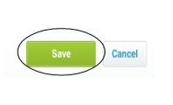
- In order to keep your company name scroll down to the bottom of the screen and click the green Save button, otherwise your business name will not change.

Xero is live software. Dates in your exercises and assessments are important!
You are going to use Xero’s Demo Company to learn how to process a variety of transactions using Xero accounting software. Because Xero is live software and works with real businesses living in the real world in real time, you are going to create a business with transactions using dates in 2013. This is so they are before any of the Demo Company transaction dates.

Demo Company
The bank statement files are setup for 2013 dates and the bank reconciliation process WILL NOT go smoothly if you have entered incorrect dates.
If you leave the date as current when you are working on your exercises, your transactions are going to get muddled up with all of the Demo Company transactions and will be hard to find. You don’t want that, particularly in your assessment, so copy the dates listed in the exercises.
Correct dates for balances and entries are very important.

Manage Your Xero Access
When you have finished working with Xero you should logout. If you forget, Xero will log you out automatically after your account has been idle for a while.
When you login again you may arrive at the My Xero screen.
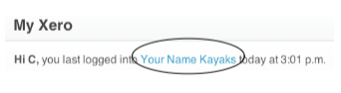
- In the My Xero screen click on the name you have given the Demo Company.
- You can do this to go back to where you were up to with your exercise.
- Everything you do is saved.

Note: if you haven’t been away long Xero will take you straight to the company

Xero Security
Make sure you have made a strong secure password and use wise digital strategies when you are online.
Here are some suggestions from Xero and some security concerns to look out for when you are online.
https://www.xero.com/nz/about/security/
Never give anyone else your login & password (if you want to invite other users to your Xero account you can do this within Xero using user settings)

Navigate Your Way Around
Now you've setup your Organization in Xero, let’s take a tour of the menus and dashboard to get comfortable.

Menus
Xero has 2 menus to help you set up Xero the way you want and move between Organizations:
- Name menu
- My Xero
Name Menu
Click your name at the top right of the screen to display the menu allowing you to access your profile and account settings and the logout button.
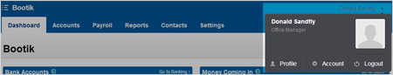

My Xero
From the header, click the list icon to see the My Xero menu. From here you can view and manage all Organizations and personal finances you have access to.
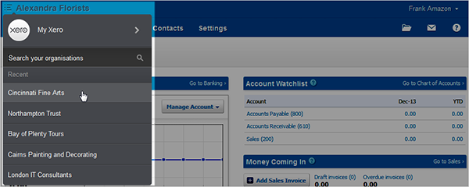

Icons
Xero displays up to 4 icons on the top right of the screen which provide access to some special features. Your user role will determine which icons you can see.
- Files
- Notifications
- Help
- Global Search
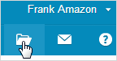 | Files  From the header, click the file icon to open the file library where you can use and manage your files.
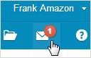 | Notifications  Click the envelope icon to view and manage notifications Xero sends to you. The number in the red dot shows how many unread messages are in your mailbox.
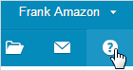 | Help  From the header, click the question mark icon to see all your options for getting help while you are using Xero.

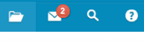 | Global Search  From the header, click the search icon to search for any $ amount, name or account in Xero. Xero search will help you find any transactions you have entered or uploaded.

Tabs
The main menu bar has up to 6 tabs, as well as the Dashboard, to help you use Xero for the organization you are logged in to.
Accounts
Manage the main business functions of your organization:
- Bank accounts
- Sales
- Purchases
- Inventory
- Expense claims
- Fixed assets
Reports
View your data using standard and Xero reports. You can customize many of these reports to suit your organization’s needs. You will need to view Journal Reports and Account Transaction reports from the All Reports link.
Contacts
Add and manage the people and organizations you do business with.
Settings
Change your organization settings, manage users and find add-on services.
Organization
- Organization Settings
- Tracking
- Conversion Balances
- Tax Rates
- Chart of Accounts
- Financial Settings
- Users
- Custom Contact Links
Features
- Invoice Settings
- Currencies (for some Xero pricing plans)
- Fixed Assets
- Email Settings
Connect
- Xero to Xero
- Add-ons
- Payment Services

Adviser
The Adviser menu tab is where you can create, edit and save reports and manual journals.
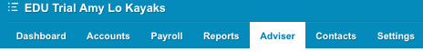

Dashboard tab
When you've set up your Xero account, the Dashboard screen is like a home page for your organization. The dashboard provides graphical snapshots of key indicators for your organization. The Dashboard is the main screen for each organization in Xero and displays a snapshot of your organization's financial position based on transactions entered into Xero. Use the Dashboard to directly drill down into a transaction, or do common tasks quickly like bank reconciliation or adding sales invoices or bills.

If you have just started with Xero, your Dashboard is likely to be fairly empty. Don't worry. Once we start with the exercises in the workbook, the dashboard will fill up with all sorts of great info fast!

Using excel .csv files
Excel .csv files are provided for students to upload a number of the general ledger accounts needed to complete each exercise, and bank statement line items for the bank reconciliation process.

The following files are available for this exercise:
- Chart of Accounts Kayaks-student.csv
This file has all the accounts the student needs to download into the Chart of Accounts for the business. Students are required to modify some accounts and add additional accounts to their Chart of Accounts. This is required for assessment.
- Bank Statement-Kayaks.csv
This file has the bank statement line items for each exercise so students are able to process transactions through Xero’s powerful bank reconciliation function. This will enable them to reconcile the bank as if they were using a live bank feed.

Xero Hints and Tips
Xero is designed to save you time and make things easier. Here are some tips for getting the most out of Xero.

Add New Accounts or Inventory items
The Settings drop down menu provides access to the Chart of Accounts where you can add new accounts. You can also add new accounts on the fly by clicking on the drop down arrow in the account cell of a transaction window where a blue +Add new account link will open up a new account window.
The Accounts drop down menu provides access to Inventory items where you can add new inventory items. You can also add new inventory items on the fly by clicking on the drop down arrow in the Item cell of a transaction window where a blue +New item link will open up a new inventory item window.

Reports
The Reports drop down menu is where you can access the Journal Report you will need to export to PDF to save and/or print out. Because the Journal Report allows you to check your entries as you work through an exercise it’s a good idea to make it readily accessible. Click on the Reports menu and select All Reports.

Favorites
The Xero pre-set Favorites, which appear in the Reports menu, are displayed with a solid blue star.
Under the heading Detail Reports, click on the star by Journal Report to include it in your favorites. Click on the star by Account Transactions, as you will find this useful when recording the sale of a fixed asset. You can click on the solid blue star beside any of the pre-set favorite reports to remove them from the Favorites list if you want to. This will reduce the Reports drop down menu and make it easier to locate the two reports you want access to.
Keep Profit and Loss and Balance Sheet reports so you can easily view these at the end of each exercise.
Click back on the Dashboard tab. Now you can access the Journal Report and the Account Transactions report from the Favorites list in the drop down menu under the Reports tab.

Xero’s Dashboard and Accounts drop-down menu
The Dashboard is where you should go to process your frequent transactions.
From the Dashboard you can manage your bank account and easily add new sales invoices for accounts receivable and new bills for accounts payable. You can also access transaction screens from the Accounts drop down menu but this manual recommends using the Dashboard for most frequent transactions.

Select Accounts – Use Names or Numbers
There are two easy ways to select the accounts to enter in a transaction window other than using the drop down arrow. You can use account names or numbers.

Use Account Names
Xero’s alpha recognition of account names has been used in these explanations by suggesting you type the first few letters of an account name to locate and select it easily. However unless the name has unique letters other accounts will also appear in the list. Make sure you select the correct account.

Use Account Numbers
Type an account number to give you access to that account alone. When you know the account number you can type this in to select the account. In some instances this may be quicker. Figure out what works best for different types of transactions. For example if you set up your inventory as 601, 602 and 603 using the account numbers to find the right inventory account may be quicker.

For more helpful hints see the Xero Help Centre (https://help.xero.com/nz/XeroTips)

Chart of Accounts
Your Chart of Accounts is a list of accounts that every transaction you enter into Xero is 'coded' to. This is important for management and reporting. You can leave the default Chart of Accounts, or edit and delete items from it, or add your own to suit your business.

Set Up Your Chart of Accounts
If you're using the Xero default Chart of Accounts you'll see it contains a broad range of typical accounts that will be suitable to most businesses. The account types used in Xero are arranged into the five financial elements. Some have slightly different names but they all belong in the same financial elements that we are used to:
- Assets
- Liabilities
- Equity
- Incomes
- Expenses
Xero Chart of Accounts  Account types | Xero Code Range | What we call this in school
Assets |  | Assets
Bank | 600s | Part of Current Assets
Inventory | 600s | Part of Current Assets
Prepayment | 600s | Part of Current Assets
Current Asset | 600s | Current Assets
Fixed Asset | 700s | Non-current Assets - PPE
Non-current Asset | 700s | Non-current Assets
Liabilities |  | Liabilities
Current Liability | 800s | Current Liabilities
Non-current Liability | 900-950 | Non-current Liability
Expenses |  | Expenses
Depreciation | 400s | Part of Expenses
Direct Costs | 300s | Cost of Goods Sold
Expense | 400s | Expenses
Overhead | 400s | Part of Expenses
Equity |  | Equity
Equity | 960-999 | Equity
Revenue |  | Income
Other Income | 200s | Part of Income
Revenue | 200s | Income
Sale | 200s | Sales (of goods)

When you add new accounts in Xero you must use the correct Account Type.
For assessment and moderation purposes, you should also ensure you allocate a code in the Xero code range for that type of account. Direct Costs have been assigned codes in the 300s to distinguish Cost of Goods Sold accounts from other Expense accounts. In the examples used in this manual Expense has been used for all expense accounts other than cost of goods sold.

Tax Details
You must also make sure the Tax details are correct. Entering incorrect tax details for an account means transactions processed to that account will not automatically be processed correctly in terms of GST. You will be told the tax details for each account you have to add, so ensure you enter these correctly.

Introductory Exercise Your Name Kayaks
The following instructions walk you through the introductory exercise step by step. You will need to have reset the Demo Company or started a new Trial Organization.
The introductory exercise is included in full without instructions as Appendix A.

Objective
At the end of this exercise you should be
- familiar with the set-up of an exercise in Xero using the Demo Company
- able to process frequent, infrequent and complex transactions in Xero

The Business Scenario
You are a small business owner. On 1 January 2013 you, the owner of Your Name Kayaks, decided to start using Xero accounting software to process your transactions.
You sell three main types of kayaks:
- Sea Kayaks
- River Kayaks
- Kids Kayaks

Personalise your business name
Change the Demo Company name to EDU “Your Name Kayaks” such as EDU Amy Lo Kayaks using the Organization Settings in the Settings, General Settings menu.

Customize the Chart of Accounts
Every business needs a Chart of Accounts that is unique for the business. In order to create a Chart of Accounts that has the accounts related to a kayak sales business, the following four steps are needed. These are explained in detail.
- Archive the accounts in the current Chart of Accounts.
- Import the exercise Chart of Accounts related to Your Name Kayaks.
- Create a Xero bank account for the business.
- Modify the imported Chart of Accounts.

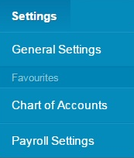
Access the Chart of Accounts
- Click on the Settings drop down menu.
- Select Chart of Accounts

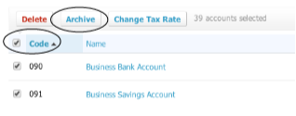
Archive Accounts
- Check the box by Code. This will select all the accounts in the list.
- Then click Archive which will bring up an Archive Accounts window where you click OK.

Import the Chart of Accounts related to your business
- To import a Chart of Accounts select the Import tab on the Chart of Accounts window

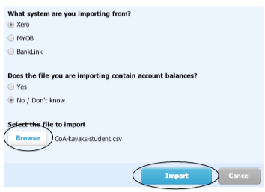
- Leave the Xero and No buttons selected in the Import your Chart of Accounts screen.
- Click the blue Browse button to find and upload the relevant Chart of Accounts file. (Your teacher will provide these files. The file for the kayaks introduction exercise is called CoA-kayaks-student.csv.)
- Once you have selected the correct Chart of Accounts file click Import.
- In the next screen click Confirm to confirm your Chart of Accounts. Don't worry - you can ignore any warnings.

Create a Xero Bank Account
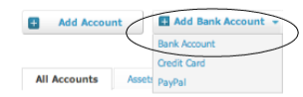
You need to add a bank account in order to spend or receive money in Xero.
To add a bank account you will need:
- a bank
- an account name
- a chart of accounts code for the account
- a bank account number
Make your Bank be “Your last name” FCU.
- Click on the down arrow on the right of + Add Bank Account.
- Select Bank Account.
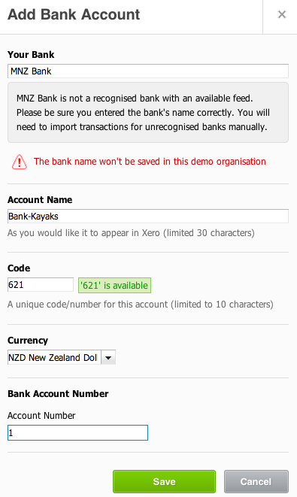
Here’s an example using the introductory exercise:
- Name the bank ‘Your last name’ FCU.
This will result in a message telling you this is not a recognized bank with an available feed. This is exactly what we want for exercise purposes. Having a recognized bank complicates matters as Xero is set up for the real world! So do not use a recognized bank here, just ignore the warning.
- For the Account Name: Use ‘Your name”.
- Use a code provided in the exercise for the bank account. eg. 601. Codes in the 600s are current assets.
- Provide your bank account number using any number – even 1 will do!
- Click Save when you have entered the required details.

You can use the tab key to easily move around fields in the screen.

Modify the Imported Chart of Accounts
You will need to modify the imported Chart of Accounts to meet the requirements of your exercise. Adding new accounts is required for your assessment, so you will do this for each exercise.
First you need to modify the Tax Rates to save some frustration. Got to Settings: Tax Rates. Pick Tax Rates and the Edit. Here you will click on + New Tax Rate and add the following:15% GST on income, 15% GST on expenses and No GST.
You can modify most existing accounts by clicking on the account name in the Chart of Accounts window. This brings up the edit screen where you can change the account details. For example you are expected to add your name to the Capital and Drawings accounts. System accounts like Accounts Receivable and Accounts Payable are locked and cannot be deleted or changed.
Here is a list of the accounts you need to add (highlighted in blue) and modify for the introductory Kayaks exercise. In the exercises and assessment you will find these accounts highlighted in the trial balance or additional accounts list. Make sure you use the correct account type and tax details for each account you create.
Code | Account Name | Account Type | Tax details
201 | Sea Kayak Sales | Sale | 15% GST on income
211 | Kayak Repair Fees | Other Income | 15% GST on income
301 | Sea Kayak COGS | Direct costs | No GST
434 | Shop Insurance | Expense | 15% GST on expenses
471 | Interest on Loan | Expense | No GST
605 | Sea Kayak Inventory | Inventory | 15% GST on expenses
740 | Vehicles & Trailers | Fixed Asset | 15% GST on expenses
741 | Accumulated Depreciation on Vehicles & Trailers | Fixed Asset | No GST
811 | Kea Trailers* | Current Liability | No GST
905 | Loan - MNZB | Non-current Liability | No GST
971 | Capital – Your Name | Equity | No GST
981 | Drawings – Your Name | Equity | No GST
* The supplier, in this example, for the credit purchase of plant and equipment
It is easier to manage adding and modifying accounts using the Assets, Liabilities, Equity, Expenses and Revenue tabs so you are not looking at too many accounts at once.
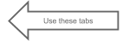
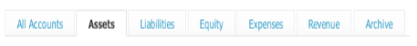

Add New Accounts
When adding new accounts the two most important things to get right are the Account Type and the Tax setting for GST:
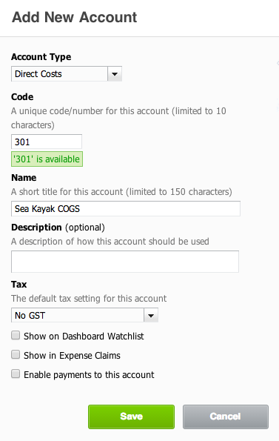
- The Account Type must be correct so the account will end up in the right place in the financial statements. An expense account must not end up in the balance sheet so the type for an expense account must be ‘Expense’ or if it is a cost of goods sold type account use ‘Direct Costs’ in Xero.
- Inventory accounts must be ‘Inventory’ or you won’t be able to set up your inventory items correctly.
- The Tax must be correct so GST will be correctly calculated when necessary or ignored when the transaction or account does not involve GST. For example internal cost transfer accounts like cost of goods sold, inventory shortage and depreciation do not have GST. On the other hand, Inventory and PPE asset accounts have 15% GST on expenses. It is up to you to make sure the GST is set correctly. The default settings are not always what you want.
- This example shows a cost of goods sold account being created for Sea Kayaks.

Practice your new skill
Now create all of the highlighted accounts in the account list above (page 24). And modify the Equity and Drawings account names to include your name. Use the Settings tab and Chart of Accounts settings screen to make these account code additions and changes.
You will need to edit Account 820 to GST.
Opening Balances
You are almost ready to start processing transactions for your business, but first you need to enter the opening balances from the trial balance. Xero calls these Conversion Balances. Enter your Organization's conversion balances so your starting point in Xero is correct.
You might like to think of conversion balances as one large journal that's used to bring in an Organization's opening balances.

Conversion Date
To enter Conversion Balances you first need to set the Conversion Date.
- From the Settings drop down menu select General Settings
- Click on Conversion Balances
- Click on Conversion Date
In the Conversion Balances window update the Conversion Date,
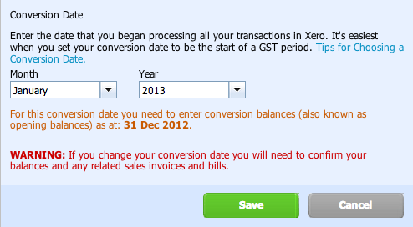
The conversion date (or start date) is the date you've chosen to start entering your day-to-day transactions into Xero.
- Change the Conversion Date to the month and year you are starting Xero
- For the introductory exercise change the month to January and the year to 2013
- Ignore the warning and click Save.

As a general rule, the conversion date is the date you start using Xero. You should only have transactions and invoices or bills in Xero that occur after this date.

Conversion Balances
If using the Demo Company you will now have the following screen.
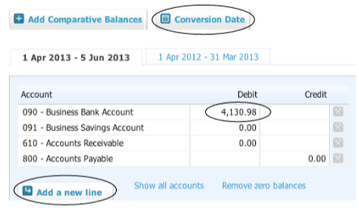

Remove Current balances
Using the Demo Company the Business Bank Account will have a balance that needs to be changed to zero. You are NOT going to use this account. You have set up your own bank account to use. Make sure Business Bank Account has a zero balance before you add your trial balance amounts.
We are now ready to enter the trial balance amounts.

Enter Trial Balance Amounts
Initially the conversion balance screen only shows bank balance(s) and Accounts Receivable and Accounts Payable system accounts with zero balances. You will enter the balances from your trial balance for these two system accounts.
Using the trial balance below enter the opening balances in the following way:
- Use the ADD a New Line button to add the other trial balance accounts and enter their balances as debit or credit.
- Xero has excellent alpha and numeric recognition so to find an account all you have to do is type the first few letters of the account name and options will appear or key in the account number.
- Do make sure you select the correct account, as you do not want to select Inventory Shortage when you need Inventory Adjustment. If you use the account number this will ensure you have the correct account.
- The Accounts Receivable and Accounts Payable balances in the trial balance must be entered in the System accounts which are already on the screen.
- Demo Company: Make sure you add your bank account (eg Bank-Your Name Kayaks) for the bank balance from the trial balance. Do not use the Demo Company’s Business Bank Account.
- When you have finished, total debits should equal total credits and the Adjustments number should be zero.
Xero will add the cents to any whole dollars you enter. You do not need to enter .00 for whole dollar amounts. eg. enter 590 and Xero will correctly record the amount as 590.00.

Your Name Kayaks
Trial Balance as at 31 December 2012

Note: The calculation for Inventory Adjustment amount is:
Code | Account Name | Debit | Credit
120 | Accounts Receivable* | 590
200 | Accounts Payable** |  | 3,130
601 | Bank – Kayaks (Your Name) | 3,400
699 | Inventory adjustment | 27,490
730 | Fittings & Equipment | 27,000
731 | Accumulated Depreciation on Fittings & Equipment |  | 10,800
740 | Vehicles & Trailers | 42,000
741 | Accumulated Depreciation on Vehicles & Trailers |  | 12,600
820 | GST |  | 950
905 | Loan - MNZB |  | 9,000
971 | Capital – Your Name |  | 64,000
 |  | 100,480 | 100,480
the total value of the inventory on hand – cost price x quantity added for each item.
For more help with conversion balances see the help/xero.com
https://help.xero.com/Settings_ConversionBalances
Always click Save after you make any changes to your conversion balances.

Here is what the example trial balance should look like before saving.
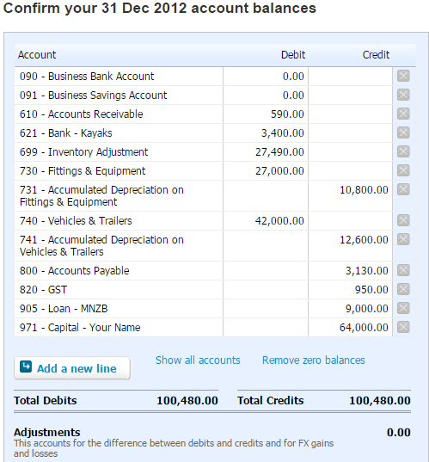
- Click Save when you are satisfied you have entered your opening trial balance or conversion balances correctly.
- Your adjustments figure should be zero as total debits equal total credits.

Opening individual Accounts Receivable and Accounts Payable balances
Saving your opening balance trial balance automatically brings up the Sales Invoices screen where you enter the amounts owing by individual debtor(s) that make up the Accounts Receivable total in the trial balance. In this exercise you are going to enter $590 owed by Blue Water at 31 Dec 2012.
- Click Add Invoice
- On the Sales Invoice for Accounts Receivable and Bill for Accounts Payable use the Tab key to move around.
  - To or From: Type the debtor’s or creditor’s name. This will automatically create an account for the debtor or creditor, so spell their name correctly!
  - Date: Leave as set by Xero for opening balance invoices
  - Due date: 20th of the January. This is important.
  - Invoice #: Leave as default, Reference: Leave blank
  - Total: Accounts Payable invoice only – leave blank; it will set itself
  - Currency: Leave as default which should be USD
  - Amounts are: Change to Tax Exclusive
  - Item: Leave blank (tab through)
  - Description: “Historical sale/purchase”.
  - Qty: 1, Unit Price: The amount owing by the debtor or to the creditor. $590
  - Account: Type hist and select Historical Adjustment or select from the drop down menu. It is important to use this account.
The screen looks like this for the introductory exercise showing $590 owing by Blue Water.
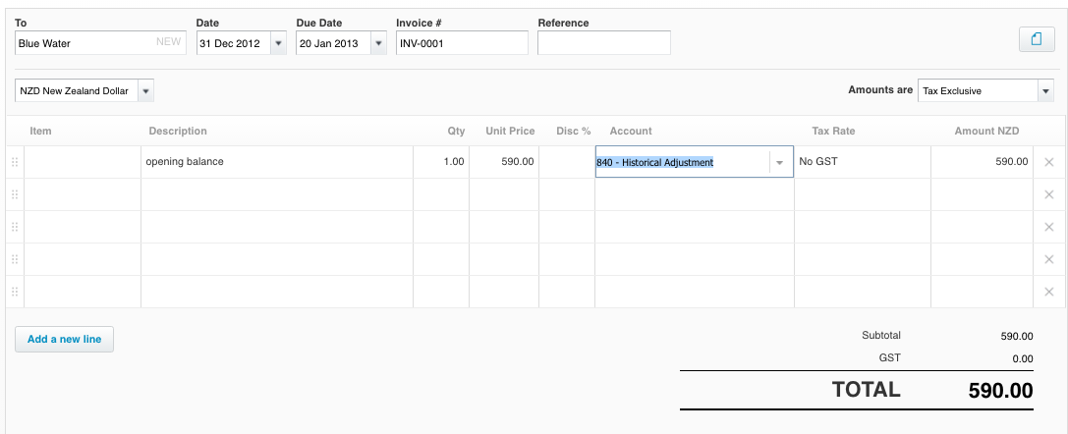
- Click Save
The next screen will tell you your total invoices match your total accounts receivable when you have entered all of them (in the example there was only one to enter).
- Click Next and repeat for opening creditor(s)
In this exercise you are going to enter $3130 owed by Kayak World at 31 Dec 2012.
The Kayak example opening creditor bill looks like this:
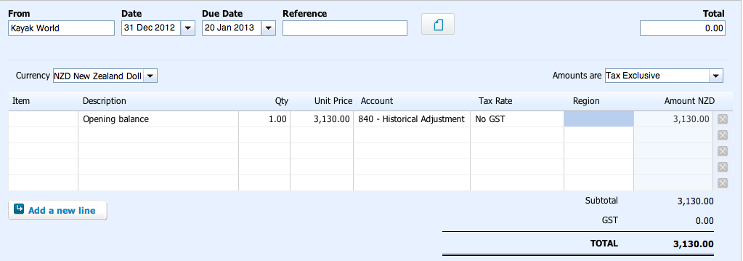
- Click add bill & enter the above bill details.
- Click save and you see the screen telling you your total bills match your accounts payable balance.
- Click Next and you have finished entering opening conversion balances.
The green message tells you that your conversion balances have been saved:
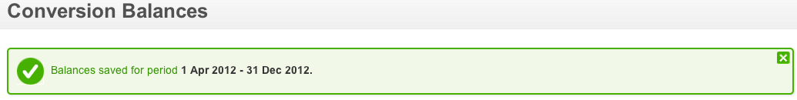
Congratulations! You are now ready to set up your inventory items.

Inventory Set Up
When you set up your inventory items as tracked Xero will track inventory balances, update them with each inventory transaction. Costs of goods sold balances are also automatically updated for inventory sales and sales return transactions.
Xero automatically keeps a running balance of the number of inventory items on hand and uses weighted average cost to allocate the average cost to cost of goods sold when you sell tracked inventory items.
Use inventory items for services or products you frequently charge or pay for to speed up creation of bills, invoices, credit notes, Spend and Receive Money transactions, and purchase orders. When you add or edit a transaction or purchase order, you can use the Item menu to search your list of inventory items by item codes and names. When you select an inventory item from the list, Xero will prefill the fields on the transaction or purchase order with the details from your inventory item, such as description and unit price.
Here are the inventory items in the introductory kayaks exercise:
 | Sea Kayaks | River Kayaks | Kids Kayaks
Cost price excluding GST | $1,375 | $575 | $196
Selling price excluding GST | $2,085 | $1,285 | $515
Quantity | 12 | 14 | 15

To set up your inventory items:
- From the Accounts drop down menu select Inventory which takes you to the Inventory window.
- If using the Demo Company delete all the current inventory items by selecting them all and clicking on Delete. You won’t be able to delete the tracked items but you won’t use them either.
- Click +New Item
- In Item Code write the short name of the item e.g. Sea Kayaks = “SK01”
- Item Name: Write the item name here e.g. Sea Kayaks
- Tick the I track this item button which brings up a drop down box to select the Inventory account associated with the item of inventory
- Key in, or select from the drop down menu, the associated inventory account eg 605 - Sea Kayak Inventory – you should have created this – if not you can create it here.
- In the I purchase this item area:
  - Unit Price: enter the GST exclusive cost of the inventory item
  - Cost of goods sold account: key in or enter the associated cost of goods sold account e.g. Sea Kayak COGS
  - Tax rate will default to No GST if you have set up your COGS account correctly
  - Purchase description: Credit purchase
- In the I sell this item area:
  - Unit Price: enter the GST exclusive selling price of the inventory item
  - Account: enter the associated sales account for the item eg Sea Kayak Sales
  - Tax rate will default to 15% GST on Income if you have set up your sales account correctly
  - Sales description: Credit sale
- Click Save
- Add other inventory items in the same way.
Here is what the Sea Kayaks inventory card looks like before clicking Save:
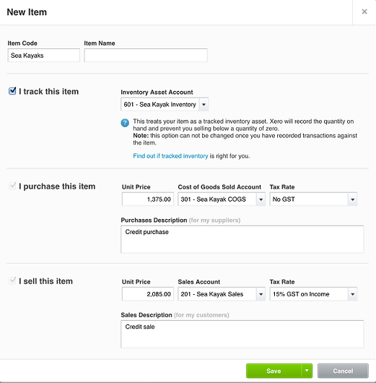

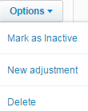
Add the opening quantity on hand NEW!!
- In the inventory window click on the inventory name under Item code eg Sea Kayaks
- You are now in the Sea Kayaks window
- From the Options drop down menu (on the right) select New adjustment
- In the Adjustment window:
  - Adjustment type: Select Increase quantity from the drop down menu
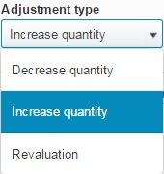
  - Date: 1 Jan 2013 (you can type this date in)
  - Adjustment: Enter the quantity on hand, eg 12
  - Cost price: Enter the unit cost price excluding GST for the inventory on hand
  - New qty on hand will be your adjustment number
  - Adjustment Account: Key 699 – Inventory Adjustment. Make sure you have the Inventory Adjustment account entered here, do not use Inventory Shortage
  - Note: Key “On hand”
Your window should look like this before clicking Review Adjustment
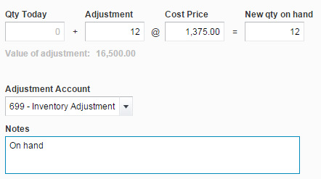

- Click Review Adjustment
  - You will see a debit to the inventory account and a credit (brackets) to the inventory adjustment account for the total of the adjustment (12x1,375=16,500)
- Click Post Adjustment

Practice your new skill
Repeat the process for other items of inventory - River kayaks and Kids kayaks.
Click on Inventory above the Sea Kayak name to return to the inventory window and select your next item of inventory to adjust.
Note: when you are familiar with the entire process you can adjust each item of inventory immediately after setting it up.
Remember to check your transaction entering as you go!
All the transactions you enter can be checked in the journal report under the reports tab, journal report. All transactions are listed in the journal report in date order.

Transaction Time!
Now that we are all set up we can get to the good stuff. Let’s learn to process transactions using Xero accounting software. You’ll notice that the examples used to illustrate concepts here are all in the introductory exercise, Your Name Kayaks. Here in the manual you will have all the info you need to learn about Xero. Use the exercises in the workbook to put to practice what you have learned here.

Process Credit Transactions for Inventory Items
Keep track of inventory items you have bought or sold.

Inventory Purchases on Credit
Add a bill that you have received and need to pay.
Enter the details of the bill you received, using as many line items as required (there must be at least one). If needed, you can use different inventory items, accounts, tax rates, and prices (positive, negative or zero amounts) on different lines as necessary.
If you set up inventory items in Xero, you can choose an item from this list. Doing this automatically populates your bill fields, using the information you have saved against the inventory item in the set up.
For tracked items the selected inventory account cannot be changed on your bill screen so it must be entered correctly in the inventory setup. If there is an error correct it under inventory.

Worked Example:
7 Jan 2013 - Purchased 6 river kayaks and 5 kids kayaks on credit from Wild Water Ltd.
- Go to the dashboard
- Select New Bill under Bills you need to pay on the Dashboard
- In the New Bill window type and tab between
  - From: Wild Water Ltd
  - Date: 7 Jan 2013
  - Due date: 20 Feb 2013
  - Tab through to Item on the first detail line leaving Reference and Total blank, the Currency set to USD United States dollar
  - Amounts are: Tax Exclusive.
  - Item: Type River and select River Kayaks or select from the drop down menu
  - Description: Credit purchase (will default if entered in inventory setup)
  - Quantity: 6
  - Tax rate: Change to 15% GST on expenses – this is very important as regardless of your inventory account settings, Xero defaults to No GST and needs to be changed to include GST on your bill
  - Tab to the second line under Item
  - Item: Type Kids to select Kids Kayaks or select from the drop down menu
  - Description: Credit purchase (default – tab through)
  - Quantity: 5
  - Tax rate: Change to 15% GST on expenses (to quickly access type 1 and tab)
  - Key tab to complete the bill
  - Check your bill has an amount for GST included
- Click Approve
Your bill should look like this before clicking Approve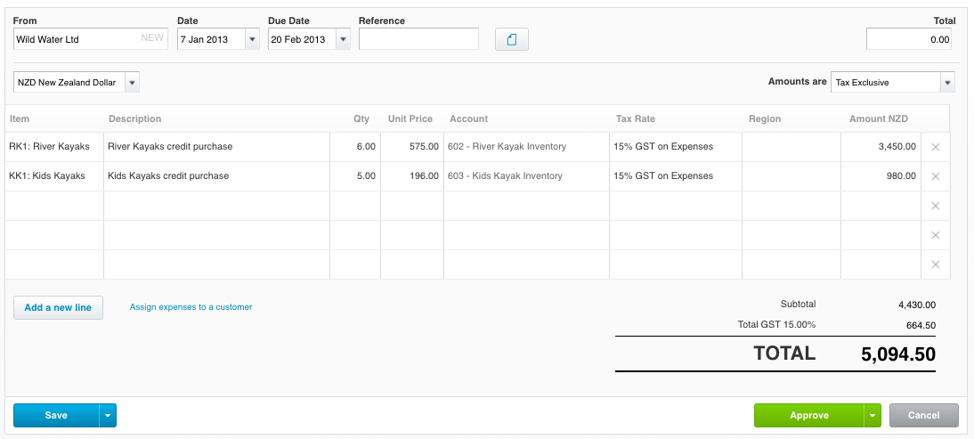
You can Add Another Bill or return to the Dashboard for your next transaction.
Once you have saved or approved the bill, you can create the bill as a PDF to print.

Practice your new skill entering Bills
Process these additional bills for Kayaks Ltd using the steps outlined in the worked example above.
Date  2013 | Transaction  All bills are due on 20 February 2013 | Bill Total
Jan 8 | Purchased 5 sea kayaks on credit from Kayak World. | $7906.25 GST Inclusive
Jan 16 | Purchased 4 river kayaks and 7 kids kayaks on credit from Wild Water Ltd. | $4222.80 GST Inclusive

Inventory Sales on Credit
Add a sales invoice for someone to pay you and send it to them

Worked Example:
7 Jan 2013 Sold 2 sea kayaks and 3 kids kayaks on credit to Blue Water.
- Go to the dashboard
- Select New Sales Invoice under Invoices owed to you on the Dashboard
- In the New Invoice window type and tab between:
  - To: Blue Water
  - Date: 7 Jan 2013
  - Due date: 20 Feb 2013
  - Invoice #: leave default INV-0042
  - Tab through to Amounts are Tax Exclusive
  - Amounts are: For inventory items ensure Tax Exclusive is set. In the first instance this is the default setting. However the setting will change for a GST inclusive charge for repair fees or equivalent so you need to ensure it is Tax Exclusive when you are entering inventory sales.
  - Item: Type Sea to select Sea Kayaks or select from the drop down menu
  - Description: Credit sale (will default if entered in inventory setup)
  - Quantity: 2
  - Unit price: will default to the selling price you entered at inventory setup ($2,085)
  - Account: will default to the sales account you entered at inventory setup (Sea Kayak Sales)
  - Tab to the second line under Item
  - Item: Type Kids to select Kids Kayaks or select from the drop down menu
  - Description: Credit sale (default tab through)
  - Quantity: 3
  - Unit price and Account will default to the entries made at inventory setup ($515)
  - Key tab to accept the quantity
- Click Approve

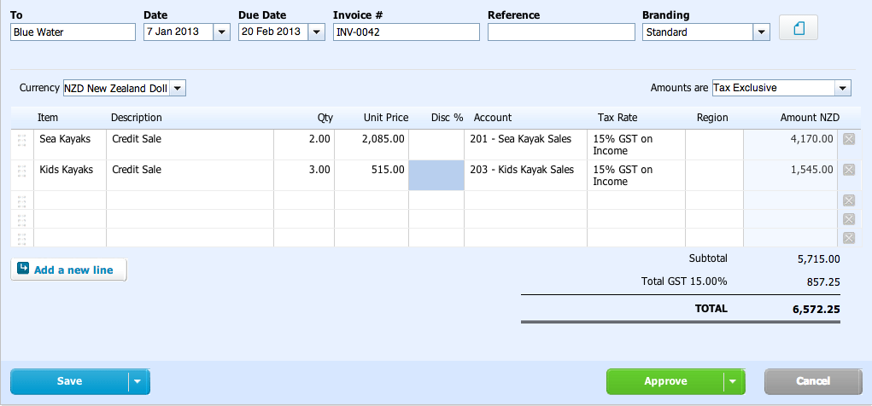
Your invoice should look like this before clicking Approve:

Once you have saved or approved the invoice, send a PDF or online invoice to your customer.

Cost of goods sold transfer

In the background Xero has completed a cost of goods sold transfer for you.

You can check this by viewing the Journal Report. The first time you view this report you need to locate it.

From the Reports drop down menu, select All Reports if you have not already made Journal Reports a favorite
- Click on the blue star beside Journal Report so it becomes a favorite in the drop down menu and easy to access to check other entries. You can uncheck the blue star beside reports you don’t need to see like aged receivables and aged payables so there are less items in the drop down menu.
- In the Journal Report window change the date range as follows:
  - From: 1 Jan 2013
  - To: 31 Jan 2013,
- Click Update to view the journal entries you have completed.
Here are two entries related to the credit sale on 7 Jan 2013.

Note: If the journal entries appear in a different order on your journal report that is fine. It is just the way Xero processes the transaction in your software version.
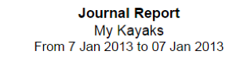
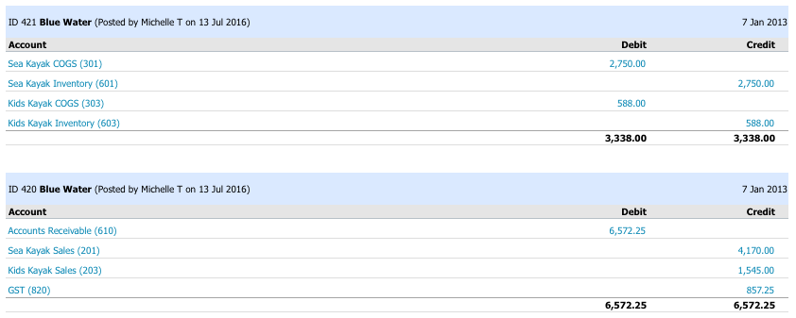

Practice your new skill entering invoices
Process these additional credit sales invoices following the steps outlined in the worked example above
Date  2013 | Transaction  All invoices are due on 20 February 2013 | Invoice Total
Jan 11 | Sold 6 river kayaks to Paddle Plus on credit. | $8866.50 GST Inclusive
Jan 24 | Sold 1 sea kayak and 4 kids kayaks to Blue Water on credit. | $4766.75 GST Inclusive

Process Cash Transactions
Xero has a number of ways to record cash receipts and cash payments transactions. We will learn the following methods:
- Spend Money or Receive Money except for payments associated with bills or invoices.
- Adding a payment to a creditor for a bill received.
- Adding a payment received from a debtor for an invoice issued
- Bank reconciliation process after importing a bank statement
Each of these methods is now explained in detail.

Spend Money
If a payment has been made that is NOT a bill payment to a creditor (Accounts Payable/supplier), enter a Spend Money transaction at the time you pay the money.
Worked Example:
4 Jan 2013
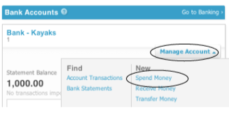
Paid Key Media for marketing $368.90 by online bill payment #6372.
- From the Dashboard Bank Accounts access the Manage Account drop down menu for Bank-Kayaks and select Spend Money.
- In the New Spend Money window type in the cells
  - Spent as: leave set to Direct Payment
  - To: Key Media
  - Date: 4 Jan 2013
  - Reference: BP 6372
  - Amounts are: Tax Inclusive (you can leave this setting for all expenses as the codes set up with no GST, like wages and interest on loan ignore this GST inclusive setting)
  - Item: leave this blank, you can tab through
  - Description: Marketing
  - Quantity: 1
  - Unit Price: $368.90
  - Account: Type Mar to select Marketing or select from the drop down menu
- Click Save or Save & add another if you are doing another Spend Money next
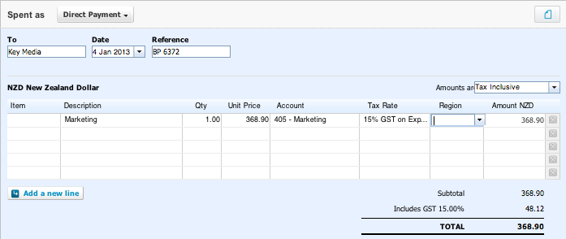
Here’s what it looks like before clicking Save:

Practice your new skill
Process these additional payments
Date  2013 | Transaction  Transactions include GST where relevant unless otherwise stated | Transaction Details
Jan 13 | Paid Joe Henry $826.54 for wages by online bill payment #2385 | Code to wages  Enter as spend money  Ref #2385
Jan 21 | Paid for personal groceries at Pak ‘n Save with the business EFTPOS card $197.65 | Code to drawings  Enter as Spend Money
Jan 27 | Paid Kiwi Property for shop rent $935.00 by online bill payment #5192 | Code to rent  Enter as spend money  Ref #5192

Personal expenses are not business expenses. All personal expenses are recorded and coded to the account code Drawings.

Receive Money
If a cash sale or payment has been received that is NOT an invoice payment from a credit customer (Accounts Receivable), enter a Receive Money transaction at the time you receive the money.
You need to be able to process cash received for other income or the sale of a fixed asset as well as cash sales of inventory. Cash sales of inventory is explained separately.
Worked Example: 1) Cash Receipts (except cash sales of inventory items):
9 Jan 2013
Received and banked a check for kayak repairs $143.72
- Select New Receive Money from the Bank Accounts Manage Account drop down menu. In the Receive Money window type and tab between
  - From: Cash customer
  - Date: 9 Jan 2013
  - Reference: Check deposit
  - Amounts are: Tax Inclusive (for income and asset sales including GST)
  - Item: leave blank
  - Description: Kayak repairs
  - Quantity: 1
  - Unit Price: $143.72
  - Account: Type Repair and select Kayak Repair Fees or select from the drop down menu
- Click Save or Save & add another if you are doing another Receive Money next
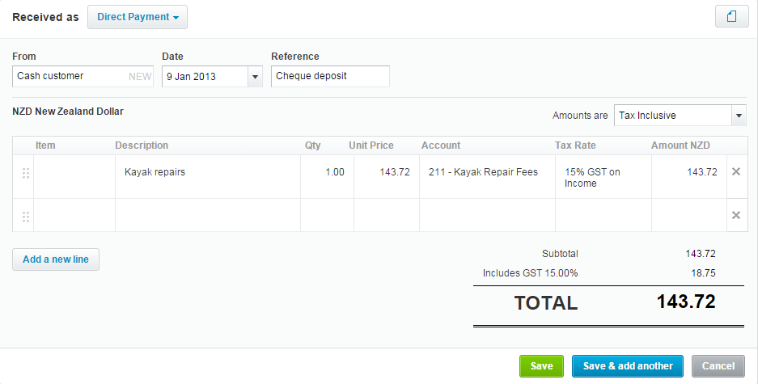
Here’s what it looks like before clicking Save:

Worked Example:

2) Cash Sales of Inventory items:
4 Jan 2013 - Cash sales: 2 Sea Kayaks, 3 River Kayaks and 4 Kids Kayaks
In the Receive Money window type and tab between:
- From: Cash customer
- Date: 4 Jan 2013
- Reference: EFTPOS
- Amounts are: Tax exclusive (important as selling price of inventory items is tax exclusive)
- Item: Sea Kayaks
- Description: Cash sale – change Credit to Cash in the default entry
- Quantity: 2
- Unit Price: Will default to $2085 if you set up Sea Kayak inventory correctly
- Account: Will default to Sea Kayak Sales if you set up Sea Kayak inventory correctly
- Tab to the second row
- Item: River Kayaks
- Description: Cash sale – change Credit to Cash in the default entry
- Quantity: 3
- Unit Price: will default to $1,285
- Account: will default to River Kayak Sales
- Tab to the third row
- Item: Kids Kayaks
- Description: Cash sale - Credit to Cash in the default entry
- Quantity: 4
- Unit Price: will default to $515
- Account: will default to Kids Kayak Sales
- Click Save or Save & add another if you are doing another Receive Money next

Here’s what it should look like before you click Save:
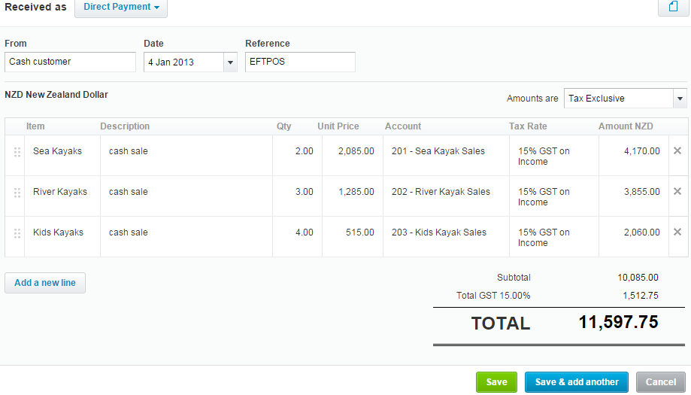

Practice your new skills
Process these additional cash receipts
Date  2013 | Transaction  Transactions include GST where relevant unless otherwise stated | Transaction Details
Jan 16 | Received cash (EFTPOS) for repair fees $289.00  (make sure amounts are Tax Inclusive) | Code to repair fees  Enter as receive money  Ref #EFTPOS
Jan 16 | Cash sales (EFTPOS): 3 sea kayaks and 3 kids kayaks  (make sure amounts are Tax Exclusive) | Code to sea & kid kayak sales  Enter as receive money  Total $8970.00 GST inclusive
Jan 25 | Cash sales (EFTPOS): 4 river kayaks and 2 kids kayaks (make sure amounts are Tax Exclusive) | Code to river & kid kayak sales  Enter as receive money  Total $7095.50 GST inclusive

Process Invoice/Bill Payments
Money Received from Credit Customers (Accounts receivable)
For money received from credit customers (Accounts Receivable) you can access the invoices using the graph for Invoices owed to you on the Dashboard.
If you have correctly entered the invoices for your accounts receivable they will appear in the “Older” section of the graph.
Click on the bar for “Older” and the invoices you have entered will appear. You must select the correct invoice. For an opening balance payment select the opening balance invoice.
If your invoices don’t appear in front of you, click on the Awaiting Payment tab to find them. If they are not there you will have, by mistake, entered a payment for them when you initially processed them. If this is the case they can only be found under the All tab.
Money Paid to Credit Suppliers (Accounts Payable)
For money paid to credit suppliers (Accounts Payable) you will follow the same procedure using the graph in the Bills you need to pay section of the dashboard.
Clicking on the Older section of the graph should bring up your invoices.
To more easily locate your invoices/bills click on Date to change the date order and bring your bills to the top of the list – provided of course you have entered them with the correct dates
Once you have selected the correct invoice or bill that is being paid such as the opening balance invoice/bill the procedure will be the same for Accounts Receivable and Accounts Payable.
Clicking on the debtor/creditor name will bring up the View Invoice/View Bill screen where the invoice/bill will show as Awaiting Payment.
Demo Company users will have additional invoices/bills in the awaiting payment screen that relate to the Demo Company. You need to ignore these. Click on the date arrow to change the date order and bring your bills to the top of the list.

Worked Example:
20 Jan 2013 — Used online bill payment # 1735 to pay $2,130 to Kayak World in part payment of the amount owing on 31 December 2012.
In the blue section at the bottom you need to:
- Check the Amount Paid is correct – you will have to change the amount if it is for less than the total of the invoice/bill as the Amount Paid defaults to this total.
- Eg: In this example for Kayak World change $3,130 to $2,130.
- Add the Date Paid.
- In Paid To/From type Bank-Kayaks or select Bank-Kayaks from the drop down menu.
- Add a Reference eg BP 1735
- Click Add Payment.
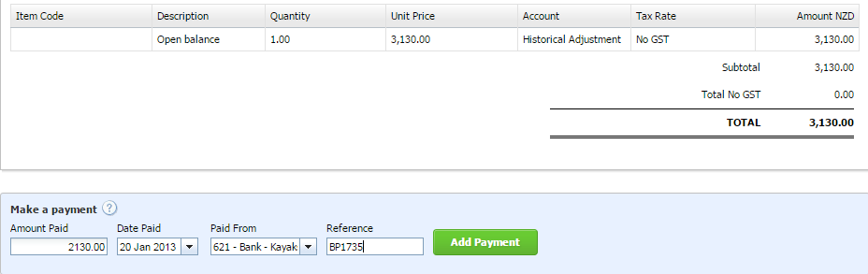
By following the instructions above the payment section of your bill should look like this before clicking Add Payment.

Practice your new skills
Process these additional invoice/bill payments
Date  2013 | Transaction | Transaction Details
Jan 22 | Received and banked a check for $590 from Blue Water in full settlement of the amount owing on 31 December 2012. | Enter through Invoices Owed to Me – Awaiting Payment
Jan 28 | Used online bill payment #2914 to pay Wild Water Ltd in full settlement of the invoice dated 7 January 2013 | Enter through Bills to pay – Awaiting Payment $5094.50
NOTE | Don’t forget to check your journal report to see if the transactions have been entered correctly | Remember to change the date range to go from Jan 2013

Cash Receipts and Payments via Bank Reconciliation
In the real world, Xero has a brilliant bank reconciliation function that allows live feeds from your Bank showing the transactions coming through your bank account on a daily basis. This means each day you can update all your cash payment and cash receipt transactions straight from your bank reconciliation screen in Xero. You actually don’t have to record them first in almost all instances.
Xero will find matches where it can and you can add rules to tell Xero what to look for. You can create Spend Money or Receive Money transactions in the bank reconciliation window when Xero hasn’t found a match. We are only going to ‘scratch the surface’ so to speak in regards to how powerful Xero’s bank reconciliation function is in this regard.
As we cannot have real live bank feeds we will have to import a bank statement file but once we have done this Xero will work in exactly the same way as if the bank statement items had arrived overnight from the banking system.
Your teacher will provide you with the bank statement file to import for each exercise. The exercise instructions will tell you at what point.

Bank Reconciliation Procedure
Bank reconciliation is when you match statement lines from your bank account with transactions you create in Xero. Xero automatically matches transactions in Xero with statement lines where it can. Alternatively, to reconcile your statement lines, you can create Spend or Receive Money transactions on the spot or find and match transactions you've already entered into Xero.
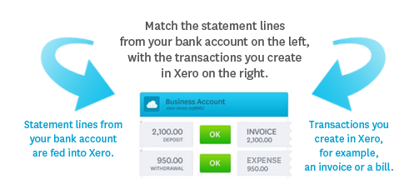
On the Dashboard, your Bank account will show a Statement Balance of the opening balance you entered.
If you have recorded any Spend Money or Receive Money or any invoice/bill payments the balance in Xero will show the effect of those transactions on the Statement Balance (your opening balance).

Import Bank Statement File
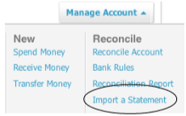
You now need to import a csv file of your bank statement.
This will be provided by your teacher.
- IMPORTANT: Make sure you select the correct bank account from the dashboard – Select the ‘Your Name Kayaks Bank Account’ before you import the bank statement
- To import your bank statement - from the Manage Account drop down menu under Reconcile (on the ‘Your name kayaks bank account) select Import a Statement.
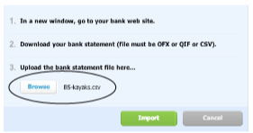
- In the next screen click on the blue Browse button, find and upload the correct csv bank statement file then click Import.

- The following Statement Import Options screen will appear.
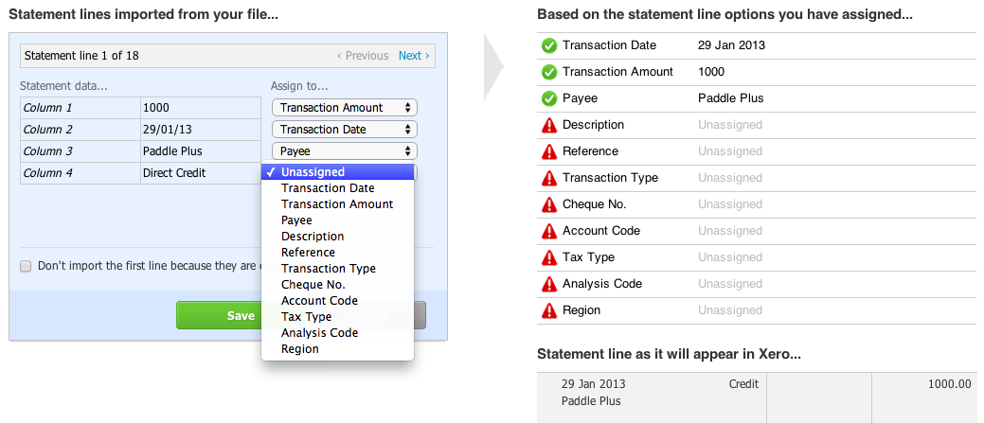
- IMPORTANT: You need to assign Payee to Column 3 and Reference to Column 4 by using the drop down menus
- then click Save.
- Click OK.
- Close the Getting Started box on the next screen.
- You will then see ‘Review your bank statement lines… …then match with your transactions in Xero.

Once the bank statement has been imported follow the instructions to match different types of transactions.

Bank Statement Terms
These terms will help you with the reconciliation process.
- Your Name Kayaks All Cards - This is the one total on the bank statement for all cash transactions on the same day received via EFTPOS. All Cards means all commonly used debit and credit cards from the major banks. The business name is the Payee.
- MNZ Bank 1554 Deposit - A deposit of physical cash and/or checks is recorded with the bank name and branch number where the deposit was made as the Payee.
- Direct debits and direct credits - Details of direct debit and direct credit payments will be provided.

For Your Name Kayaks
On the bank statement the details for the direct bank transactions are:
- Teleco Direct Debit is for Phone & Website Expense
- L Hohaia Direct Credit is for Kayak Repair Fees
- Max Energy Direct Debit is for Electricity
- Paddle Plus Direct Credit is in part payment of their invoice dated 11 Jan 2013
- Bank charges, interest on loan and loan principal are all paid to MNZ Bank

Do not proceed with the next section until you have processed all the transactions in the Introductory Exercise above.

Xero does not always automatically match the correct transaction. If you need to change the match click find & match on the right of the bank reconciliation box and select the correct invoice.

Match Transactions
For most of the transactions you have already entered as Spend Money or Receive Money, you will see Xero has found a match in the right hand column for your bank statement line item in the left hand column.

When Xero finds a match you see it highlighted in green so matches are easy to spot.

When you are happy the match is correct click the OK button between the two columns and the item is reconciled and removed from the list.

- Click OK for the second item Key Media $368.90 as this is the correct match.
The screen looks like this:
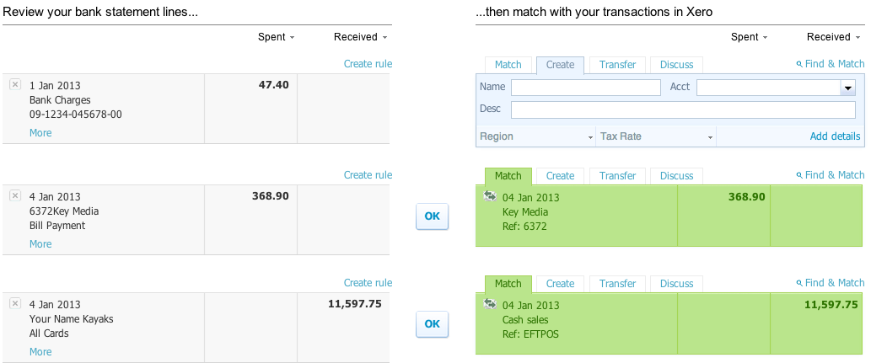
- Click OK for the Cash Sales Your Name Kayaks as this is a correct match for total of $11597.75 EFTPOS sales of kayaks.
- Continue to review and remove all the matches you are happy are correct before dealing with the remaining transactions.
- If you are working on the introductory kayaks exercise you will be left with 8 bank statement line items to code and reconcile after agreeing to the matches Xero has found for you. See below for instructions on entering transactions from the bank reconciliation screen.
Except for the Your Name Kayaks All Cards deposit on 16 January 2013 and the direct credit from Paddle Plus on 29 January 2013 proceed as follows:
When using the Demo Company make sure Xero hasn’t found a match with one of its more recent transactions. If this happens you will need to find your transaction using find & match and remove the transaction Xero has found for you.

Create Transactions for Direct Bank Entries
In the blue shaded boxes on the right of the bank statement line item:
- Name: The payee – use MNZ Bank as the payee for bank charges, interest on loan and loan repayments.
- Acct: Select the correct account by typing the name or selecting from the drop down menu.
- Description: Write what the transaction is for. Do not leave this blank.
- Click OK.
The OK button didn’t appear? Make sure you have a payee and an account otherwise Xero can’t create your transaction. You should also have a description before clicking on OK.

Here’s how it looks for the 1 Jan 2013 bank charges:
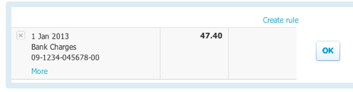 | 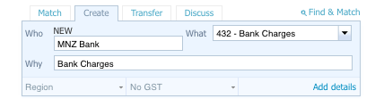
and for the direct debit to Telco:
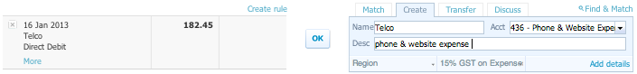
and for the bank loan principal repayment:
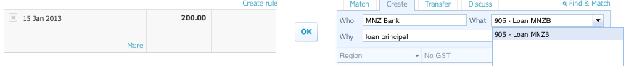there are 3 more transactions for you to code and enter. Interest on Loan payment, Max Energy-electricity payment, L Hohaia-kayak repair income.

Process Direct Credits for Part Payment of Sales Invoices
This example relates to the part payment of an invoice issued to Paddle Plus. Because the direct credit payment received is not for the full amount of the invoice, Xero won’t be able to find a match. You have to find the invoice the payment relates to and allocate the payment to the invoice.
- To find the invoice the payment relates to click on the Find & Match tab on the right.
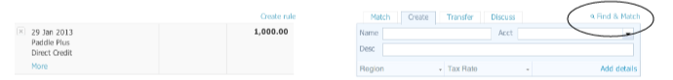
- This will bring up a find and match screen with a number of transactions identified.
- You need to tick the relevant transaction, in this case Paddle Plus invoice on 11 Jan 2013. Because the invoice is for more than the $1,000 received, the word Split will appear.
- You need to click on Split as you are splitting the payments for this invoice (i.e. receiving more than one payment to pay it off).
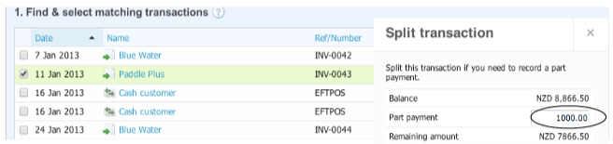
This will bring up the Split transaction screen where you will see the $1000 showing as a part payment.
- Click Split 
- The Paddle Plus transaction will now be ready to be reconciled and will appear in green as follows:
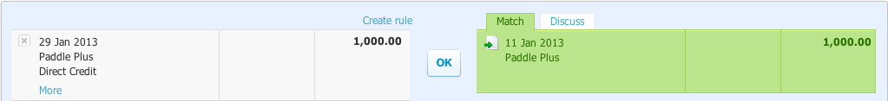
- Click OK and the payment will be processed to the 11 Jan 2013 invoice.

Work with Multiple Matches
When two (or more) Xero transactions make up a deposit its called a multiple match.
The Your Name Kayaks All Cards deposit does not have a match in Xero even though the transactions making up this deposit have been processed. Xero didn’t find a match because it is a multiple match. This means two (or more) Xero transactions make up this deposit. EFTPOS overnight deposits will create this situation on a daily basis if you classify your income into different codes when you record it in Xero.
Because we know we have actually recorded the two transactions (cash sales of kayak inventory and kayak repair fees in the introductory exercise) that make up this deposit we can get Xero to find them for us.
- Click Find & Match on the right of the Xero transaction column.
- Under 1. Find & select matching transactions:
  - Tick the box beside each of the items dated 16 Jan 2013.
  - This allows Xero to identify that these two transactions sum to the EFTPOS deposit on 16 Jan 2013 and Xero creates for you a green-highlighted Match stating 2 transactions selected.
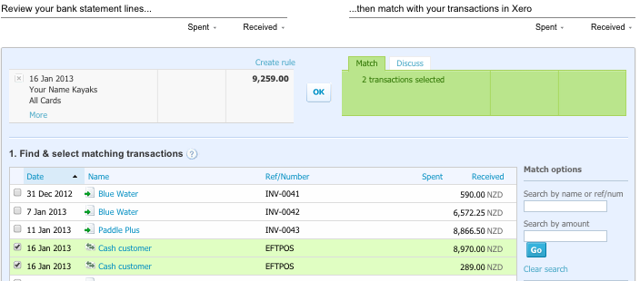
- Now click OK.
- When you have completed the bank reconciliation process you should receive this message:
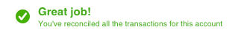
Doesn’t match on your bank reconciliation screen? Don’t panic! If an amount or other details are wrong on your bank reconciliation screen you can edit any transaction directly from here. Click on the find and match tab and click the transaction name. Xero takes you directly into the transaction and under the bill options tab use edit to make any changes you need. Go back and reconcile the item in bank reconciliation.

Process Infrequent Transactions
So now that we've learned about the basics, let’s consider some less common transactions you will need to know how to process in Xero.

Inventory Returns
Before processing a sales return from a credit customer (Accounts Receivable) or a purchases return to a credit supplier (Accounts Payable) you need to have processed the related credit sale or credit purchase.
Xero has two different ways to process a return of inventory. Both involve the preparation of a credit note.
You can assign the inventory return as a credit note attached to the invoice or bill directly by opening the unpaid invoice or bill and selecting Add Credit Note. As a beginner this method has a number of traps for the unwary and is not recommended unless you are fully conversant with what an inventory return entry should involve.
As a beginner, you are much less likely to make a serious mistake with the inventory return, if you create a new credit note for the return first. This is the process that is explained here. Either method, completed correctly, results in exactly the same journal and related accounting entries in Xero.
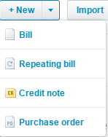
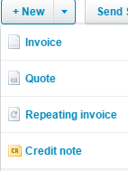
Creating a new credit note
From the Accounts drop down menu select Sales for a Sales Return or Purchases for a Purchases Return.
Alternatively click on Invoices owed to you or Bills you need to pay on the Dashboard.
In the Sales or Purchases window click on the +New drop down menu and select Credit Note

Inventory Returns to Credit Suppliers (Purchases credit note)
Worked Example:
11 Jan 2013 — Returned one sea kayak purchased on 8 January 2013 to Kayak World.
Note: Before processing this purchases return, you need to have processed the related credit purchase of 5 sea kayaks on 8 January 2013.
- Access a New Credit Note from the Purchases window
- In the New Credit Note window type and tab between
  - From: Kayak World
  - Date: 11 Jan 13
  - Reference and Total: Leave blank.
  - Currency and Amounts are: Leave as USD and Tax Exclusive
  - Item: Type Sea to select Sea Kayaks
  - Description: Credit purchase return – add return to the default Credit purchase
  - Qty: Number returned (1 in this example)
  - Tab to Tax rate and change
  - Tax rate: 15% GST on expenses (like for processing bills for inventory, you must change this as default for the inventory account is No GST)
  - Tab to complete the return
- Click Approve
ve
The credit note for the worked example looks like this before clicking Approve:
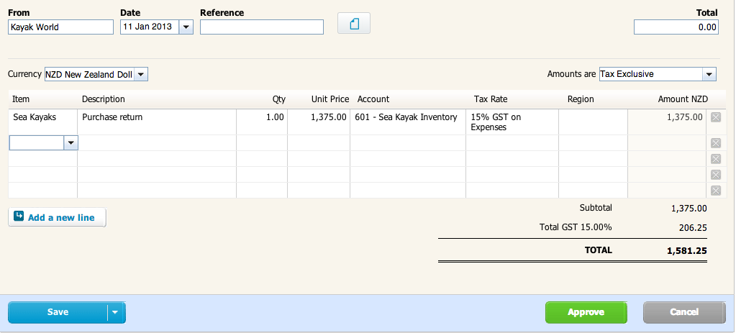
Once you have clicked Approve the Allocate balance on Credit Note screen will appear:
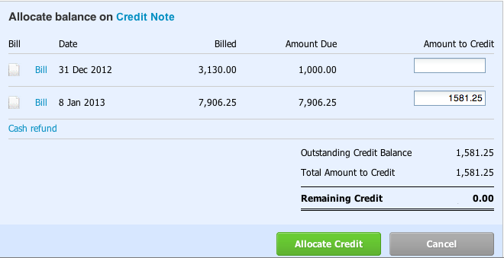

- Select the bill the credit note relates to and enter the total outstanding credit balance in the Amount to Credit box.
- If there is more than one bill make sure you have allocated the credit to the correct bill and key tab. In this example you must not allocate the credit to the opening balance bill as the return is not related to this.
- Key Tab to accept the ‘Amount to Credit’
- Remaining Credit should then be zero
- Click Allocate Credit.

Practice your new skills
Process this additional purchases return
Date  2013 | Transaction | Transaction Details
Jan 18 | Returned 2 kids kayaks purchased on 16 January 2013 to Wild Water Ltd | Purchases credit note  2 x Kids kayaks  Total Credit note $450.80

Inventory Returns by Credit Customers (Sales credit note)
Worked Example:
14 Jan 2013 — Paddle Plus returned 2 river kayaks purchased on 11 January 2013.
Note: Before processing this sales return, you need to have processed the related credit sale of 6 river kayaks on 11 January 2013.
- Access a New Credit Note from the Sales window
- In the New Credit Note window type and tab between:
  - To: Paddle Plus
  - Date: 14 Jan 2013
  - Tab through to Item (leave default settings, ensure Amounts are:
Tax exclusive)
  - Item: Type River to select River Kayaks
  - Description: Sales return
  - Qty: 2
  - Tab to accept the number returned.
  - The Unit price and Account will correctly default to the selling price and relevant sales account
  - Tab through to accept - Tax rate: 15% GST on income
- Click Approve.
The worked example credit note should look like this:

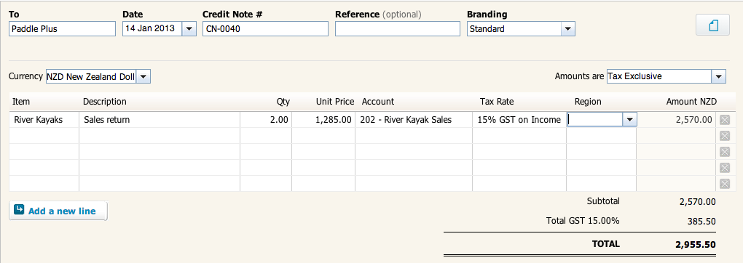

Once you have clicked Approve the Allocate balance on credit note screen will appear:
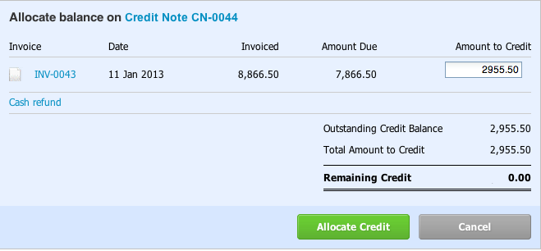
- Select the invoice the credit note relates to and enter the total outstanding credit balance in the Amount to Credit box.
- If there is more than one invoice make sure you have allocated the credit to the correct invoice and key tab.
- Remaining Credit should then be zero
- Click Allocate Credit.
In the background, Xero will have reversed the cost of goods sold entry for this return.
You can check the journal entries by viewing them in Journal Reports.

Practice your new skills
Process this additional sales return
Date  2013 | Transaction | Transaction Details
Jan 28 | Blue Water returned 1 kids kayak purchased on 24 January 2013 | Sales credit note  1 x Kids kayaks  Total Credit note $592.25

Sundry Charges from Suppliers

Add a Freight Charge to a Credit Purchase Bill for Inventory Items
When the unit cost price of each inventory item is GST exclusive, the freight charge must also be recorded at the GST exclusive cost.
Worked Example:
15 Jan 2013 — Purchased 4 sea kayaks and 4 kids kayaks from Kayak World. Kayak World added a freight charge of $75.00 excluding GST.
- From the Dashboard from Bills you need to pay select New bill.
- Enter Kayak World, the date above, Due date 20 Feb 2013
- 4 sea kayaks and 4 kids kayaks add on the bill,
- Amounts are Tax Exclusive, ensuring you have adjusted the Tax Rate for the Inventory accounts to 15% GST on expenses, then proceed as follows on the next row:
  - Item: leave blank
  - Description: Freight charge
  - Quantity: 1
  - Unit cost: GST exclusive cost of the freight – in the example $75.00
  - Account: Type Freight to select Freight Inwards or select from the drop down menu
- Click Approve.
The worked example bill should look like this before clicking approve:
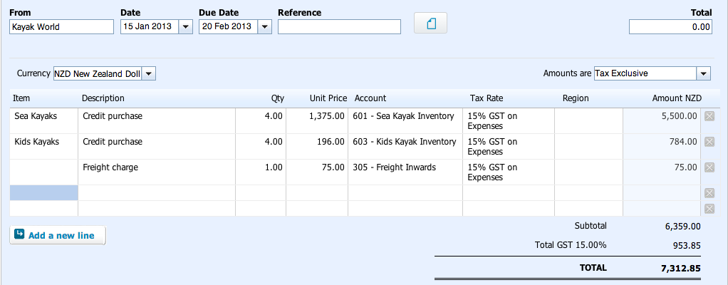

Receive a Bill/Invoice for a Service Provided
A new supplier will be created when the bill is recorded. If you are provided the GST inclusive amount of the charge, the new bill will also need to be set to Amounts are: Tax Inclusive.
Worked Example:
22 Jan 2013 — Canoe & Kayak sent an invoice for advertising in NZ Kayak magazine $247.50 including GST. Advertising is recorded in the Marketing account.
- From the Dashboard select New bill.
- In the New Bill window type and tab between:
  - From: Canoe & Kayak, Date: 22 Jan 2013
  - Due date: 20 Feb 2013,
  - Reference and Total: Leave blank, Currency: leave default
  - Amounts are: change to Tax Inclusive (as you have been given a GST inclusive amount)
  - Item: leave blank
  - Description: NZ Kayak magazine advertising
  - Qty: 1, Unit price: 247.50
  - Account: type Mar to select Marketing or select from the drop down menu
  - Tab to accept account
- Click Approve.
The worked example invoice should look like this before clicking Approve:
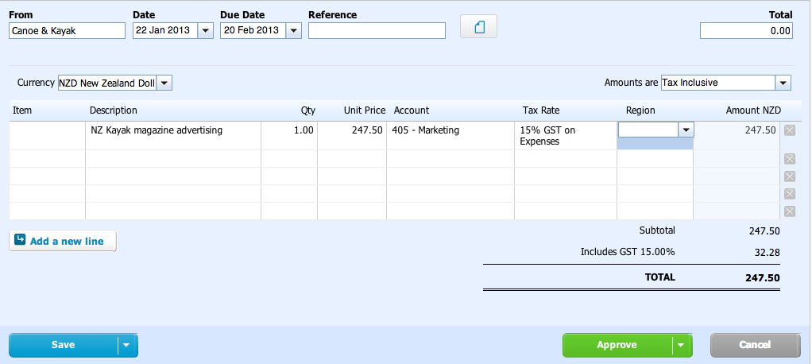
If you create this bill with ‘Amounts are’ Tax Inclusive and then process another bill for inventory items you will have to reset the ‘Amounts are’ back to Tax Exclusive.

Sundry Charges to Credit Customers

Add a Charge to a Credit Sales Invoice for Inventory Items
When the unit selling price of each inventory item is GST exclusive, the charge must also be recorded at the GST exclusive price. A new debtor will be created when the invoice is recorded.
Worked Example:
17 Jan 2013 — Sold 2 kids kayaks to A Lo on credit.
Added $34.00 excluding GST for painting names on the kayaks. Account to use: Kayak repair fees.
- From the Dashboard Invoices owed to you select New sales invoice
- Enter A Lo, the date, due date 20 Feb 2013
- and 2 kids kayaks on the invoice then proceed as follows:
  - Tab to the second line
  - Item: leave blank
  - Description: Painting names on kayaks
  - Quantity: 1
  - Unit cost: GST exclusive cost of the repair fees – in the example $34.00
  - Account: Type Repair and select Kayak Repair Fees or select from the drop down menu
- Click Approve
The worked example invoice should look like this before clicking Approve:
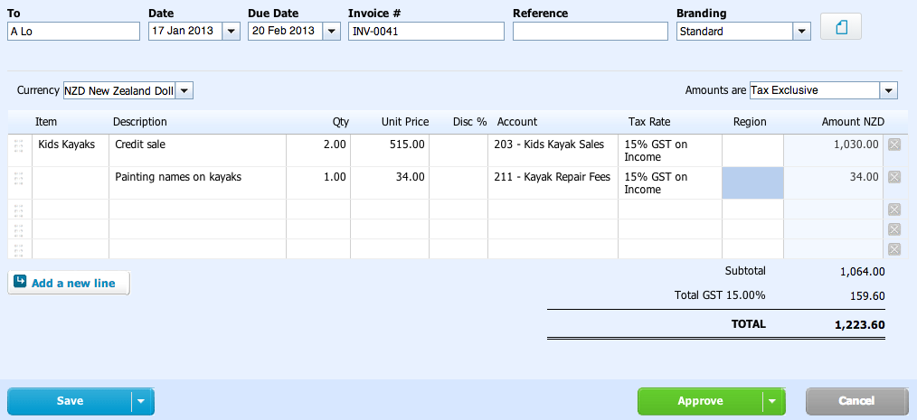

A Charge for Repair Fees or Other Income
A new debtor will be created when the invoice is recorded. If you are provided the GST inclusive amount of the fee, the new sales invoice will be set to Amounts are: Tax Inclusive.
Worked Example:
22 Jan 2013 Charged L Huang $54.65 including GST for repairs to her old kayak.
- From the Dashboard select New Sales Invoice
- In the New Invoice window type and tab between
  - To: L Huang , Date: 22 Jan 2013
  - Due date: 20 Feb 2013
  - Tab through to Amounts are:
  - Amounts are: change to Tax Inclusive (as you have been given a GST inclusive amount)
  - Item: leave blank
  - Description: Kayak repairs
  - Qty: 1, Unit price: 54.65
  - Account: type Rep to select Kayak Repair Fees or select from the drop down menu
  - Tab to accept account
- Click Approve.
The worked example invoice should look like this before clicking Approve:
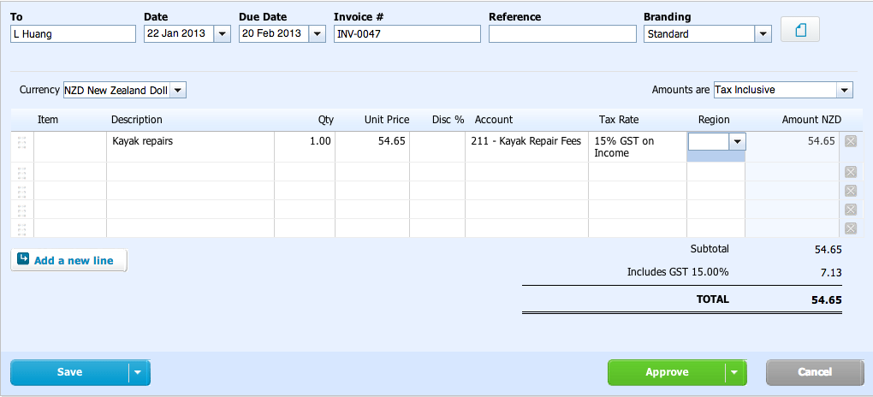
If you Create this invoice with Amounts are Tax Inclusive and then process another invoice for inventory items you will have to reset the Amounts are back to Tax Exclusive.

Drawings of Goods
Personal expenses are not business expenses. Drawings is the accounting term for money or stock you use from the business for personal use. All personal expenses are recorded and coded to the account code Drawings.

Two entries are required.
      - The first entry records the reduction in inventory at GST exclusive cost using an Inventory Adjustment, which will debit drawings and credit the relevant inventory account.
      - The second entry records the reversal of the GST claimed by a debit entry to drawings for the GST that can no longer be claimed for this inventory and a credit entry to GST.
It may help to see what you would do in the class room (with good old fashioned paper and pen) to understand these two entries.
For example:
The general journal entry to record drawings of one kid’s kayak which cost $196 excluding GST would be:
 | Debit: Drawings | 225.40
 | Credit: Inventory |  | 196.00
 | Credit: GST |  | 29.40

This can be separated into a debit to drawings and credit to inventory for the GST exclusive cost $196 which in Xero is an inventory adjustment and a debit to drawings of $29.40 and a credit to GST of $29.40 which needs to be recorded in Xero in a Manual Journal (which is Xero’s General Journal).

Worked Example:
28 Jan 2013 — You gave one river kayak to your friend as a birthday present.

Step One: Complete the inventory adjustment
- From the Accounts drop down menu select Inventory.
- Click on the Inventory name you need to adjust – eg river kayaks
- Select New Adjustment from the Options drop down menu on the right
- In the New Adjustment window type and tab between (note explains the worked example):
  - Adjustment type: Leave default as Decrease quantity
  - Date: 28 Jan 2013
  - Adjustment: Enter the number of items taken for personal use eg 1
  - New qty on hand will update
  - Adjustment Account: Type Draw and select Drawings or select from the drop down menu
  - Notes: River kayak for friend
- Click Review adjustment
- Note the adjustment dollar amount as you need to use this in the next entry. In this example note $575
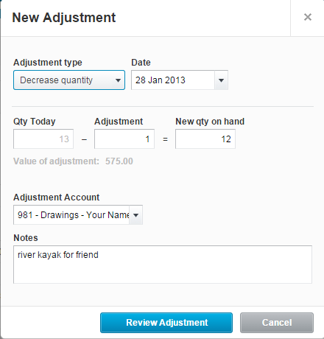
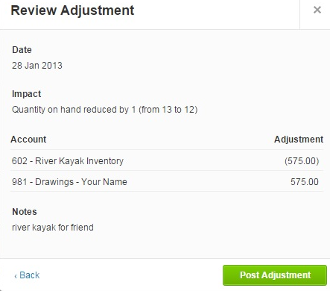
The worked example New Adjustment and Review Adjustment look like this before clicking Post Adjustment

Step Two: Complete the manual journal entry to reverse the GST claimed for the inventory
- From the Adviser drop down menu select Manual Journals.
- Click New Journal
  - Narration: Reverse GST on river kayak for friend
  - Date: 28 Jan 2013
  - Tab to Description
  - Tab – the narration will enter as your description
  - Account: type Draw or select Drawings from the drop down menu
  - Tab to the Debit column: enter the cost of inventory taken times 0.15 – you are entering a formula into this cell so use the * key for times.
For example for one River Kayak type 1*575*0.15 (when it’s 1 you don’t need the 1* but this formula shows how to enter a formula in Xero) tab and you will see 86.25 entered in the debit column
Note Xero does the calculation for you if you type the calculation in its cell
  - Tab through to Account on the second row
  - Account (second row): GST
  - Tab to the credit column
  - Enter the same amount as your debit – 86.25
  - Key enter to accept
- Click Post

Your Manual Journal should look like this before clicking post:
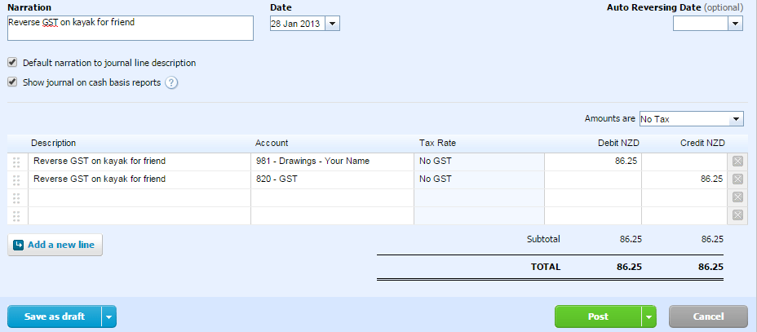

Inventory Shortages
When a physical count of inventory (stock-take) establishes that there is actually less stock on hand than records indicate it is necessary to adjust for the shortage.
An adjustment to inventory can also be required if an item of inventory is no longer in saleable condition and needs to be written off. In either case an inventory adjustment is required.
Worked Example:
28 Jan 2013 — One damaged kids kayak is required to be written off.
- From the Accounts drop down menu select Inventory
- Click on the Inventory name you need to adjust – eg kids kayaks
- Select New Adjustment from the Options drop down menu on the right
- In the New Adjustment window type and tab between (note explains the worked example):
  - Adjustment type: default Decrease quantity
  - Date: 28 Jan 2013
  - Adjustment: number to write off – eg 1
  - Adjustment Account: Inventory Shortage
  - Notes: Damaged kids kayak written off
  - Click Review Adjustment
- Click Post Adjustment
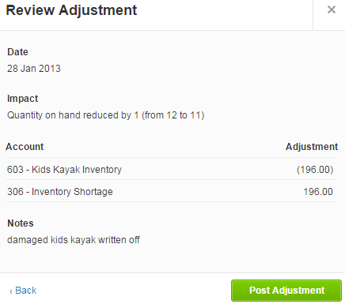
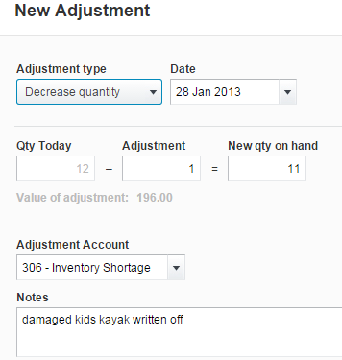
The worked example looks like this before clicking Review Adjustment and Post Adjustment

Purchase of Plant or Equipment on Credit
You will use a manual journal and a separately created current liability account for the credit supplier.
There are two ways to process this credit purchase. The first is to prepare a manual journal entry that looks like one you would prepare on paper in the classroom. This might make lots of sense to you and is explained first. The second uses a GST inclusive setting that lets Xero calculate the GST for you so it is simpler.
Worked Example:
30 Jan 2013 — Purchased a new trailer on credit from Kea Trailers $3,220 including GST

Prepare a Manual Journal that is like a Textbook Written Example
- From the Adviser drop down menu select Manual Journals.
- Click New Journal.
- In the New Manual Journal window type and tab between (note explains the worked example):
  - Narration: Purchase new trailer
  - Date: 30 Jan 2013
  - Tab through to Account on the first row leaving the Amounts are No Tax as the default and allowing the Narration to automatically enter as the Description
  - Account: Type Veh and select Vehicles & Trailers or select from the drop down menu
  - Tab to the Debit column and enter the GST exclusive cost of the asset (you can type the formula 3220/1.15 then tab and 2800 will be entered)
  - Tab through to Account on the second row
  - Account: Type GST and select GST
  - Tab to the Debit column and enter the GST amount (you can type the formula 2800*.15 then tab and 420 will be entered)
  - Tab through to Account on the third row
  - Account: Type Kea and select Kea Trailers or select your creditor for fixed assets account.
  - Tab to the Credit column and enter the GST inclusive amount owing to the creditor and key Enter to accept rather than tab.
- Click Post.

The worked example manual journal looks like this before clicking post:
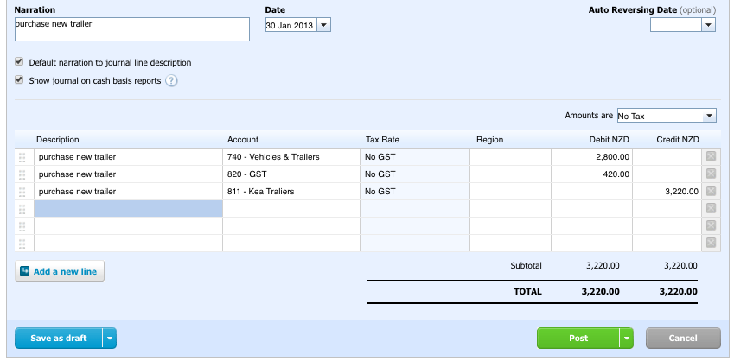
— Alternatively and more simply (don’t do this entry as well!) —
Only do one of these entries for recording the purchase of a new trailer

Prepare a GST Inclusive Manual Journal
- In the New Manual Journal window type and tab between (note explains the worked example):
  - Narration: Purchase new trailer
  - Date: 30 Jan 2013
  - Amounts are Change to Tax Inclusive (this is important or the entry will not calculate GST correctly – you must set Tax Inclusive before you start entering the transaction)
  - Description Tab through so the narration is entered
  - Account: Type Veh and select Vehicles & Trailers or select from the drop down menu
  - Tab to the Debit column and enter the GST inclusive cost of the asset (3220)
  - Tab through to Account on the second row
  - Account: Type Kea and select Kea Trailers or select your creditor for fixed assets account.
  - Tab to the Credit column and enter the GST inclusive amount owing to the creditor and key Enter to accept rather than tab.
- Click Post.

The worked example manual journal looks like this before clicking post – you will see that Xero knows there is 420 of GST associated with the entry for the Vehicles & Trailers:
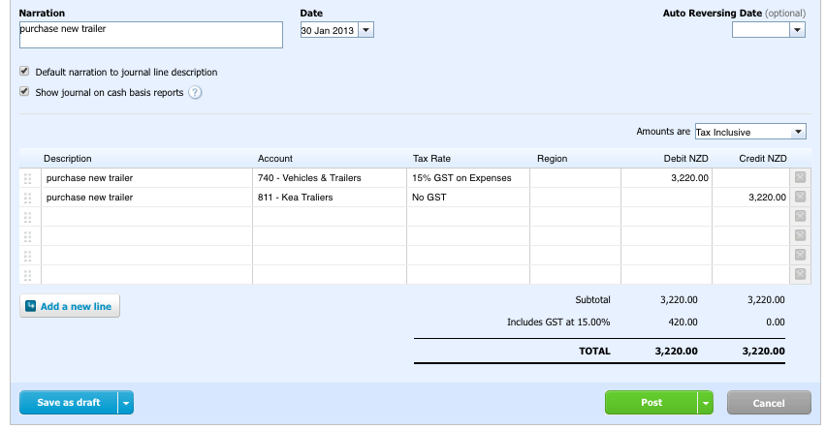
You might find this approach easier as you don’t have to calculate the GST, you can simply process the transaction using the GST inclusive figure given.
Just make sure you have set the journal to ‘Amounts are’ Tax Inclusive before entering the transaction.

Correct Errors
Every now and then you may happen upon an error. To fix these errors you need to consider what did happen. Which accounts were debited and which accounts were credited. Then consider what should have happened. Which accounts should have been debited and which accounts should have been credited.
It is a good idea to write out the entries so they are easily entered in the manual journal.

Setting the manual journal to GST inclusive for ALL errors allows Xero to correct GST entries when required.
If we let Xero correct any GST related to the error, we only need to worry about which account needs a debit entry and which account needs a credit entry to correct the error, along with the total amount we have been given.
Worked Example one:
30 Jan 2013 — Last month the phone & website expense of $174.65 including GST was posted to the marketing account in error. Correct this error.

Thinking process:
What did happen:
A debit to Marketing $151.87 ($174.65/1.15 – ie: GST exclusive),
a debit to GST $22.78 and a credit to Bank-Kayaks $174.65
What should have happened:
A debit to Phone & Website Expense $151.87 ($174.65/1.15 – ie: GST exclusive),
a debit to GST $22.78 and a credit to Bank-Kayaks $174.65
To fix the error we only need to debit Phone & Website Expense and credit Marketing. In Xero if we set the manual journal to GST inclusive we can enter the GST inclusive amount and allow Xero to sort out the GST for us.
Alternatively you could determine the GST exclusive amount and record the entry with No GST. You can discuss this option with your teacher if you prefer to use it.
This manual illustrates the use of the GST inclusive amount because this is the amount you will be given; set the journal to GST inclusive and let Xero do the work for you.
- From the Adviser drop down menu select Manual Journals.
- Click New Journal.
- In the New Manual Journal window type and tab between (note explains the worked example):
  - Narration: Correct error processing phone & website expense
  - Date: 30 Jan 2013
  - Tab through to Amounts are:
  - Amounts are: Change to Tax Inclusive – this is important for correcting all errors as explained above
  - Tab to Account allowing the Narration to automatically enter as the Description.
  - Account: Type Phone and select Phone & Website expense or select from the drop down menu
  - Tab to the Debit column and enter the GST inclusive amount of the transaction $174.65
  - Tab through to Account on the second row
  - Account: Type Mar and select Marketing or select from the drop down menu
  - Tab to the Credit column and enter the GST inclusive amount of the transaction.
- Click Post.
The worked example manual journal looks like this before clicking post:
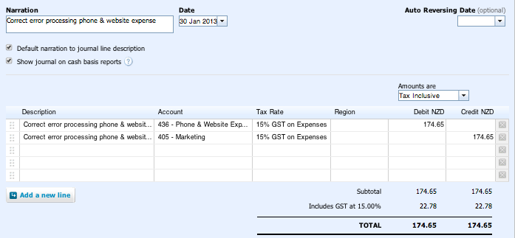
The Journal Report of this manual journal entry confirms the error has been correctly processed excluding GST, which has already been accounted for.
Access the Journal Report from the Reports drop down menu, set the date range to 2013 to include the transactions you want to view.
Journal Report extract:
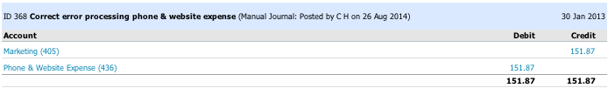

Worked Example two:
30 Jan 2013 — Last month the interest on loan $52.43 was posted to the shop insurance account in error. Correct this error.

Thinking process:
What did happen:
Debit Shop Insurance $45.59 (GST exclusive); Debit GST $6.84; Credit Bank-Kayaks $52.43
What should have happened:
Debit Interest on Loan $52.43, Credit Bank-Kayaks $52.43
To correct the error we need to credit both Shop Insurance and GST and debit Interest on Loan.
Setting the manual journal to GST inclusive and using the full amount of the transaction allows Xero to sort out the GST.
This is the approach illustrated here.
- From the Adviser drop down menu select Manual Journals
- Click New Journal
- In the New Manual Journal window type and tab between (note explains the worked example)
  - Narration: Correct error processing interest on loan
  - Date: 30 Jan 2013
  - Tab through to Amounts are:
  - Amounts are: Change to Tax Inclusive – this is important for correcting all errors
  - Tab to Account allowing the Narration to automatically enter as the Description.
  - Account: Type Interest and select Interest on Loan or select from the drop down menu
  - Tab to the Debit column and enter the amount that should have been recorded in Interest on Loan $52.43
  - Tab through to Account on the second row
  - Account: Type Shop and select Shop Insurance or select from the drop down menu
  - Tab to the Credit column and enter the amount that was recorded in Shop Insurance in error $52.43 (Xero will sort out the GST) and key enter to accept rather than tab.
- Click Post

The worked example manual journal looks like this before clicking post:
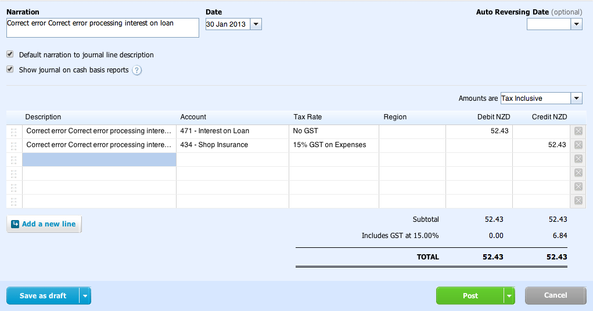
Check the error has been correctly processed by viewing your journal report:
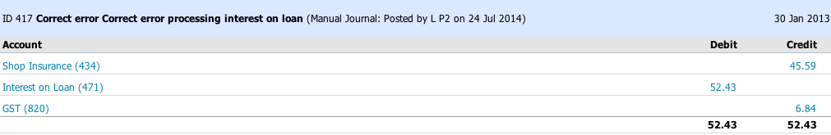

Dispose of Plant or Equipment
A number of entries are required. It is recommended that you complete each entry separately, though you can combine them if you want to.
Worked Example:
30 Jan 2013 — Traded-in an old trailer to Kea Trailers for $989 including GST
The trailer originally cost $2,000 excluding GST.
Straight-line depreciation at 10% p.a. has been recorded for three full years.
At the date of disposal an additional three months depreciation is required to be recorded.
Each part of the process to complete this transaction is explained separately using the worked example.
Access Manual Journals from the Adviser drop down menu.
Three months depreciation at 10% p.a. straight line:
The amount will be 3/12 or ¼ of 10% of $2,000 = 50 – you can enter the formula in Xero as 3/12*.1*2000
- In a New Manual Journal window type and tab between
  - Narration: 3 months depreciation on trailer
  - Date: 30 Jan 2013
  - Tab through to Account on the first row leaving the Amounts are No Tax as the default and allowing the Narration to automatically enter as the Description.
  - Account: Type dep and select Depreciation on Vehicles & Trailers
  - Tab to the Debit column and enter the depreciation you have calculated or the formula to calculate it (3/12*.1*2000 or 50)
  - Tab through to Account on the second row
  - Account: Type Accum and select Accumulated depreciation on Vehicles & Trailers
  - Tab to the credit column and enter the depreciation you have calculated (50)
Your manual journal should have the following debit and credit entries:
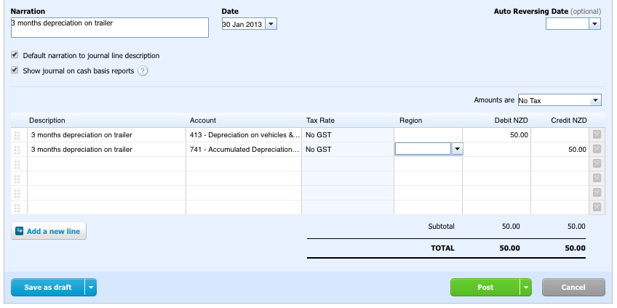
Transfer of the trailer to the Trailer Disposal account:
The amount will be $2,000 – the GST exclusive cost of the trailer.
Proceed as in (a) above in a New Manual Journal with the following details:
- Narration: Transfer trailer to disposal
- Date: 30 Jan 2013
- Amounts are: No tax (default – it is important that the setting is No tax)
- Account: Trailer Disposal
- Debit column 2000
- Account: Vehicles & Trailers
- Credit column 2000
Your manual journal should have the following debit and credit entries:
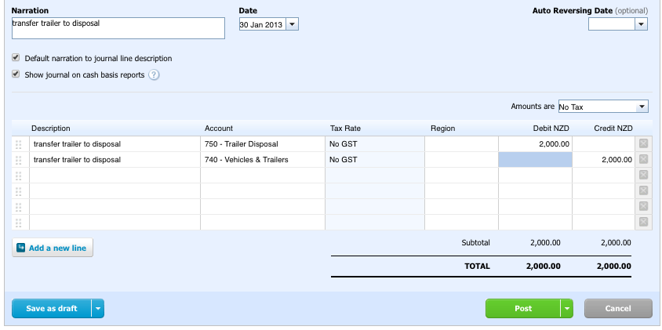
Write off accumulated depreciation to the Trailer Disposal account:
The amount will be 3 years of depreciation plus the additional 3 months of depreciation as above
(3 x 10% x 2000) + 50 (from (a) above) = 600 + 50 = 650
Proceed as in (a) above in a New Manual Journal with the following details:
- Narration: Write off accumulated depreciation on trailer
- Date: 30 Jan 2013
- Amounts are: No tax (default)
- Account: Accumulated depreciation on vehicles & trailers
- Debit column 650 or the above formula to calculate this
- Account: Trailer Disposal
- Credit column 650
Your manual journal should have the following debit and credit entries:
Record the Trade-in of the old trailer in a new Manual Journal with these entries:
- Narration: Trade-in of old trailer
- Date: 30 Jan 2013
- Amounts are: Tax Inclusive (this is important, make sure you change the default tax setting)
- Description Tab through so the narration is entered
- Account: Kea and select Kea Trailers or select from the drop down menu
- Tab to the Debit column and enter the GST inclusive trade-in amount received - 989
- Tab through to Account on the second row
- Account: Type Disp and select Trailer Disposal
- Tab to the Credit column and enter the GST inclusive amount of the trade-in and key Enter to accept rather than tab.
- Click Post.
Here’s what the manual journal looks like for the trade-in to Kea Trailers for $989 including GST with ‘Amounts Are’ set to Tax Inclusive.
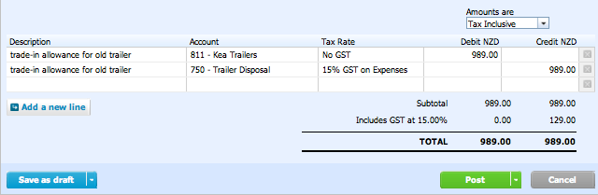
You will see Xero has calculated and recorded the GST so only the GST exclusive amount will be recorded in the Trailer Disposal account. You could record this as No Tax but you would then have to determine the GST exclusive amount to record in the Trailer Disposal account as a credit and add the GST account on a new line for the amount of GST, also a credit.
Record the loss or gain on disposal
- To find out the loss or gain on disposal go to the Reports drop down menu:
  - select Account Transactions.
It should be a favorite if you set it at the beginning. If not find it in All Reports.
  - Select Trailer Disposal in the Account window
  - From and To: make sure the dates cover the month of your transactions eg from 1 Jan 2013.
  - Click Update.
  - Review the Trailer Disposal Account Transactions to determine whether you need to record a loss or gain on disposal.
  - A debit balance means you have a loss to record,
  - A credit balance means you have a gain to record.
The account transactions for the trailer disposal look like this (note: your entries may be in a different order)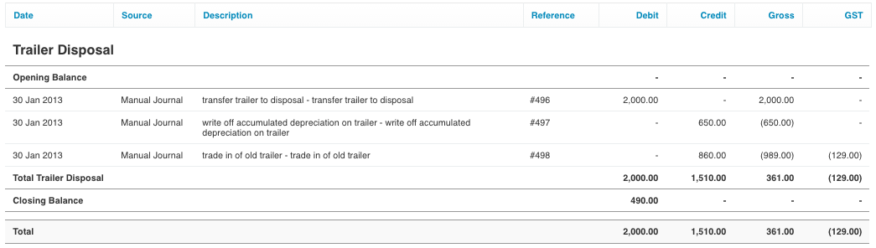
The $490 closing balance is a debit balance.
This means we have a loss on disposal of $490 to record in the general journal.
Because we don’t know whether we will have a loss or gain on disposal of an asset, we create this account code on the fly in the manual journal.
Instructions follow:
Proceed as in above in a New Manual Journal with the following details:
- Narration: Record loss on disposal of trailer
- Date: 30 Jan 2013
- Amounts are: No Tax (default)
- Account: Click on the down arrow and select +Add new account. Create an account for Loss on disposal trailer* – Type: Expense, Code: 481, Name: Loss on disposal – trailer, Tax: No GST. Click Save and your new account will be entered.
- Debit column 490
- Account: Trailer Disposal
- Credit column 490
If you have to create a Gain on Disposal account. The Type will be Other Income, the Code will be 281, Name will be Gain on Disposal - asset and Tax No GST. The entry will be a debit for the Asset Disposal account and a credit for the Gain on Disposal - asset account.
Your manual journal should have the following debit and credit entries:
When you have completed all of the above review the Trailer Disposal account transactions to ensure the balance is now zero.

Deal with a Sale Other than a Trade-in of Plant or Equipment (Fixed Assets)
If the fixed asset is sold for cash prepare a GST Inclusive Receive Money transaction, with the account as ‘Asset’ Disposal and the amount recorded as the GST inclusive amount of cash received.
If the fixed asset is sold on credit to a person/business other than the one you purchased the asset from, you need to create a current asset account, code in 600s, tax default of No tax, for the debtor.
Prepare a Manual Journal set to Tax Inclusive in the same way as you prepared the purchase of asset Manual Journal, except you will debit the debtor and credit the asset disposal account.
Xero will sort out the GST if you have set the journal to Tax Inclusive.

View Your Reports
All that work can’t be for nothing. Once you have finished an exercise, or at any time during the exercise, you can view your Reports to see how you are going. It is a good idea to see how Xero reports your transactions in the financial statements.

Journal Report
It lists all items going into and out of your general ledger. When you have finished an exercise you need to save the Journal Report as a PDF file and print it if required.
Once you have saved your final journal report and are sure you do not need to make any changes to the exercise you can reset your demo company ready for the next exercise.
From the Reports drop down menu select Journal Report from favorites if you set it as a favorite at the beginning. Otherwise go to All Reports and select Journal Report.
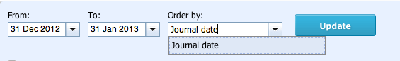
- In the Journal Report window set the From: and To: dates to include the month of your transactions only. The From date should also include the conversion trial balance date so for example from 31 December 2012 to 31 January 2013.
- Change Order by to Journal Date.
- Click Update.
You will see that Xero creates general journal style entries for all your transactions so you can easily see the debits and credits.
- Scroll to the bottom of your report.
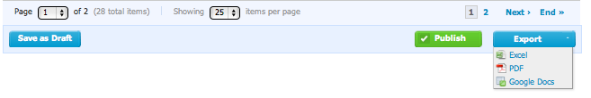
- From here you can change the number of items displayed per page on your screen, select different pages of your report to view and Export your whole report.
- For assessment purposes you will export your report to a PDF file to guarantee authenticity.
Your teacher will provide you with any other instructions regarding exporting, saving and/or printing your Journal Reports.

Profit and Loss
The Profit and Loss report (Income Statement) shows your Organization's net income, by deducting expenses from revenue for the report period.
- From the Reports menu select Profit and Loss.
- Click on the Show Date Range tab.
- Set From as the 1st of the month your transactions are in and To as the last of the month your transactions are in.
- Set the Compare With and Compare Periods to None.
- Click Update.
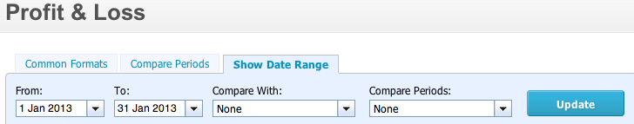
This is illustrated here for January 2013.

Balance Sheet
The Balance Sheet report details the net worth of your Organization as of a particular date.
- From the Reports menu select Balance Sheet.
- Adjust the dates and other options to suit.
- Select the month and year your transactions are in for the Balance Date.
- Set Compare To and Compare Periods to None.
- Click Update.
This is illustrated for a balance date of 31 January 2013.
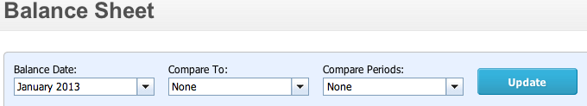

Wrap it Up
Happy ?
Once you are happy with your Journal report and you have saved it you are ready to start on a new exercise.
Congratulations! You have completed the introductory exercise.
You are now ready to reset the demo company and start your next exercise
In order to do this you must first Reset the Demo Company that you have been working with. Then you can use the Demo Company again to do your next exercise or assessment task.

Correct Your Mistakes
If you discover you have made a mistake entering a transaction you can correct your mistake by editing the transaction or removing and redoing the transaction correctly. Xero keeps a record of your incorrect transaction and automatically creates a reversal. Xero does not delete any transactions. Your Journal Report will show your original entry, the automatically created reversing entry and your new entry.
We all make mistakes so the following will assist you with correcting them.
How you correct a mistake depends largely on the type of transaction it relates to.

Correcting Receive Money or Spend Money Transactions
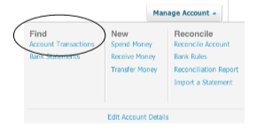
To correct a Receive Money or Spend Money transaction from the Bank Account screen or Dashboard:
- Go to the Manage Account drop down menu
- Select Find Account Transactions.
A list of transactions will appear.
You can select the transaction you need to edit. If you find the error when completing your bank reconciliation click the Status tab so un-reconciled entries will be first. Then tick on the left to highlight the entry you want to correct and select Remove & Redo.
This example shows the payment to Key Media for marketing of $368.90 being incorrectly recorded as $386.90 meaning Xero will not find a match for it when doing the bank reconciliation.
Notice that for reconciled transactions the Status is a tick in a green circle, while un-reconciled transactions have an orange icon in the Status column.
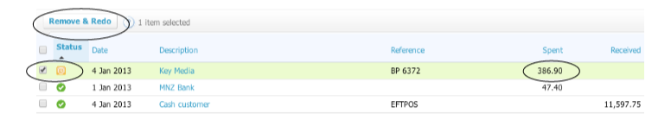

Clicking Remove & Redo will bring up this screen.
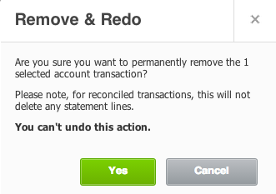
Notice that if you have to Remove & Redo a transaction you have reconciled the (bank) statement line will remain and once you have removed and redone the transaction it will appear as un-reconciled and you will have to reconcile it by going back to the bank reconciliation screen.
In this example the transaction can’t be reconciled because the figure was entered incorrectly. Once it is corrected, it can be reconciled.
Click Yes to Remove & Redo your transaction. This will take you back to the transaction screen. You need to go through the Manage Account, New Spend Money or Receive Money process to redo the transaction. Once you have done that, return to the Reconcile Account screen from the Manage Account menu and reconcile the now correct transaction with the bank statement.

Invoices/Bills and Credit Notes
- From the Dashboard Go to Sales (for debtor invoices) or Purchases (for creditor bills)
- Select See all
Because you now see all the Demo Company Invoices/Bills and yours are likely to have vanished to the bottom of a long list, click on the Date tab to change the Date order to earliest invoices first.
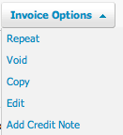
Your invoices, if you have correct dates, will now be at the top of the list. Open the invoice/bill you want to change by clicking on the name in the To/From column.
The options to change the invoice/bill depend on whether or not it has had a payment or credit note applied. Options for editing the invoice/bill are found in the drop down menu on the right of the invoice or bill. Void means to delete which may be tempting but you should not do this.
You won’t be given the Void option if the invoice/bill has a payment applied to it. If the invoice has a credit note applied to it, the credit note will need to be voided before you can make many changes to the details on the invoice other than the account codes.
If you have to change any invoice/bill use the edit option. This will force you to Remove & Redo any payment or void a credit note first so you know you have to deal with those again after you have edited the invoice.
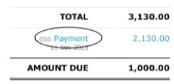
To access the payment or credit note, click on the link on the invoice/bill under the total. This illustration shows a Payment of 2,130.00. The blue word means this is a link to the Payment transaction.
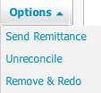
Clicking on Payment link will give you the Option to Remove & Redo the payment. Remove the payment and return to the invoice/bill, which you can now edit more fully.
You can add the payment to the corrected invoice/bill in the payment section before you save it.
Clicking on the credit note link in the invoice/bill will give you access to the credit note which you can void allowing you to edit the invoice fully and re-enter the credit note.

Manual Journal Transactions
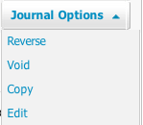
- From the Adviser menu select Manual Journals.
A list of posted manual journal entries will be on the screen.
Select the journal entry you wish to edit by clicking on the blue narration link. On the right of the screen, just as with invoices, you have an options menu. You can simply select Reverse which means Xero will create the reversing entry for you. Then re-enter the journal entry correctly.

Additional Resources
The Xero team has created many resources to help you out along the way. We have only just scratched the surface of all the amazing things Xero can do. Use the resources below to learn more or get assistance.

Help Centre
Use Xero's Help centre to access user guides, common scenarios and information about how Xero does its accounting. Just go to http://help.xero.com/nz/#home to browse all the great info available!
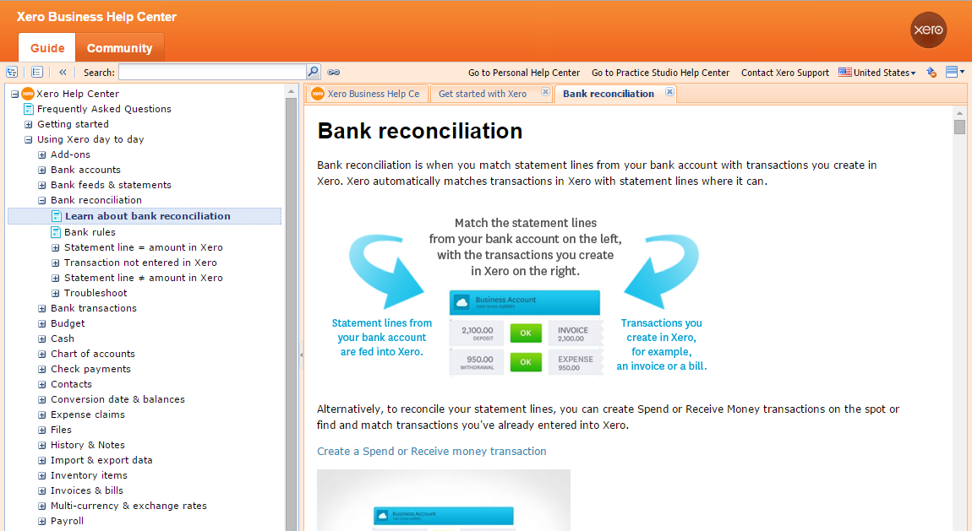

Xero TV
Get started with Xero 101, check out case studies, see what's new with the Xero team, see product updates and learn more about Xero accounting software from helpful how-to videos. https://www.xero.com/nz/tv/
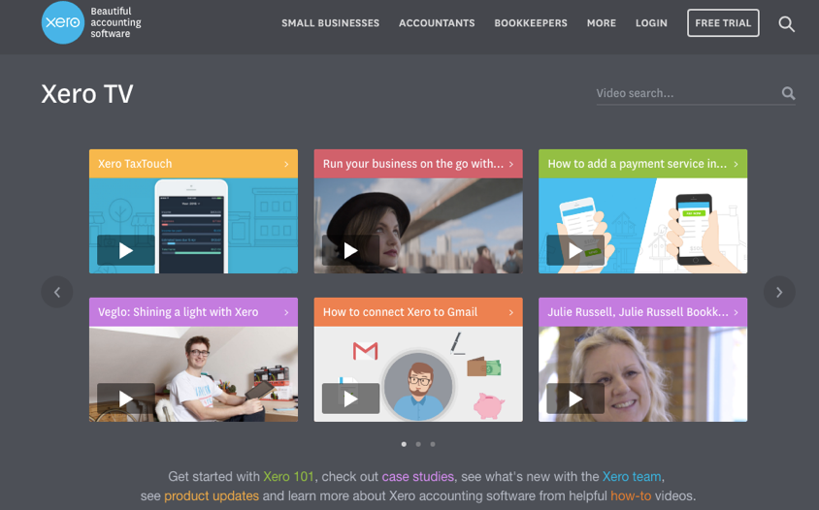

Xero U
Find education, training and events tailored for small businesses. If you are an accountant, bookkeeper or other financial professional we have courses for you. https://www.xero.com/nz/training/
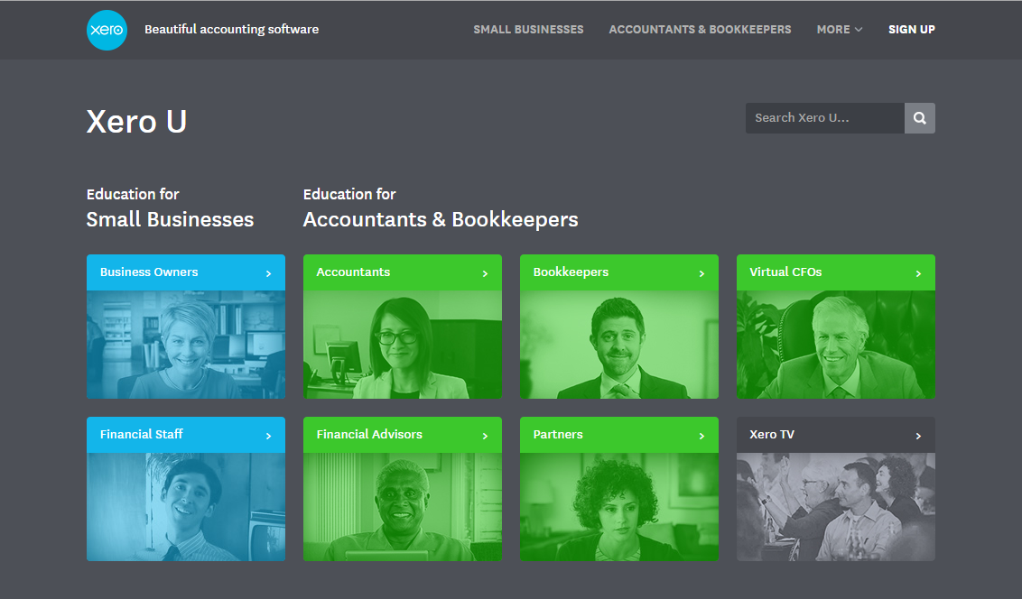

Learn More About Using Xero
Xero U has great online training pathways for you to learn all you need to know about Xero. http://www.xero.com/training
Follow our Business Essentials Program to be confident using Xeros’ key features.
Use our Business Learning pathway to be competent and capable on Xero

Keep up to date with Xero and our product releases with Xero Now
Monthly broadcasts designed to keep you up to date with Xero. Register on line and always have the latest monthly updates from Xero. http://www.xero.com/xero-now

Learn More with our series of SMB & Accounting Guides
Tips & tricks and accounting essentials for business success www.xero.com/small-business-guides

Listen to great business podcasts
Innovative insights from people who know business inside and out http://www.xero.com/podcasts
Appendix A

Introduction Exercise - Kayaks

Objective
At the end of this exercise you should be
- familiar with the set-up of an exercise in Xero using the Demo Company
- able to process frequent, infrequent and complex transactions in Xero

The Business Scenario
You are a small business owner. On 1 January 2013 you, the owner of Your Name Kayaks, decided to start using Xero accounting software to process your transactions.
You sell three main types of kayaks:
- Sea Kayaks
- River Kayaks
- Kids Kayaks
You have the following balances on 31 December 2012:
Your Name Kayaks
Trial Balance as at 31 December 2012
Code | Account Name | Debit | Credit
610 | Accounts Receivable* | 590
800 | Accounts Payable** |  | 3,130
621 | MNZB Bank - Kayaks | 3,400
699 | #Inventory adjustment | 27,490
730 | Fittings & Equipment | 27,000
731 | Accumulated Depreciation on Fittings & Equipment |  | 10,800
740 | Vehicles & Trailers | 42,000
741 | Accumulated Depreciation on Vehicles & Trailers |  | 12,600
820 | GST |  | 950
905 | Loan - MNZB |  | 9,000
971 | Capital – Your Name |  | 64,000
 |  | 100,480 | 100,480
* The Accounts Receivable represents $590 owing by Blue Water.
**The Accounts Payable represents $3,130 owing to Kayak World.
#Inventory adjustment is the total value (price x cost) of three items of inventory on hand.

Additional info:
- Bank-Kayaks must be set up as a Xero bank account. This is very important. You must set up a Xero bank account for each exercise. Bank account number is a mandatory field, so if you are not given a bank account number, you need to make one up even 1 will do!
- Tax details for Plant and Equipment (Fixed Asset) accounts are 15% GST on expenses
- Tax details for Accumulated Depreciation (Fixed Asset) and Loan (Non-current liability) accounts are No GST
Your Name Kayaks has the following additional income, expense, asset, liability and equity accounts:
Code | Account Name | Account Type | Tax details
201 | Sea Kayak Sales | Sale | 15% GST on income
202 | River Kayak Sales | Sale | 15% GST on income
203 | Kids Kayak Sales | Sale | 15% GST on income
211 | Kayak Repair Fees | Other Income | 15% GST on income
301 | Sea Kayak COGS | Direct costs | No GST
302 | River Kayak COGS | Direct costs | No GST
303 | Kids Kayak COGS | Direct costs | No GST
305 | Freight Inwards | Direct costs | 15% GST on expenses
306 | Inventory Shortage | Direct costs | No GST
405 | Marketing | Expense | 15% GST on expenses
411 | Vehicle Expenses | Expense | 15% GST on expenses
413 | Depreciation on vehicles & trailers | Expense | No GST
414 | Depreciation on fittings & equipment | Expense | No GST
421 | Electricity | Expense | 15% GST on expenses
432 | Bank Charges | Expense | No GST
434 | Shop Insurance | Expense | 15% GST on expenses
436 | Phone & Website Expense | Expense | 15% GST on expenses
441 | Shop Rent | Expense | 15% GST on expenses
451 | Wages | Expense | No GST
471 | Interest on Loan | Expense | No GST
601 | Sea Kayak Inventory | Inventory | 15% GST on expenses
602 | River Kayak Inventory | Inventory | 15% GST on expenses
603 | Kids Kayak Inventory | Inventory | 15% GST on expenses
750 | Trailer Disposal | Fixed Asset | 15% GST on expenses
811 | Kea Trailers* | Current Liability | No GST
981 | Drawings – Your Name | Equity | No GST
* The supplier, in this example, for the credit purchase of plant and equipment

Highlighted accounts in the trial balance and account list are added by you to your imported Chart of Accounts. All other accounts in the account list are in the imported Chart of Accounts.

Part A – Get Your Company Set Up in Xero
You are excited to start using Xero. You want to be sure to set everything up correctly.
Change the demo company name to reflect your company. And Add EDU as a prefix eg: EDU Amy Lo Kayaks Ltd
Set up your Chart of Accounts by importing the chart of accounts file: CoA-kayaks-student.csv
Add a Xero Bank account – Bank-Kayaks
Create new accounts for the highlighted accounts in the trial balance and additional accounts list.
Enter the amounts in the trial balance as Conversion Balances with the Conversion date set to 1 January 2013.

Part B – Set Up Inventory Items
Now that you're all set with stating company and bank info, you need to add tracked inventory items.
Set up the following three inventory items as tracked inventory.
It is recommended that you delete the Demo Company Inventory items first.
 | Sea Kayaks | River Kayaks | Kids Kayaks
Cost price excluding GST | $1,375 | $575 | $196
Selling price excluding GST | $2,085 | $1,285 | $515
Quantity | 12 | 14 | 15

Part C – Process Credit Transactions for Inventory Items
Step 1 – Process credit purchases of inventory items
Process the following credit purchases.
We’ll walk through the first one together, then you will practice by doing the next two in the same way.
Date  2013 | Transaction  All invoices and bills are due on 20 February 2013
Jan 7 | Purchased 6 river kayaks and 5 kids kayaks on credit from Wild Water Ltd.
Jan 8 | Purchased 5 sea kayaks on credit from Kayak World.
Jan 16 | Purchased 4 river kayaks and 7 kids kayaks on credit from Wild Water Ltd.

Step 2 – Processing credit sales of inventory items
Complete the following credit sales of inventory. We’ll do the first one together, then you should practice by doing the next two in the same way on your own.
Date  2013 | Transaction  All invoices and bills are due on 20 February 2013
Jan 7 | Sold 2 sea kayaks and 3 kids kayaks to Blue Water on credit.
Jan 11 | Sold 6 river kayaks to Paddle Plus on credit.
Jan 24 | Sold 1 sea kayak and 4 kids kayaks to Blue Water on credit.

Part D - Processing Cash Receipts and Cash Payments
Sometimes you’ll pay cash and you’ll need to record this in Xero as well. Let’s take a look at cash receipts and cash payments except invoice/bill payments.
Step 1 – Spend Money
- Spend Money can be used for cash expenses, cash drawings, cash purchase of plant and equipment, repayment of long term debt eg loan repayments.
Spend Money cannot be used to pay or partly pay a credit supplier bill.

Complete the following “Spend Money” transactions. We’ll do the first one together, then you should practice by doing the next three in the same way.

Date  2013 | Transaction  All amounts include GST where relevant
Jan 4 | Paid Key Media for marketing $368.90 by online bill payment #6372
Jan 13 | Paid Joe Henry $826.54 for wages by online bill payment #2385
Jan 21 | Paid for personal groceries at Pak ‘n Save with the business EFTPOS card $197.65
Jan 27 | Paid Kiwi Property for shop rent $935.00 by online bill payment #5192

Step 2 – Receive Money
Receive Money can be used for cash sales, cash contribution by the owner, cash sale of plant and equipment, raising long term debt eg receiving a loan.
Receive Money cannot be used to receive money from a credit customer for payment or part payment of an invoice.

This section covers two types of “Receive Money” transactions:
- Cash from other income eg repair income, fees received or cash contribution by the owner or cash from the sale of plant and equipment.
- Cash sales of inventory items.

Cash Receipts (Except Cash Sales of Inventory Items)
Complete the following “Receive Money” transactions. Well do the first one together. You should then practice by doing the next one in the same way.
Date  2013 | Transaction (note amounts include GST)
Jan 9 | Received and banked a check for kayak repairs $143.72
Jan 16 | Received cash (EFTPOS) for repair fees $289.00

Cash Sales of Inventory Items
Complete the following “Receive Money” cash sales of inventory. You guessed it, we’ll do the first together then it’s all you.
Date  2013 | Transaction
Jan 4 | Cash sales (EFTPOS): 2 sea kayaks, 3 river kayaks and 4 kids kayaks
Jan 16 | Cash sales (EFTPOS): 3 sea kayaks and 3 kids kayaks
Jan 25 | Cash sales (EFTPOS): 4 river kayaks and 2 kids kayaks

Part E – Processing Invoice/Bill Payments
When you receive money from a debtor for an invoice you have previously issued, or make a payment to a creditor for a bill you have recorded, the payment is recorded on the relevant invoice or bill. The payment could be a part payment of the invoice or bill. When you enter the payment you need to take care if it is a part payment to change the amount received/paid as it will default to the total of the invoice or bill.
The first one is completed together then over to you!
- Complete the following invoice/bill payments.
Date  2013 | Transaction
Jan 20 | Used online bill payment #1735 to pay $2,130 to Kayak World in part payment of the amount owing on 1 January 2013.
Jan 22 | Received and banked a check for $590 from Blue Water in full settlement of the amount owing on 1 January 2013.
Jan 28 | Used online bill payment #2914 to pay Wild Water Ltd in full settlement of the invoice dated 7 January 2013

Part F

Process Cash Receipts and Payments through the Bank Reconciliation Process
On the bank statement the details for the direct transactions are:
- Teleco Direct Debit is for Phone & Website Expense
- L Hohaia Direct Credit is for Kayak Repair Fees
- Max Energy Direct Debit is for Electricity
- Paddle Plus Direct Credit is in part payment of their invoice dated 11 Jan 2013
- Bank charges, interest on loan and loan principal are all paid to MNZ Bank
Download the bank statement file for Your Name Kayaks BS-kayaks.csv and complete the bank reconciliation procedure.

Part G – Process Inventory Returns and Sundry Charges
Inventory returns from credit sales or credit purchases are processed by attaching a credit note to the related invoice or bill.
Step 1 – Inventory returns to credit suppliers
Complete the following inventory returns to suppliers. Walk through the first one together. You should then practice by doing the next one in the same way.
Date  2013 | Transaction
Jan 11 | Returned 1 sea kayak purchased on 8 January 2013 to Kayak World
Jan 18 | Returned 2 kids kayaks purchased on 16 January 2013 to Wild Water Ltd

Step 2 - Inventory returns by credit customers
Complete the following inventory returns by customers. Walk through the first one together. You should then practice by doing the next one in the same way
Date  2013 | Transaction
Jan 14 | Paddle Plus returned 2 river kayaks purchased on 11 January 2013
Jan 28 | Blue Water returned 1 kids kayak purchased on 24 January 2013
Step 3 – Sundry charges from suppliers
Sundry charges may include:
- A freight charge added to an invoice for the purchase of inventory
- A service charge such as for repairs, advertising, etc
Complete the following sundry charge bills. Each one is explained separately.
Date  2013 | Transaction  All amounts include GST where relevant unless otherwise stated
Jan 15 | Purchased 4 sea kayaks and 4 kids kayaks from Kayak World. Kayak World added a freight charge of $75.00 excluding GST.
Jan 22 | Received an invoice from Canoe & Kayak Ltd $247.50 including GST for advertising in the NZ Kayak magazine. Advertising is recorded in the  Marketing account.

Step 4 – Sundry charges to credit customers
Sundry charges may include
- An additional charge added to a customer invoice for inventory items
- A charge for repair fees or income other than from the sale of inventory items.
Complete the following sundry charge invoices. We’ll work through both below.
Date  2013 | Transaction  All amounts include GST where relevant unless otherwise stated
Jan 17 | Sold 2 kids kayaks to A Lo on credit. Added $34.00 excluding GST for painting her children’s names on the kayaks. Account to use: Kayak repair fees.
Jan 22 | Charged Y Huang $54.65 including GST for repairs to his old kayak.

Part H

Infrequent Transactions in the General Journal – Manual Journal in Xero and Inventory Adjustments
Step 1 – Drawings of goods
When the owner takes goods for him/herself the item(s) is removed from inventory at cost excluding GST using an Inventory Adjustment entry and the GST already claimed is added back to drawings using a Manual Journal entry.
This example is walked through.
Note you must complete TWO SEPARATE entries for this transaction.
Date  2013 | Transaction
Jan 28 | You gave one river kayak to your friend as a birthday present.

Step 2 – Inventory losses/shortages
Inventory shortages are removed from inventory at cost excluding GST. An inventory shortage account is used to record the shortage.
Date  2013 | Transaction
Jan 28 | The kids kayak returned by Blue Water had been seriously damaged in transit and is to be written off.

Step 3 - Purchase of plant or equipment on credit
Credit purchases of plant or equipment are recorded in the general journal with a separate current liability account created for the supplier.
Date  2013 | Transaction
Jan 30 | Purchased a new trailer on credit from Kea Trailers $3,220 including GST.

Step 4 - Correction of errors
Errors will be corrected through the general journal. Two types of errors will be considered.
- Errors where the GST has already been accounted for or there is no GST to account for.
- Errors involving an adjustment to GST (complex errors)
A. Errors where the GST has already been accounted for or there is no GST to account for.
Date  2013 | Transaction
Jan 30 | Last month the phone & website expense $174.65 including GST was posted to  the marketing expense in error. Correct this error.

B. Errors involving an adjustment to GST (complex errors)
Date  2013 | Transaction
Jan 30 | Last month the interest on loan expense $52.43 was posted to shop insurance  in error. Correct this error.

Step 5 - Disposal of an item of plant or equipment.
Date  2013 | Transaction
Jan 30 | Traded-in an old trailer to Kea Trailers for $989 including GST  The trailer originally cost $2,000 excluding GST. Straight-line depreciation  at 10% p.a. has been recorded for three full years.  At the date of disposal an additional three months depreciation is required  to be recorded.  Record the following:  - Three months depreciation at 10% p.a. straight line  - Transfer of the trailer to the Trailer Disposal account.  - Write off accumulated depreciation to the Trailer Disposal account.  - Record the trade-in of the old trailer to Kea Trailers  - Record the loss or gain on disposal – review the Trailer Disposal  Account Transactions to determine whether you need to record a  loss or gain on disposal.  When you have completed all of the above review the Trailer Disposal account  to ensure the balance is now zero.
G

Wrap it Up
You have now completed all the different types of transactions in Xero. You should view your journal report and Export it to a PDF file before resetting your Demo Company.

View Your Journal Report
- Go to All Reports and select Journal Report.
- In the Journal Report window set the From: and To: dates to include the month of your
transactions only.
  - The From date should also include the conversion trial balance date so for example from
31 December 2012 to 31 January 2013.
- Change Order by to Journal Date.
- Click Update.
- Scroll to the bottom of your report.
  - From here you can change the number of items displayed per page on your screen,
select different pages of your report to view and Export your report.
- For assessment purposes you will export your report to a PDF file to guarantee authenticity.
Happy? Once you are happy with your Journal report and you have saved it you are ready to start on a new exercise. In order to do this you must first Reset the Demo Company that you have been working with. Then you can use the Demo Company again to do your next exercise or assessment task.

Appendix B Your Name Home Care
Your Name Home Care is a house cleaning business in your local area. At the beginning of February 2013 you decided to add a gardening service to your business.
Reset the Demo Company
Name the company Your Name Home Care using your own name.
Access the Chart of Accounts window from the Settings menu
- Click on 200 Sales and change the account name to Housecleaning Fees Received
- Click on 260 Other Revenue and change the account name to Gardening Fees Received.
- Add a Xero bank account: Bank: MNZ Bank, Account code 621, Account Name: Bank-Homecare, Account Number 1
- Click on the Asset tab, click on 710 Office Equipment and change the account name to Gardening Equipment
- Click on the Equity tab, click on 970 Owner A Funds Introduced and change the account name to Capital
If using the Demo Company:
Click on the Asset tab in the Chart of Accounts window and select the Business Bank account and Business Savings account.
Archive these two accounts to remove them from the Dashboard, once selected, click Archive – you must not process transactions to these accounts for this exercise.
Note:
All the cash transactions must be through the bank account you created: Bank Home Care.
Make sure you access Spend and Receive money transactions through the Manage drop down box associated with this bank account on the dash board:
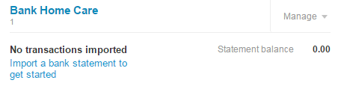

Process the following transactions in Xero.
Brief explanations are provided for the first of each type of transaction. For a full explanation read the similar transactions for Your Name Kayaks in the Student Manual.
Process these transactions:
Date  2013 | Transaction  All invoices and bills are due on 20 March 2013  All transactions include GST where relevant unless otherwise stated
Feb 1 | Invested $12,000 cash in the business. Receive money entry, Account is 970 Capital.
Feb 1 | Charged the business account at Bunnings for new gardening equipment $9,200. New Bill entry, Amounts are: Tax Inclusive, Account is 710 Gardening Equipment
Feb 7 | Charged J Kay for fortnightly house clean $135.00.  New sales invoice entry, Amounts are: Tax Inclusive. Account is 200 Housecleaning Fees Received
Feb 8 | Paid cleaning assistant J Wills wages $384.25.  Spend money entry, Account is 477 Salaries.
Feb 11 | Cash customers paid for housecleaning using mobile EFTPOS $275.00  Receive money entry, Amounts are: Tax Inclusive. Account is 200 Housecleaning Fees Received
Feb 11 | Cash customers paid for gardening using mobile EFTPOS $324.90  Receive money entry, Amounts are: Tax Inclusive. Account is 260 Gardening Fees Received
Feb 12 | Paid AM Motors vehicle expenses $106.45 by EFTPOS. Spend Money, Amounts are: Tax Inclusive. Account is Motor Vehicle Expenses.
Feb 14 | Charged J Kay for fortnightly house clean $135.00
Feb 16 | Paid for a family dinner out at Bravo with the business EFTPOS card $172.30. Account is 980 Owner A Drawings
Feb 18 | Cash customers paid for housecleaning using mobile EFTPOS $325.50
Feb 18 | Cash customers paid for gardening using mobile EFTPOS $287.40
Feb 20 | Imported your first bank statement to start entering transactions directly from the bank statement. Import the file BS-homecare.csv

On the bank statement – in no particular order (other items should be self explanatory)
Item | What to do:
Green highlighted items where Xero has found a match | Click OK
All Cards 11 and 18 Feb | Use Find & Match and select the two entries for the day, click ok
Xero | Account 412 Consulting & Accounting
AA Plus Insurance | Account 433 Insurance
Bank charges | Account 404 Bank fees
K Hill direct credit | Account 200 Housecleaning Fees Received
J Kay direct credit | Use Find & Match – Select invoice 7 Feb and invoice 14 Feb, split 14 Feb invoice, click OK
Bunnings | Use Find & Match – Select bill, split bill, click ok

