Part 1

Type of strategic plan
This market expansion and market entry strategic plan are prepared for the existing organization of Pure Oasis Juice situated in Canada. It has been identified that this strategic plan will be focused on the market expansion of Pure Oasis Juice organization through market entry within the United States.

Vision, mission and values of Pure Oasis Juice
The vision of Pure Oasis Juice is to develop a range of healthy juice products for the consumption of all age groups to improve the level of health and well-being(Cain et al., 2015). The organization envisions serving to the society through providing with the steady source of nutrients rich and healthy juice items.
The mission statement of Pure Oasis Juice lies in providing with the highest quality fruit juices that are made from the nutritious ingredients (Dibrell et al., 2014). Health and nutrition remain the forefront of the organizational focus due to which quality assurance, industry expertise and state of the art manufacturing are utilized to produce innovative products.
Values of the organization lie in three components of quality, innovativeness, trust, standard and integrity.

Organizational values driving the culture
The strong values of trust, high quality, integrity and innovation promotes the culture of innovativeness and authenticity within the workplace due to which the workforce remains motivated to adopt the best possible methods to prepare the freshest fruit juice possible.
The culture of Pure Oasis Juice can be characterised as motivating, energizing, innovative, creative and driven towards productivity(Gnizy et al., 2014). The workforce of the organization is constantly striving towards achieving the improvements within the rate of production, delivery times and sales volumes.

Competitive advantage
The uniqueness of the fruit drinks prepared by the organization serves as the competitive advantage for the Pure Oasis Juice(Dibrell et al., 2014). It has been found that the organization provides with the extensive collection of the fruit based juice drinks, smoothies and shakes with the prominent brand image of health consciousness(Cain et al., 2015). This has provided the organization with the ability to attract more customers from the competitors.

Part 2: External and Internal Assessment
Results of environmental scan
It was established from undertaking the SWOT analysis of the organization that while the industry of fruit juice is old, the business model of this organization is relatively new and the breadth of products preferred by the customers within the market provides the organization with the competitive advantage(Grant, 2016). It was further identified that the industry of fruit juice beverages is highly competitive. Furthermore, it was established that there are high barriers to entry within the market due to the time and effort it requires to train the workforce and secure the funds.
Learning about the Pure Oasis Juice
The organization of Pure Oasis Juice is constantly facing the pressures from the global players as the majority of the fruit juice manufacturers have globalized their product lines and have started to offer packaged and cold-pressed juices(Li and Liu, 2014). However, since the product offerings of Pure Oasis is unique, it is critical that the business enters the market of United States to improve the market share, volume of the sales and improving both revenue and profitability.
The results of the internal and external assessment tools were segregated into four distinct sections of strengths, weaknesses, opportunities and threats. Hence, this provides the overview of areas that are required to be minimized such as the weaknesses and threats to further improve the strengths to capture the opportunities that are present.
Learning during the process including key issues
It was identified that the key issues present within the industry and the entry of the organization in the United States is the ability to hire suitable employees and training the workforce(Wheelen and Hunger, 2017). However, the change in the consumer preferences towards healthy eating habits have improved the room of opportunity for the business.
Preliminary strategic initiative plan
The organizational culture of innovation and high quality combined with high performance is considered as the strategic initiative plan focuses on transferring theses values that drive the culture to the new location of the business within the entered market(Zhu et al., 2013).
Part 3: Organizational Chart

Operations Chart
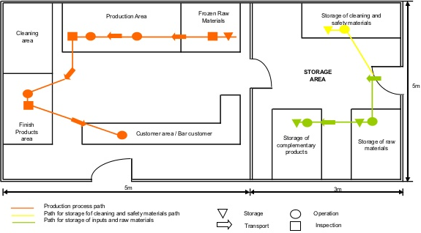
Part 4: Marketing
Target Market
It has been established from the market research within the domain of fruit juice industry in the context of Pure Oasis Juice organization has identified the target market for the business.
Young professionals: This segment consist of youth members of the society that falls between the age ranges of 20 to 45 years(Andaleeb, 2016). The average income level of this customer group is more than $40,000 on an annual basis. This target market of consumers is more inclined towards participating in physical and athletic activities. The consumer preferences of this target market are to shop the health benefiting products(Hollensen, 2015). The general shopping tendencies of this group imply that the young professionals often shop in the upscale food stores.
The market segmentation has indicated various metro areas where the target customers can be reached. The products will be initially distributed to the states of New Jersey and New York. The focus will remain on not only reaching to the customers but also developing the customer satisfaction.
Size of target market
It has been identified from the research that the young professionals have outpaced the growth of the college graduates. It has been identified that there are more than 17 million young professionals within the workforce across the workplaces of United States(Kuman and Zia, 2016). It has been identified that the young professionals function across both professional and technical job positions that range from teachers, computer programmers, nurses and civil engineers among other 175 different occupational positions. Hence, it can be considered that the size of the target market is substantial(Andaleeb, 2016). It is found that out of the total 61 million employed individuals, 28 percent of the professional workforce is made up of the young professionals. Furthermore, the research indicated that these professionals are present across not only healthcare and technical occupations but also within the management, finance, architecture, legal and social service along with media and entertainment(Hollensen, 2015). The income level of the young professionals is growing on an annual basis with the annual performance reviews and promotions(Kuman and Zia, 2016). Furthermore, it is to consider that the young professionals are yet to reach the highest point of their carrier due to which these customers will be able to shop more once they reach the state of affluence.
Resources required for implementation of plan
It is to consider that the resources that will be required for entering the market of United States will be financial and human capital(Kuman and Zia, 2016). The financial resources will be required to set up the business across the United States and distributing the products in the local markets.The second resource requirement is to recruit and train the workforce to commence the operations.
Realising the plan
The marketing plan will be achieved through taking into consideration the behaviours, demographics, motivation, goals and needs of the target market. It has been identified from the market research that the needs of the target market have changed towards adopting healthy consumable food items(Andaleeb, 2016). The marketing plan will be achieved through introducing the products of Pure Oasis Juice with the discount strategy of providing 20 percent discount on the normal pricing. Furthermore, the first time customers will be attracted and converted into loyal customers through offering a free fruit juice beverage followed by recoding the personal information of the customer to avoid offering the free product again(Hollensen, 2015). The marketing strategy will further shape the sales strategy towards developing customer loyalty among the new markets.
Achieving vision through marketing strategy
The marketing strategy will be effective in achieving the vision of Pure Oasis Juice. The organization will use the combination of social media marketing and evangelism marketing. The social media marketing will focus on maintaining the presence of Pure Oasis Juice across different social media platforms whereas the evangelism marketing will utilize consumers to spread word of mouth.
Leadership and innovative qualities in execution of marketing strategy
The combination of the evangelism and social media marketing will bring the required innovative and leadership qualities within the marketing strategies’ execution. The marketing strategy’s achievement of vision can be measured by linking the marketing goals with the sales target of the organization(Kuman and Zia, 2016). Achievement of the baseline sales forecasts required for generating sufficient revenue will indicate the firm operation of the marketing strategy. The indicators will be the volume of sales, some social media interactions and the number of evangelist marketers are connected with the brand.
Part 5: Financials
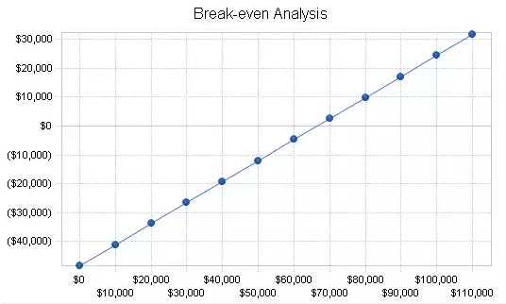
The break event point for monthly basis is $66,000.
Projected Financial Statement Analysis (Pro Forma 3-Year Financial Plan
The projected monthly sales of Pure Oasis Juice will be $85,000 for the year of 2018. The direct cost of sales will be $23,166 on a monthly basis. The total cost of sales will be same as the direct sales cost. The gross margin as per the profit and loss statement on a monthly basis will be $61,833. The payroll expense for monthly basis will be 32,000. The expenses of the sales and marketing on a monthly basis for the first year will be $6,000. The cost of depreciation on the monthly basis is found to be at $800. The cost of utilities is $1,000 per month. The insurance is $800. The per month rent for the premises will be $3,000. This is followed by the payroll taxes that make up $4,800 per month. Hence, the total operating expenses on a monthly basis are $48,400. The profits before interest and taxes according to the financial analysis has been identified to be at $13,433 per month. The EBITDA on a monthly basis is $14,233. The expense associated with the interest is $775 per month. The amount of taxes incurred for each month in the first year is $ 3,797. The financial analysis indicates that the net profit that will be experienced after the market entry by Pure Oasis Juice will be $8,860 per month which will allow the business to experience the profit of 10.42%.
Pro Forma Profit and Loss for 1st year
Part 6: Critical Milestones

Gantt Chart
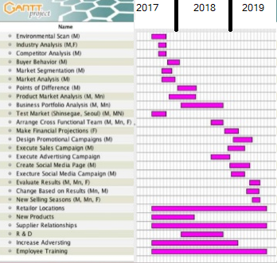
Summary
The Gantt chart has been prepared to ascertain that each objective, milestones and action required to be undertaken within the achievement of this strategic market entry plan. Hence, the Gantt chart was developed with the help of a graphic generating software to include all the milestones that are critical to achieving (Dayani and Gelbard, 2015). The Gantt chart is essential to be included in the project plan as it provides with the defined plan that is required to be implemented. The Gantt chart is a specialised bar chart which graphically represents and schedules the tasks and milestones of the project(Mohammad et al., 2016). Therefore, to effectively achieve the objectives to this market entry plan, the provided Gantt chart covers all the required areas that need to be addressed promptly.
One of the critical risk that can prevent meeting each of the objectives of the plan is the component of changing by the results that will be derived from executing the different strategies (Wren and Wren, 2015). The potential risk of inability to change as per the results can be minimized through adopting the appropriate leadership techniques and informing the workforce about the changes before they take place(Dayani and Gelbard, 2015). This will allow both resources allocation and management efficiency to be maximized as the employees will be able to function as the higher levels of productivity.

Part 7: Executive Summary and Consolidated Presentation
Executive Summary
Pure Oasis Juice has been a market leader in the industry of fruit juice beverage across the market of Canada. The organization has been providing the consumers with not only pure and natural fruit juice but also with the options of 100 percent fruit juice and organic juice. These offerings of the brand provide it with the competitive edge within the marketplace due to which majority of the consumers prefer Pure Oasis Juice over their competitors. The environmental scan and market analysis of the industry and consumers have established that the competition within the fruit juice industry has increased due to the entry of the major global players. This intense environment is further stringent with the changing needs and trends of the customers. The target market of Pure Oasis Juice is the young professionals that range between 20 to 45 years old. This target market is found to be the fastest growing segment across the United States. The Pure Oasis Juice has been catering to both young and ageing population of Canada due to which it holds the experience in developing the urgency to adopt healthy consumption habits and lifestyle to reduce growing health care costs and insurance costs along with improving the well-being of the society. The Christian perspective has been adopted by the organization to undertake greater good for the society(Mason and Simmons, 2014). The organization has developed the product mix that focuses on improving the nutritional intake of the consumers and prompting them to adopt further healthy habits. Hence, this allows the organization to function with the Christian perspective in the organizational framework and working towards the improving the society(Kolk, 2016).
The organization is planning to increase the market share, revenue and customer base which can be addressed through the market entry into a different nation where the similar business operates and the market for the fruit juice is established. Hence, the organization will secure a $100,000 loan for short term to enter the market of United States. The sales revenue through this expansion will result in the generation of $1.2 million by the 2nd year of the operations.
The organization will establish the operations in the United States by the end of 2017 to initiate the business transactions from 2018.The challenges present in executing the plan have been identified with the subsequent contingency plan. The recruitment and training of the employees pose a major challenge across the United States in the fruit juice industry(Crane and Matten, 2016). However, this can be mitigated through transferring the knowledge and training the members from scratch to integrate them into the organizational culture of high quality, trust and integrity.
The business will be required to maintain stringent cost control during the expansion to ensure that the resources directed towards the expansion do not impact the existing operations of the organization. The thorough financial analysis of the projections has indicated that the organization be required to maintain the monthly sales of $66,000 to reach the break event point. This will be achievable since the projections indicate the average sales of over $80,000.

References
Part 1
Cain, D. M., Moore, D. A., & Haran, U. (2015). Making sense of overconfidence in market entry. Strategic Management Journal, 36(1), 1-18.
Dibrell, C., Craig, J. B., &Neubaum, D. O. (2014). Linking the formal strategic planning process, planning flexibility, and innovativeness to firm performance. Journal of Business Research, 67(9), 2000-2007.
Gnizy, I., E. Baker, W., & Grinstein, A. (2014). Proactive learning culture: A dynamic capability and key success factor for SMEs entering foreign markets. International marketing review, 31(5), 477-505.
Part 2
Grant, R. M. (2016). Contemporary strategy analysis: Text and cases edition. John Wiley & Sons.
Li, D. Y., & Liu, J. (2014). Dynamic capabilities, environmental dynamism, and competitive advantage: Evidence from China. Journal of Business Research, 67(1), 2793-2799.
Wheelen, T. L., & Hunger, J. D. (2017). Strategic management and business policy. pearson.
Zhu, Q., Sarkis, J., & Lai, K. H. (2013). Institutional-based antecedents and performance outcomes of internal and external green supply chain management practices. Journal of Purchasing and Supply Management, 19(2), 106-117.
Part 4
Andaleeb, S. S. (2016). Market Segmentation, Targeting, and Positioning. In Strategic Marketing Management in Asia: Case Studies and Lessons across Industries (pp. 179-207). Emerald Group Publishing Limited.
Hollensen, S. (2015). Marketing management: A relationship approach. Pearson Education.
Kumar, N. S., & Zia, M. (2016). A Three Dimensional Vertical Differentiation Model: Implications for Segmentation, Targeting and Positioning.
Part 6
Dayani, M., &Gelbard, R. (2015). Automatic Conversion of Software Specification into a Gantt-chart subject to Organization's Constraints. Procedia Computer Science, 64, 73-78.
Mohammad, I., van den Broek, H., Boots, M. L., & Wong, R. (2016). U.S. Patent No. 9,336,502. Washington, DC: U.S. Patent and Trademark Office.
Wren, D. A., & Wren, D. A. (2015). Implementing the Gantt chart in Europe and Britain: the contributions of Wallace Clark. Journal of Management History, 21(3), 309-327.
Part 7
Crane, A., & Matten, D. (2016). Business ethics: Managing corporate citizenship and sustainability in the age of globalization. Oxford University Press.
Kolk, A. (2016). The social responsibility of international business: From ethics and the environment to CSR and sustainable development. Journal of World Business, 51(1), 23-34.
Mason, C., & Simmons, J. (2014). Embedding corporate social responsibility in corporate governance: A stakeholder systems approach. Journal of Business Ethics, 119(1), 77.

