Problem 1
Maria lives 2 periods. In period 1, she is a student in Philosophy. Her income is 0 and she does not pay taxes. In period 2, she will have a BA in Philosophy. Her income after tax will be $55,000. The interest rate is 10% (0.10). Her utility is given by

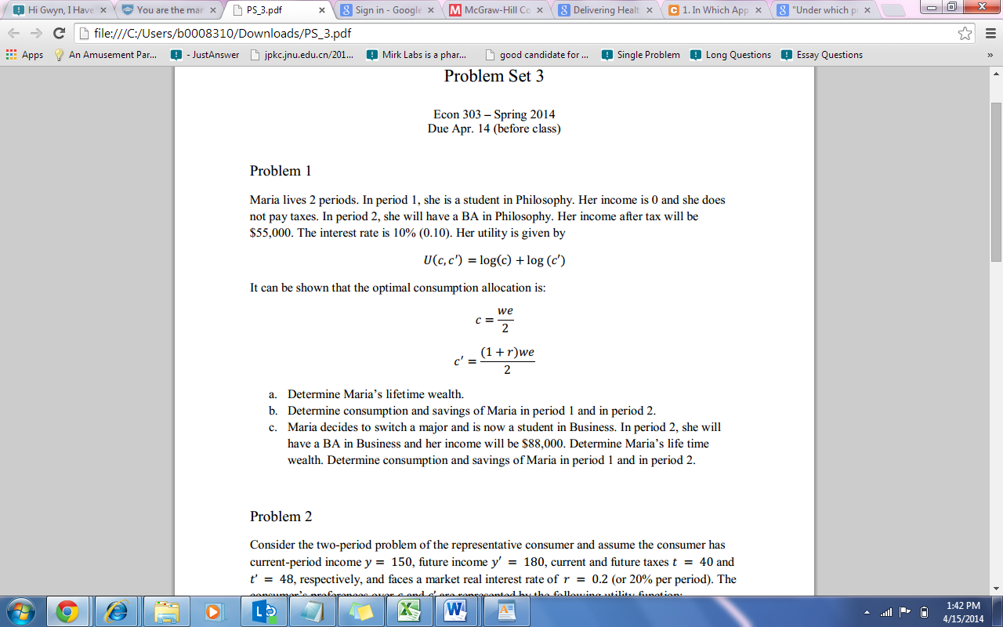
It can be shown that the optimal consumption allocation is:

a. Determine Maria’s lifetime wealth.
b. Determine consumption and savings of Maria in period 1 and in period 2.
c. Maria decides to switch a major and is now a student in Business. In period 2, she will have a BA in Business and her income will be $88,000. Determine Maria’s life time wealth. Determine consumption and savings of Maria in period 1 and in period 2.

Problem 2
Consider the two-period problem of the representative consumer and assume the consumer has
current-period income y = 150, future income y' =180, current and future taxes t = 40 and t' = 48, respectively, and faces a market real interest rate of r= 0.2 (or 20% per period). The consumer’s preferences over c and c' are represented by the following utility function:

a. Show the consumer’s lifetime budget constraint and indifference curves on a diagram (label the axes clearly).
b. Calculate his or her lifetime wealth, optimal current-period and future-period consumption, and optimal saving. Show these values on your diagram. Is the consumer a lender or a borrower?
c. Suppose that everything remains unchanged, except that now t = 10 and t’ = 84. Calculate the effects on current and future consumption and on optimal saving and show this on your diagram. Explain your results in light of the Ricardian Equivalence Theorem.

d. Now, assume that the consumer cannot borrow at all; a consumer who was deciding s<0 before is not allowed to do so anymore and is then forced to set s= 0 instead. The consumer has still the possibility to save (s>0). Repeat parts a) to c) and explain any differences.

Problem 3 (from Working with the Data 2, Chapter 7, Williamson)
Suppose that we divide the countries of the world into three groups: low income per worker in 1960 (less than 33% of income per worker in the U.S.), middle income per worker in 1960 (between 33% and 67% of income per worker in the U.S.), and high income (greater than 67% of income per worker in the U.S.).
The data can be downloaded from the following link:
http://wps.aw.com/aw_williamson_macroecon_4/134/34507/8833897.cw/index.html
a. Calculate average income per worker for the low income, middle income, and high income countries, respectively, for 1960 and 1995, and calculate the rates of growth of average income for the low, middle, and high income countries between 1960 and 1995. b. Do the statistics you calculated in part a) indicate any tendency for convergence among these three groups of countries?

