University of Colorado Phet CONCENTRATION Exercise -
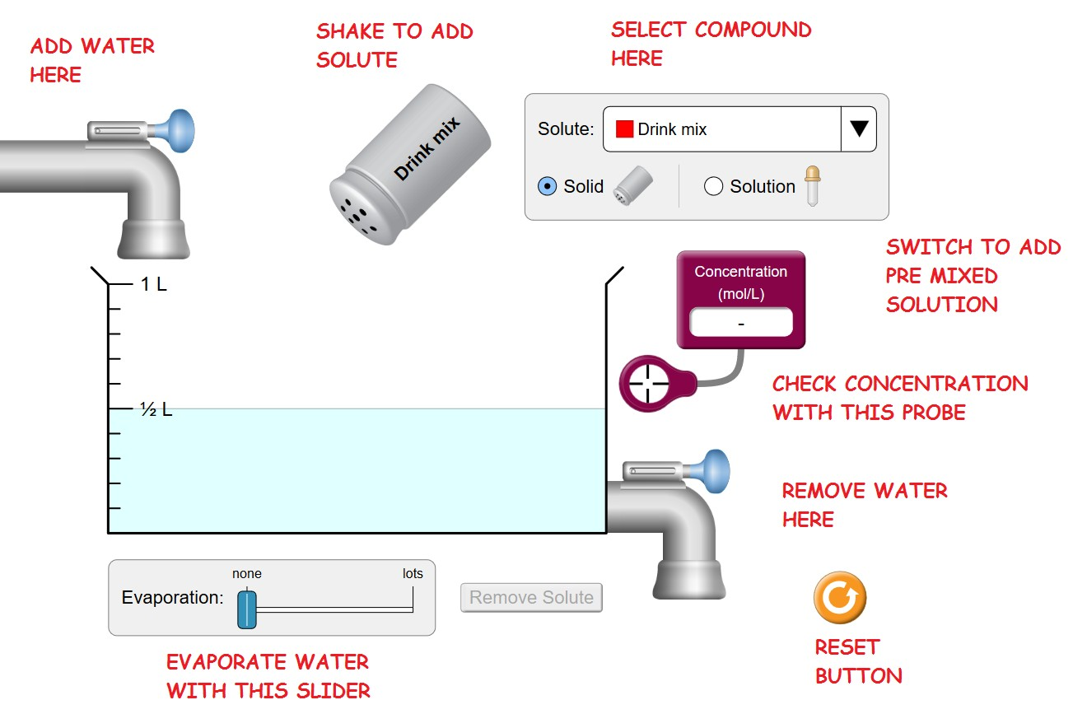
https://phet.colorado.edu/sims/html/concentration/latest/concentration_en.html

Familiarize yourself with the operation of the various functions of the simulation. You can always press the RESET
button to get back to the original situation.

Press Reset. Move the Concentration Probe into the liquid. Then Shake some Drink mix into the water. Continue to add
More Solute.
PART 1 – Effect of Changing Amount of Solute/Solvent
1. What happens to the concentration as more solute is added?
2. What units of the concentration on the meter measuring Concentration? _
3. What happens to the color as more solute is added?
4. What is the relationship between concentration and color?
5. Now add water. What happens to the concentration as the quantity of water increases? Explain why. (Mention what is happening to the quantity of solvent and solute)

6. Now Remove water with the valve on the lower right. What happens to the concentration as the quantity of water decreases?
Explain why. (Mention what is happening to the quantity of solvent and solute)

7. Now Remove water with the Evaporation Slider Bar on the bottom. What happens to the concentration as the quantity of water decreases?
Explain why. (Mention what is happening to the quantity of solvent and solute)

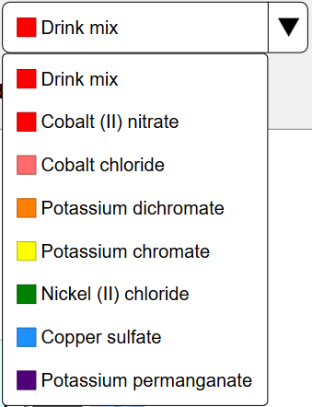
PART 2 - Saturation
Press Reset then. Switch to a different Compound by selecting the Drop Down Menu called
SOLUTE. Select CuSO4(If you don’t know what this is, look it up)
1. Can a saturated solution be created?

2. How do you know when a saturated solution is created?

3. Move the Concentration Probe into the liquid. (At this time the solution should be saturated) What is the concentration? (Include Units)

4. Add more solute. What happens to the concentration? (Explain why)

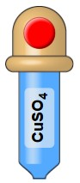
PART 3 – Using the Eye-dropper
Press Reset then. Switch to a the Eye dropper by selecting Solution in the upper right.

Logic Puzzle: Determine the concentration in the eye dropper. Write the steps below.

What is the concentration of the solution in the Eyedropper?

Logic Puzzle: How can a saturated solution be made from the liquid from the eye dropper? Write the steps below.

PART 4 – Controlling the Concentration
Press Reset then Select CuSO4. Add enough to create a .5 Molar Solution in the ½ liter of water originally in the beaker.

1. Show the calculation of the number of moles of in the beaker. (You may need the Equation for Molarity, look it up.)

2. Predict the concentration if the solution is diluted to a volume of 1 liter. Show the calculation of this concentration, include units in all your work.

After you make the calculation: Add water with the valve in the upper left until there is 1 liter of water in the beaker .
3. What is the concentration? Does this match your calculation? Yes or No

4. Predict the concentration if the solution is now concentrated (by using evaporation) to a volume of .75 liters (1/2 way between .5 liters and 1 liter). Show the calculation of this concentration, include units in all your work.

After you make the calculation: Evaporate water with Evaporation Slider Bar at the buttom until there is .75 liter of solution in the beaker.
5. What is the concentration? Does this match your calculation? Yes or No

6. From the concentration & Volume calculate the number of moles of solute in the solution. Show your calculation with units.

7. How does the # moles of solute compare to the # of moles of solute calculated in question 1. Explain why these numbers compare as they do.

8. Predict the concentration & # of moles of solute if water is added until the volume is 1 liter. (This should be easy)

9. Fill the beaker to a volume of 1 liter and check the concentration. What is the concentration?

Open the Remove Water Valve (on the lower right) until there is ½ a liter of solution in the beaker.

10. What happened to the concentration when ½ of the solution was allowed to run out? (Explain why in terms of the amount of solute and solvent)

11. From the concentration & Volume calculate the number of moles of solute in the solution. Show your calculation with units.

12. How does the # moles of solute compare to the # of moles of solute calculated in question 1. Explain why these numbers compare as they do.

13. Predict the concentration if the solution is diluted to a volume of 1 liter. Show the calculation of this concentration, include units in all your work.

After you make the calculation: Add water with the valve in the upper left until there is 1 liter of water in the beaker .
14. What is the concentration? Does this match your calculation? Yes or No

SUMMARY OF LEARNING OBJECTIVES
Adding solute (solid) to an unsaturated solution causes the concentration of the solution to: INCREASE /DECREASE/ REMAIN UNCHANGED.

Adding pure water to a saturated solution will cause the concentration of the solution to: INCREASE /DECREASE/ REMAIN UNCHANGED.

Adding a solid salt to a saturated solution cases the concentration of the solution to: INCREASE /DECREASE/ REMAIN UNCHANGED.

Evaporation acting on an unsaturated solution causes the concentration of the solution to: INCREASE /DECREASE/ REMAIN UNCHANGED

Evaporation acting on a saturated solution causes the concentration of the solution to: INCREASE /DECREASE/ REMAIN UNCHANGED.

