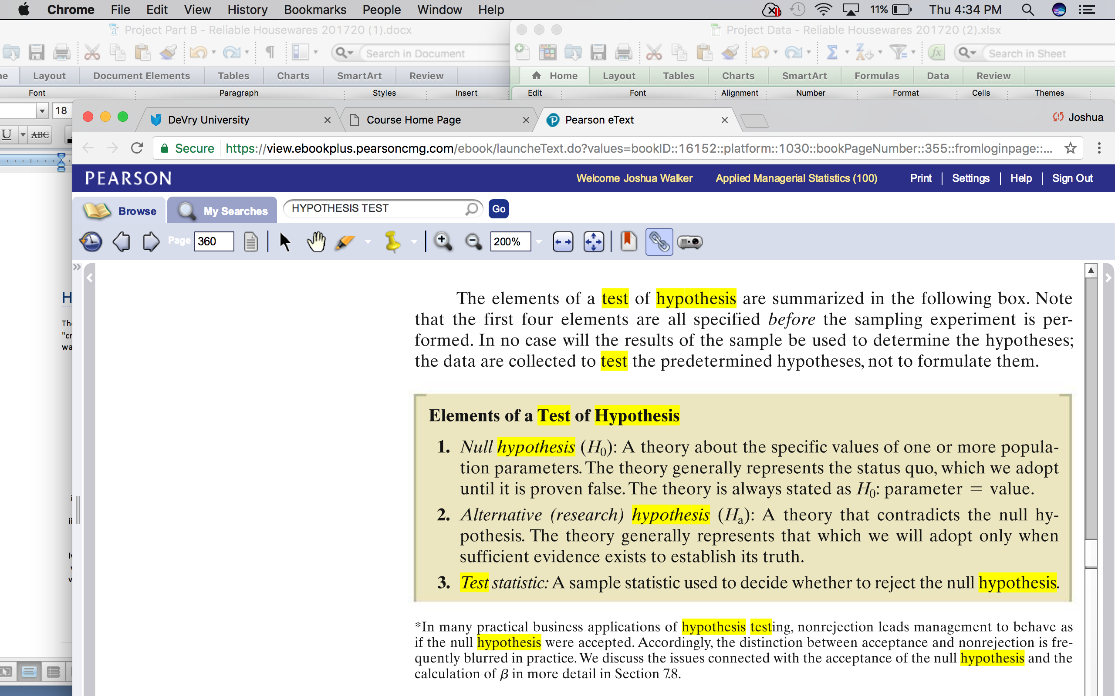

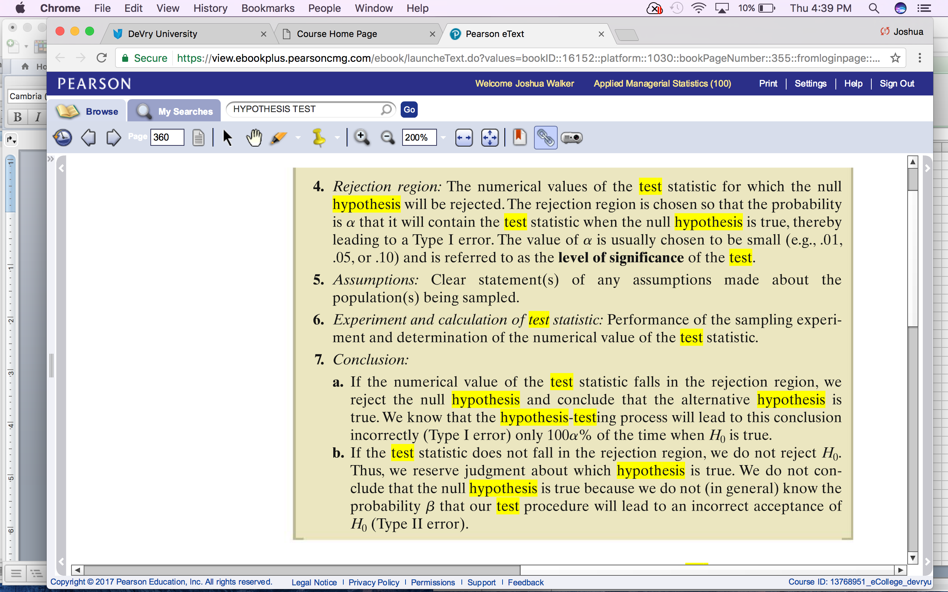

PROJECT PART B
Reliable Housewares is a local store that sells many household items and issues its own credit card to its customers. The store manager wants to study the purchasing behavior of its "credit" customers. To that end, he has come to DeVry and asked our MBA students for help. The manager has brought with him data on five variables of 50 randomly selected credit customers.
- LOCATION (Rural, Urban, Suburban – Household location of the credit customer)
- INCOME (in $1,000's – be careful with this)
- SIZE (Household Size - number of people living in the household of credit customer)
- YEARS (the number of years that the customer has lived in the current location)
- CREDIT BALANCE ($ balance on customer’s store credit card)

Hypothesis Testing and Confidence Intervals
The Reliable Housewares store manager wants to learn more about the purchasing behavior of its "credit" customers. In fact, he is speculating about four specific cases shown below (a) through (d) and wants you to help him test their accuracy.
- The average annual income of credit customers is less than $50,000.
- The true population proportion of credit customers who live in an urban area exceeds 40%.
- The average number of years lived in the current home is less than 13 years.
- The average credit balance for suburban customers is more than $4,300.
- Using the dataset provided in DocSharing, perform the hypothesis test for each of the above speculations (a) through (d) in order to see if there is an statistical evidence to support the manager’s belief. In each case, use the Seven Elements of a Test of Hypothesis, in Section 6.1 of your textbook (on or about Page 324). Use α=5% for all your analyses. Explain your conclusion in simple terms. Also be sure to indicate which hypothesis is the “claim”, compute the p-value, and interpret your results. Look above for Seven Elements of a Test of Hypothesis
- Follow your work in (i) with computing a confidence interval for each of the variables described in (a) though (d). Interpret these intervals.
- Write an executive summary for the Reliable Housewares store manager about your analysis, distilling down the results in a way that would be understandable to someone who does not know statistics. Clear explanations and interpretations are critical.
- All DeVry University policies are in effect, including the plagiarism policy.
- Project Part B report is due by the end of Week 6.
- Project Part B is worth 100 total points. See grading rubric below.

Submission: A report in Microsoft Word containing the following:
- The summary report from (iii) above. This will make the body of your report
- All of the relevant work done in the hypothesis testing (including your Excel calculations showing the excel functions or Excel calculator outputs) in Part (i). This will be in Appendix
- All of the relevant work done in calculating confidence intervals (using Excel Calculator outputs or Excel functions) in Part (ii). This will be in Appendix

Report Format:
- Executive Summary – This will be the summary of your findings to the management of Reliable Housewares. It will have four sections (A) through (D) corresponding to the four speculations (a) through (d). Each section will be about one or two paragraphs long. Clarity and conciseness in your conclusions are key here. Avoid using technical terminologies in this section.
- Appendix – Your report will have four appendices (A) through (D) corresponding to the four speculations (a) through (d). In each appendix, indicate all the steps in hypothesis testing (i.e., the Seven Elements of a Test of Hypothesis in Section 6.1 of your text book). Don’t forget to mark which hypothesis is the claim and interpret your findings. Also, show your results for the confidence interval and the p-value for each speculation. Include all relevant Excel outputs.

Project Part B: Grading Rubric
Category | Points | % | Description
Executive Summary | 20 | 20 | One or two paragraphs on each of the speculations. Explain your conclusions in simple, cohesive, and concise way. Management does not know statistics.
Addressing each speculation - 20 pts. each | 80 | 80 | Hypothesis test, claim, confidence interval, p-value, and interpretations
Total | 100 | 100 | A quality paper will meet or exceed all of the above requirements. They will be concise, clear, and to the point. Also, since this is a graduate level course, spelling, grammar, clarity, logic, cohesiveness, and adherence to the above format are expected and will result in point deductions if not met.

