  - The SCR in Figure 1 below requires a 3 V trigger. Using Multsim, design a system by which the gears are shifted when a CdS photocell resistance drops below 4k.
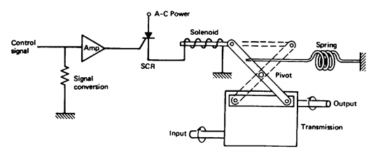
Figure 1
  - Using Multisim, design a system by which a control signal of 4 to 20 mA is converted into a force of 200 to 1000N. Use a pneumatic actuator and specify the required diaphragm area if the pressure output is to be in the range of 20 to 100kPa. An I/P converter is available that converts 0 to 5 V into 20 to 100 kPa. A block diagraph of the system is shown below. (Hint: Use a differential amplifier. You are only designing the circuit to interface into the I/P below)
