Assignment Overview
Type: Individual Project [Business Law I]
Unit: Business Organizations & Regulation
Due Date: Thu, 10/26/16 1300 CST, Greenwich Meantime, London Time
Grading Type: Numeric
Deliverable Length: 1300 words, Format: APA to include in-text citations and citations after every paragraph
Originality: 80 percent in own words, not authors.

Assignment Details

Assignment Description
Weekly tasks or assignments (Individual or Group Projects) will be due by Thursday and late submissions will be assigned a late penalty in accordance with the late penalty policy found in the syllabus. NOTE: All submission posting times are based on 1300 Central Time.
As an entrepreneur, you want to start a business. You know that the first step is to consider drafting a business plan proposal to organize all of your ideas. For this assignment, you will be submitting a business plan proposal outline for your imaginary business. For research purposes, you can choose any state for the location of your business. Your business plan outline should include the following:
- Introduction of the proposed business (200-300 words)
- Description and explanation of the type of business entity that is best for your business (200-400 words)
  - Your business should be a partnership, corporation, or another type (For this assignment, you should not choose a sole proprietorship for your business entity.).
  - Provide an explanation for your choice of business entity (advantages or disadvantages of the selected type of business entity).
- Description of the specific steps that need to be followed to successfully and legally start the business (700-900 words)
  - Steps will vary depending on the type of business that you choose.
  - Good sources of research for this area include the following:
    - Textbooks
    - State statutes (e.g., Chapters 47 and 48 of the South Dakota Codified Laws include information on the business formation process.)
    - The Small Business Administration Web site will be helpful because it includes information on how to start a small business.
- A draft of a valid contract with a vendor, supplier, customer, and so forth that illustrates all elements of a contract and takes into consideration some of the topics discussed in the contract chapters List of Elements of a Contract notated on next page.

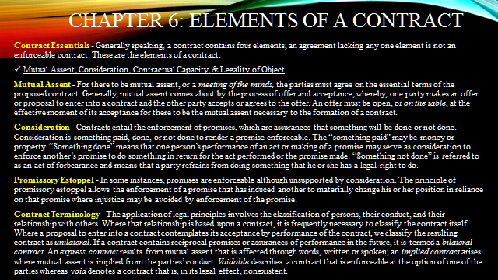

For assistance with your assignment, please use your text, Web resources, and all course materials.

