ACCT230- Principles of Cost Accounting
Portfolio Project
Submission 3

Problem 1
Jim Tallon has obtained the following data relative to the Gibbs & Vaughan consulting job:
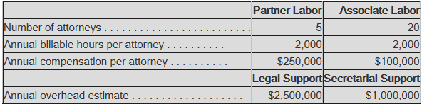
Assume that the Wilkes Barre job will require 50 partner hours and 20 associate hours, while the Scranton job will require 15 partner hours and 55 associate hours.
Required:
1. a. Using a simplified costing system with one direct cost category for professional labor and one indirect cost category for support costs with professional labor hours as the allocation base, compute the bid price for the Wilkes Barre job and the Scranton job, assuming a 25% markup on cost. (Round to the nearest whole dollar.)
b. Do you think that your results seem reasonable? Why?
2. Using an activity-based costing system with two direct cost categories for partner labor and associate labor, and two indirect cost categories, one for legal support and one for secretarial support with cost allocation bases of professional labor hours and partner labor hours, respectively, compute the bid price for the Wilkes Barre job and the Scranton job, assuming a markup of 25% on cost.
3. a. Compute the difference in bid price for each job between the simplified costing system and the activity-based costing system.
b. Were the jobs undercosted, overcosted, or a combination of each? Which job had the greater differential, depending on which costing system was used, and why?

Problem 2
The Eradicate Inc. segment produces and sells a line of insect repellants that is sold primarily in the summer months. Recently, the chief operating officer has become interested in possibly manufacturing a repellant, “Halt,” that can prevent a person from being attacked by use of a “pepper” repellant. The appeal of this product is that it would have year-round sales and would help stabilize the company's income.
The product, however, must be sold in a specially designed spray can that will be safe from being discharged accidentally. The product will be sold in cartons that hold 24 cans of the repellant. The sales price will be $96 per carton. The plant is now operating at only 65% of its total capacity, so no additional fixed costs will be incurred. However, a $100,000 fixed overhead charge will be allocated to the new product from the company's present total of fixed costs.
Using the current estimates for 100,000 cartons of “Halt” as a standard volume, the following costs were developed for each carton, including the cost of the can:
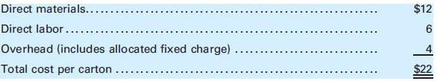
Eradicate Inc., has requested a bid from a manufacturer of specialty dispensers for a purchase price of an empty can that could be used for the new product. The specialty company offered a price of $5 for a carton of cans. If the proposal is accepted, Eradicate Inc. estimates that direct labor and variable overhead costs would be reduced by 10% and direct materials would be reduced by 20%.
Required:
1. Should Eradicate make or buy the special cans?
2. What would be the maximum purchase price acceptable to Eradicate for the cans?

Problem 3
Leprechaun Enterprises Inc., is considering building a manufacturing plant in County Cork. Predicting sales of 100,000 units, Leprechaun estimates the following expenses:
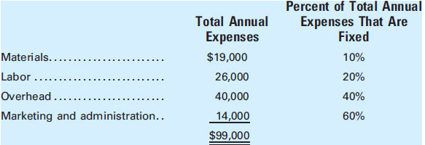
An Irish firm that specializes in marketing will be engaged to sell the manufactured product and will receive a commission of 10% of the sales price. None of the U.S. home office expense will be allocated to the Irish facility.
Required:
1. If the unit sales price is $2, how many units must be sold to break even?
2. Calculate the margin of safety ratio.
3. Calculate the contribution margin ratio.

